**Unzer**

22-Feb-23

**Trello Task**

**QA Engineer Task**

**Roopali Vijayakumar**

**Assignment  
Please create a simple test suite that combines verification of basic functionality of [Trello] (**[**https://trello.com/**](https://trello.com/)**) task management tool both through its UI and REST API.**

**• Simple test suite to test the basic functionalities of Trello. – API Testing**

I have chosen the following test scenarios to test through API REST Assured.

1.Create new board  
2.Get board details  
3.Create new List in the board  
4.Delete a board  
5.Create a card in the list  
6.Delete a card

I have used Java with TestNG framework because it makes automated tests more structured, readable, maintainable and user-friendly. All the necessary dependencies are placed in the POM.xml file. Also I have used eclipse IDE as it supports Java and it is open-source.

Below each class represents one test case individually as per my code. Please refer my code in Github to get the complete picture. Using TestNG, we can run each test individually or we can run all the tests together on priority basis.

public void test()  
This class is used for testing the "Create new board " functionality through API.

public void test1()  
This class is used to test whether the board details are printed correctly through response body, status code.

public void test2()  
This class is used for testing the "Create new List in the board " functionality through API.

public void test3()  
This class is used for testing the "Delete a board " functionality through API.

public void test4()  
This class is used for testing the "Create a card in the list " functionality through API.

public void test5()  
This class is used for testing the "Delete a card " functionality through API.

**I have provided few test result screenshots after the test run.**

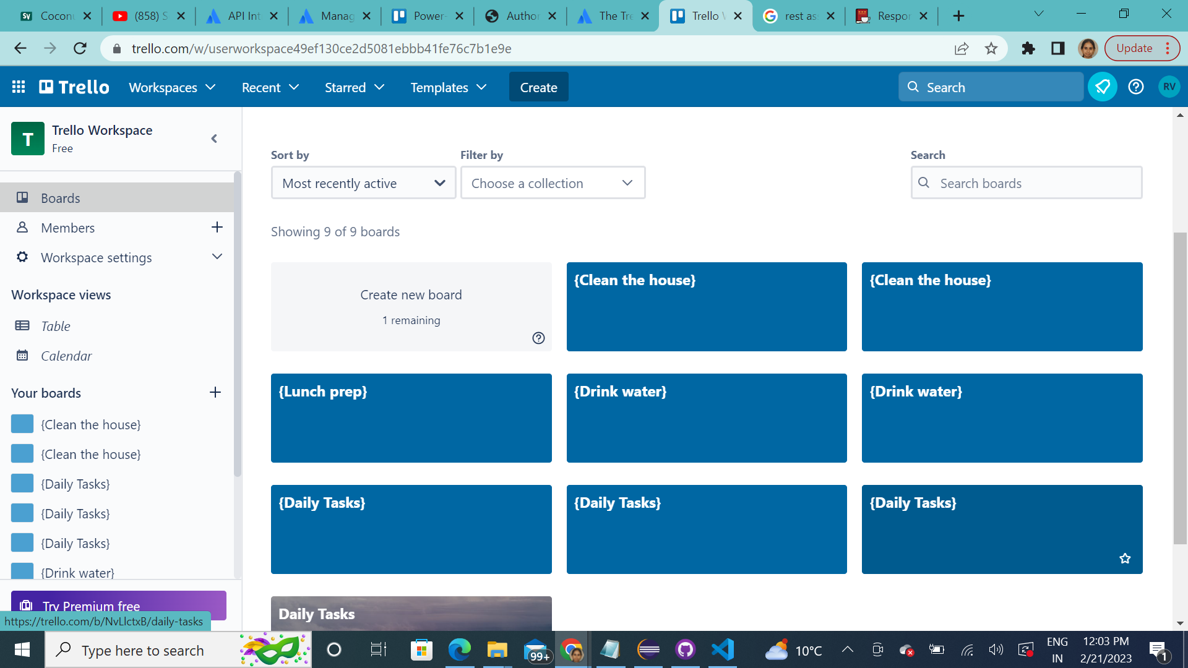

Figure 1 : Trello workspace with new boards created

The boards seen in the snapshot were created as the result of test run of creating boards. I have purposely created boards with same name for negative testing. Though the names are the same, the board id is different.

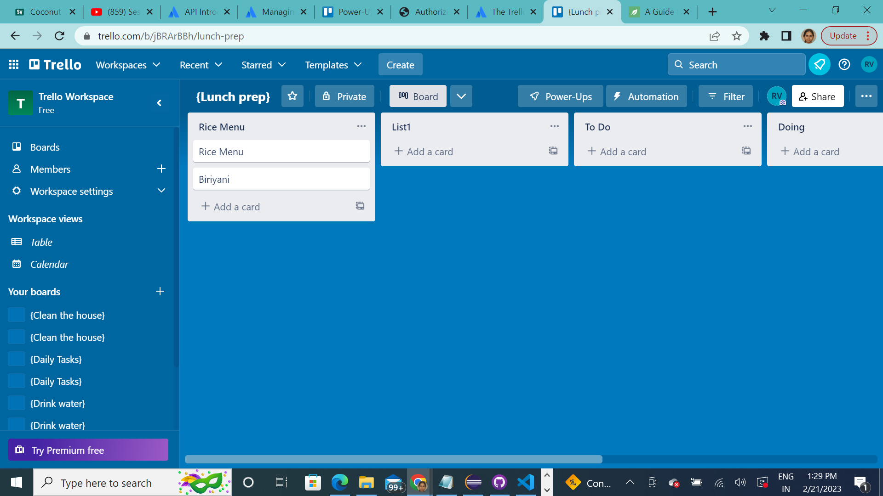

Figure 2 : Board view with Lists and Cards

We can view a board named “Lunch prep” where in I have created new lists (List1 and Rice Menu) and new cards (Rice Menu and Biriyani) through the code.

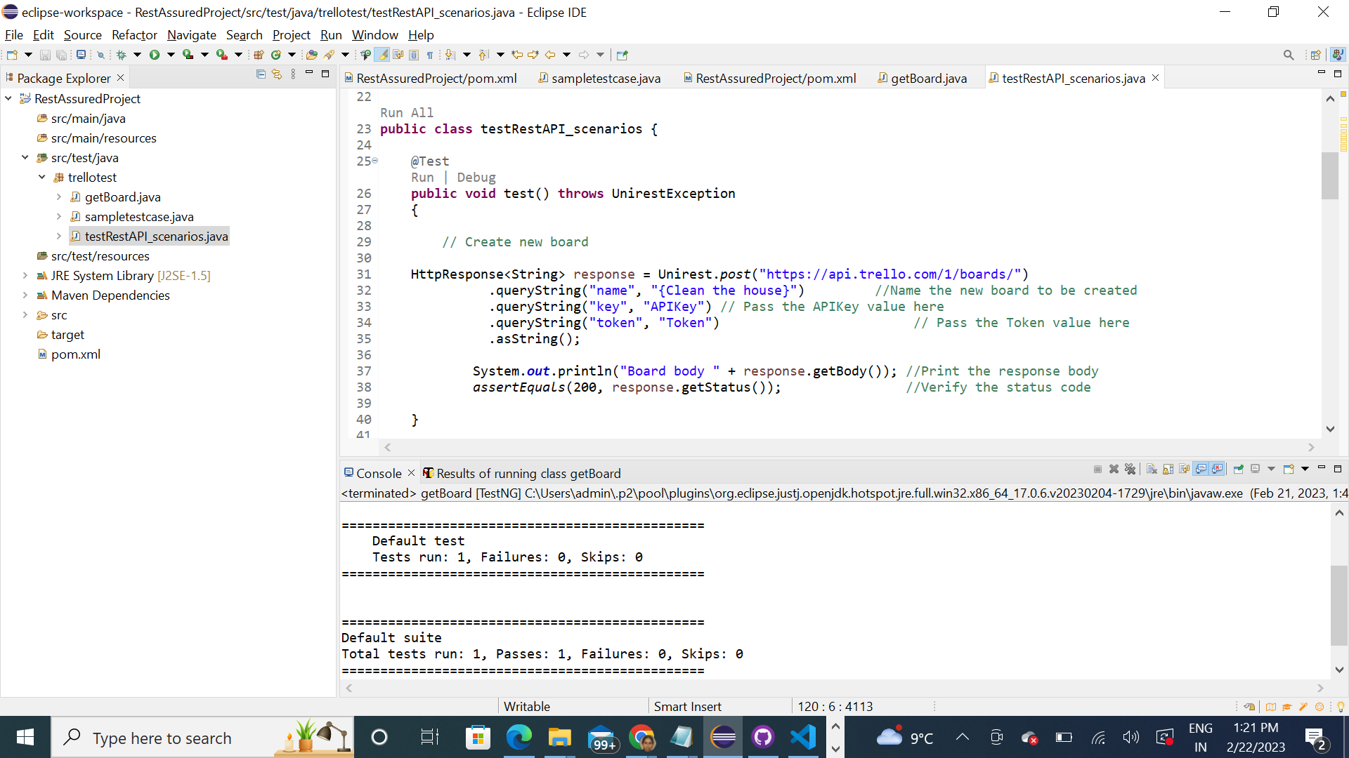

Figure 3 : A glimpse of the code in eclipse with test result in console

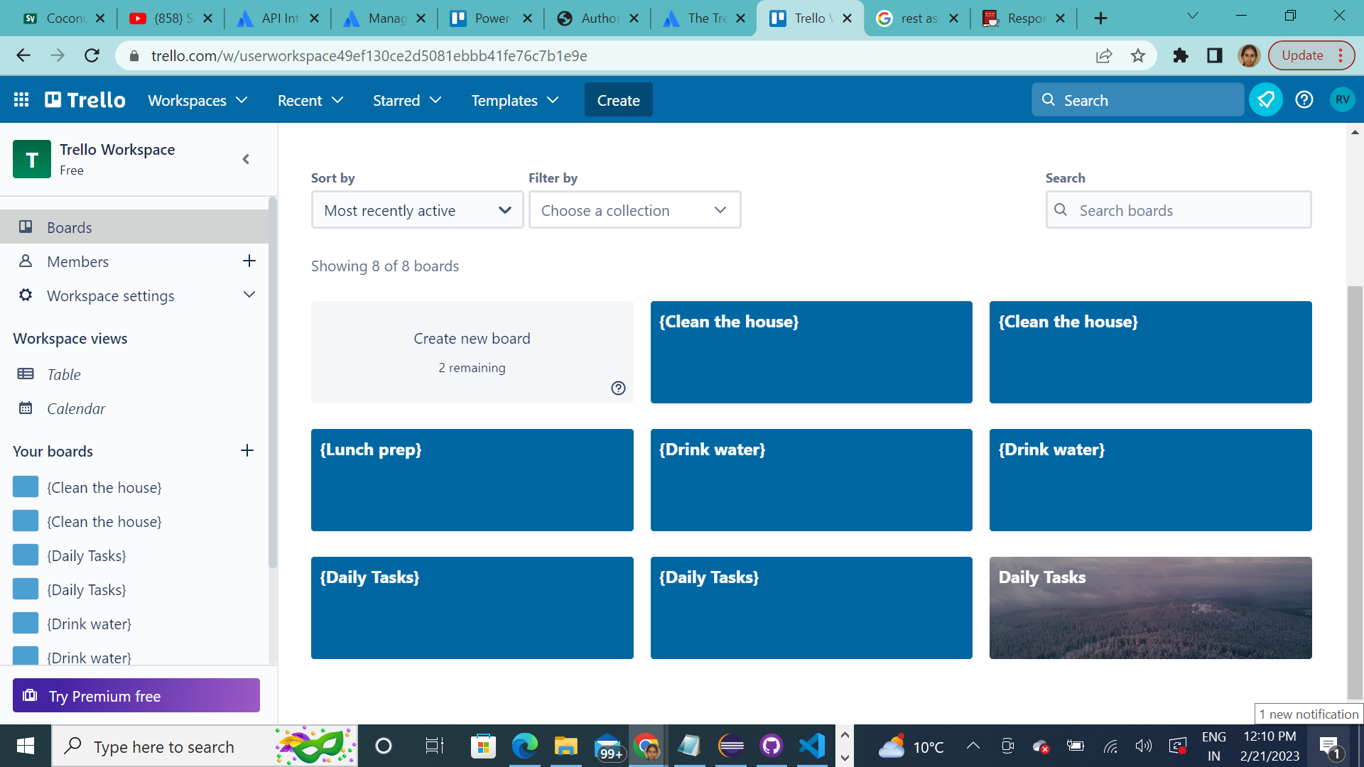

Figure 4 : The Daily Tasks board was successfully deleted using board id -test result of test3() test case

**• Simple test suite to test the basic scenarios of search functionality. – UI Testing**

The test steps for the search functionality will be as follows:

1. Launch the webpage <https://www.trello.com.login/>
2. Verify the title of the page
3. Input the e-mail ID of the user and click on the Login button
4. Input the password of the user and navigate
5. After the Login process, the user must land on the home page
6. Enter keyword in the search box and press enter
7. The results must be visible accordingly

I have used Cypress tool along with Javascript to test automate the search functionality. All my coding was done in Visual Studio Code (Source code editor) as below.

In the terminal, run the test script:

Cypress Automation > node_modules\.bin\cypress run  
This will open the test runner and we can click on one particular spec file (trello.spec.js) to see how it runs. We can see the automation with screenshots recording.

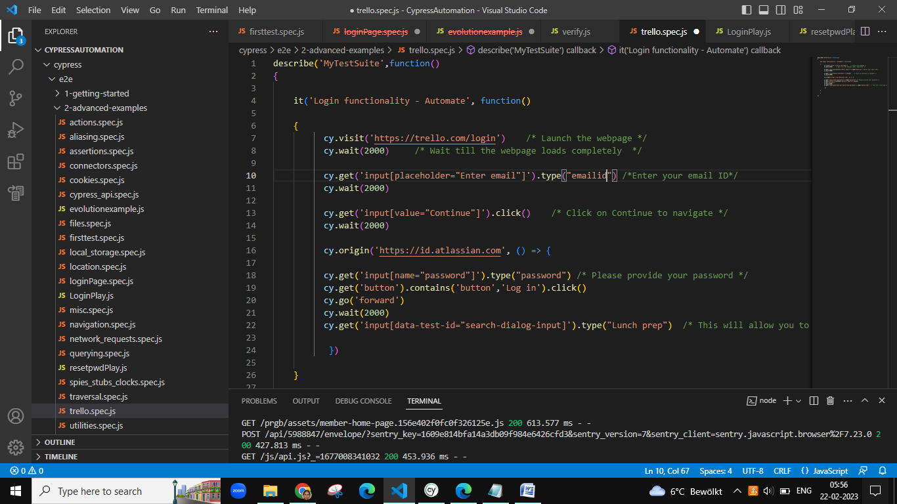

Figure 1 : A glimpse of the code in Visual Studio Code

Below are the test run screenshots:

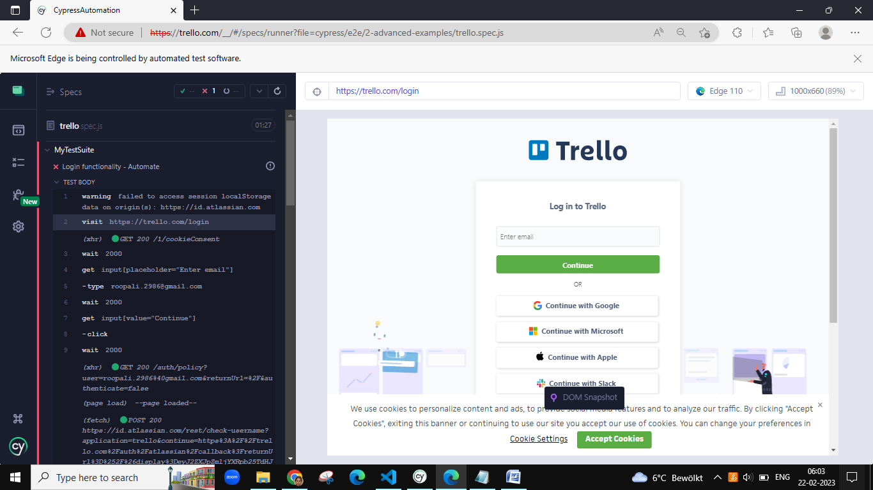

Figure 2 : Web page Launch

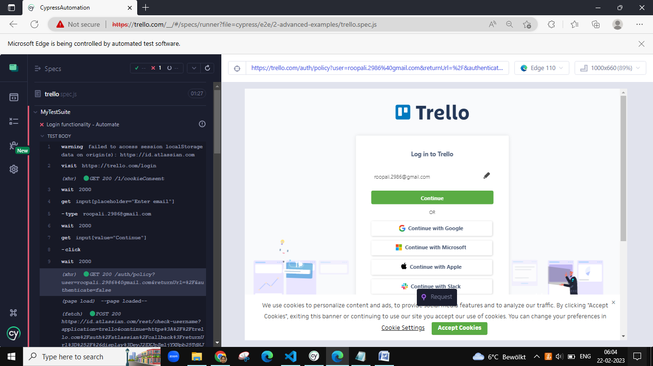

Figure 3 : Enter email address

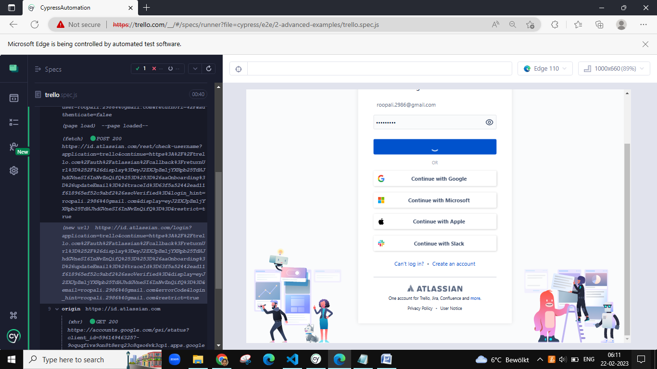

Figure 4 : Provide Login Credentials

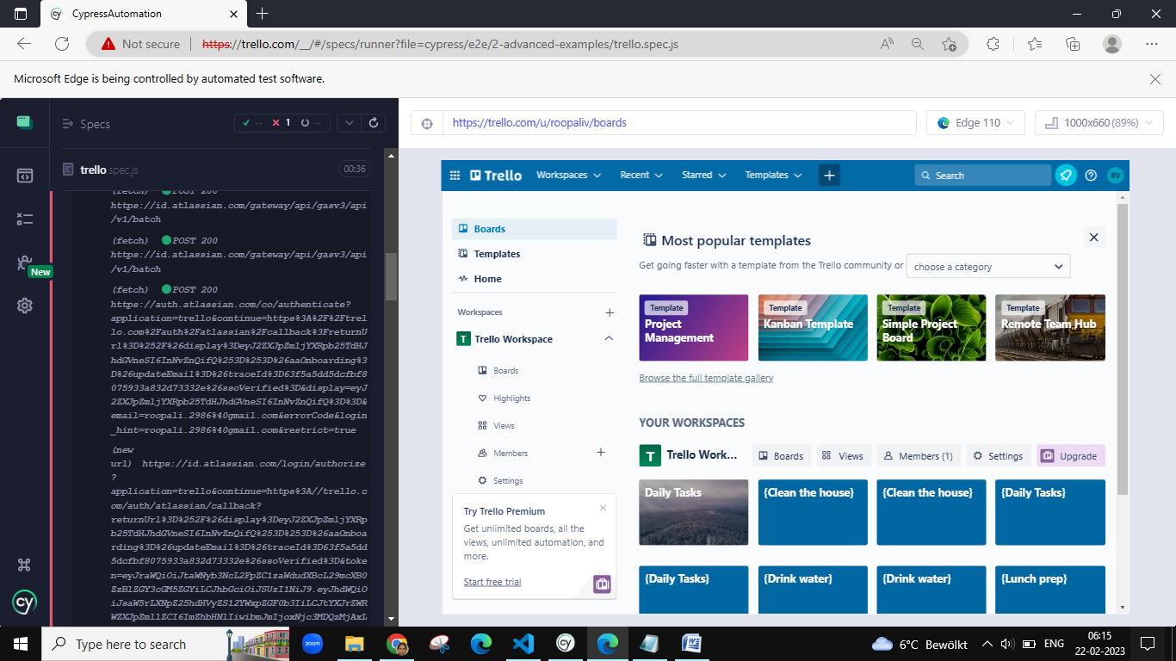

Figure 5 : Home page launched

This is the current status of the Automation task as I was not successful in entering the keyword for search functionality. The Cypress automation succeeded until launching the home page but I was stuck with an error “ResizeObserver loop limit exceeded”.

**Thank You Note**

**Dear Unzer team,**

**Thank you so much for giving me an opportunity to work on this task. It was a great experience for me to work on this assignment. I have honestly provided the solutions to the best of my knowledge. Hoping to meet you further in the selection process**.