Roopali_FML Assignment_1

2024-02-04

data(iris)  
df <- iris  
summary(df[, c("Sepal.Length", "Sepal.Width", "Petal.Length", "Petal.Width")])

## Sepal.Length Sepal.Width Petal.Length Petal.Width   
## Min. :4.300 Min. :2.000 Min. :1.000 Min. :0.100   
## 1st Qu.:5.100 1st Qu.:2.800 1st Qu.:1.600 1st Qu.:0.300   
## Median :5.800 Median :3.000 Median :4.350 Median :1.300   
## Mean :5.843 Mean :3.057 Mean :3.758 Mean :1.199   
## 3rd Qu.:6.400 3rd Qu.:3.300 3rd Qu.:5.100 3rd Qu.:1.800   
## Max. :7.900 Max. :4.400 Max. :6.900 Max. :2.500

table(df$Species)

##   
## setosa versicolor virginica   
## 50 50 50

df$Petal.Width <- df$Petal.Width^3  
hist(df$Sepal.Length, main = "Histogram of Sepal.Length", xlab = "S.L")

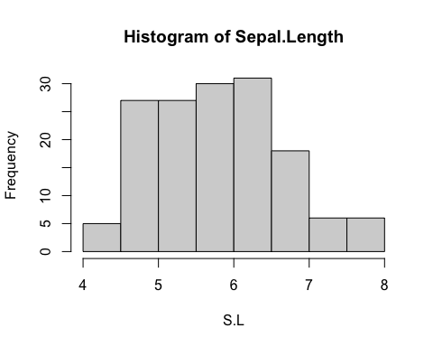

plot(df$Petal.Length, df$Petal.Width, main = "Scatterplot of Petal.Length vs Petal.Width",   
 xlab = "Length", ylab = "Width")

