Dynamic To-Do List Web Application
Name: ROOPANSHI YADAV
Roll No: 2401010016
Course: B.Tech CSE
University: K.R. Mangalam University

- Aim
To build a dynamic To-Do List web application using HTML, CSS, JavaScript, and Node.js with SQLite database to perform CRUD operations and store tasks permanently.

- Database Schema
Table: tasks
Column Type Description id INTEGER Primary Key title TEXT Task title priority TEXT Task priority is Done INTEGER Completion status createdAt DATETIME Creation time

3. API Endpoints
Method Endpoint | Purpose
GET /tasks | Retrieve all tasks
POST /tasks | Add new task
Toggle
PATCH /tasks/:id/status
completion
DELETE /tasks/:id Delete task

4. Frontend Code index.html
<!DOCTYPE html>
<html>
<head>
<title>My To-Do List</title>
<link rel="stylesheet" href="style.css">
</head>

<body>

<h1>My To-Do List</h1>

<input id="title" placeholder="Enter task">

<select id="priority">
<option>Low</option>
<option>Medium</option>
<option>High</option>
</select>

<button onclick="addTask()">Add Task</button>

<ul id="taskList"></ul>

<script src="script.js"></script>

</body>
</html>
style.css body{ font-family: Arial; text-align: center;
background:#f4f4f4;
}
li{
background:white; margin:10px auto; padding:10px; width:300px; border-radius:5px;
}

.completed{
text-decoration:line-through; color:gray;
}
script.js const API="http://localhost:3000/tasks";

async function loadTasks(){

const res=await fetch(API);
const tasks=await res.json();

const list=document.getElementById("taskList"); list.innerHTML="";

tasks.forEach(task=>{

const li=document.createElement("li");

if(task.isDone) li.classList.add("completed");

li.innerHTML=`
${task.title} (${task.priority})
<button onclick="toggleTask(${task.id})">✔</button>
<button onclick="deleteTask(${task.id})"> </button>
`;

list.appendChild(li);

});

}

async function addTask(){

const title=document.getElementById("title").value; const priority=document.getElementById("priority").value;

await fetch(API,{ method:"POST",
headers:{"Content-Type":"application/json"},
body:JSON.stringify({title,priority})
});

loadTasks();
}

async function toggleTask(id){

await fetch(API+"/"+id+"/status",{method:"PATCH"}); loadTasks();
}

async function deleteTask(id){

await fetch(API+"/"+id,{method:"DELETE"}); loadTasks();
}

loadTasks();

5. Backend Code server.js const express = require("express"); const sqlite3 = require("sqlite3").verbose(); const cors = require("cors"); const bodyParser = require("body-parser");

const app = express(); app.use(cors());
app.use(bodyParser.json());

const db = new sqlite3.Database("db.sqlite");

db.run(`CREATE TABLE IF NOT EXISTS tasks( id INTEGER PRIMARY KEY AUTOINCREMENT,
title TEXT NOT NULL, priority TEXT DEFAULT 'Medium', isDone INTEGER DEFAULT 0,
createdAt DATETIME DEFAULT CURRENT_TIMESTAMP
)`);

app.get("/tasks",(req,res)=>{ db.all("SELECT * FROM tasks",(err,rows)=>{ res.json(rows);
});
});

app.post("/tasks",(req,res)=>{ const {title,priority}=req.body;

db.run(
"INSERT INTO tasks(title,priority) VALUES(?,?)",
[title,priority], function(){
res.json({id:this.lastID});
});
});

app.patch("/tasks/:id/status",(req,res)=>{ db.run(
"UPDATE tasks SET isDone = NOT isDone WHERE id=?",
[req.params.id],
()=>{res.send("updated");}
);
});

app.delete("/tasks/:id",(req,res)=>{ db.run(
"DELETE FROM tasks WHERE id=?",
[req.params.id],
()=>{res.send("deleted");}
);
});

app.listen(3000,()=>{
console.log("Server running on port 3000");
});

Output Screenshots
Task Added
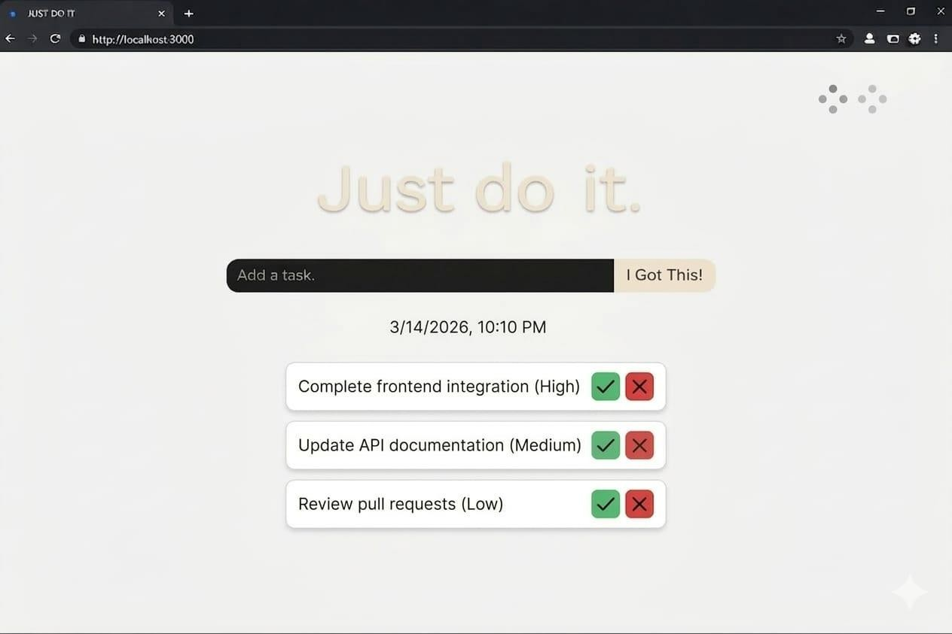
Task Completed
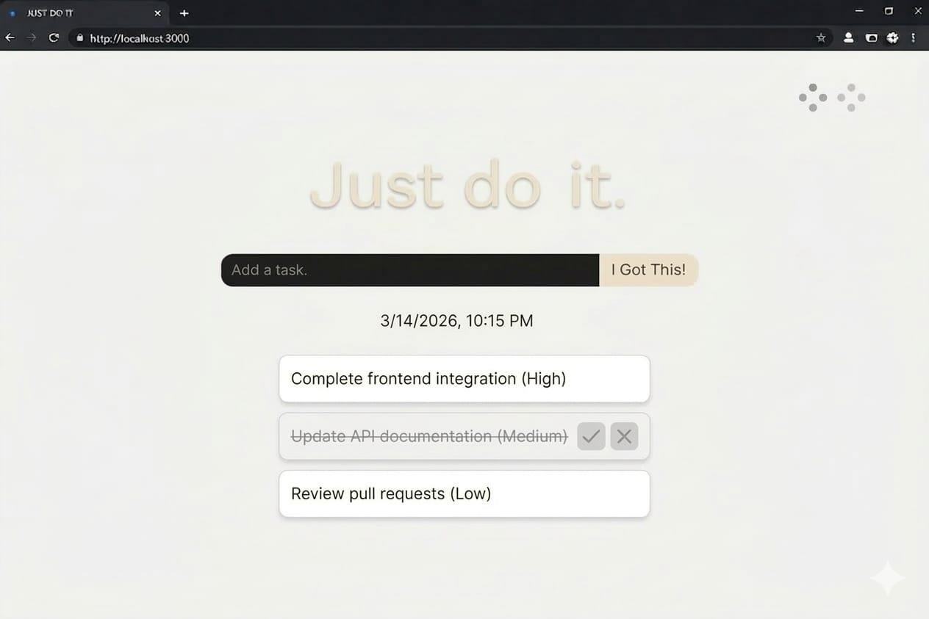

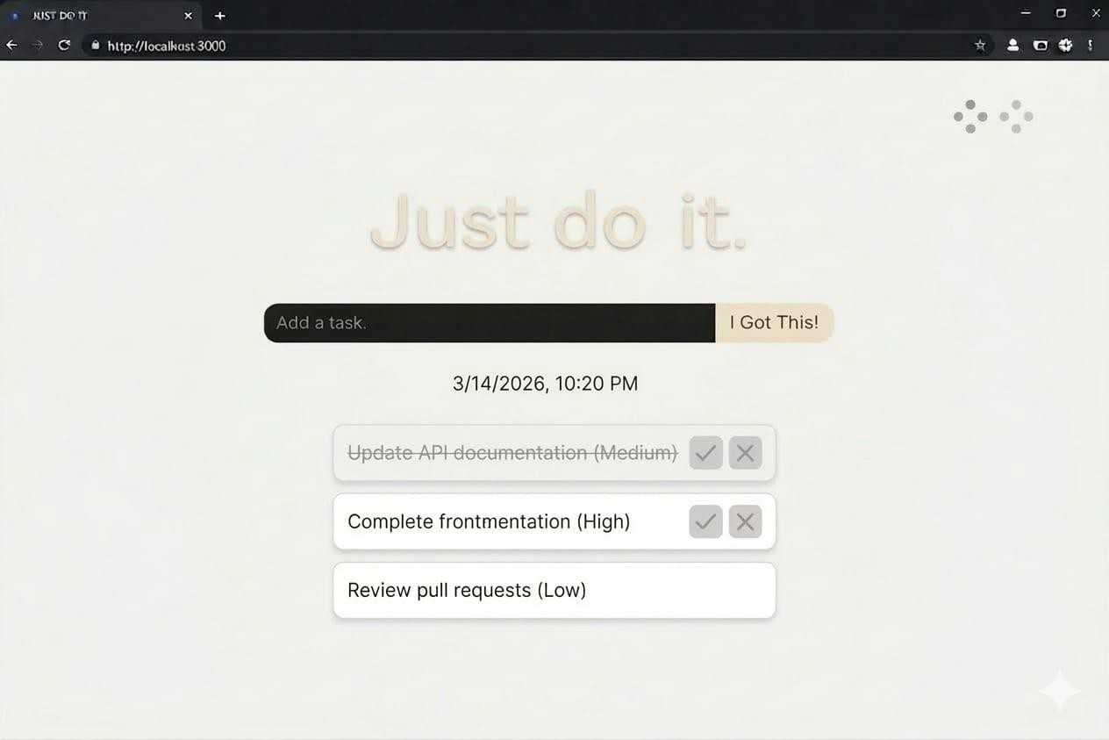

Task Deleted

Tasks Persist After Refresh
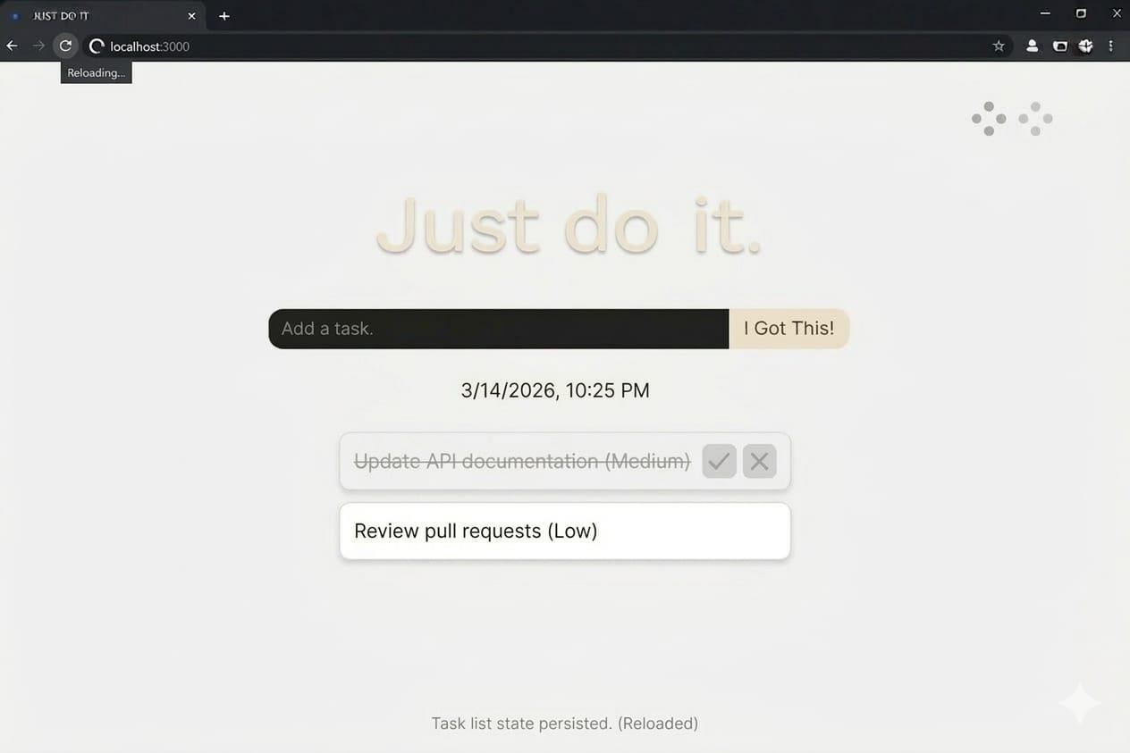

7. Challenges Faced
During the development of this project, the following challenges were encountered:
- Understanding CRUD operations in JavaScript
- Connecting frontend with backend APIs
- Handling asynchronous fetch requests
- Managing database storage using SQLite

