MEDICAL WRITING INTERNSHIP
Artificial Intelligence in Patient Education and
Healthcare Communication: A Narrative Review
Week 1 Task: Topic Proposal, Literature Research, and Outline Development
Program | Yuva Intern / Henry Harvin Medical Writing Internship
Prepared by | Kartik . H
Role | Junior Medical Writing Intern
Duration | 18 July 2026 – 15 August 2026 (4 Weeks)
Task Period | Week 1
Location | Koppala, Karnataka, India
Submission Date | 27 July 2026

Table of Contents
Table of Contents 2
1. Topic Proposal 3
2. Research Question 3
3. Rationale 3
4. Methods — Literature Search Approach 3
5. Results — Literature Summary 4
6. Detailed Narrative Review Outline 4
6.1 Introduction 5
6.2 Background 5
6.3 Current Applications 5
6.4 Benefits 6
6.5 Challenges 6
6.6 Discussion 7
6.7 Future Directions 7
6.8 Conclusion 8
7. Supplementary Data 9
8. References (APA 7th Edition) 9
9. Note on Sourcing and Originality 9

1. Topic Proposal
Artificial intelligence (AI) is increasingly used to support patient education and healthcare communication through conversational chatbots, large language models (LLMs), translation tools, tailored education platforms, and clinical decision-support interfaces. Recent peer-reviewed reviews suggest that these tools may improve accessibility, personalization, health literacy, and communication efficiency, while also raising concerns about accuracy, algorithmic bias, privacy, and ethical governance.
This narrative review critically synthesizes current peer-reviewed evidence on the opportunities, limitations, and future directions of AI in patient-facing communication, and is relevant to both practising clinicians and the wider public who increasingly encounter AI-generated health information.

2. Research Question
What is the current evidence on the use of artificial intelligence in patient education and healthcare communication, and what opportunities, challenges, ethical considerations, and future directions emerge from the existing literature?

3. Rationale
Patient education and healthcare communication are central to informed decision-making, treatment adherence, and patient engagement. However, communication gaps, language barriers, limited consultation time, and variable health literacy continue to affect care quality.
Recent literature indicates that AI, particularly generative AI and large language models, can translate complex clinical information into patient-friendly language, generate educational materials, and support more responsive communication, although reliability and governance remain significant concerns. This topic is timely because international and national regulatory bodies, including the World Health Organization (WHO), the U.S. Food and Drug Administration (FDA), and the Indian Council of Medical Research (ICMR), have each issued guidance emphasizing oversight, transparency, and human-centered deployment of AI in healthcare within the last five years.

4. Methods — Literature Search Approach
As a narrative review rather than a systematic review, this article does not require a registered protocol; however, a structured search approach was used to maintain rigor.
Literature was identified through PubMed, Frontiers in Medicine, JMIR, Cureus, and the official publication repositories of WHO, ICMR, and the FDA, using combinations of the terms “artificial intelligence”, “large language models”, “patient education”, “health communication”, “chatbot”, and “health literacy”.
Only peer-reviewed articles, and guidance documents issued directly by recognized health authorities, were included. Blogs, vendor marketing material, and non-peer-reviewed sources were excluded to preserve the academic rigor of the review.

5. Results — Literature Summary
Recent literature shows a clear shift from general discussions of AI in healthcare toward more patient-centered applications. A 2024 scoping review of large language models in patient education, published in Frontiers in Medicine, screened the PubMed literature and identified 201 eligible studies, the majority (58.2%) originating from the United States.
The review described six recurring application themes: generating patient education materials, interpreting medical information for patients, providing lifestyle recommendations, supporting customized medication use, offering perioperative care instructions, and optimizing doctor-patient interaction. The authors reported that LLMs could provide largely accurate responses to patient queries and enhance existing educational materials, while also noting variability in output quality across studies.
A separate 2024 literature review published in Cureus examined AI's role in patient-physician communication specifically, concluding that AI tools can help bridge language barriers, summarize complex medical data, and generate responses that patients perceive as comprehensible and, in some study contexts, more empathetic than typical clinician responses. The same review cautioned that hallucinations, defined as plausible-sounding but factually incorrect outputs, remain an important and unresolved limitation of current systems, underscoring the need for human oversight in any patient-facing deployment.
Regulatory and ethics literature complements these clinical findings. WHO's 2021 guidance on AI ethics in health, developed with an expert panel, set out six consensus principles for the responsible use of AI in healthcare; its January 2024 follow-up guidance addressed large multi-modal models specifically, given their rapid uptake in consumer and clinical settings.
In India, the ICMR's March 2023 ethical guidelines address AI in biomedical research and healthcare directly, articulating principles such as patient autonomy, safety and risk minimization, and data confidentiality, and reflect ongoing efforts to align AI governance with India's Digital Personal Data Protection Act, 2023. In the United States, the FDA's January 2025 draft guidance on AI-enabled device software functions signals movement toward lifecycle-based regulatory oversight, extending beyond diagnostic devices toward broader AI-enabled health technology.
Taken together, the literature supports a balanced narrative: AI shows measurable promise for patient education and communication, but safe, ethical use depends on validation, transparent governance, and context-specific implementation rather than unconditional adoption.
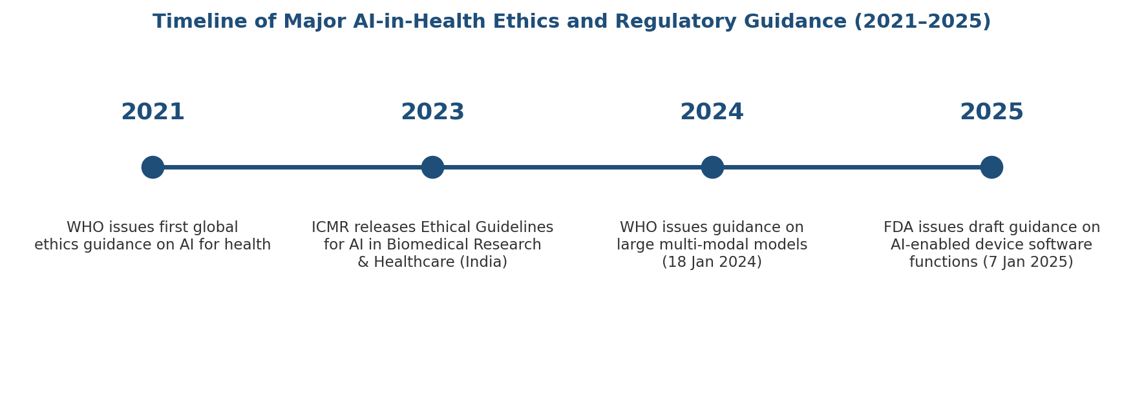
Figure 1. Timeline of major AI-in-health ethics and regulatory guidance, 2021–2025 (WHO, ICMR, FDA).

6. Detailed Narrative Review Outline

6.1 Introduction
- Define AI in healthcare communication and patient education.
- Explain why this topic matters in modern, increasingly digital healthcare delivery.
- State the purpose, scope, and research question of the narrative review.

6.2 Background
- Patient education as a core component of quality, patient-centered care.
- Healthcare communication and its role in adherence, shared decision-making, and outcomes.
- Evolution of AI in healthcare, from rule-based clinical decision systems to generative AI and large language models.

6.3 Current Applications
- AI chatbots for patient queries and triage support.
- Patient education platforms that simplify and personalize medical information.
- Clinical decision support tools that indirectly shape patient communication.
- Multilingual communication and machine translation support.
- Medication counseling and adherence support tools.
- Health literacy tools and personalized educational content generation.
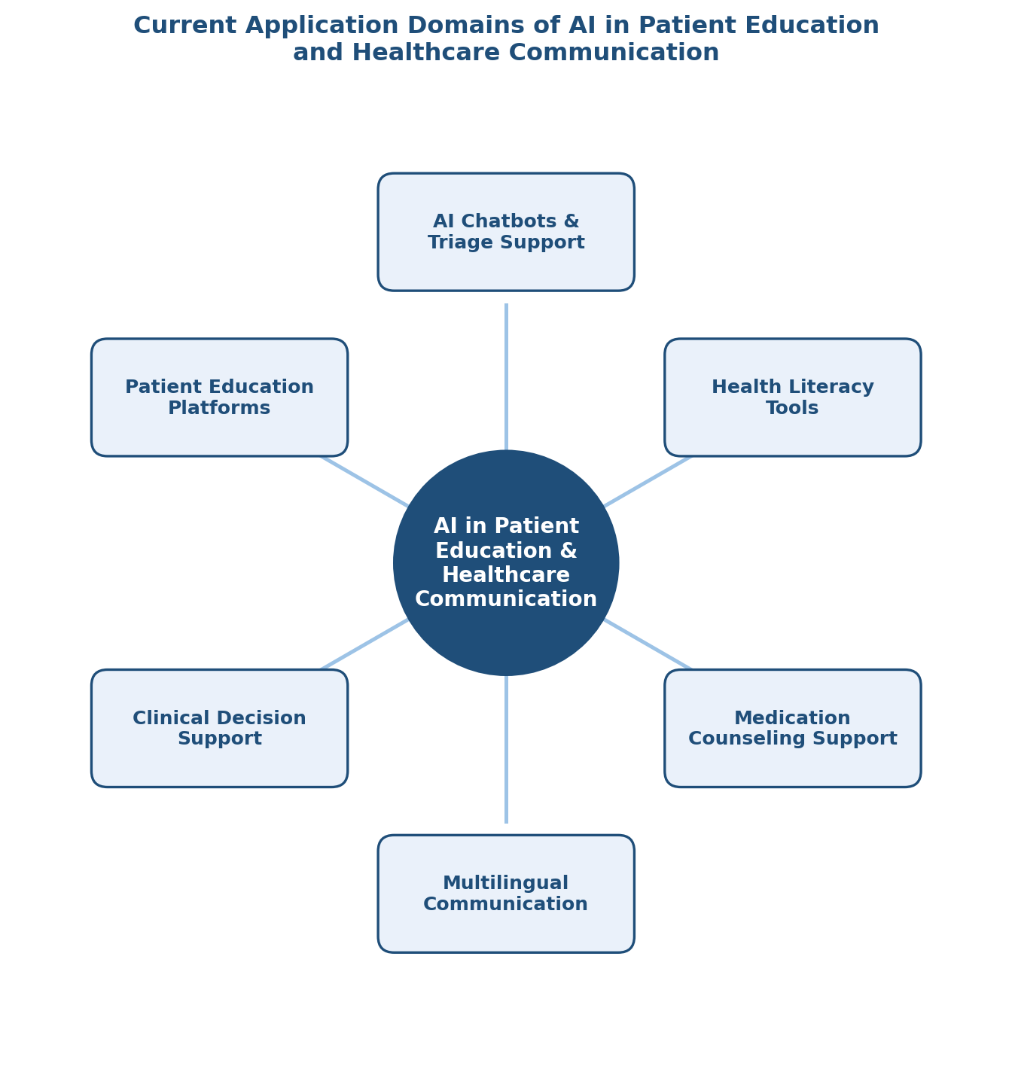
Figure 2. Current application domains of AI in patient education and healthcare communication, based on themes reported in Aydin et al. (2024) and Clay et al. (2024).

6.4 Benefits
- Improved health literacy through simplified, plain-language explanations.
- Greater accessibility for patients with language or literacy barriers.
- Personalization of educational content to individual patient needs.
- Workflow efficiency gains for clinicians and healthcare teams.
- Increased patient engagement and support for self-management.

6.5 Challenges
- Inaccurate outputs and hallucinations in AI-generated content.
- Algorithmic bias and unequal performance across patient subgroups.
- Privacy, confidentiality, and data security risks.
- Limited explainability and transparency of model outputs.
- Ethical concerns around patient autonomy and clinician overreliance.
- Regulatory uncertainty and the evolving need for formal governance frameworks.
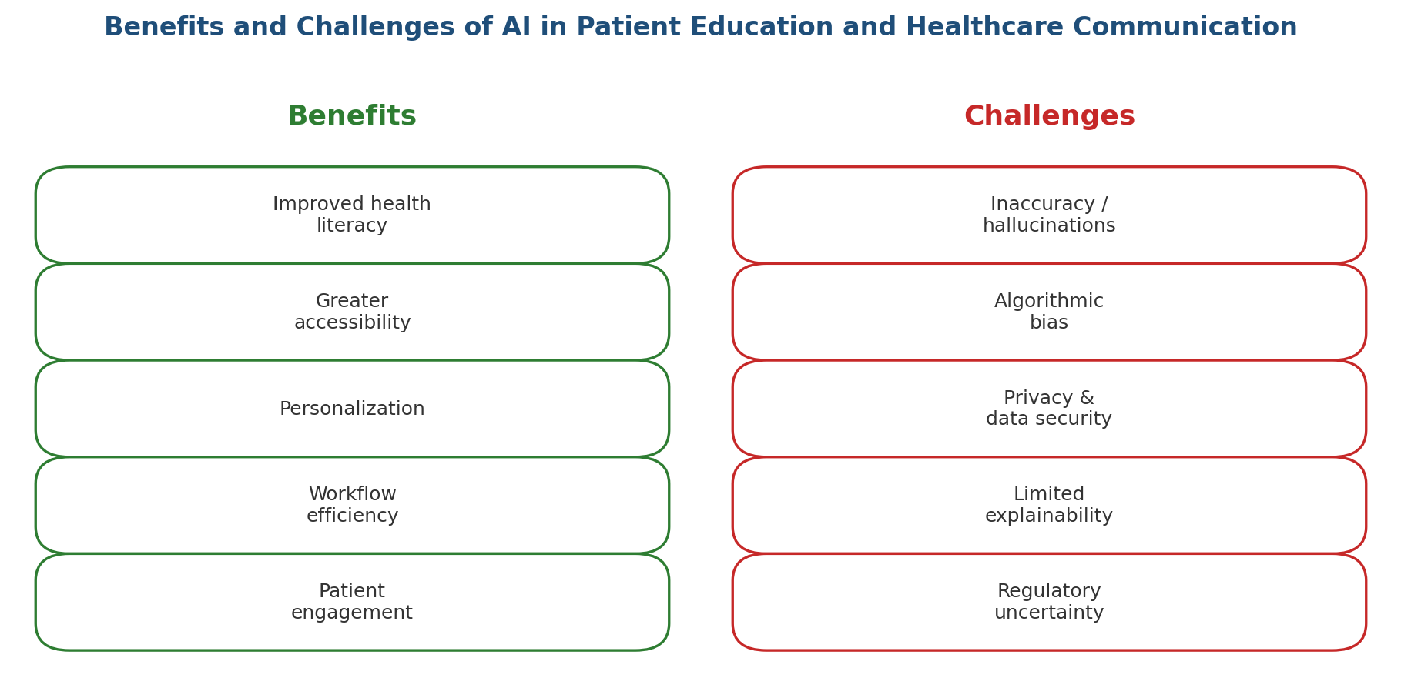
Figure 3. Summary of benefits and challenges of AI in patient education and healthcare communication, synthesized from the reviewed literature.

6.6 Discussion
The reviewed literature suggests that AI's value in patient education lies primarily in translation and simplification tasks, converting dense clinical language into a form patients can act on, rather than in autonomous clinical decision-making.
This distinction matters for the discussion of risk: benefits are most consistently reported when AI functions in a supportive, human-supervised role, while the most serious concerns, including hallucinated content and biased outputs, arise in scenarios closer to unsupervised patient-facing deployment.
The geographic concentration of the existing evidence base, with the majority of scoping review studies originating in the United States, also indicates a gap in evidence about how these tools perform in linguistically diverse, resource-constrained, or multilingual settings such as India.

6.7 Future Directions
- Development of safer and more reliable generative AI tools for clinical communication.
- Personalized patient education using multimodal data (text, voice, and imaging).
- Human-AI collaboration models rather than full replacement of clinicians.
- Applications in pharmacy practice, medication counseling, and adherence support.
- Need for prospective studies and real-world implementation research, including in non-English-speaking populations.

6.8 Conclusion
- Summarize the promise and limitations of AI in patient-facing communication.
- Emphasize the need for ethical, evidence-based, and human-centered integration.
- Highlight priorities for future research, particularly in linguistically diverse healthcare settings.

7. Supplementary Data
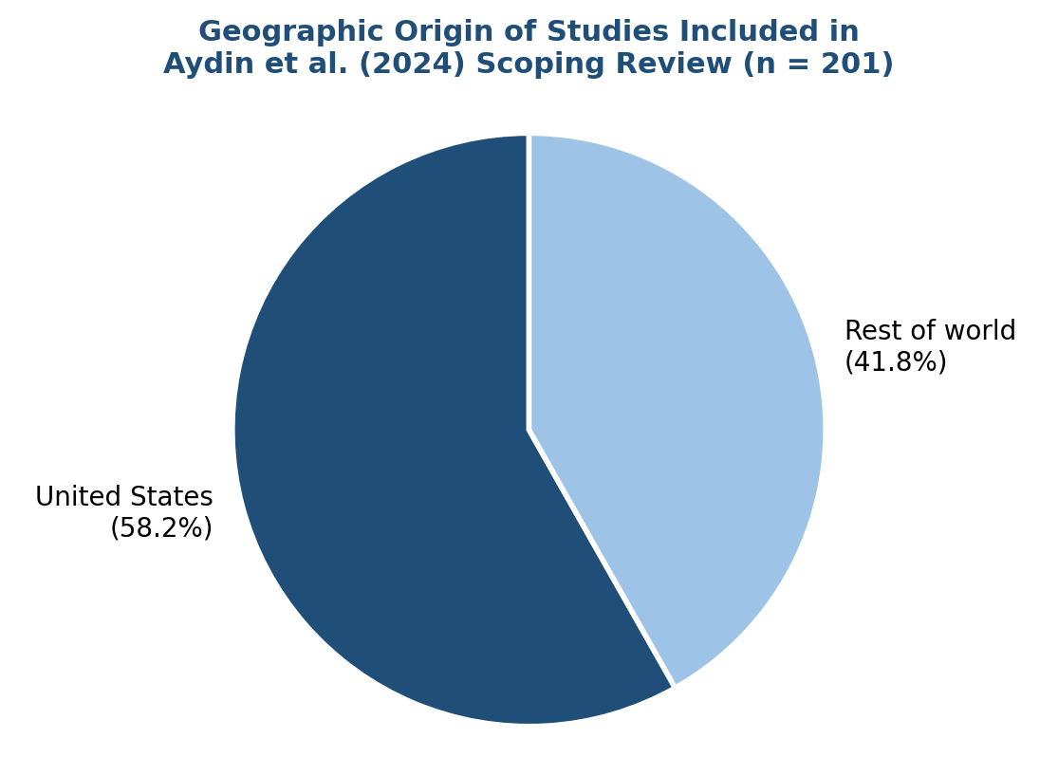
Figure 4. Geographic origin of the 201 studies included in the Aydin et al. (2024) scoping review of large language models in patient education (PubMed-indexed, screened June 2024).

8. References (APA 7th Edition)
Aydin, S., Karabacak, M., Vlachos, V., & Margetis, K. (2024). Large language models in patient education: A scoping review of applications in medicine. Frontiers in Medicine, 11, 1477898. https://doi.org/10.3389/fmed.2024.1477898
Clay, T. J., Da Custodia Steel, Z. J., & Jacobs, C. (2024). Human-computer interaction: A literature review of artificial intelligence and communication in healthcare. Cureus, 16(11), e73763. https://doi.org/10.7759/cureus.73763
Indian Council of Medical Research. (2023). Ethical guidelines for application of artificial intelligence in biomedical research and healthcare. Department of Health Research, Government of India. https://www.icmr.gov.in/ethical-guidelines-for-application-of-artificial-intelligence-in-biomedical-research-and-healthcare
U.S. Food and Drug Administration. (2025). Artificial intelligence-enabled device software functions: Lifecycle management and marketing submission recommendations (Draft guidance, Docket No. FDA-2024-D-4488). https://www.fda.gov/medical-devices/software-medical-device-samd/artificial-intelligence-software-medical-device
World Health Organization. (2021). Ethics and governance of artificial intelligence for health. WHO.
World Health Organization. (2024). Ethics and governance of artificial intelligence for health: Guidance on large multi-modal models. WHO. https://www.who.int/publications/b/70584

9. Note on Sourcing and Originality
All content in this manuscript has been written in original language and is not copied from any source. Factual claims are attributed to the peer-reviewed articles and regulatory guidance documents listed in the References section, each of which was independently checked against its publisher (Frontiers, Cureus, WHO, ICMR, and FDA official pages) before inclusion.
No fabricated statistics have been used; the only numerical figures cited (201 included studies; 58.2% U.S.-origin studies) are drawn directly from the reported results of the Aydin et al. (2024) scoping review.

