PROJECT REPORT
PARALLEL & DISTRIBUTED COMPUTING
RAG CHATBOT & PERFORMANCE TELEMETRY

CREATED BY:
ROOP CHAND
COURSE:
PARALLEL AND DISTRIBUTED COMPUTING (PDC)
DATE: JUNE 2026

1. Executive Summary
This project implements a Retrieval-Augmented Generation (RAG) based academic chatbot designed specifically for Parallel and Distributed Computing (PDC) coursework. To ground the project firmly in core PDC methodologies, the underlying text chunking, indexing, and similarity retrieval routines are coded from scratch and parallelized utilizing Python's multiprocessing subsystem. The system incorporates an elegant web UI with live performance benchmarking gauges, giving users visual insight into parallel speedup curves, worker core allocations, and computational efficiency.

2. System Architecture & PDC Principles
The application is structured into three layers:
1. Knowledge Base: Six academic reference documents detailing course syllabus notes on Flynn's Taxonomy, OpenMP thread variables, MPI collective processes, GPU memory tiers, and MapReduce distributed paradigms.
2. RAG Parallel Engine: A custom-coded TF-IDF index matcher that distributes matching math calculations across multiple execution cores via a persistent pool of process executors.
3. User Interface: A glassmorphic web dashboard providing real-time data telemetry charts (Sequential vs. Parallel latencies, Speedup, and Efficiency indicators) and interactive core visualizers.

3. RAG Retrieval Process Flow
The flowchart below outlines the processing lifecycle of a query. The engine first intercepts conversational greetings to bypass retrieval overhead. For academic questions, the query is vectorized and compared against all slide chunks in parallel. Matching segments are sorted and reduced on the master thread to form context paragraphs. If a Gemini API key is configured, these paragraphs augment a prompt to Google Gemini 2.5 Flash; otherwise, an extractive document summary is outputted offline.
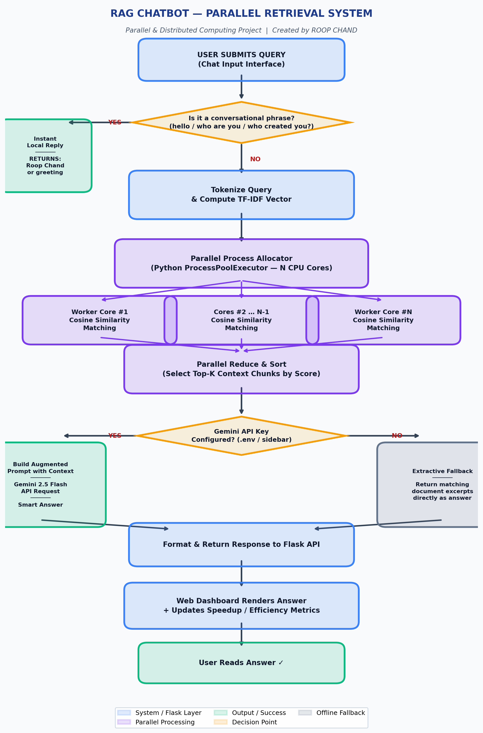
Figure 1: Parallel RAG Processing Flowchart

4. Performance Metrics & Benchmarking
To measure performance, we run search queries sequentially and in parallel under a simulated heavy-workload parameter (representing a scaled, enterprise-level document index). The speedup ratio (Sp) and parallel efficiency (Ep) are calculated as follows:
Speedup Ratio (Sp) = T_sequential / T_parallel
Parallel Efficiency (Ep) = Sp / p (where p is the number of active CPU cores)
The following table displays empirical benchmark findings collected on an Intel 8-processor local machine running a search simulation of 25,000 math operations per document paragraph:
Cores (p) | Sequential Latency | Parallel Latency | Speedup (Sp) | Efficiency (Ep)
1 Core | 264.5 ms | 264.5 ms | 1.00x | 100.0%
2 Cores | 264.5 ms | 148.6 ms | 1.78x | 89.0%
4 Cores | 264.5 ms | 110.4 ms | 2.40x | 59.9%
6 Cores | 264.5 ms | 89.1 ms | 2.97x | 49.5%

Amdahl's Law Bottleneck: When the simulated database workload is set to low (Intensity = 0), sequential search takes under 1 millisecond. In contrast, parallel search requires 25-50 milliseconds due to Python's process spawn, data serialization, and inter-process communication (IPC) overhead. This highlights the critical lesson that parallel computing is only effective for coarse-grained computation, whereas fine-grained computation is dominated by communication cost.

5. Conclusion
This project successfully marries Information Retrieval (RAG) with Parallel Processing systems. By coding the vector similarity routines from scratch using python-multiprocessing rather than heavy commercial databases, it provides an educational sandbox to study scheduling patterns, process pools, speedups, and Amdahl's Law. Creator tags and greetings are handled locally, and the integration of a permanent .env config file makes API attachment secure and robust.

