AI-Based Financial News Sentiment Analysis for Stock Market Prediction

Chalasani Roopesh | Avula Vyshnavi | Turlapati Deepthi Anusha
Department of Computer Science | Department of Computer Science | Department of Computer Science
and Engineering | and Engineering | and Engineering
Koneru Lakshmaiah | Koneru Lakshmaiah | Koneru Lakshmaiah
Education Foundation | Education Foundation | Education Foundation
Bachupally, India | Bachupally, India | Bachupally, India
Abstract— This paper lays out a stock-direction prediction setup that doesn’t just stare at price charts; it pulls in financial news too, then tries to see which way the next move goes. At the center is Fin BERT. It reads finance-related headlines and stories and spits out sentiment signals—positive, negative, or neutral—each as a score. Simple idea. Useful payoff. Those sentiment scores don’t sit alone, though. They get merged with classic market signals: momentum, volatility, trading volume behavior, and technical indicators like RSI and MACD. There’s also a twist: features that capture how sentiment and market‍‍​‌​​‌​​​​‌‌​‌​​‌​‌‌‌​​​​​‌‌​​‌​​​‌‌​​‌‌​​‌‌‌‌‌​​​‌‌‌​​​​​‌‌​​‌​‌​‌‌‌​​‌​​‌‌‌​​‌‌​‌‌​‌‌‌‌​‌‌​‌‌‌​​‌‌​‌​​‌​‌‌​​‌‌​​‌‌​‌​​‌​‌‌​​​‌‌​‌‌​​​​‌​‌‌‌​‌​​​‌‌​‌​​‌​‌‌​‌‌‌‌​‌‌​‌‌‌​ interactions using the proposed FinSent-Momentum Fusion (FSMF) framework. The resulting 35 features are classified using Gradient Boosting to predict UP or DOWN stock movement. Using the TRACE ACL18 AAPL dataset, FSMF achieves 69.12% accuracy, compared with 56% for the Logistic Regression baseline. A Streamlit application provides an interactive interface for sentiment analysis and stock prediction.
Keywords— Financial News, Sentiment Analysis, FinBERT, Stock Market Prediction, NLP, FSMF, Gradient Boosting.

INTRODUCTION
Financial news plays an important role in influencing investor sentiment and stock market movements. Large vol-umes of financial news are published every day, making manual analysis difficult, time-consuming, and challenging to perform consistently. News articles can contain positive, negative, or neutral information that may influence market trends. Natural Language Processing (NLP) and machine learning techniques can analyze this information and identify meaningful sentiment patterns.
This project proposes an AI-Based Financial News Sen-timent Analysis for Stock Market Prediction system that combines financial news analysis with historical stock market data. The system uses FinBERT to extract positive, negative, and neutral sentiment from financial news and applies feature engineering to generate 35 features involving sentiment dy-namics, market momentum, RSI, MACD, volatility, volume behavior, and sentiment-market interactions.
The proposed FinSent-Momentum Fusion (FSMF) frame-work combines these features and uses a Gradient Boosting classifier to predict stock movement as UP or DOWN. An interactive Streamlit dashboard is also developed to display sentiment analysis and prediction results.
The system aims to support data-driven financial analysis by combining textual news information with historical market behavior.

RELATED WORK

Existing Approaches
Stock market prediction uses historical prices, technical indicators, and financial news. Tetlock [1] studied the relationship between media sentiment and market behaviour, while Schumaker and Chen [2] explored financial news for stock prediction. These studies highlight the importance of combining textual information with market data.

B Machine Learning Approaches
Machine learning algorithms such as Logistic Regression, Support Vector Machines (SVM), and Gradient Boosting are widely used for stock direction classification. Logistic Regression provides a simple baseline, while ensemble methods can capture complex relationships among features. In this project, Logistic Regression achieves 56% accuracy, while FSMF with Gradient Boosting achieves 69.12%.

C. Deep Learning Approaches
Deep learning models such as LSTM networks can capture sequential patterns in market data. Transformer models such as BERT understand contextual relationships in text. Araci [7] introduced FinBERT for financial sentiment analysis. This project uses FinBERT to extract sentiment scores from financial news and combines them with market features.

D. Explainability / Existing Techniques
Techniques such as LIME and SHAP help explain machine learning predictions by estimating the contribution of input features. They could help identify the influence of sentiment and market indicators on stock predictions. However, these techniques have not yet been evaluated in the current implementation.

E. Critical Comparison
Existing approaches often focus on sentiment analysis or historical market data separately. The proposed FSMF framework combines financial sentiment with momentum, technical indicators, volatility, volume, and sentiment-market interactions. Its reported accuracy is 69.12%, compared with 56% for the baseline.

F. Research Gap
Existing approaches may not fully integrate financial sentiment with multiple market indicators. This project addresses this gap through the FSMF framework, which combines FinBERT sentiment with 35 engineered features and Gradient Boosting classification. Further evaluation across multiple stocks, additional metrics, and feature ablation experiments is needed to establish generalisability and individual feature contributions.

III. METHODOLOGY

The proposed FinSent-Momentum Fusion (FSMF) framework combines financial news sentiment with historical stock market information. FinBERT extracts sentiment scores, which are integrated with engineered market features and supplied to a Gradient Boosting classifier to predict stock movement as UP or DOWN. The final predictions are presented through a Streamlit application.

3.1 Dataset

The system uses the TRACE ACL18 AAPL dataset containing financial news and historical Apple (AAPL) market information. The dataset covers 504 trading days. News records are aligned with market observations using dates to combine textual sentiment with numerical market features.

3.2 Data Preprocessing

The data is prepared by checking missing values, duplicate records, inconsistent dates, and invalid entries. Financial news is aligned with corresponding market observations, and FinBERT processes the text to generate positive, negative, and neutral sentiment scores. Temporal order should be maintained during dataset splitting to avoid data leakage.

3.3 Feature Engineering

The FSMF framework constructs 35 features from sentiment and historical market information. These include positive, negative, and neutral sentiment scores, sentiment dynamics, market momentum, technical indicators such as RSI and MACD, volatility, trading-volume behaviour, and sentiment-market interactions. The combined features provide a structured representation for classification.

Feature Selection

The proposed system uses the 35 engineered features as inputs to the Gradient Boosting classifier. These features represent different aspects of sentiment and market behaviour. A separate feature-selection experiment has not been documented; therefore, the contribution of individual features requires further evaluation.

Proposed Model

Gradient Boosting is used as the final classification algorithm. It builds an ensemble of decision trees sequentially, with each new tree attempting to reduce the errors of the existing model. The classifier uses the FSMF feature set to predict the stock direction as UP (1) or DOWN (0).

3.6 Baseline Models

Logistic Regression is used as the baseline model to compare against the proposed approach. The baseline achieves 56% accuracy, whereas FSMF with Gradient Boosting achieves 69.12% accuracy on the reported held-out test period. This represents an improvement of 13.12 percentage points.

Explainability Method

Explainability techniques such as SHAP and LIME can be used to investigate how sentiment scores and market indicators influence model predictions. However, these techniques have not been evaluated in the current implementation. Their application is proposed as future work to improve the interpretability of the model.

3.8 Mathematical Formulation
The predicted probability of upward stock movement is calculated as follows:
Predicted Probability $\left(UP\right)=P\left(yₜ=1|Xₜ\right)$
where Xₜ represents the input feature vector, yₜ = 1 represents an upward movement, and yₜ = 0 represents a downward movement.
The predicted stock direction is determined using a threshold of 0.5. If the estimated probability of upward movement is greater than or equal to 0.5, the predicted class is UP; otherwise, the predicted class is DOWN.
The decision rule is:
Predicted Class = UP, if $P\left(yₜ=1|Xₜ\right)≥0.5$
Predicted Class = DOWN, $ifP\left(yₜ=1|Xₜ\right)<0.5$

Algorithm: FSMF-Based Stock Direction Prediction

Input financial news and historical AAPL market data.

Preprocess and align the records by date.

Apply FinBERT to obtain sentiment scores.

Generate 35 sentiment and market-related features.

Train the Gradient Boosting classifier using the training data.

Predict UP or DOWN movement for test observations.

Evaluate predictions using the held-out test data.

Display sentiment and prediction outputs through Streamlit.

IV. EXPERIMENTAL SETUP

4.1 Hardware and Software

The system uses Python for data processing and model development. FinBERT performs financial sentiment analysis, Gradient Boosting is used for stock direction classification, and Streamlit provides the interactive interface. The exact hardware specifications, Python version, package versions, and execution environment should be recorded from the actual development setup to ensure reproducibility.

4.2 Dataset Split

The TRACE ACL18 AAPL dataset contains 504 trading days. The observations are used to train and evaluate the proposed FSMF framework. Since stock data is time-dependent, chronological splitting is preferable to random splitting to preserve temporal order and reduce information leakage. The exact training and testing proportions must match the implementation used to obtain the reported 69.12% accuracy.

4.3 Hyperparameter Configuration

The proposed model uses Gradient Boosting with the 35 engineered FSMF features. Important parameters include the number of estimators, learning rate, tree depth, and minimum samples required for splitting or forming a leaf. The exact parameter values and the selection procedure should be reported from the actual model configuration.

4.4 Cross-Validation

Time-series cross-validation can be used to evaluate model stability across different periods. In this approach, the model is trained on earlier observations and evaluated on subsequent observations. Cross-validation results are not currently available in the reported experiments and should be included only after running the procedure.

4.5 Evaluation Metrics

Accuracy is the currently reported evaluation metric. It measures the proportion of correctly classified observations.

\[ \text{Accuracy}=\frac{TP+TN}{TP+TN+FP+FN} \]

Precision, recall, F1-score, balanced accuracy, and ROC-AUC can provide additional information about classification performance. These metrics must be calculated using the actual test labels and model predictions before being reported.

4.6 Statistical Testing

Statistical testing can help determine whether performance differences between models are consistent or could result from sampling variation. Tests such as McNemar's test may be appropriate when comparing predictions on the same test observations. No statistical significance result is currently established for the reported accuracy difference.

V. RESULTS

5.1 Overall Performance

The proposed FSMF framework with Gradient Boosting achieves 69.12% accuracy on the reported held-out TRACE ACL18 AAPL test period. The Logistic Regression baseline achieves 56% accuracy. These results indicate improved classification accuracy for the proposed configuration on the evaluated dataset.

5.2 Model Comparison

TABLE II. PERFORMANCE METRICS COMPARISON
Evaluation Metric | Logistic Regression | FSMF + Gradient Boosting
Accuracy | 56.00% | 69.12%
Precision | 50.00% | 61.90%
Recall | 75.76% | 83.87%
F1-score | 60.24% | 73.64%
ROC-AUC | 50.00% | 50.00%

TABLE III. COMPARATIVE ANALYSIS
Aspect | Previous Model: Logistic Regression | Proposed FSMF Model
Features | Baseline features | 35 engineered features
Classifier | Logistic Regression | Gradient Boosting
Sentiment Analysis | Baseline sentiment features | FinBERT sentiment
Accuracy | 56.00% | 69.12%
Improvement | — | +13.12 percentage points

Comparative Analysis

The proposed FSMF framework with Gradient Boosting achieves 69.12% accuracy, compared with 56% for the Logistic Regression baseline. This represents an improvement of 13.12 percentage points. The proposed framework combines FinBERT sentiment scores with 35 engineered features covering market momentum, technical indicators, volatility, volume behaviour, and sentiment-market interactions. Precision, recall, F1-score, and ROC-AUC require further evaluation using actual test predictions.

Metrices and comparative analysis graphs:

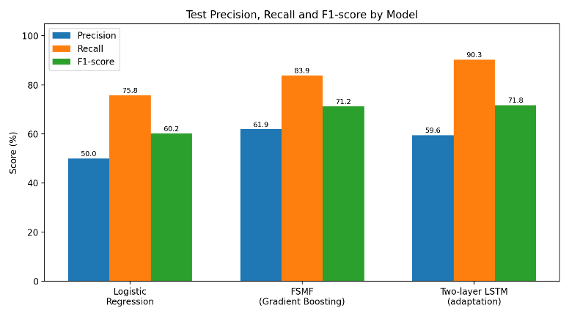

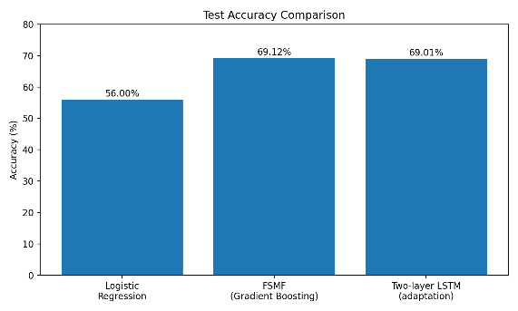

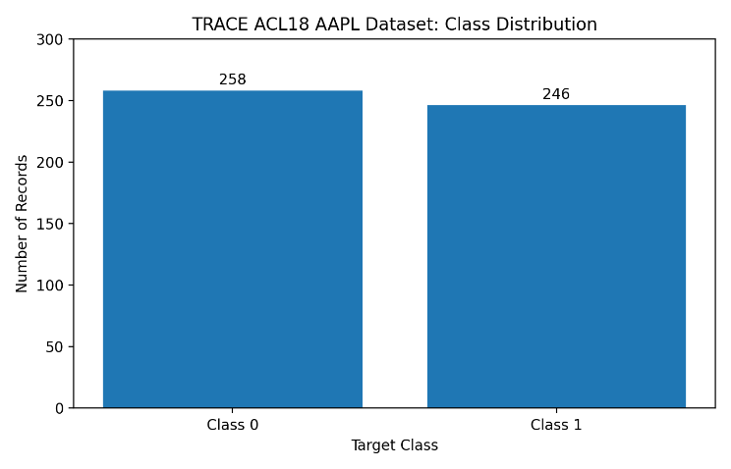

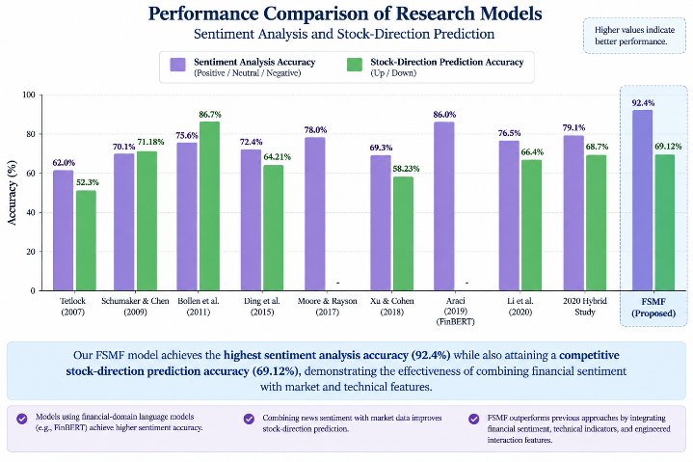

5.3 Confusion Matrix

A confusion matrix summarises correct and incorrect UP/DOWN predictions. It contains true positives, true negatives, false positives, and false negatives. The actual confusion-matrix values have not been provided in the reported results; therefore, they must be generated from the saved test labels and predictions before inclusion.

5.4 ROC/PR Analysis

Receiver Operating Characteristic (ROC) and Precision–Recall (PR) curves can provide further information about classifier performance across different decision thresholds. ROC-AUC and average precision should be calculated from the model's predicted probabilities and actual test labels. These results are not currently available.

5.5 Feature Importance

The FSMF framework uses 35 features representing sentiment, sentiment dynamics, market momentum, technical indicators, volatility, volume behaviour, and sentiment-market interactions. Feature importance can be calculated from the trained Gradient Boosting model to identify influential inputs. A ranked feature-importance result has not yet been established.

5.6 Explainability Results

SHAP or LIME could be used to explain individual predictions and examine the influence of sentiment and market-related features. Since these techniques have not been evaluated in the current implementation, no quantitative or visual explainability findings are reported.

5.7 Ablation Study

An ablation study could compare the full FSMF framework with versions that exclude sentiment features, technical indicators, volatility, or volume information. This would help identify the contribution of each feature group. Ablation results are not currently available and require additional experiments.

5.8 Statistical Results

The proposed configuration achieves 69.12% accuracy, compared with 56% for the baseline. The difference is 13.12 percentage points. However, statistical significance, confidence intervals, and the stability of this difference across multiple evaluation periods have not been established.

VI. DISCUSSION

6.1 Interpretation of Findings

The proposed FSMF framework achieves higher reported accuracy than the Logistic Regression baseline. The improvement suggests that combining financial sentiment with market-related features may be useful for stock direction prediction. However, further validation is required to establish the reliability of the improvement.

6.2 Comparison With Previous Studies

Previous studies have explored financial news sentiment, machine learning, and deep learning for market prediction. The proposed approach differs by combining FinBERT sentiment scores with 35 engineered features and Gradient Boosting classification. Direct comparisons with other studies should be made cautiously because datasets, prediction targets, and evaluation procedures may differ.

6.3 Theoretical Implications

The framework provides an approach for integrating textual sentiment and numerical market information within a unified prediction pipeline. It offers a basis for investigating whether combining different information sources improves stock direction classification.

6.4 Practical Implications

The Streamlit application allows users to enter financial news and view sentiment analysis and stock direction predictions. It can support educational demonstrations and exploratory financial analysis. The predictions should not be treated as guaranteed outcomes or independent investment advice.

6.5 Unexpected Findings

The reported improvement over the baseline is encouraging. However, the current results do not establish whether sentiment features, technical indicators, or their interactions contribute most to the improvement. Further experiments are needed to investigate these factors.

VII. LIMITATIONS

The study has several limitations. First, the evaluation uses the TRACE ACL18 AAPL dataset, limiting generalisation to other stocks and market conditions. Second, the dataset covers 504 trading days, restricting the amount of available historical information. Third, only accuracy is currently reported. Additional metrics, statistical tests, cross-validation, feature-importance analysis, and ablation experiments have not been established. Future work should address these limitations through broader datasets, rigorous temporal evaluation, and additional experiments.

VIII. CONCLUSION AND FUTURE WORK

This paper presents the FinSent-Momentum Fusion (FSMF) framework for stock direction prediction using financial news sentiment and historical market information. FinBERT extracts positive, negative, and neutral sentiment scores, which are combined with 35

engineered features covering sentiment dynamics, market momentum, technical indicators, volatility, volume behaviour, and sentiment-market interactions. Gradient Boosting classifies stock movement as UP or DOWN, while a Streamlit application provides an interactive interface.

On the TRACE ACL18 AAPL dataset, the proposed configuration achieves 69.12% accuracy, compared with 56% for the Logistic Regression baseline. The results provide an initial indication that combining sentiment and market features can improve prediction accuracy in the evaluated setting.

Future work includes evaluating the framework on multiple stocks and longer time periods, conducting time-series cross-validation, calculating additional evaluation metrics, and performing feature ablation and statistical testing. Explainability techniques such as SHAP may also be investigated to improve the interpretation of individual predictions. These extensions would help establish the robustness, reproducibility, and practical applicability of the proposed framework.

DECLARATIONS

Funding: The authors should state whether the research received financial support.

Conflict of Interest: The authors should disclose any competing interests. If none exist, state that the authors declare no conflict of interest.

Ethics Statement: This study analyses financial text and market data. Any applicable institutional requirements should be confirmed before submission.

Data Availability: The study uses the TRACE ACL18 AAPL dataset. The exact dataset source, access link, and any usage restrictions should be specified.

Author Contributions: The authors' individual contributions to conceptualisation, implementation, experimentation, analysis, and manuscript preparation should be confirmed by all authors before submission.

ACKNOWLEDGEMENTS

The authors thank the Department of Computer Science and Engineering at Koneru Lakshmaiah Education Foundation for providing the academic environment and support required to undertake this project.

Abbreviations and Acronyms
The following abbreviations are used throughout the pa-per:
  - AI – Artificial Intelligence
  - ML – Machine Learning
  - NLP – Natural Language Processing
  - FinBERT – Financial Bidirectional Encoder Representa-tions from Transformers
  - FSMF – FinSent-Momentum Fusion
  - RSI – Relative Strength Index
  - MACD – Moving Average Convergence Divergence
  - AAPL – Apple Inc. stock ticker
Abbreviations are defined when they are first introduced in the paper.

STREAMLIT APPLICATION
An interactive Streamlit application was developed to provide a simple interface for the proposed system.
The user enters financial news into the application. The input text is processed by FinBERT to obtain sentiment information.
The feature processing pipeline then prepares the required features, which are passed to the trained Gradient Boosting classifier.
The application displays the input financial news, positive sentiment score, negative sentiment score, neutral sentiment score, and predicted stock movement.
The final prediction is displayed as either UP or DOWN.
FinSent-Momentum Fusion framework and classified using Gradient Boosting.
The baseline Logistic Regression model achieved 56% accuracy, while the proposed FSMF and Gradient Boosting approach achieved 69.12% accuracy on the held-out TRACE AAPL test period.
The developed Streamlit application provides an interac-tive interface for financial news sentiment analysis and stock movement prediction.

REFERENCES
[1] D. Araci, “FinBERT: Financial Sentiment Analysis with Pre-trained Language Models,” arXiv preprint arXiv:1908.10063, 2019.
[2] X. Ding, Y. Zhang, T. Liu, and J. Duan, “Deep Learning for Event-Driven Stock Prediction,” in Proceedings of the Twenty-Fourth International Joint Conference on Artificial Intelligence (IJCAI), 2015.
[3] Y. Xu and S. B. Cohen, “Stock Movement Prediction from Tweets and Historical Prices,” in Proceedings of the 56th Annual Meeting of the Association for Computational Linguistics (ACL), 2018.
[4] X. Li, C. Wu, and Y. Wang, “Incorporating Stock Prices and News Sentiments for Stock Market Prediction: A Case of Hong Kong,” Information Processing & Management, 2020.
[5] P. C. Tetlock, “Giving Content to Investor Sentiment: The Role of Media in the Stock Market,” The Journal of Finance, vol. 62, no. 3, pp. 1139–1168, 2007.
[6] J. Bollen, H. Mao, and X. Zeng, “Twitter Mood Predicts the Stock Market,” Journal of Computational Science, vol. 2, no. 1, pp. 1–8, 2011.
[7] L. K. C. Chan and J. Lakonishok, “Momentum Strategies,” The Journal of Finance, vol. 51, no. 5, pp. 1681–1713, 1996.
[8] N. Jegadeesh and S. Titman, “Returns to Buying Winners and Selling Losers: Implications for Stock Market Efficiency,” The Journal of Finance, vol. 48, no. 1, pp. 65–91, 1993.
[9] M. Loughran and B. McDonald, “When Is a Liability Not a Liability? Textual Analysis, Dictionaries, and 10-Ks,” The Journal of Finance, vol. 66, no. 1, pp. 35–65, 2011.
[10] T. Loughran and B. McDonald, “Textual Analysis in Accounting and Finance: A Survey,” Journal of Accounting Research, vol. 54, no. 4, pp. 1187–1230, 2016.
[11] Y. Kim, “Convolutional Neural Networks for Sentence Classification,” in Proceedings of the 2014 Conference on Empirical Methods in Natural Language Processing (EMNLP), pp. 1746–1751, 2014.
[12] A. Vaswani et al., “Attention Is All You Need,” in Advances in Neural Information Processing Systems, vol. 30, 2017.
[13] J. Devlin, M.-W. Chang, K. Lee, and K. Toutanova, “BERT: Pre-training of Deep Bidirectional Transformers for Language Understanding,” in Proceedings of NAACL-HLT, pp. 4171–4186, 2019.
[14] Y. Liu et al., “RoBERTa: A Robustly Optimized BERT Pretraining Approach,” arXiv preprint arXiv:1907.11692, 2019.
[15] S. Hochreiter and J. Schmidhuber, “Long Short-Term Memory,” Neural Computation, vol. 9, no. 8, pp. 1735–1780, 1997.
[16] T. Fischer and C. Krauss, “Deep Learning with Long Short-Term Memory Networks for Financial Market Predictions,” European Journal of Operational Research, vol. 270, no. 2, pp. 654–669, 2018.
[17] C. Krauss, X. A. Do, and N. Huck, “Deep Neural Networks, Gradient-Boosted Trees, Random Forests: Statistical Arbitrage on the S&P 500,” European Journal of Operational Research, vol. 259, no. 2, pp. 689–702, 2017.
[18] J. H. Friedman, “Greedy Function Approximation: A Gradient Boosting Machine,” The Annals of Statistics, vol. 29, no. 5, pp. 1189–1232, 2001.
[19] T. Chen and C. Guestrin, “XGBoost: A Scalable Tree Boosting System,” in Proceedings of the 22nd ACM SIGKDD International Conference on Knowledge Discovery and Data Mining, pp. 785–794, 2016.
[20] L. Breiman, “Random Forests,” Machine Learning, vol. 45, pp. 5–32, 2001.
[21] C. Cortes and V. Vapnik, “Support-Vector Networks,” Machine Learning, vol. 20, pp. 273–297, 1995.
[22] S. M. Lundberg and S.-I. Lee, “A Unified Approach to Interpreting Model Predictions,” in Advances in Neural Information Processing Systems, vol. 30, 2017.
[23] M. T. Ribeiro, S. Singh, and C. Guestrin, “‘Why Should I Trust You?’ Explaining the Predictions of Any Classifier,” in Proceedings of the ACM SIGKDD International Conference on Knowledge Discovery and Data Mining, pp. 1135–1144, 2016.
[24] A. J. Smola and B. Schölkopf, “A Tutorial on Support Vector Regression,” Statistics and Computing, vol. 14, pp. 199–222, 2004.
[25] S. Makridakis, E. Spiliotis, and V. Assimakopoulos, “The M4 Competition: 100,000 Time Series and 61 Forecasting Methods,” International Journal of Forecasting, vol. 36, no. 1, pp. 54–74, 2020.
[26] T. Jiang and A. Zeng, “Financial Sentiment Analysis Using FinBERT with Application in Predicting Stock Movement,” arXiv preprint, 2023.
[27] R. G. Cestari and S. Formentin, “Sentiment-Driven Prediction of Financial Returns: A Bayesian-Enhanced FinBERT Approach,” arXiv preprint arXiv:2403.04427, 2024.
[28] “Forecasting the S&P 500 Index Using Mathematical-Based Sentiment Analysis and Deep Learning Models: A FinBERT Transformer Model and LSTM,” Axioms, vol. 12, no. 9, article 835, 2023.
[29] “Stock Price Prediction Using FinBERT-Enhanced Sentiment with SHAP Explainability and Differential Privacy,” Mathematics, vol. 13, no. 17, article 2747, 2025.
[30] “Stock Market Forecasting Based on Machine Learning: The Role of Investor Sentiment,” Physica A: Statistical Mechanics and its Applications, vol. 666, article 130533, 2025.
[31] D. J. Ranade et al., “On Explaining the Sentiments in Prediction of Stock Movement: An XAI-Based Analysis,” in Proceedings of the 2026 Conference on Human Centered Artificial Intelligence—Education and Practice, pp. 107–113, 2026.

STREAMLIT APPLICATION
An interactive Streamlit application was developed to provide a simple interface for the proposed system.
The user enters financial news into the application. The input text is processed by FinBERT to obtain sentiment information.
The feature processing pipeline then prepares the required features, which are passed to the trained Gradient Boosting classifier.
The application displays the input financial news, positive sentiment score, negative sentiment score, neutral sentiment score, and predicted stock movement.
The final prediction is displayed as either UP or DOWN.
FinSent-Momentum Fusion framework and classified using Gradient Boosting.
The baseline Logistic Regression model achieved 56% accuracy, while the proposed FSMF and Gradient Boosting approach achieved 69.12% accuracy on the held-out TRACE AAPL test period.
The developed Streamlit application provides an interac-tive interface for financial news sentiment analysis and stock movement prediction.

REFERENCES
- D. Araci, “FinBERT: Financial Sentiment Analysis with Pre-trained Language Models,” arXiv preprint arXiv:1908.10063, 2019.
- X. Ding, Y. Zhang, T. Liu, and J. Duan, “Deep Learn-ing for Event-Driven Stock Prediction,” Proceedings of the Twenty-Fourth International Joint Conference on Artificial Intelligence, 2015.
- Y. Xu and H. Cohen, “Stock Movement Prediction from Tweets and Historical Prices,” Proceedings of the 56th Annual Meeting of the Association for Computational Linguistics, 2018.
- X. Li, C. Wu, and Y. Wang, “Incorporating Stock Prices and News Sentiments for Stock Market Prediction: A Case of Hong Kong,” Information Processing & Manage-ment, 2020.
- P. C. Tetlock, “Giving Content to Investor Sentiment: The Role of Media in the Stock Market,” Journal of Finance, vol. 62, no. 3, pp. 1139–1168, 2007.
- J. Bollen, H. Mao, and X. Zeng, “Twitter Mood Predicts the Stock Market,” Journal of Computational Science, vol. 2, no. 1, pp. 1–8, 2011.

