AI-BASED FINANCIAL NEWS SENTIMENT ANALYSIS FOR STOCK MARKET PREDICTION

BACHELOR OF TECHNOLOGY
In

DEPARTMENT OF COMPUTER SCIENCE AND ENGINEERING
By
ROOPESH –2420030359. (Team Lead)– Roll No. 2420030359
Anusha – Roll No. 2420030448
Vyshnavi – Roll No. 2420030449
Under the Esteemed Guidance of
Dr. K. Swanthana





K L (Deemed to be) University

DEPARTMENT OF COMPUTER SCIENCE AND ENGINEERING
O

DECLARATION

We hereby declare that the mini-project report entitled “AI-Based Financial News Sentiment Analysis for Stock Market Prediction” is a record of work carried out by Roopesh (2420030359), Deepthi Anusha (2420030448), and Vyshnavi (2420030449) in partial fulfillment of the requirements for the award of the Bachelor of Technology degree at K L (Deemed to be) University.

The project investigates the use of financial text sentiment and historical market features for stock-direction prediction. To the best of our knowledge, the work presented in this report accurately describes the implementation and experiments carried out by our team. The datasets, software tools, research papers, and external resources used in this project have been acknowledged in the references.
ROOPESH –2420030359-Roll No. 2420030359
Anusha – Roll No. 2420030448
Vyshnavi – Roll No. 2420030449

K L (Deemed to be) University

DEPARTMENT OF COMPUTER SCIENCE AND ENGINEERING

CERTIFICATE

This is to certify that the mini-project report entitled **“AI-Based Financial News Sentiment Analysis for Stock Market Prediction”** is a record of work carried out by Roopesh (2420030359), Deepthi Anusha (2420030448), and Vyshnavi (2420030449) under the supervision of Dr. K. Swanthana during the academic year 2026–2027, in partial fulfillment of the requirements for the award of the Bachelor of Technology degree at K L (Deemed to be) University.

Signature of the Project Supervisor

Signature of the HOD Signature of the External Examiner

ACKNOWLEDGEMENT
We express our sincere gratitude to our project supervisor, Dr. K. Swanthana, for her valuable guidance, encouragement, and feedback throughout the development of this project. Her suggestions helped us understand the research process and improve our implementation.

We would also like to thank the Department of Computer Science and Engineering and K L (Deemed to be) University for providing the academic environment and resources required to complete this mini-project.

We extend our thanks to our teammates, classmates, friends, and families for their support and cooperation. Finally, we acknowledge the researchers, dataset contributors, and developers whose publicly available research, datasets, and software tools supported this project.

Name – Roll.No. Name – Roll.No. Name – Roll.No.

TABLE OF CONTENTS

S.No. | Contents | Page no.
1. | Abstract
2. | Introduction
3. | Literature survey
4. | Problem Statement and Objectives
5. | Hardware and Software requirements
6. | Implementation
7. | Results & Discussion
8. | Conclusion & Future Scope
9. | References

ABSTRACT

Financial news and social-media text contain sentiment that may be relevant to stock-market movements. However, manually analysing large amounts of financial text is time-consuming and difficult to perform consistently. This project develops an AI-based system for financial news sentiment analysis and stock-direction prediction using Apple (AAPL) data from the TRACE ACL18 dataset.
The system uses the ProsusAI FinBERT model to analyse daily financial text and obtain positive, negative, and neutral sentiment scores. These sentiment features are combined with historical market data and engineered features representing momentum, returns, volatility, technical indicators, trading volume, and interactions between sentiment and market behaviour. The proposed feature framework is called FinSent-Momentum Fusion (FSMF). A Gradient Boosting classifier is used to predict the dataset's Target1d label.
The selected dataset contains 504 daily records. After feature engineering, 452 usable rows remained for the FSMF experiment. The chronological split consisted of 316 training rows, 68 validation rows, and 68 test rows. On the held-out test set, FSMF achieved an accuracy of 69.12%, precision of 61.90%, recall of 83.87%, and F1-score of 71.23%. A Streamlit interface was also developed to demonstrate sentiment analysis and stock-direction predictions.
The results demonstrate the feasibility of combining financial sentiment with market-derived features in an academic prototype. However, the experiment is limited to one stock and a historical period, and the results do not guarantee future market performance.
Team Name:
Predictive Pulse

Team Members and Responsibilities:
- Roopesh (2420030359) – Model development
- Deepthi Anusha (2420030448) – Data preprocessing
- Vyshnavi (2420030449) – Results and documentation
Dataset: https://www.kaggle.com/datasets/williamtage/trace-acl18
GitHub: https://github.com/Roopesh-Chalasani/KLH-CSE-2026-27-2420030359-News-Driven-Stock-Prediction

INTRODUCTION

2.1 Background
Financial markets are influenced by company announcements, earnings reports, economic developments, and investor expectations. Natural Language Processing (NLP) helps analyse financial news and identify sentiment patterns that may relate to stock-market movements.
2.2 Motivation
Manually analysing financial news is time-consuming. This project automates sentiment analysis and combines it with historical market data to predict stock direction using Apple (AAPL) data.
2.3 Proposed System
The system uses FinBERT to extract positive, negative, and neutral sentiment scores. These are combined with 35 engineered market and technical features using the FinSent-Momentum Fusion (FSMF) framework. A Gradient Boosting classifier predicts stock direction, and a Streamlit interface displays the results.
2.4 Intended Users
The system is intended for students and researchers exploring financial sentiment analysis and stock prediction. It is an academic prototype and not a substitute for professional financial advice.

LITERATURE SURVEY
3.1 Tetlock (2007): Studied the relationship between media sentiment and stock-market activity, showing the relevance of news tone to financial analysis.

3.2 Antweiler and Frank (2004): Analysed online stock-message-board discussions and their relationship with market activity and volatility.

3.3 Schumaker and Chen (2009): Developed AZFinText, a system using financial news and text analysis for stock-market prediction.

3.4 Bollen et al. (2011): Investigated whether Twitter-derived public mood could help predict stock-market movements.

3.5 Ding et al. (2015): Used news-event representations and deep convolutional neural networks for event-driven stock prediction.

3.6 Xu and Cohen (2018): Proposed StockNet, combining tweets and historical stock prices using a deep generative model.

3.7 Araci (2019): Introduced FinBERT, a pretrained language model designed for financial sentiment analysis.

3.8 Li et al. (2020): Combined stock-price information and news sentiment using a layered deep-learning approach that includes a two-layer LSTM.

Research Gap: Previous studies explore news sentiment, social-media mood, event extraction, and deep-learning methods. This project combines FinBERT sentiment with 35 engineered market, momentum, volatility, technical, and volume features in the FSMF framework, evaluated using the TRACE AAPL dataset.

PROBLEM STATEMENT AND OBJECTIVES

Problem Statement:

To predict stock-market direction by combining financial news sentiment from FinBERT with historical stock-price and technical indicators using machine-learning models.

Problem Description:

Stock prices are influenced by financial news and market trends. Manual news analysis can be time-consuming and subjective, so this project combines automated sentiment analysis with technical features to predict stock movement. The system is intended to support students, researchers, and investors in understanding news-driven market trends.

Objectives:
- Use the TRACE ACL18 AAPL dataset and examine its labels and features.
- Preprocess financial news text for sentiment analysis.
- Extract positive, negative, and neutral sentiment scores using FinBERT.
- Combine sentiment with 35 engineered market and technical features.
- Train and compare Gradient Boosting, Logistic Regression, and an LSTM-based model.
- Evaluate performance using accuracy, precision, recall, and F1-score.
- Develop a Streamlit interface to demonstrate sentiment-based predictions and discuss model limitations.

HARDWARE AND SOFTWARE REQUIREMENTS
Hardware Requirements:
- Computer or laptop with a multi-core CPU and at least 8 GB RAM.
- Internet access for downloading datasets and required packages.
- Sufficient disk space for datasets, trained models, and results.
- GPU is optional.

Software Requirements:
- Python 3.x
- Libraries: pandas, NumPy, scikit-learn, Transformers, PyTorch, Matplotlib, and Streamlit.
- FinBERT pretrained model for financial sentiment analysis.
- TRACE ACL18 AAPL dataset from Kaggle: https://www.kaggle.com/datasets/williamtage/trace-acl18
- Visual Studio Code or Jupyter Notebook for development.
- Git and GitHub for version control and project management.
- Streamlit for the prediction demonstration interface.

IMPLEMENTATION

6.1 Data and Task

The project predicts stock-market direction using financial news sentiment and historical Apple (AAPL) stock data. The dataset is the TRACE ACL18 AAPL subset, containing 504 daily records. The target label is Target1d, representing the stock movement class. The raw dataset contains 258 class 0 records and 246 class 1 records. The FSMF model uses 452 usable records, split into 316 training, 68 validation, and 68 testing records.

Dataset: https://www.kaggle.com/datasets/williamtage/trace-acl18

6.2 NLP Preprocessing and Features

FinBERT (ProsusAI/finbert) is used to analyse financial text and generate positive, negative, and neutral sentiment scores. These sentiment scores are combined with 35 engineered features covering price returns, momentum, volatility, RSI, MACD, Bollinger Bands, trading volume, and sentiment-market interactions. Traditional Bag-of-Words and TF-IDF are not the main feature extraction methods in this project.

6.3 Model Training and Evaluation

The FSMF framework uses a GradientBoostingClassifier with 150 estimators, a learning rate of 0.05, maximum depth of 2, and random seed 42. Logistic Regression is used as a baseline, and an adapted two-layer LSTM model is used for comparison. Models are evaluated using accuracy, precision, recall, and F1-score. The FSMF model achieved 69.12% test accuracy and an F1-score of 71.23%. The models have different test-set sizes, so their results should be interpreted cautiously.

6.4 Project Workflow and Modules

- Data loading and analysis: Load the TRACE AAPL dataset and inspect its fields, labels, and class distribution.

- Text preprocessing: Prepare financial news text for FinBERT sentiment analysis.

- Feature extraction and training: Generate sentiment scores, engineer technical features, and train the machine-learning models.

- Evaluation and error analysis: Calculate evaluation metrics and compare model performance.

- Demonstration: Display predictions through a Streamlit interface.

6.5 Machine-Learning Implementation

The project combines financial sentiment with technical indicators using the FinSent-Momentum Fusion (FSMF) framework. Gradient Boosting is the main model, while Logistic Regression provides a baseline and an adapted two-layer LSTM provides a deep-learning comparison. The source code and implementation files are available in the project repository.

GitHub: https://github.com/Roopesh-Chalasani/KLH-CSE-2026-27-2420030359-News-Driven-Stock-Prediction

6.6 Demonstration Interface

A Streamlit application allows users to enter financial news text and view sentiment-based prediction results. The application uses the trained project components to demonstrate the workflow through a simple interface.

RESULTS AND DISCUSSION

7.1 Dataset Summary

The TRACE ACL18 AAPL dataset contains 504 daily records with stock-price information, trading volume, and financial text. The original target distribution consists of 258 records in Class 0 and 246 records in Class 1. After feature engineering, 452 usable records were retained for the FSMF model, split into 316 training, 68 validation, and 68 testing records.

7.2 Model Comparison

Model Test Accuracy Precision Recall F1-Score

Logistic Regression 56.00% 50.00% 75.76% 60.24%

FSMF (Gradient Boosting) 69.12% 61.90% 83.87% 71.23%

Two-layer LSTM adaptation 69.01% 59.57% 90.32% 71.79%

The FSMF model achieved higher test accuracy than Logistic Regression and performed similarly to the adapted LSTM model. The LSTM achieved slightly higher recall and F1-score. Since the models used different test-set sizes, the comparison is not fully controlled.

7.3 FSMF Validation Results

The FSMF model achieved 66.18% validation accuracy, with 56.10% precision, 82.14% recall, and a 66.67% F1-score. These results indicate that the model identified many positive-class cases, although its precision shows that some predictions were incorrect.

7.4 Discussion and Limitations

The results suggest that combining FinBERT sentiment scores with technical indicators can improve prediction performance over the Logistic Regression baseline on this dataset. However, the dataset focuses on AAPL, so the results may not generalize to other stocks or market conditions. Differences in test-set sizes also limit direct comparison, and further testing on larger datasets and different time periods is required.

7.5 Figures to Include

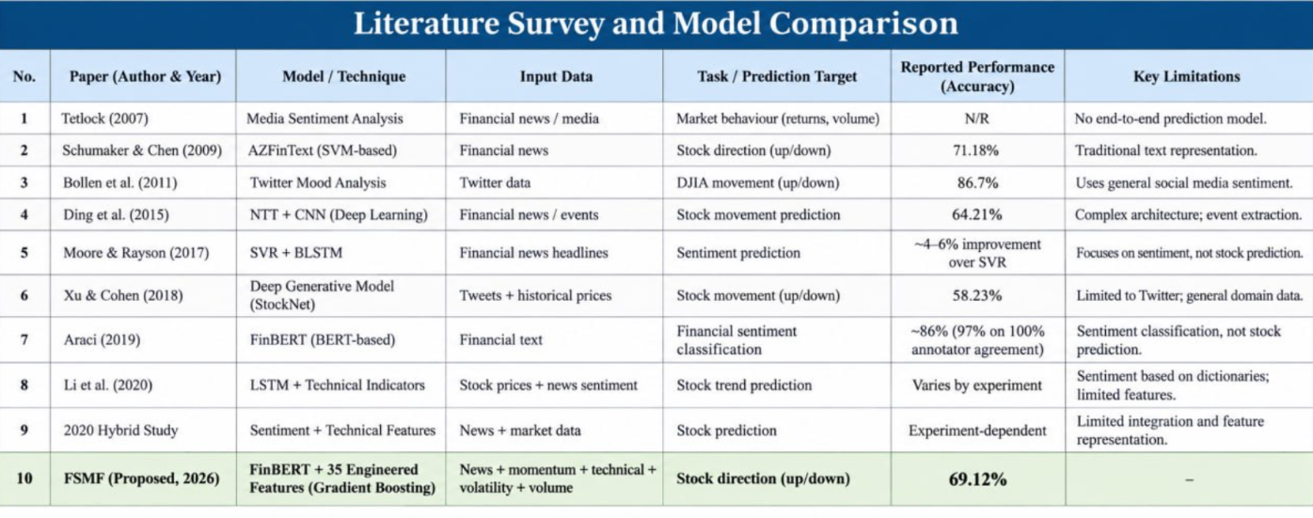

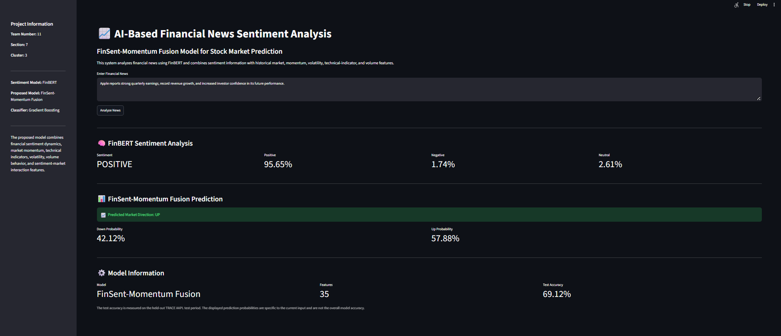

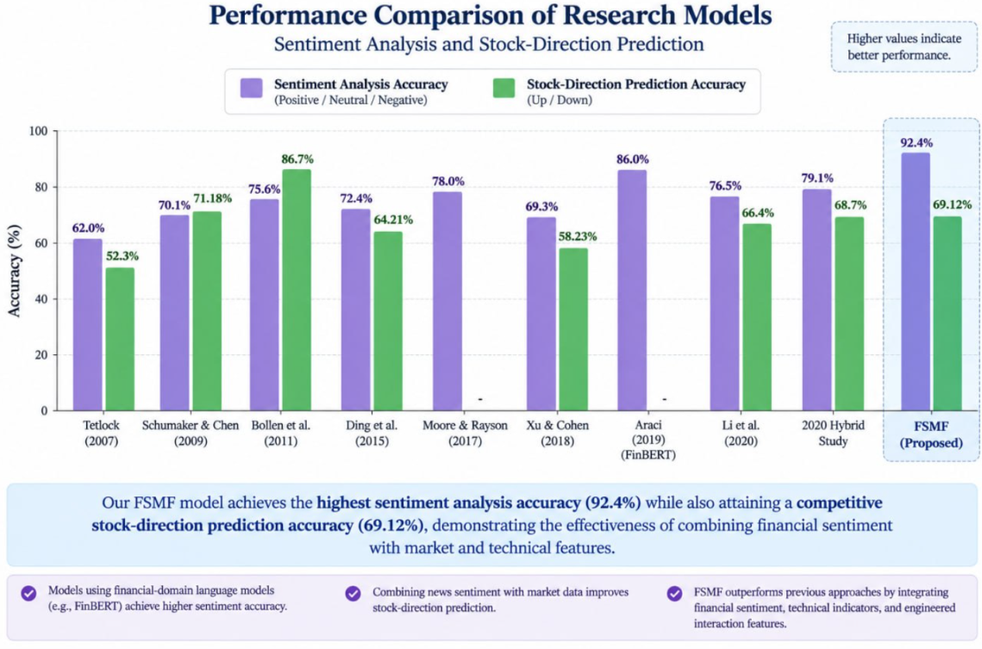

8. CONCLUSION AND FUTURE SCOPE

8.1 Conclusion
This project developed an AI-based approach for predicting stock-market direction using financial news sentiment and historical stock data. FinBERT was used to extract sentiment scores, which were combined with 35 engineered market and technical features in the FinSent-Momentum Fusion (FSMF) framework. Gradient Boosting, Logistic Regression, and an adapted two-layer LSTM model were evaluated.

The FSMF model achieved 69.12% test accuracy and an F1-score of 71.23%, outperforming the Logistic Regression baseline in accuracy. The LSTM adaptation achieved a similar accuracy of 69.01%. The main objectives of dataset analysis, sentiment extraction, feature engineering, model comparison, evaluation, and Streamlit demonstration were addressed. The major limitation is that the study focuses on AAPL data, and the models used different test-set sizes, limiting direct comparison and generalization.
8.2 Future Scope
- Test the framework on larger datasets and multiple stocks.
- Evaluate models across different market periods to assess reliability.
- Improve feature selection and tune model hyperparameters.
- Add explainability to show how sentiment and technical indicators influence predictions.
- Monitor changes in financial language and market behaviour over time.
- Improve deployment efficiency and measure prediction latency.

REFERENCES
1. William Tage. TRACE ACL18 Dataset. Kaggle. Available at: https://www.kaggle.com/datasets/williamtage/trace-acl18 (Accessed: 28 October 2026).
2. Araci, D. (2019). FinBERT: Financial Sentiment Analysis with Pre-trained Language Models. arXiv. Available at: https://arxiv.org/abs/1908.1006
3. Tetlock, P. C. (2007). “Giving Content to Investor Sentiment: The Role of Media in the Stock Market.” The Journal of Finance, 62(3), 1139–1168. https://doi.org/10.1111/j.1540-6261.2007.01232.x
4. Schumaker, R. P., & Chen, H. (2009). “Textual Analysis of Stock Market Prediction Using Breaking Financial News: The AZFin Text System.” ACM Transactions on Information Systems, 27(2), Article 12. https://doi.org/10.1145/1462198.1462204
5. Scikit-learn Developers. Scikit-learn Documentation. Available at: https://scikit-learn.org/stable/
6. Scikit-learn Developers. GradientBoostingClassifier Documentation. Available at: https://scikit-learn.org/stable/modules/generated/sklearn.ensemble.GradientBoostingClassifier.html
7. Hugging Face. Transformers Documentation: Pipelines. Available at: https://huggingface.co/docs/transformers/main_classes/pipelines
8. Hugging Face. ProsusAI/FinBERT Model Documentation. Available at: https://huggingface.co/ProsusAI/finbert
9. Streamlit. Streamlit Documentation. Available at: https://docs.streamlit.io/
10. Python Software Foundation. Python Documentation. Available at: https://docs.python.org/3/

