AI-BASED FINANCIAL NEWS SENTIMENT ANALYSIS
FOR STOCK MARKET PREDICTION

1. Project Title
AI-Based Financial News Sentiment Analysis for Stock Market Prediction

2. Problem Statement:
Financial news is generated in large volumes, making manual analysis time-consuming and inefficient. Delayed interpretation of financial news can lead to inaccurate investment decisions. Therefore, an intelligent system is needed to automatically analyse news sentiment and predict potential stock-market trends.

3. Objectives and Proposed Model / Framework
Objectives:
- To collect relevant financial news and historical stock-market data.
- To preprocess and clean the collected financial data.
- To analyse financial news using AI and NLP techniques.
- To classify financial news into Positive, Negative, and Neutral sentiments.
- To combine news sentiment with relevant market indicators for prediction.
- To predict potential stock-market trends based on the analysed data.
- To evaluate the performance of the proposed prediction model using suitable metrics.
- To develop a user-friendly dashboard for displaying news sentiment and prediction results.

Proposed Model / Framework:

- News Collection Layer → collects financial headlines/articles from a reliable dataset or permitted news source.
- Preprocessing Layer → removes duplicates/noise, normalizes text, handles missing values and aligns news with trading dates.
- Financial NLP Layer → FinBERT classifies each news item as Positive, Negative or Neutral and produces sentiment probabilities.
- Feature Engineering Layer → aggregates sentiment by stock/day and calculates market features and technical indicators.
- Prediction Layer → XGBoost/LightGBM is proposed as the primary trend classifier because it is practical for tabular mixed features; LSTM can be used as a comparison model for sequential data.
- Evaluation Layer → compares market-only versus market+sentiment models using Accuracy, Precision, Recall, F1-score, ROC-AUC and confusion matrix.
- Dashboard Layer → displays latest analysed news, sentiment distribution, market indicators, predicted direction and model confidence.

4. Literature Survey:

Research Paper | Model | Outcome | Limitation | Dataset
FinBERT: Financial Sentiment Analysis with Pre-trained Language Models | FinBERT / BERT | Effective financial sentiment classification | Mainly sentiment analysis, not complete stock prediction | Financial PhraseBank
Textual Analysis of Stock Market Prediction Using Breaking Financial News | SVM-based model | Used financial news to predict short-term stock movement | Short prediction horizon | Reuters financial news + stock data
Deep Learning for Event-Driven Stock Prediction | Neural Tensor Network + CNN | Improved stock prediction using financial events | Complex architecture | Financial news + S&P 500
Incorporating Stock Prices and News Sentiments for Stock Market Prediction | LSTM / deep learning | Combining news + prices improved prediction | Dataset/market specific | Hong Kong stock + financial news
Explainable Stock Prices Prediction from Financial News Articles | LSTM + sentiment analysis | Combined news sentiment with market information | Specific market/news source | Financial news + Yahoo Finance
A Cooperative Deep Learning Model for Stock Market Prediction | Autoencoder + LSTM/GRU | Combined sentiment and price features | More complex model | Yahoo Finance + financial news
Stock Market Prediction Using Microblogging Sentiment Analysis | SVM, RF, KNN, etc. | Social-media sentiment improved prediction | Uses social media rather than financial news | Twitter + StockTwits + stock data
Comparative Study on Effect of News Sentiment on Stock Price Prediction | LSTM / GRU | News sentiment improved prediction | Historical/offline study | S&P 500 + news
LSTM Based Stock Prediction Using Weighted and Categorized Financial News | WCN-LSTM | Combined categorized news with stock information | Depends on manual news categorization | Stock + financial news
StockNet: Stock Movement Prediction from Tweets and Historical Prices | Deep generative model | Combined text and historical prices for movement prediction | Uses Twitter rather than financial news | Tweets + Yahoo Finance

5. Research Gap Identification
Over-dependence on historical market data: Many approaches use historical price/technical data as the dominant input. News sentiment can provide an additional current-information signal.
Limited use of financial news compared with social media: A large portion of sentiment-based work uses Twitter/StockTwits. Financial news is more directly connected to corporate events, earnings, policy and market information.
Generic sentiment models may miss financial context: Financial language contains domain-specific expressions. A finance-domain model such as FinBERT is more suitable than relying only on generic sentiment tools.
Static or offline experiments: Many studies are based on fixed historical datasets. A practical system should be designed so that new news can be processed without rebuilding the whole workflow.
Difficulty under changing market conditions: Market relationships are non-stationary. Therefore, the system should use time-based validation, compare baselines, and report confidence rather than presenting predictions as guaranteed outcomes.
Lack of an end-to-end academic dashboard: Research models often focus on predictive accuracy. Our project will connect collection, sentiment, prediction and visualization in one demonstrable workflow.
Gap-to-solution mapping:
- Historical-data dependence → combine market/technical features with financial-news sentiment.
- Social-media emphasis → prioritize financial news headlines/articles.
- Generic sentiment limitations → use or fine-tune FinBERT on financial text.
- Offline/static limitation → design a modular pipeline capable of processing newly collected news.
- Dynamic-market limitation → time-based train/validation/test split, rolling/walk-forward evaluation and baseline comparison.
- Interpretability/usability limitation → dashboard with sentiment, evidence/news headline, market features, prediction and confidence.

6. Innovation
- Integrates financial-news NLP and stock-market trend prediction in one workflow.
- Uses finance-domain sentiment rather than treating all text with a generic sentiment model.
- Combines unstructured text features with structured market/technical features.
- Evaluates the incremental value of news sentiment by comparing a market-only baseline with a sentiment-enhanced model.
- Supports near-real-time processing as an extension of the trained historical model.

7. Creativity
- Interactive dashboard with sentiment distribution and market trend visualization.
- News cards showing Positive / Neutral / Negative classification and confidence.
- Stock-wise sentiment timeline to show how news sentiment changes over time.
- Simple explanation panel: key news + sentiment + technical indicators + predicted direction.
- Use of graphs and traffic-light style indicators to make technical results understandable to non-expert users.

8. Novelty
The novelty is not the invention of sentiment analysis itself; that field is well established. The proposed project’s novelty is the practical integration of financial-news sentiment, market features, short-term trend prediction, comparative evaluation and dashboard-based interpretation in a single academic framework. The system will explicitly test whether adding financial-news sentiment provides measurable improvement over a market-only baseline.

9. Feasibility
Technical feasibility: Python, pandas, scikit-learn/XGBoost or LightGBM, PyTorch/Transformers, and a dashboard framework such as Streamlit are sufficient for implementation.
Data feasibility: Historical stock data can be obtained from public datasets such as Yahoo Finance-based datasets, while financial sentiment datasets such as Financial PhraseBank and FiQA are available for NLP evaluation.
Model feasibility: A pre-trained FinBERT model reduces the need to train a transformer from scratch. A tree-based classifier can handle mixed numerical and sentiment features efficiently.
Evaluation feasibility: The project can be evaluated using standard classification metrics and an ablation study comparing market-only and market+sentiment inputs.
Project feasibility: The work can be completed incrementally: first sentiment analysis, then market feature integration, then prediction, and finally dashboard deployment.

10. Project Plan – Complete Workflow of Execution
- Phase 1 – Requirement and literature study: Finalize research questions, define target stock/market, study existing models, select datasets, define evaluation metrics and document the research gap.
- Phase 2 – Data acquisition: Collect/download financial news and historical market data. Candidate datasets include Daily News for Stock Market Prediction, Financial PhraseBank/FiQA for sentiment, and Yahoo Finance-based historical prices.
- Phase 3 – Data preprocessing: Clean news text, remove duplicates/noise, normalize timestamps, handle missing values, identify stock/company entities, align news with trading dates and prepare market features.
- Phase 4 – Sentiment model: Run FinBERT on financial headlines/articles. Store positive, neutral and negative probabilities, predicted class and a continuous sentiment score.
- Phase 5 – Feature engineering: Aggregate news sentiment by stock/day; calculate return, moving averages, volatility, RSI/MACD or a small selected set of technical indicators; avoid leakage by using only information available before the prediction time.
- Phase 6 – Baseline models: Build a market-only baseline using logistic regression/XGBoost or another simple classifier. This establishes how well market features predict direction without news.
- Phase 7 – Proposed prediction model: Add sentiment features to the market features and train the proposed XGBoost/LightGBM trend classifier. Optionally compare with LSTM for sequential modelling.
- Phase 8 – Evaluation: Use chronological train/validation/test splits or walk-forward validation. Compare market-only vs market+sentiment using Accuracy, Precision, Recall, F1, ROC-AUC and confusion matrix. For price regression, use MAE/RMSE/MAPE only if an exact-price prediction experiment is included.
- Phase 9 – Explainability: Show feature importance and/or SHAP explanations for the prediction model, and display the news headlines that contributed to the sentiment signal.
- Phase 10 – Dashboard: Build a dashboard showing stock selection, latest news, sentiment, sentiment trend, price/technical charts, predicted direction and confidence.
- Phase 11 – Testing and validation: Test data handling, model inference, dashboard outputs, edge cases and performance. Verify that future information is not accidentally included in training features.
- Phase 12 – Final documentation and presentation: Prepare methodology, literature survey, research gap, results, limitations, screenshots, conclusions, future scope and final demonstration.

End-to-end workflow:
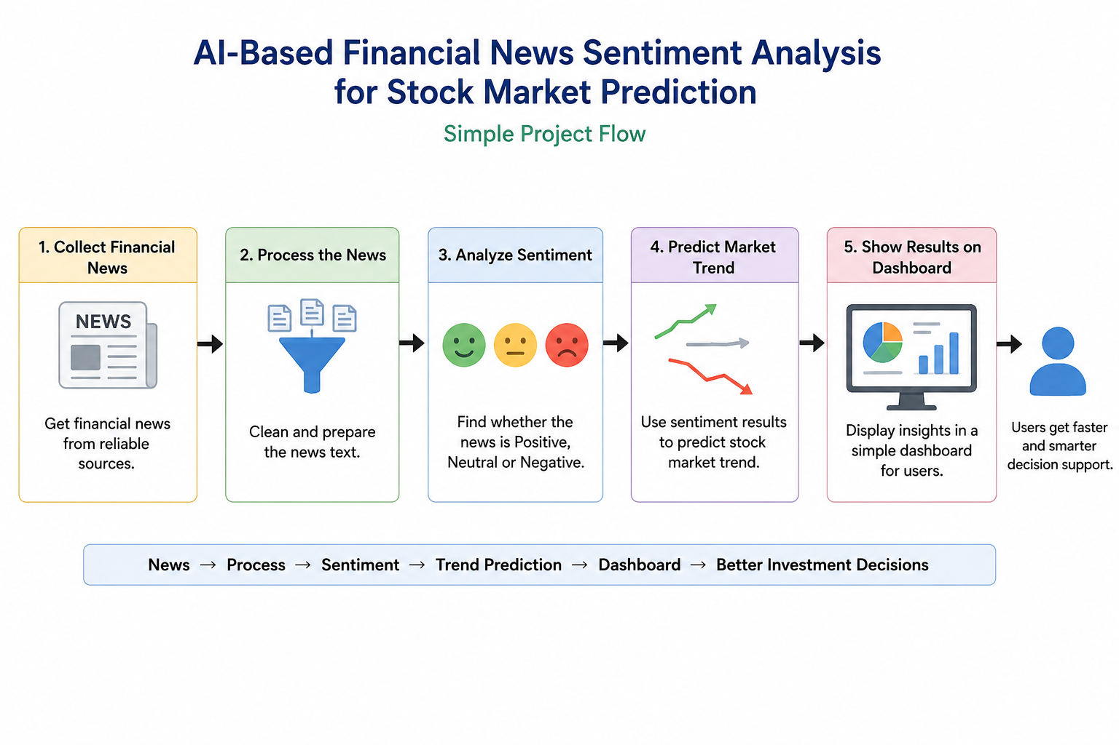

11. Expected Outputs
- A trained financial-news sentiment analysis component.
- A stock-market trend prediction model.
- Comparative results showing whether sentiment adds predictive value.
- A dashboard for news sentiment and predicted market direction.
- A documented dataset-preprocessing and modelling pipeline.
- Final report containing literature survey, research gap, methodology, results, limitations and future scope.

12. Important Scope and Limitations
- The system should be presented as a research/decision-support prototype, not as financial advice.
- Positive news does not guarantee a price increase; market movement depends on many factors.
- Prediction accuracy can change across stocks, sectors and market regimes.
- News-source availability, API limits, timestamp quality and data licensing must be checked before using live news.
- The final model and claimed novelty should be updated after experimental results are obtained; no accuracy percentage should be promised before evaluation.

13. Key Dataset / Resource Links
- Daily News for Stock Market Prediction (Kaggle) — https://www.kaggle.com/datasets/aaron7sun/stocknews
- StockNet dataset (tweets + historical prices) — https://github.com/yumoxu/stocknet-dataset
- Financial PhraseBank / FinBERT resources — https://github.com/ProsusAI/finBERT
- FiQA financial sentiment dataset — https://sites.google.com/view/fiqa/home
- FiQA sentiment dataset on Hugging Face — https://huggingface.co/datasets/TheFinAI/fiqa-sentiment-classification
- Reuters Corpora / RCV1/RCV2 access information — https://trec.nist.gov/data/reuters/reuters.html
- S&P 500 + financial news headlines dataset (Kaggle) — https://www.kaggle.com/datasets/dyutidasmahaptra/s-and-p-500-with-financial-news-headlines-20082024/data
- PLOS study data collection / OSF information — https://doi.org/10.1371/journal.pone.0284695
- Zenodo dataset for cooperative deep-learning study — https://doi.org/10.5281/zenodo.7044026

14. Research Paper Sources
- Textual analysis of stock market prediction using breaking financial news: The AZFin text system — https://doi.org/10.1145/1462198.1462204
- Deep Learning for Event-Driven Stock Prediction — https://www.ijcai.org/Abstract/15/329
- Stock Movement Prediction from Tweets and Historical Prices — https://github.com/yumoxu/stocknet-dataset
- Incorporating stock prices and news sentiments for stock market prediction: A case of Hong Kong — https://doi.org/10.1016/j.ipm.2020.102212
- Explainable stock prices prediction from financial news articles using sentiment analysis — https://pmc.ncbi.nlm.nih.gov/articles/PMC7924447/
- A cooperative deep learning model for stock market prediction using deep autoencoder and sentiment analysis — https://doi.org/10.5281/zenodo.7044026
- Stock Market Prediction Using Microblogging Sentiment Analysis and Machine Learning — https://www.mdpi.com/2673-4001/3/2/19
- A comparative study on effect of news sentiment on stock price prediction with deep learning architecture — https://doi.org/10.1371/journal.pone.0284695
- LSTM based stock prediction using weighted and categorized financial news — https://pmc.ncbi.nlm.nih.gov/articles/PMC9990937/
- FinBERT: Financial Sentiment Analysis with Pre-trained Language Models — https://arxiv.org/abs/1908.10063
- .

