Name: ROOPESH CHALASANI
Roll No: 2420030359, Sec: 6
TASK: GITFLOW LAB - 5

Objective
To practice a basic Gitflow workflow by creating development and feature branches, committing and pushing changes, merging a feature into develop, intentionally creating a merge conflict, resolving it, and verifying the final Git history.

Procedure

1. Initialize repository and push main
Initialized the local Git repository, renamed the default branch to main, created README.md, committed it, connected the GitHub remote, and pushed main.

2. Create develop and feature/login
Created the develop branch and pushed it to GitHub. From develop, created feature/login and added a small Python login program.

3. Run the Python program
Executed app.py using Python and verified the expected output: Welcome Student.

4. Commit and push feature/login
Staged app.py, committed the login feature, and pushed feature/login to GitHub.

5. Merge feature/login into develop
Switched to develop, merged feature/login using a fast-forward merge, and pushed develop.

6. Create feature/conflict
Created feature/conflict to demonstrate conflict handling in Git.

7. Create a merge conflict
Made different README.md changes on develop and feature/conflict and merged the branches, producing a content conflict in README.md.

8. Resolve and commit the conflict
Replaced the conflict markers with a clean final README.md value, staged the file, and committed the resolution.

9. Push final branches
Pushed the resolved develop branch and feature/conflict branch to GitHub.

10. Verify final history
Used git status and git log --oneline --graph --all to confirm a clean working tree and the expected branch/merge history.

Execution Screenshots
Screenshot 1
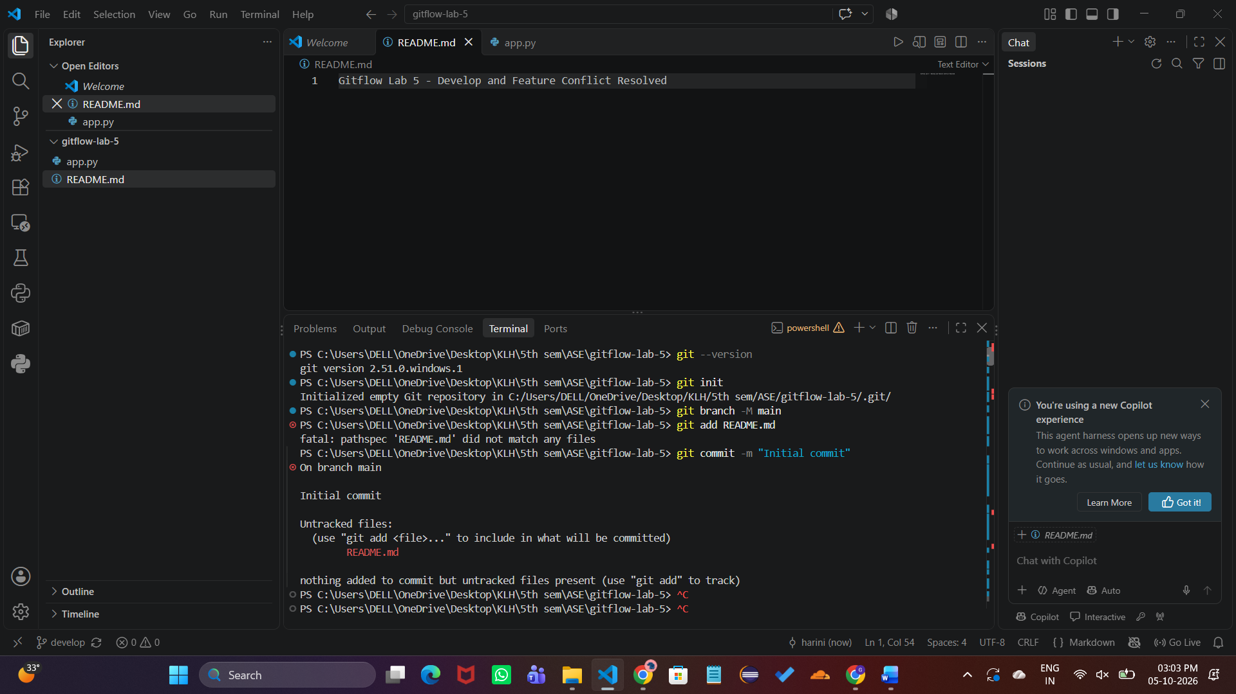
Repository initialization, initial commit, remote setup, and push to main.
Screenshot 2
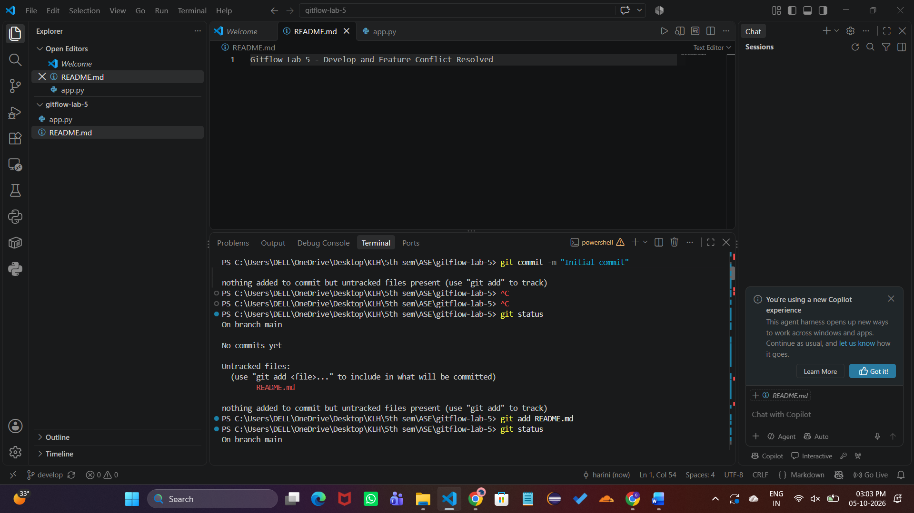
Created develop and feature/login branches; app.py prepared.

Screenshot 3
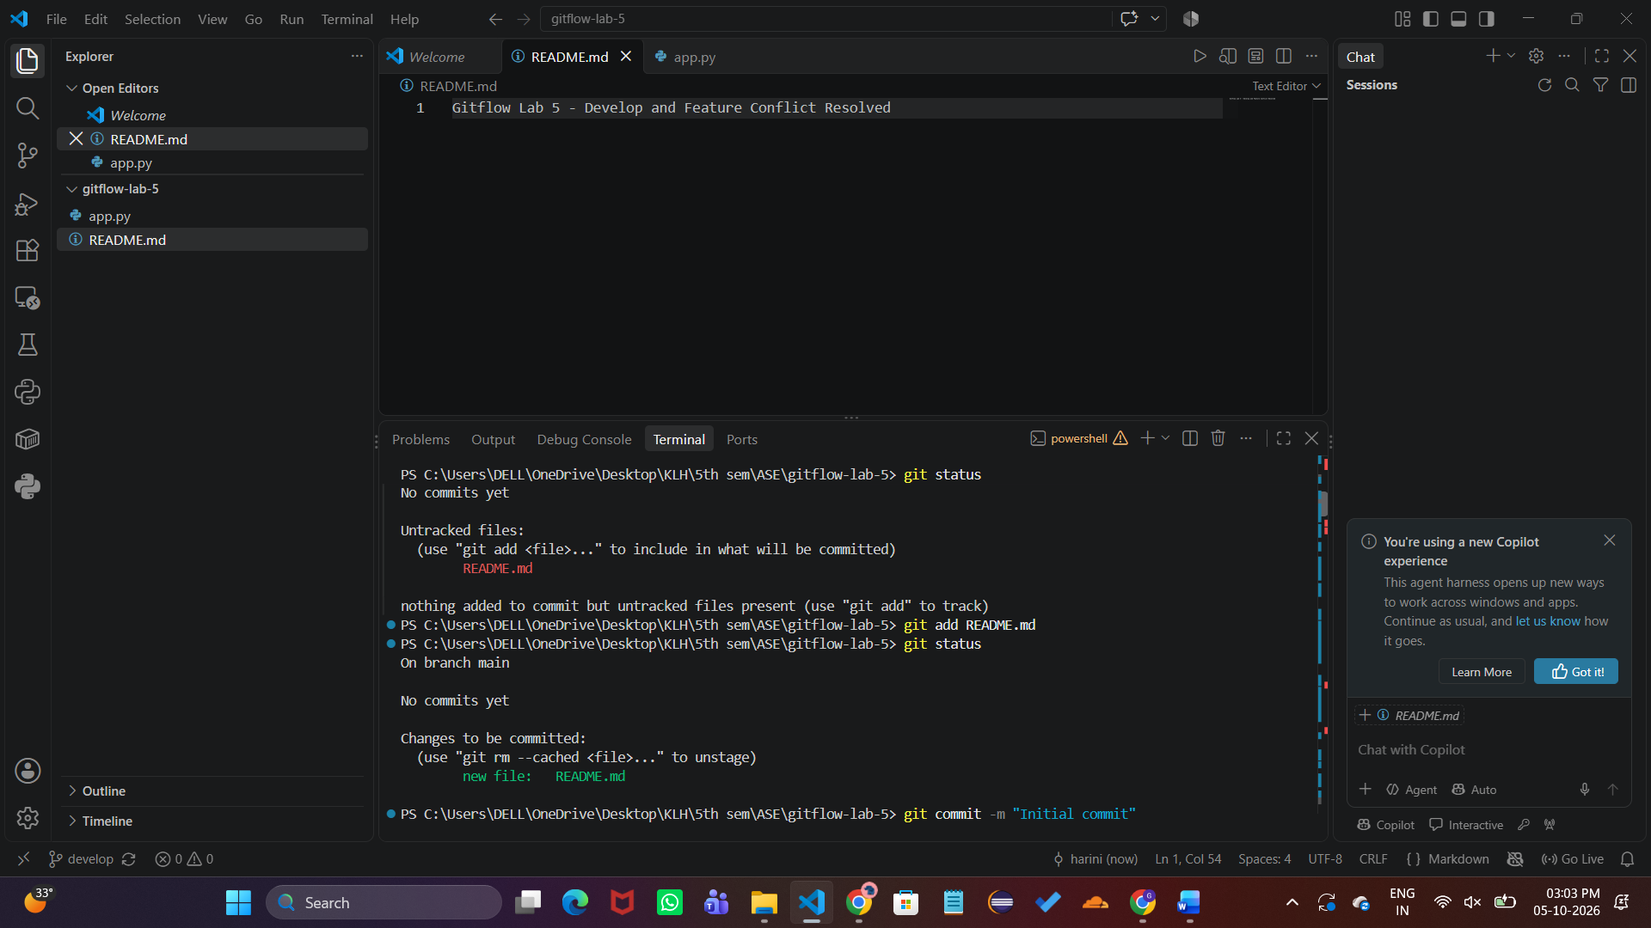
Executed app.py successfully and verified the output "Welcome Student".
Screenshot 4
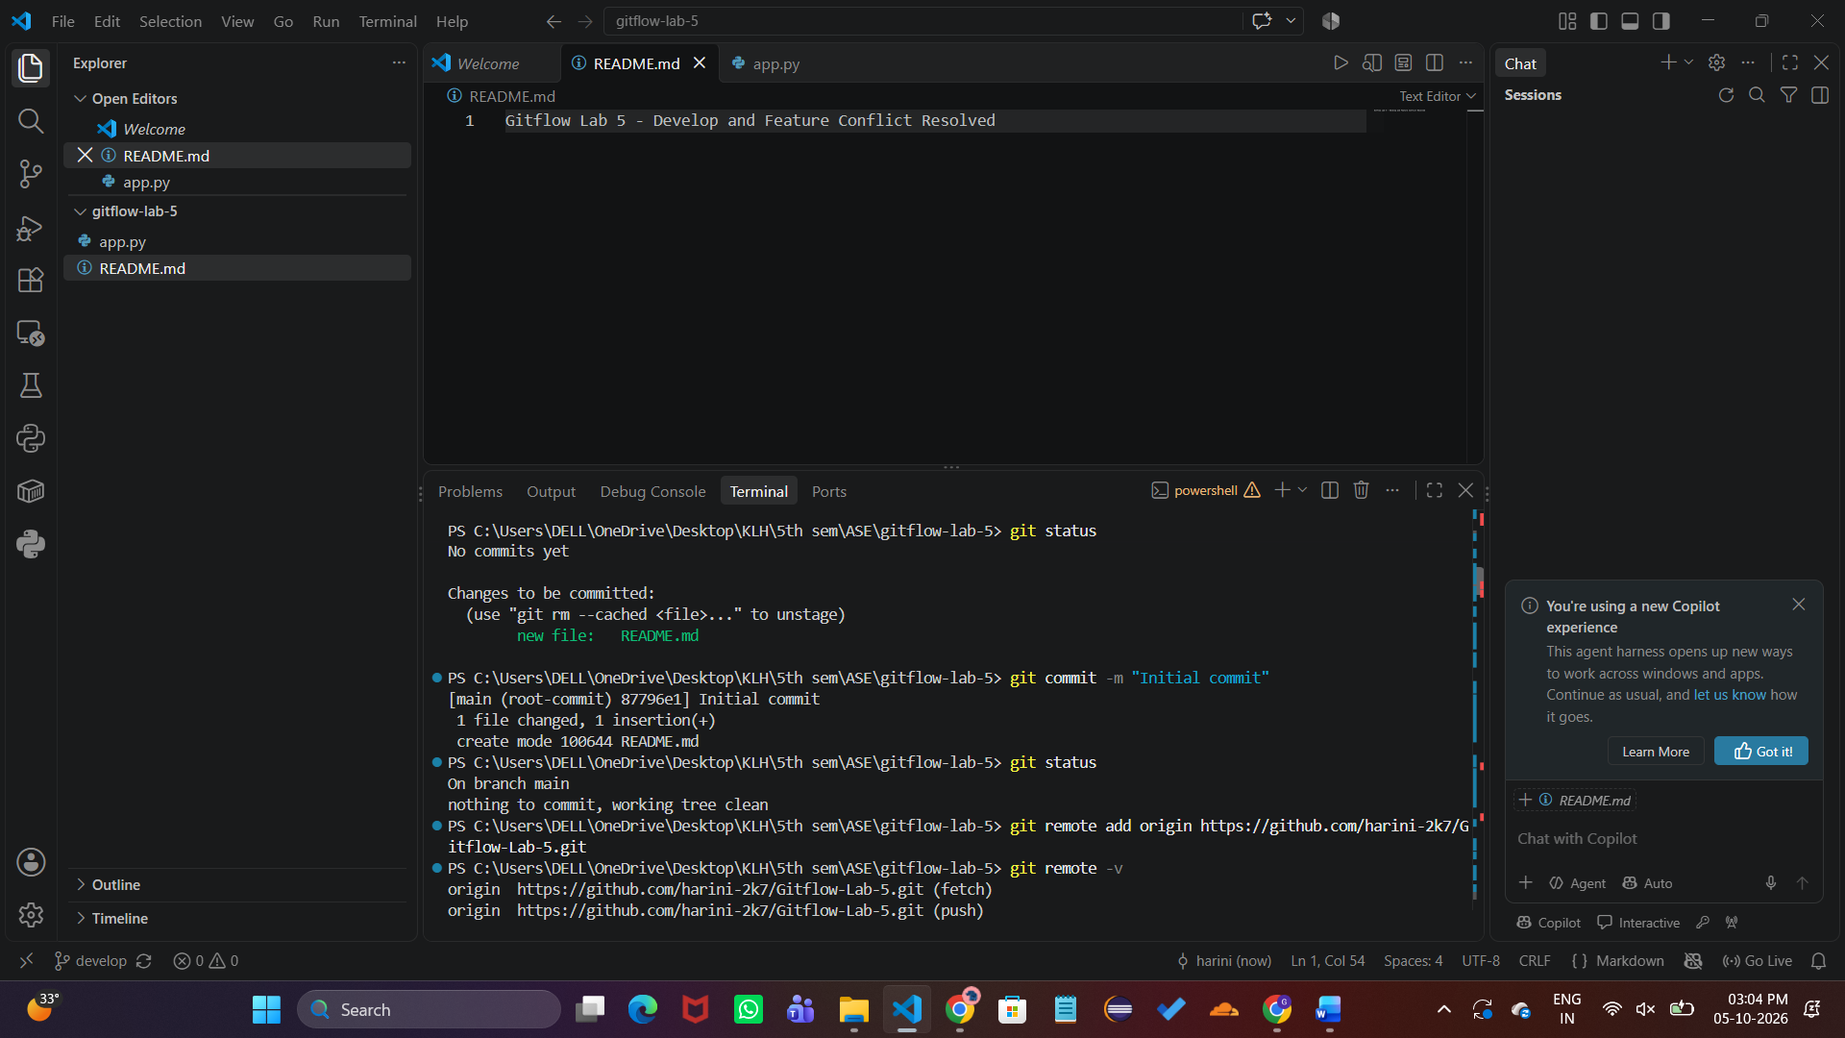
Committed and pushed the login feature to feature/login.

Screenshot 5
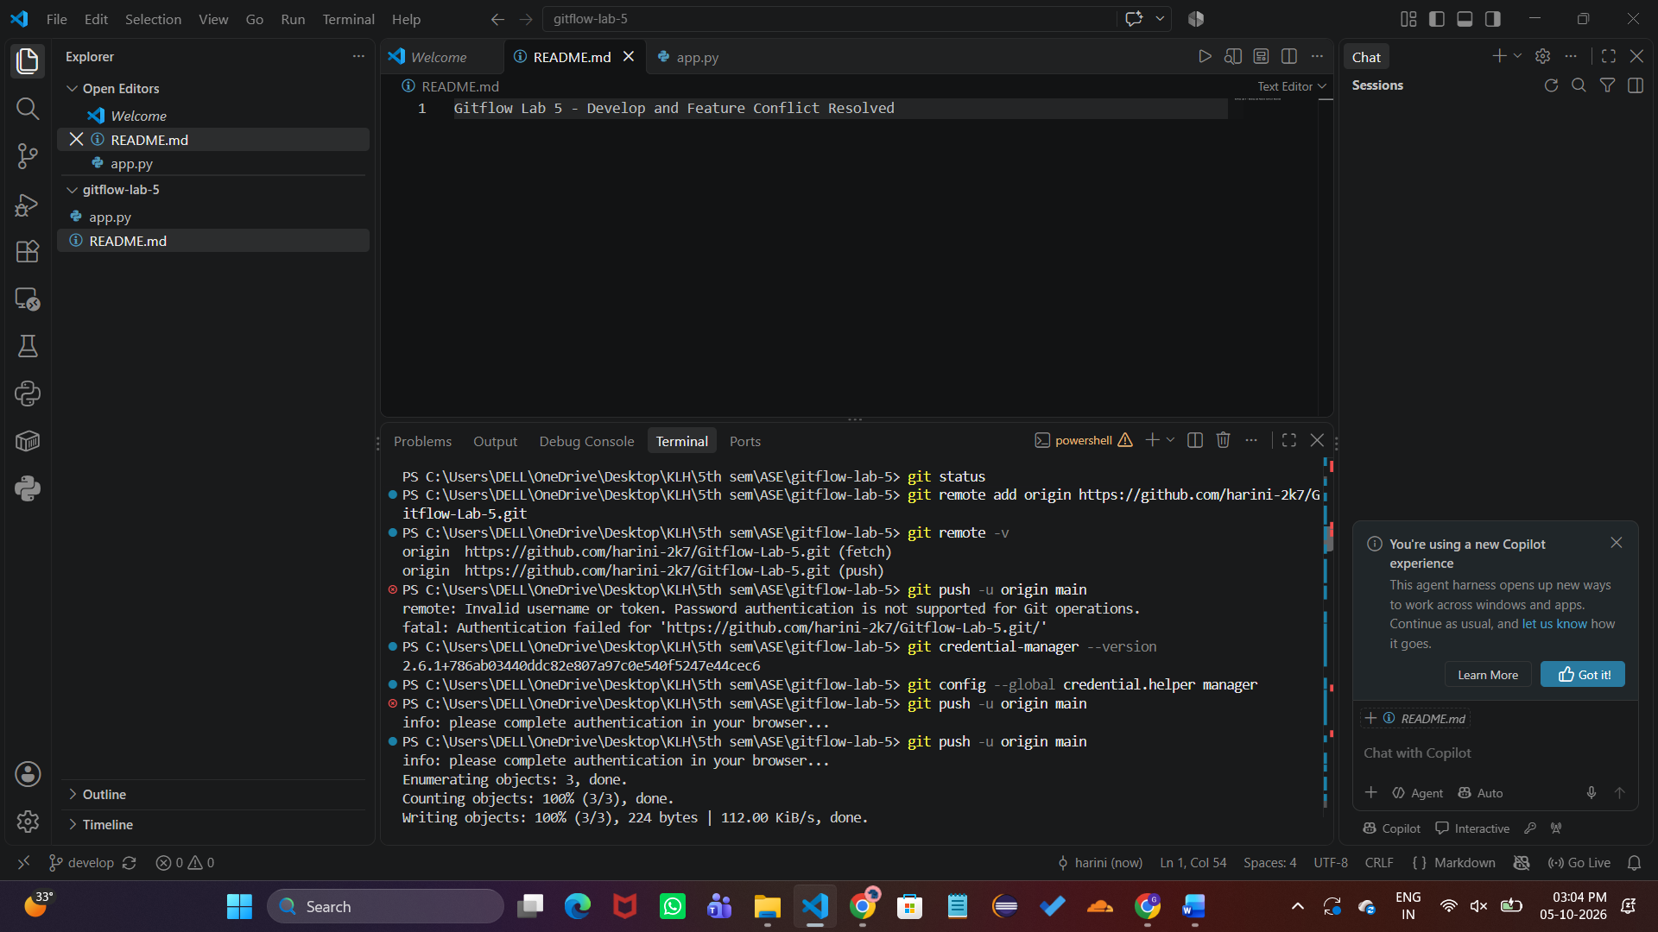
Merged feature/login into develop and pushed the updated develop branch.
Screenshot 6
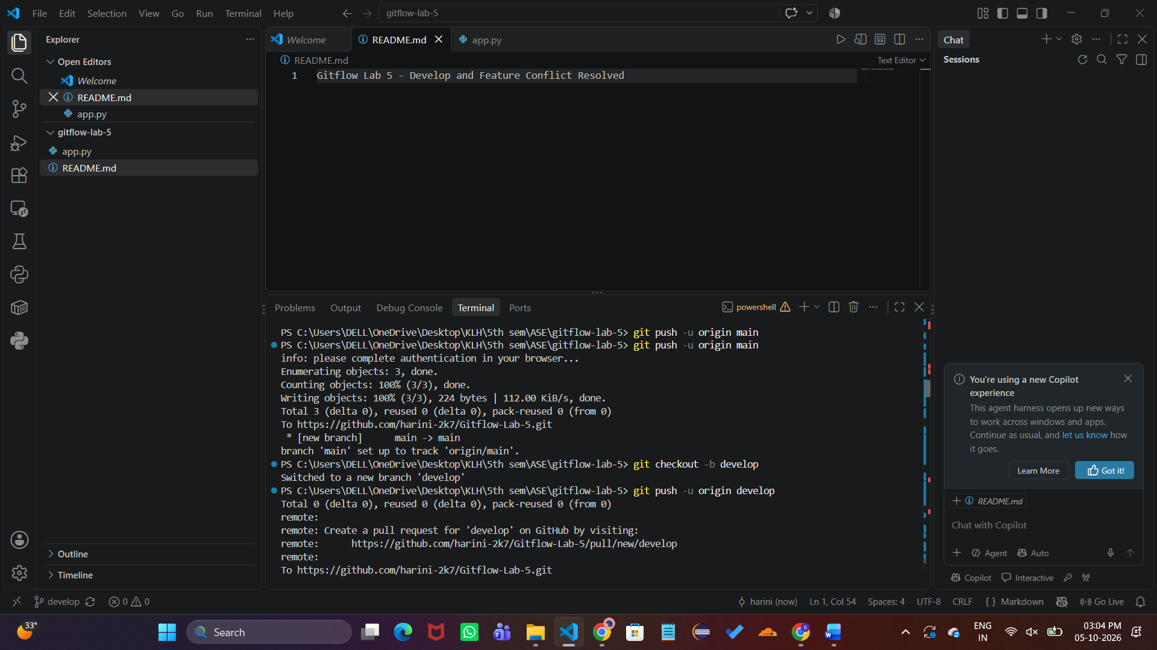
Created feature/conflict branch to demonstrate merge conflict handling.

Screenshot 7
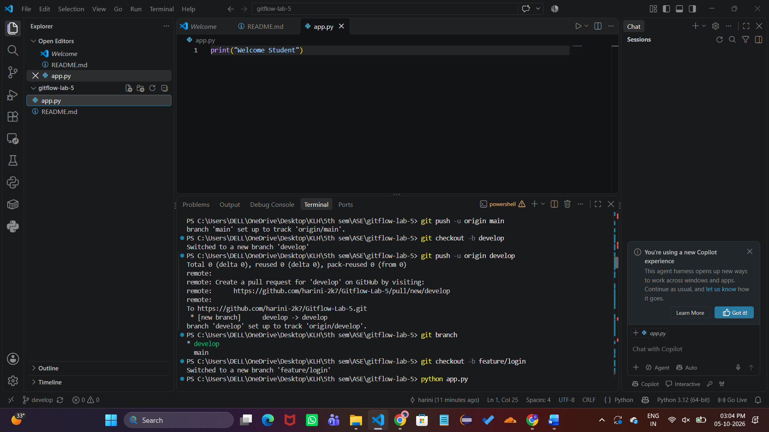
Generated an actual merge conflict in README.md between develop and feature/conflict.
Screenshot 8
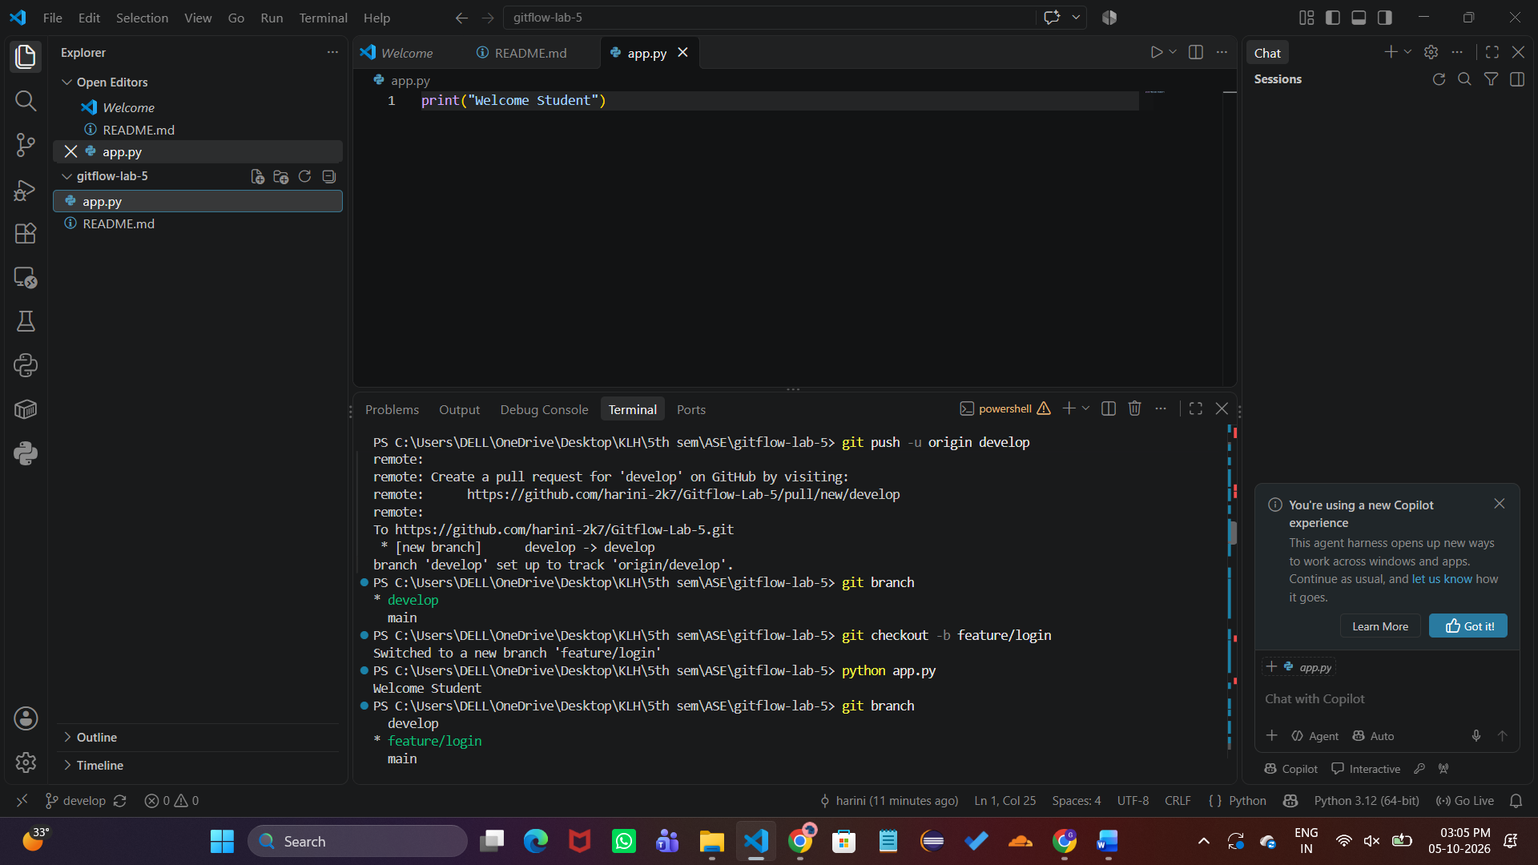
Resolved the README.md conflict and committed the resolved version.

Screenshot 9
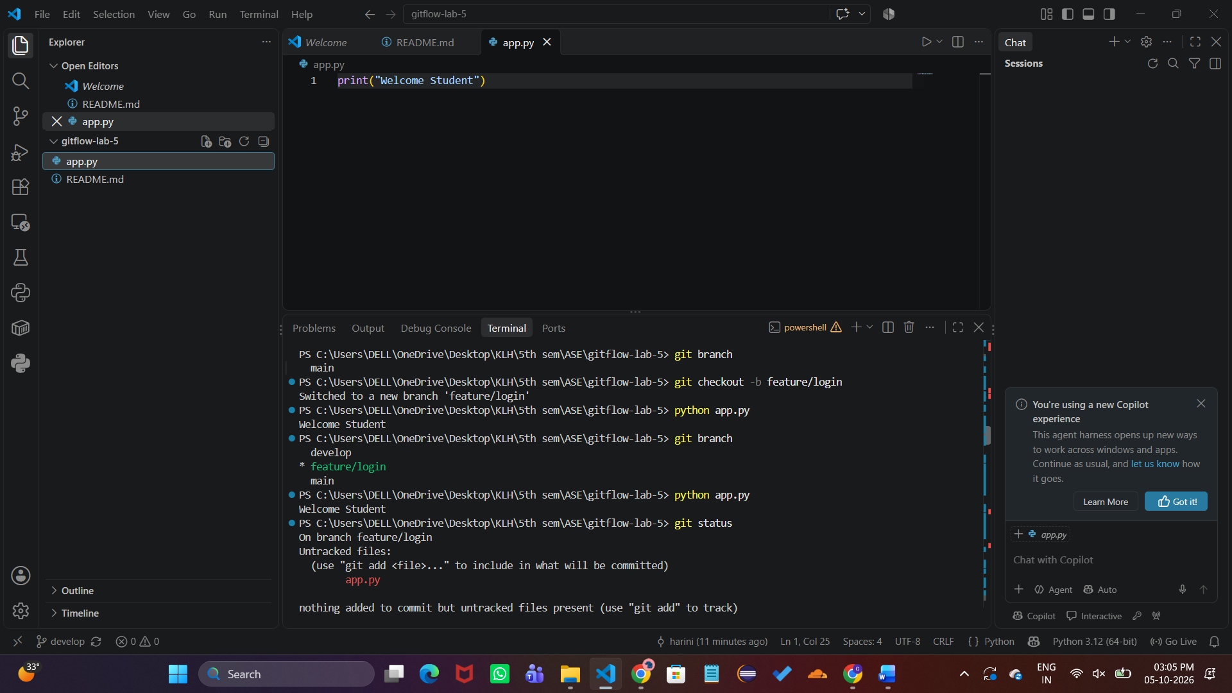
Pushed develop and feature/conflict branches successfully to GitHub.
Screenshot 10
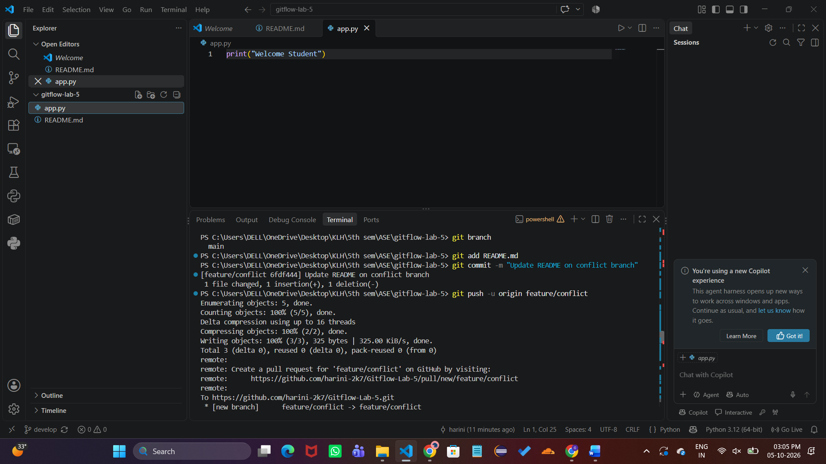
Verified clean working tree and reviewed complete Git branch/commit history.

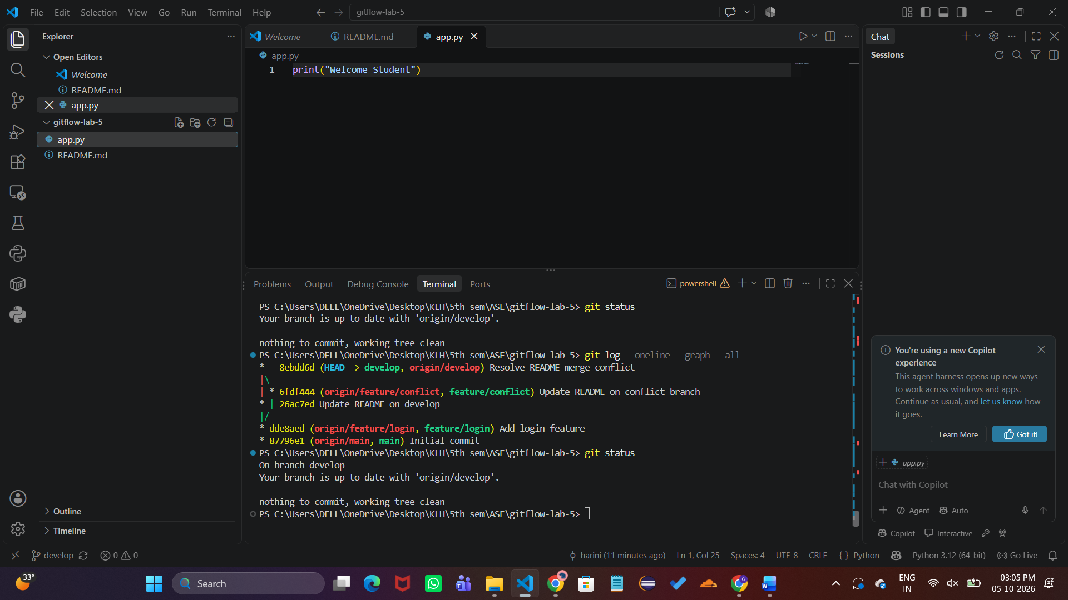

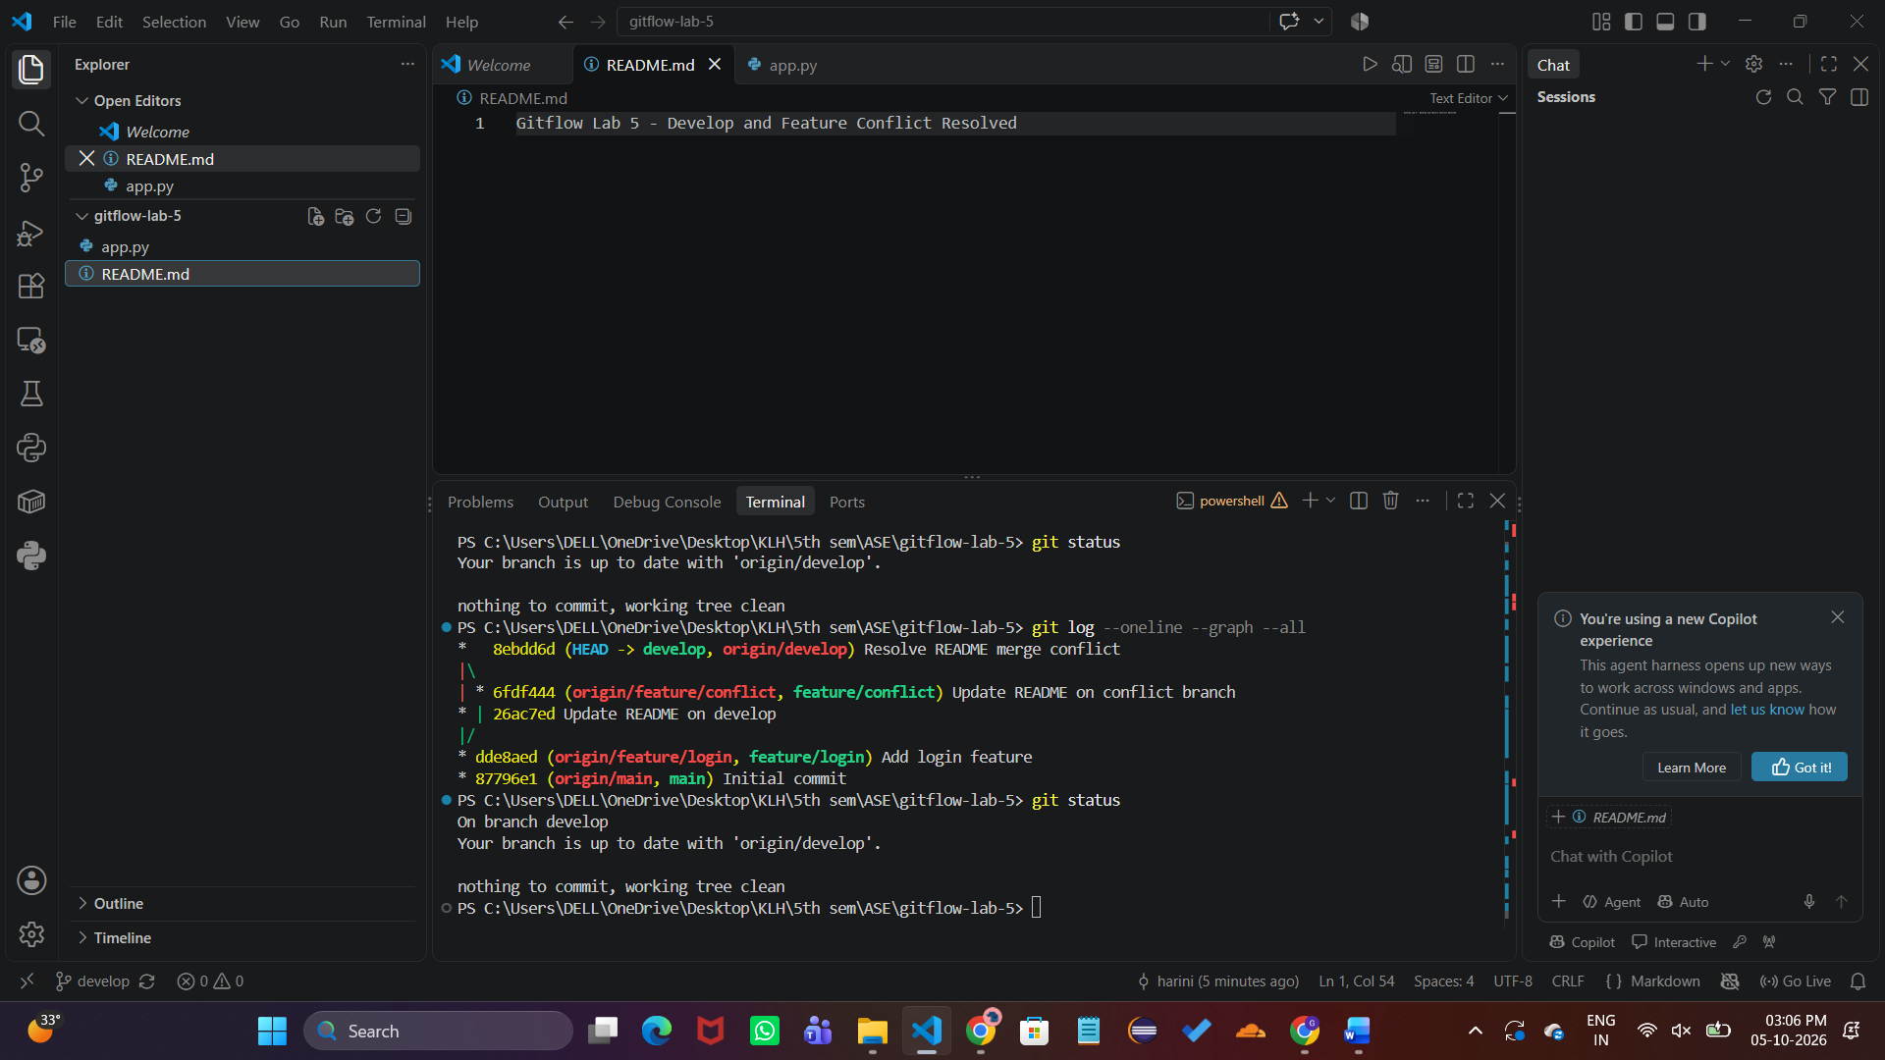Result
The Gitflow Lab 5 workflow was completed successfully. The final develop branch contained the integrated login feature and the resolved README.md. The Git status showed a clean working tree, and the Git graph confirmed the main, develop, feature/login, and feature/conflict branch history.

Important Commands Used
- git init
- git branch -M main
- git checkout -b develop
- git checkout -b feature/login
- git add <file>
- git commit -m "message"
- git push -u origin <branch>
- git merge <branch>
- git status
- git log --oneline --graph --all
- python app.py

