Name: ROOPESH CHALASANI

Roll no:2420030359

Task 3: Jira Board Setup, User Stories and Story Points
Aim: To create a Scrum project in Jira, define five user stories, assign story points, create a sprint, and manage work using a Scrum Board.

Step 1: Create a Jira Account
- Go to https://www.atlassian.com/software/jira
- Click Get it Free or Sign Up.
- Create an Atlassian account and verify your email.(Domain Mail Id Only)
- Log in to Jira.
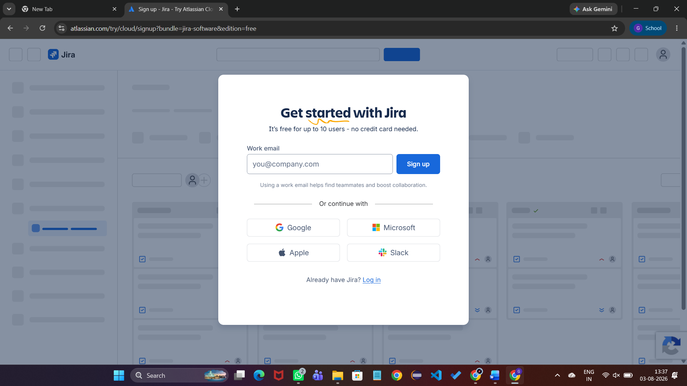

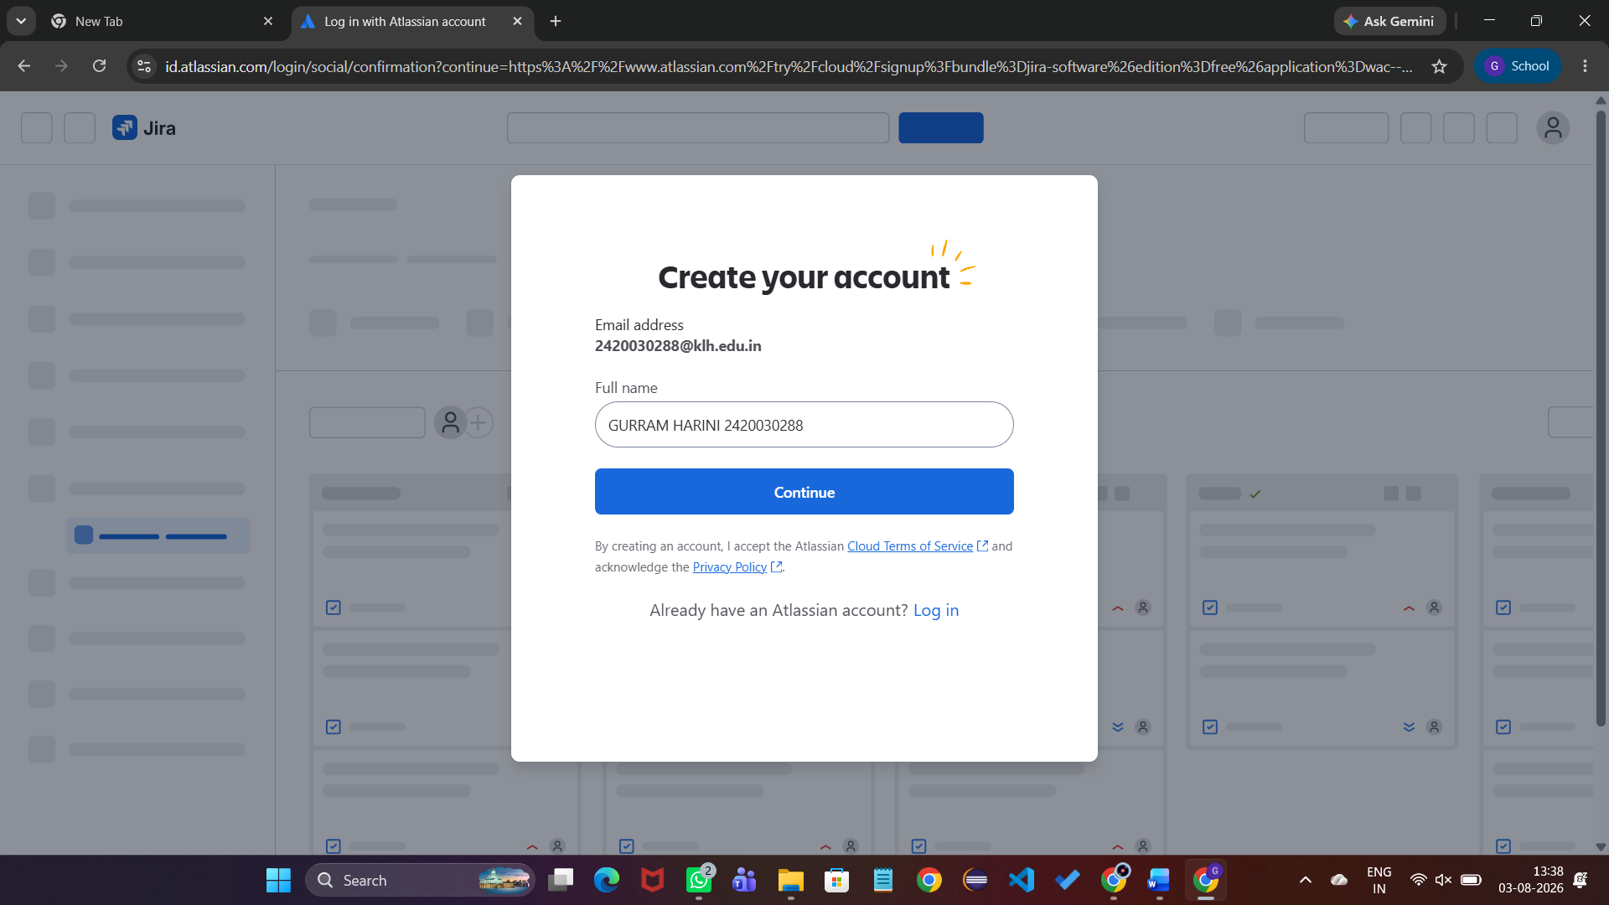
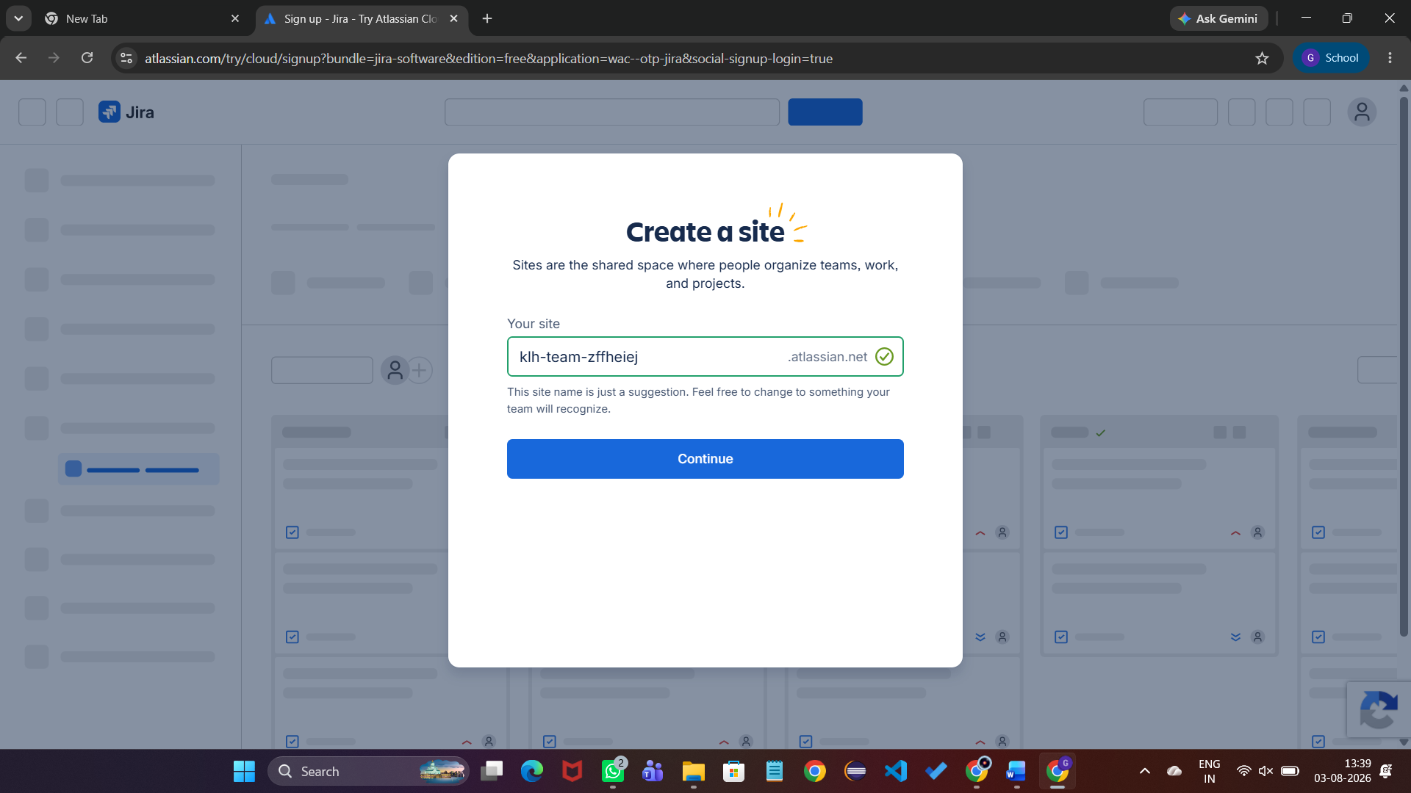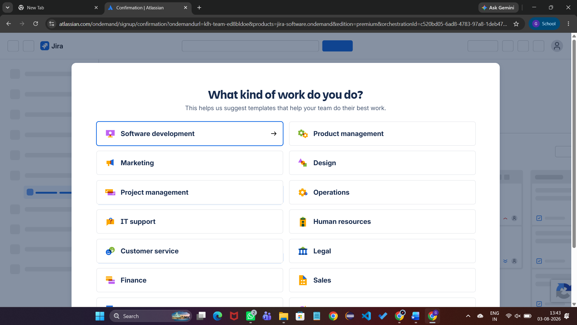
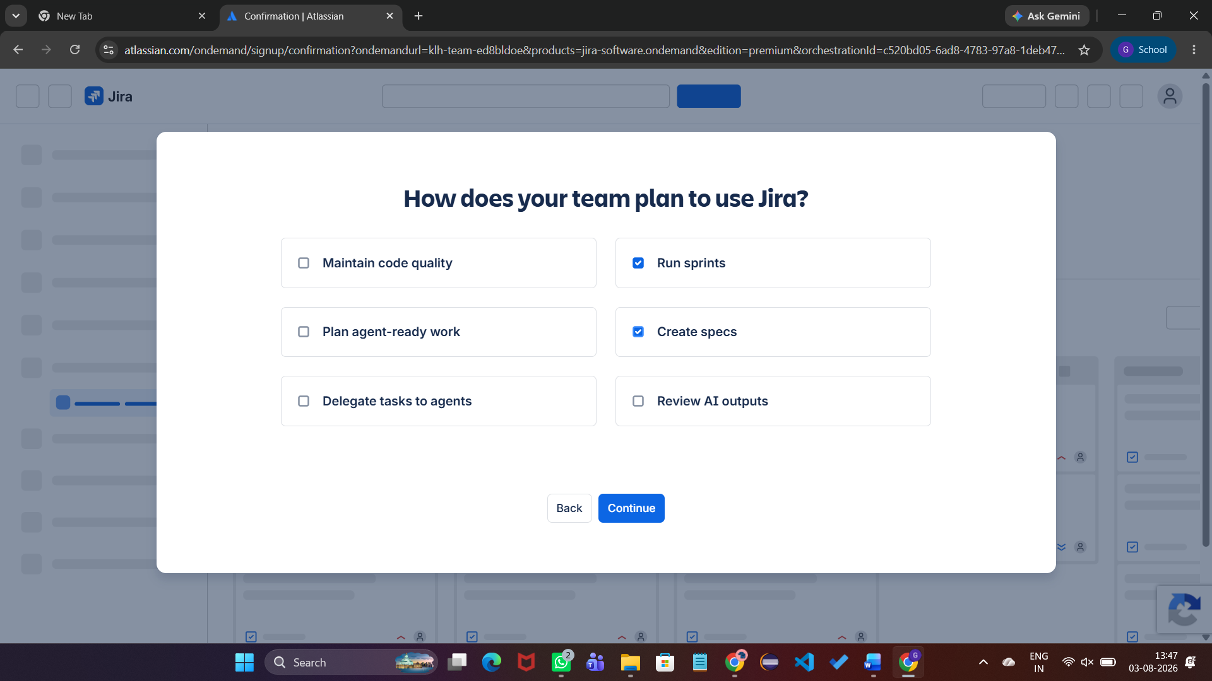

Step 2: Create a Scrum Project
Create a Software project using the Scrum template. Give the project a name such as 'My Software Team'.

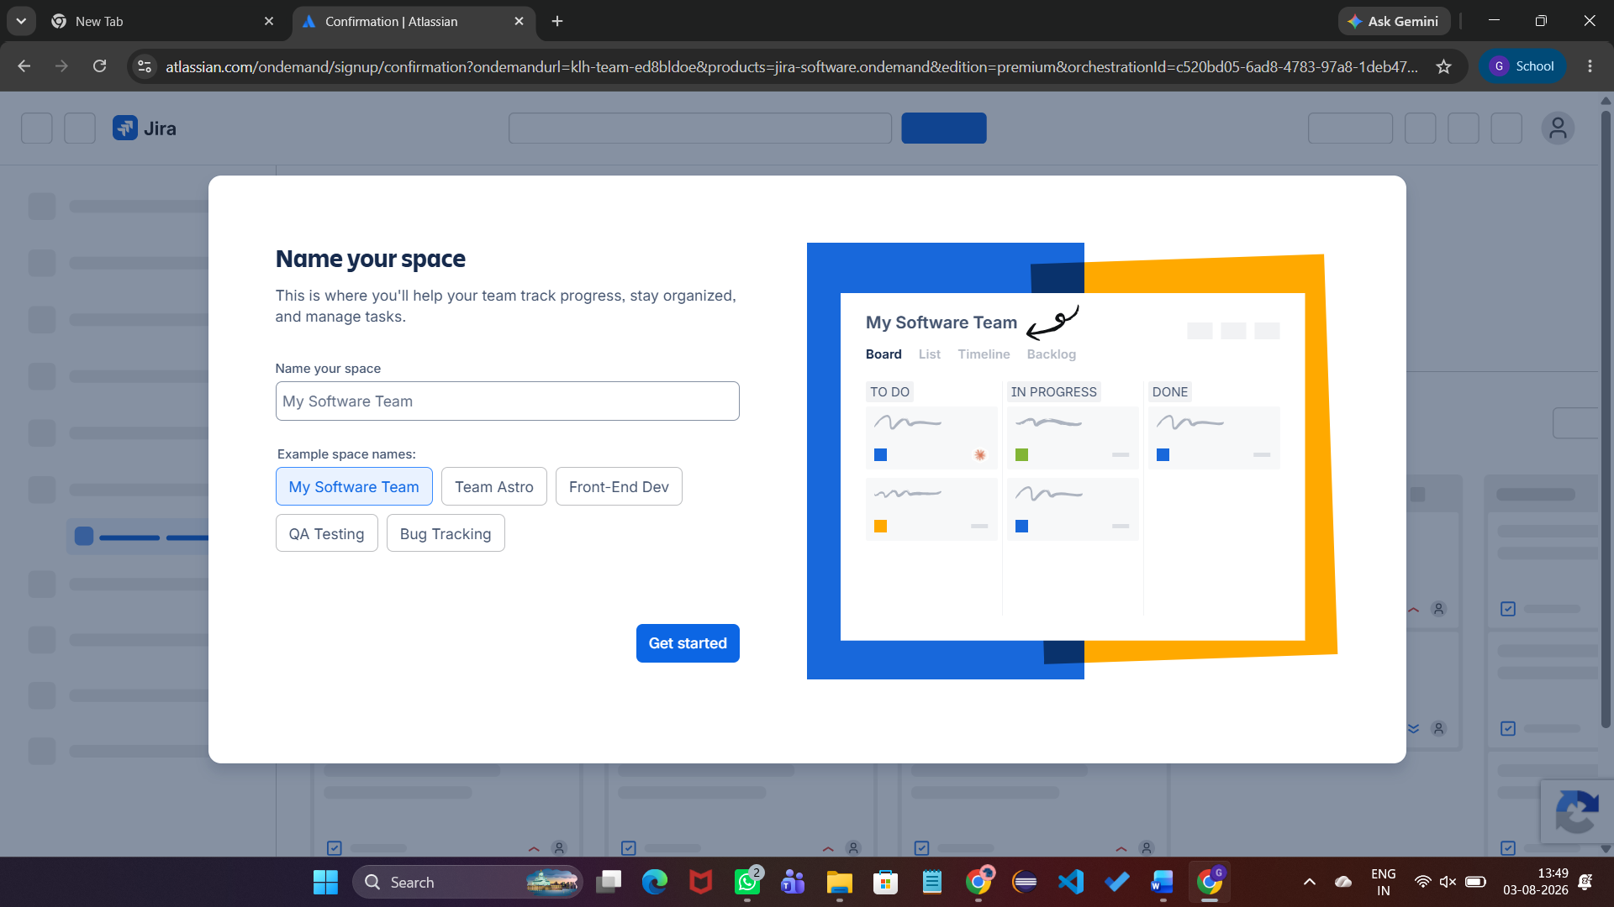

Step 3: Select Work Types
Select Story and Task as work types. Stories represent user requirements.

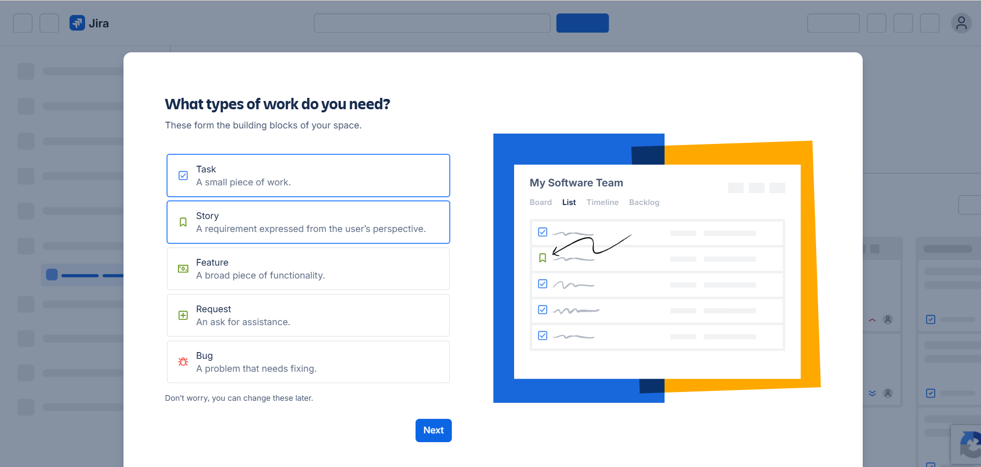Step 4: Configure Workflow
Keep the default workflow: To Do → In Progress → In Review → Done.
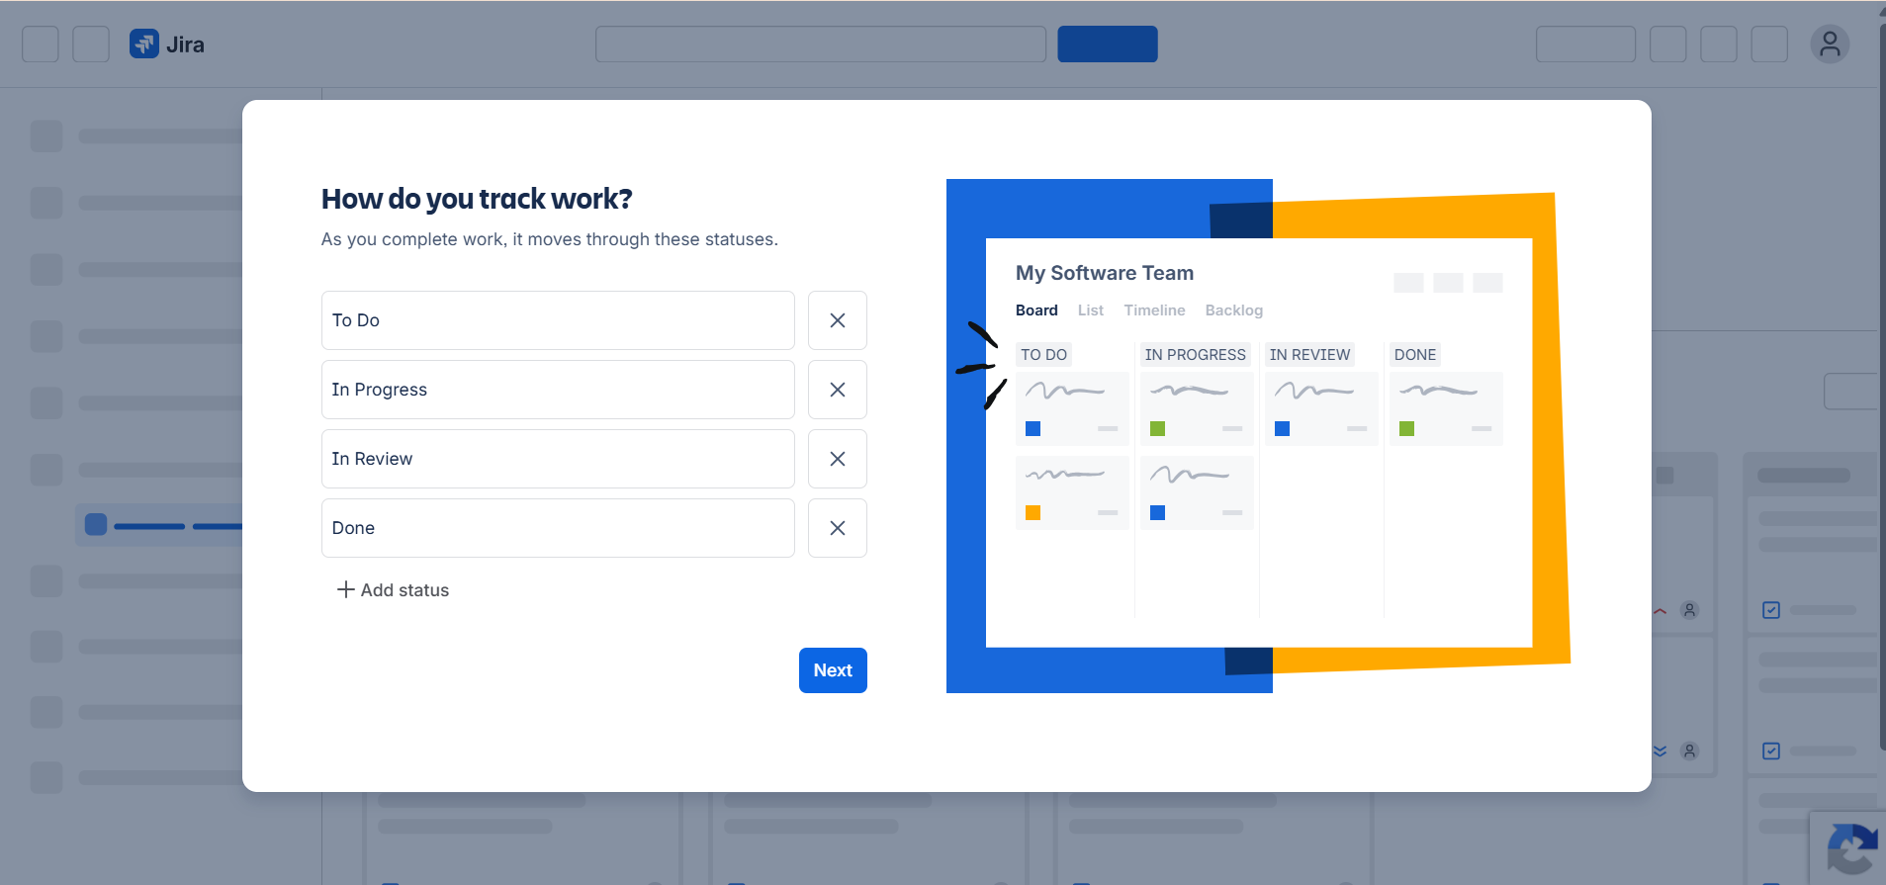

Step 5: Skip Team Invitation
Skip inviting teammates and proceed to Jira.
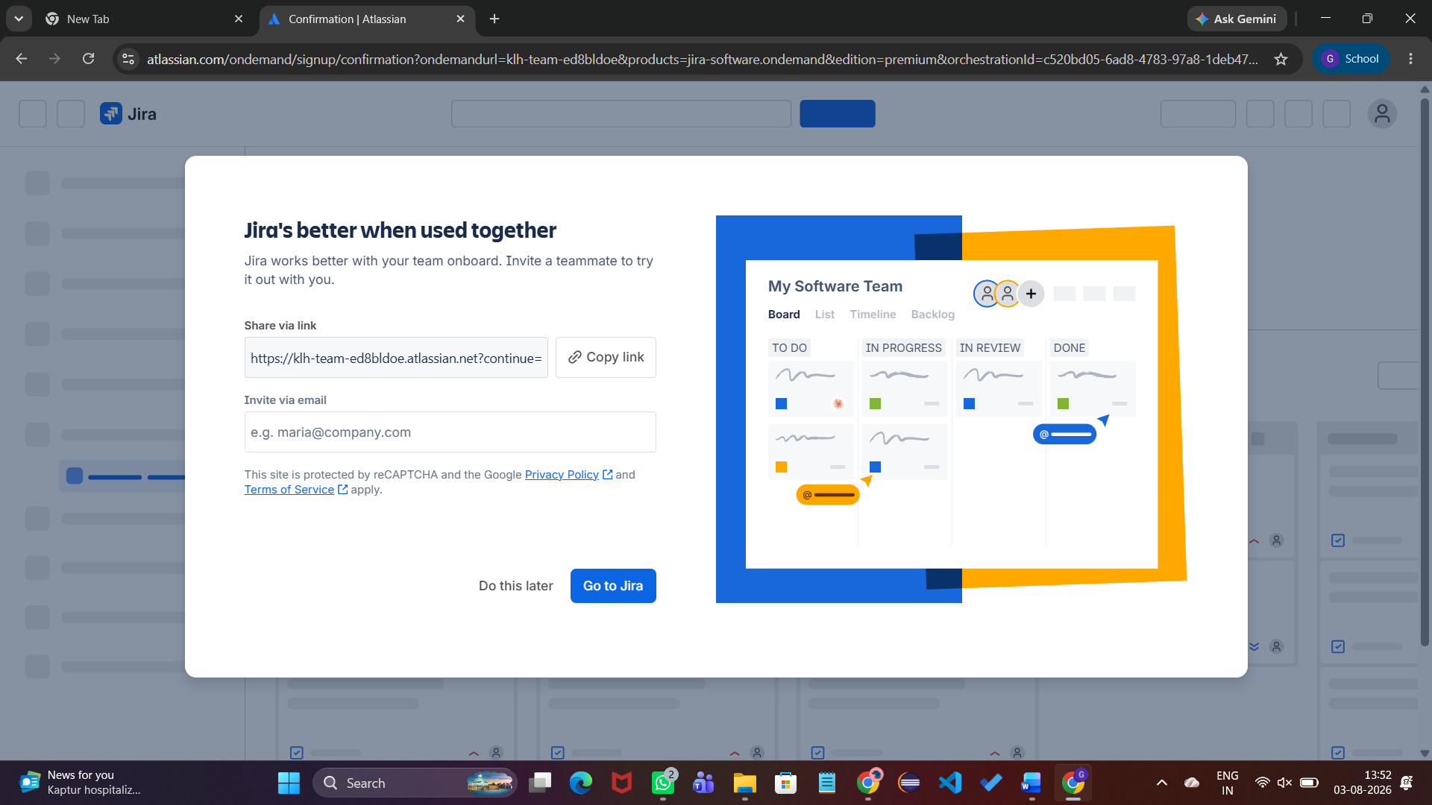

Step 6: Create User Stories
Create five stories:
• Student Login
• Course Registration
• View Attendance
• Faculty Enter Marks
• View Results
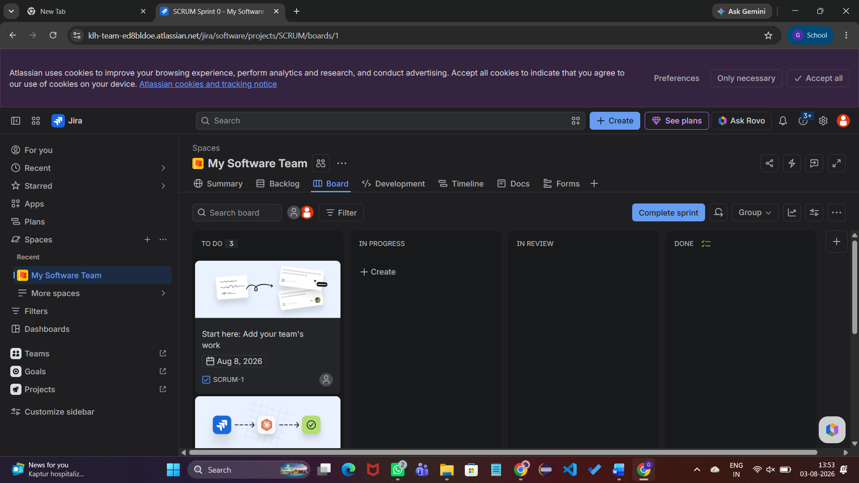
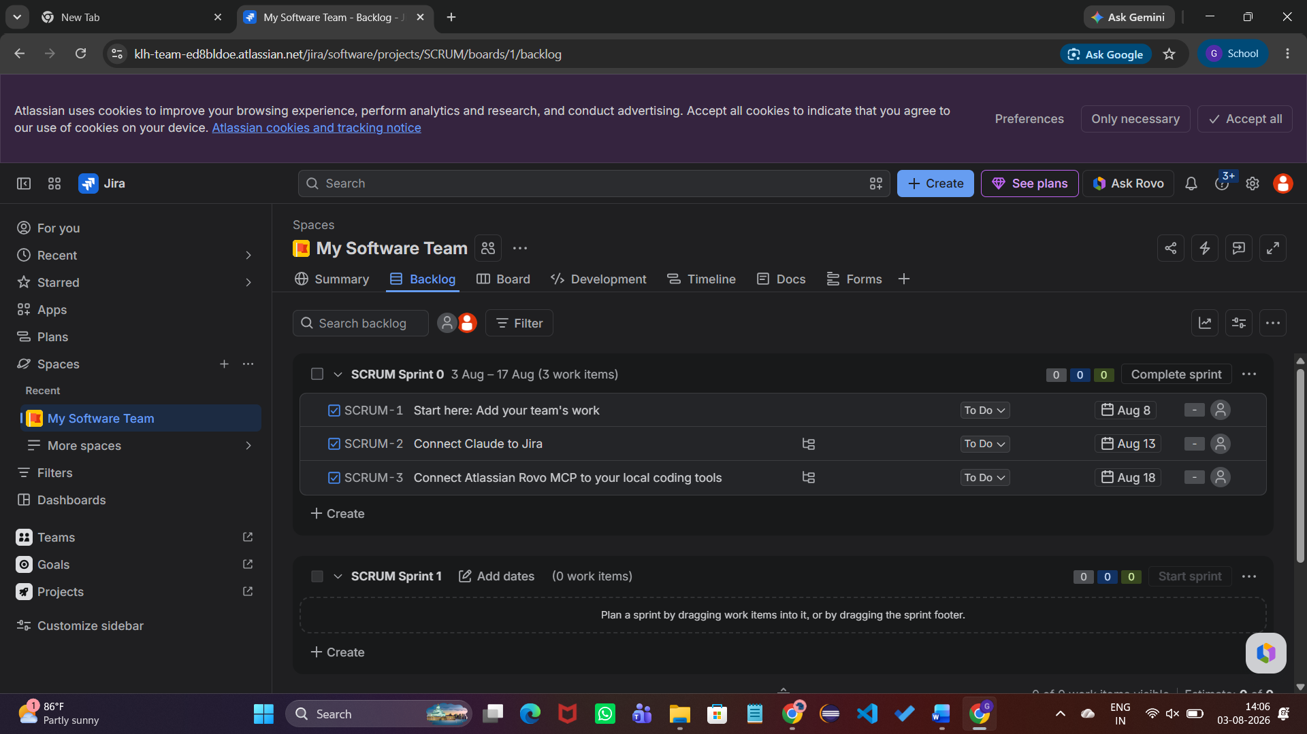
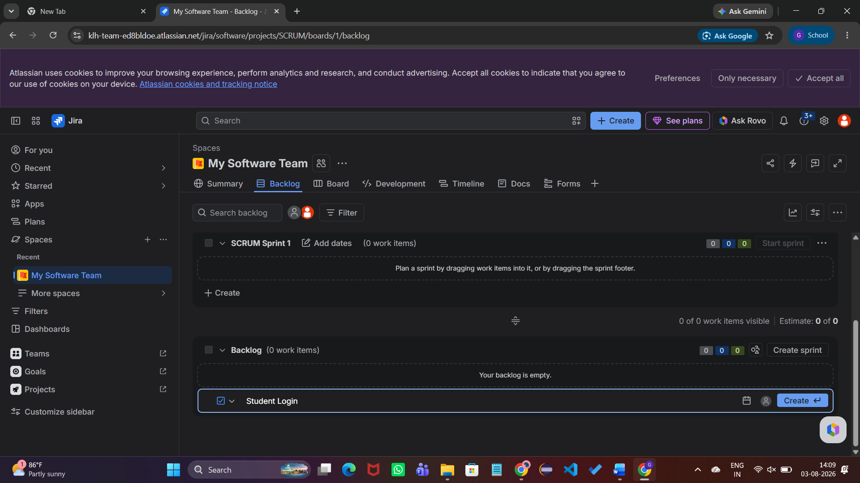

Step 7: Assign Story Points
Assign story points using Fibonacci estimates:
Student Login–3
Course Registration–5
View Attendance–2
Faculty Enter Marks–5
View Results–3

After clicking "Go to Jira"
You should see your project dashboard.

Go to Backlog
From the left navigation menu, click Backlog.

Create User Stories
Click Create (top menu or in the backlog).

Story 1
Summary*
Student Login
Description
As a Astudent,
I want to log in securely,
So that I can access my academic information.
Status
- To Do (leave as it is)
Story Point Estimate
3
Priority
- Medium (leave as default)
Reporter
- Leave as default
Click Create.
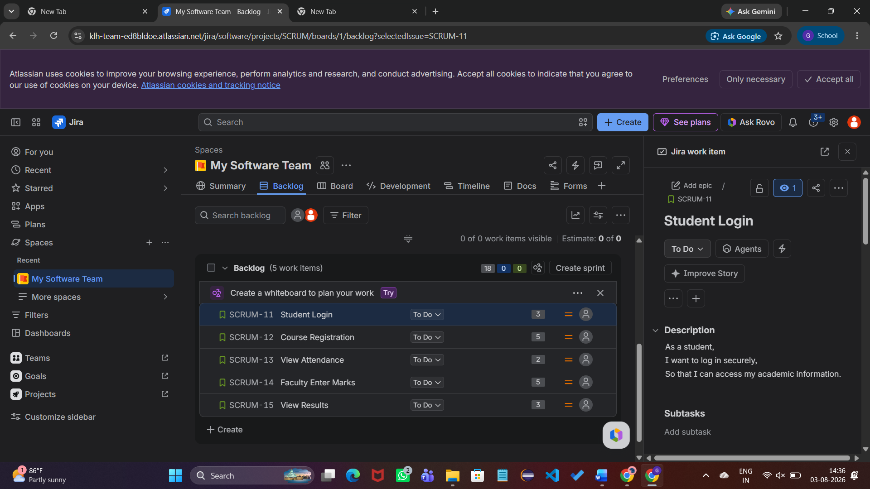

Create the remaining four stories

Story 2
Summary: Course Registration
Description:
As a student,
I want to register for courses,
So that I can enroll in my subjects.
Story Points: 5
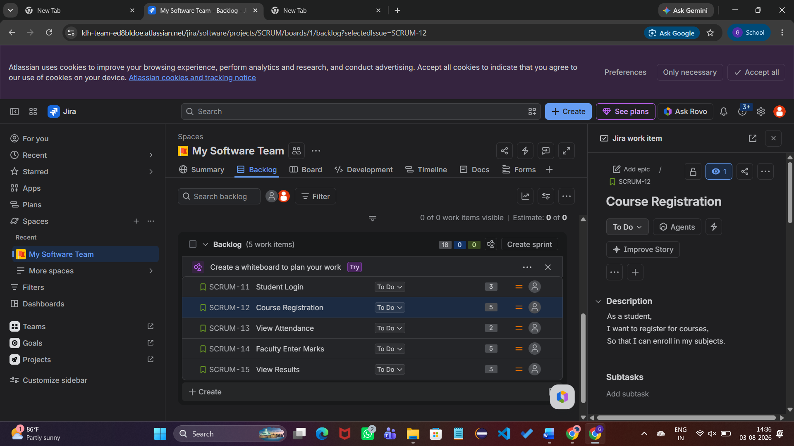

Story 3
Summary: View Attendance
Description:
As a student,
I want to view my attendance,
So that I can monitor my academic progress.
Story Points: 2
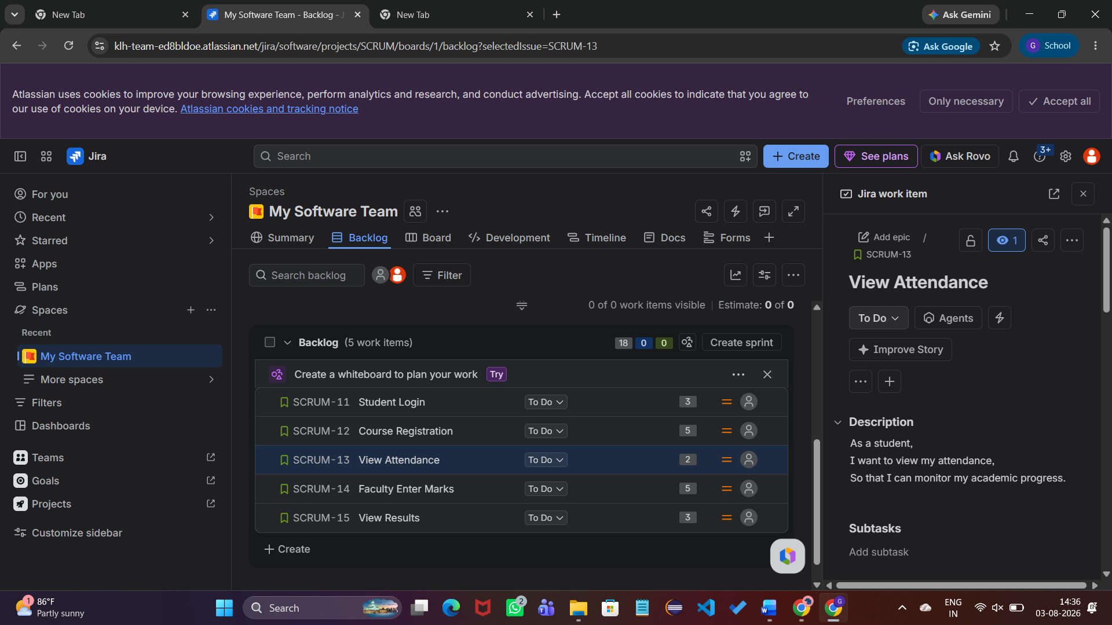

Story 4
Summary: Faculty Enter Marks
Description:
As a faculty member,
I want to enter student marks,
So that students can view their academic performance.
Story Points: 5
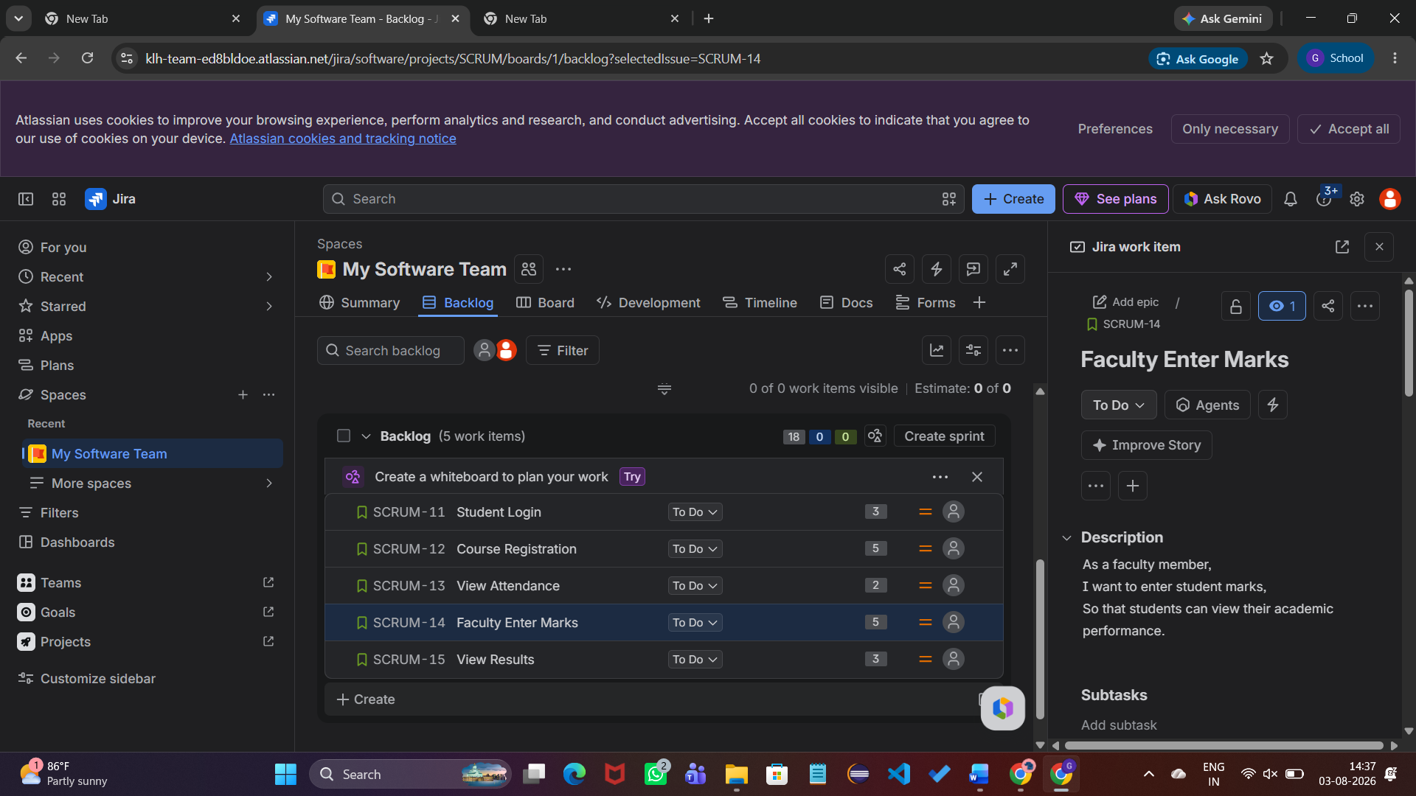

Story 5
Summary: View Results
Description:
As a student,
I want to view my examination results,
So that I can evaluate my performance.
Story Points: 3
Click Create.
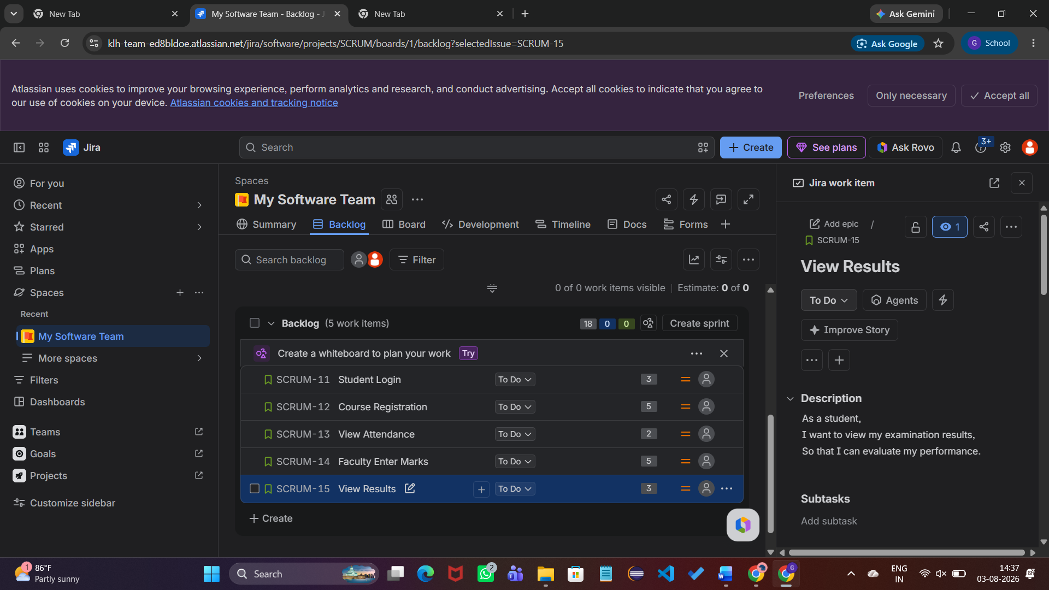
Repeat for these stories:
Summary | Story Points
Student Login | 3
Course Registration | 5
View Attendance | 2
Faculty Enter Marks | 5
View Results | 3

Step 3: Assign Story Points
Open each story and set the corresponding Story Points.
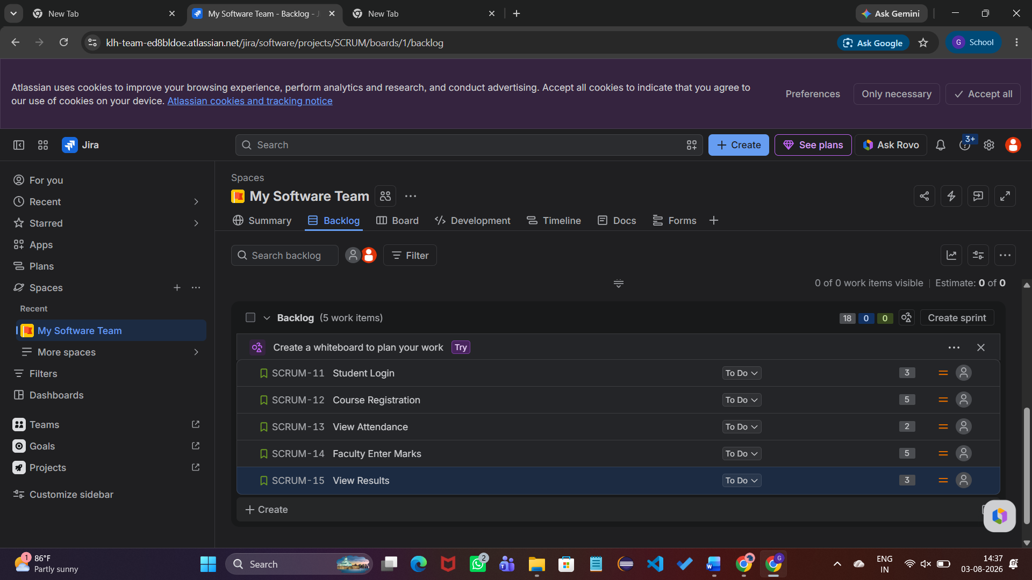

Step 4: Create Sprint
- Click Create Sprint
- Drag all five stories into Sprint 1
- Click Start Sprint#

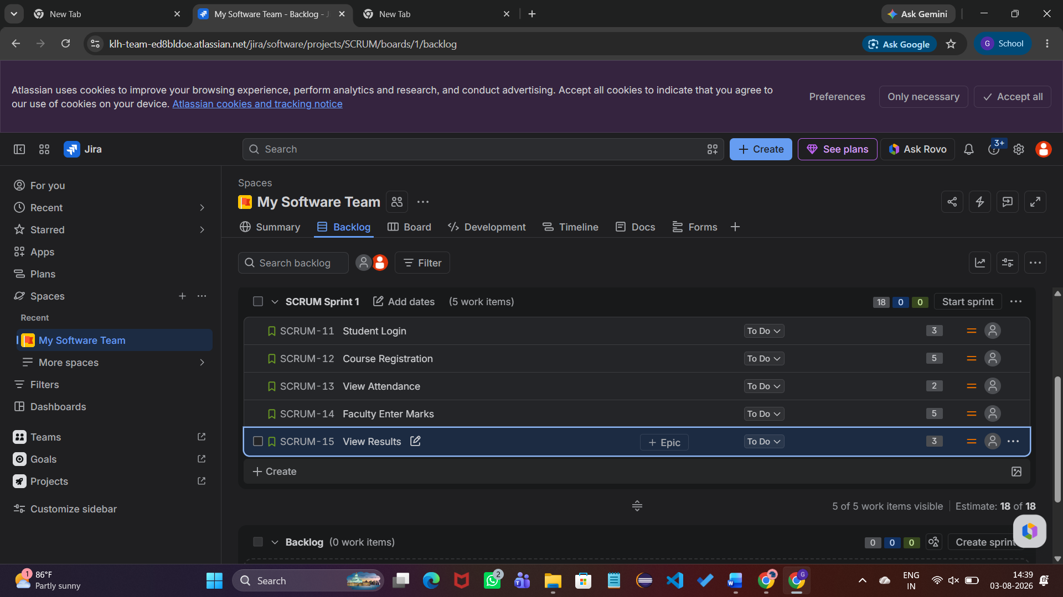

Step 8: Verify Product Backlog
Ensure all five stories appear in the backlog.

Step 9: Create Sprint
Create SCRUM Sprint 1 and move all stories into the sprint.
Sprint Goal: Implement student login, course registration, attendance viewing, faculty marks entry, and result viewing.

Step 10: Start Sprint
Start Sprint 1 with the default duration.
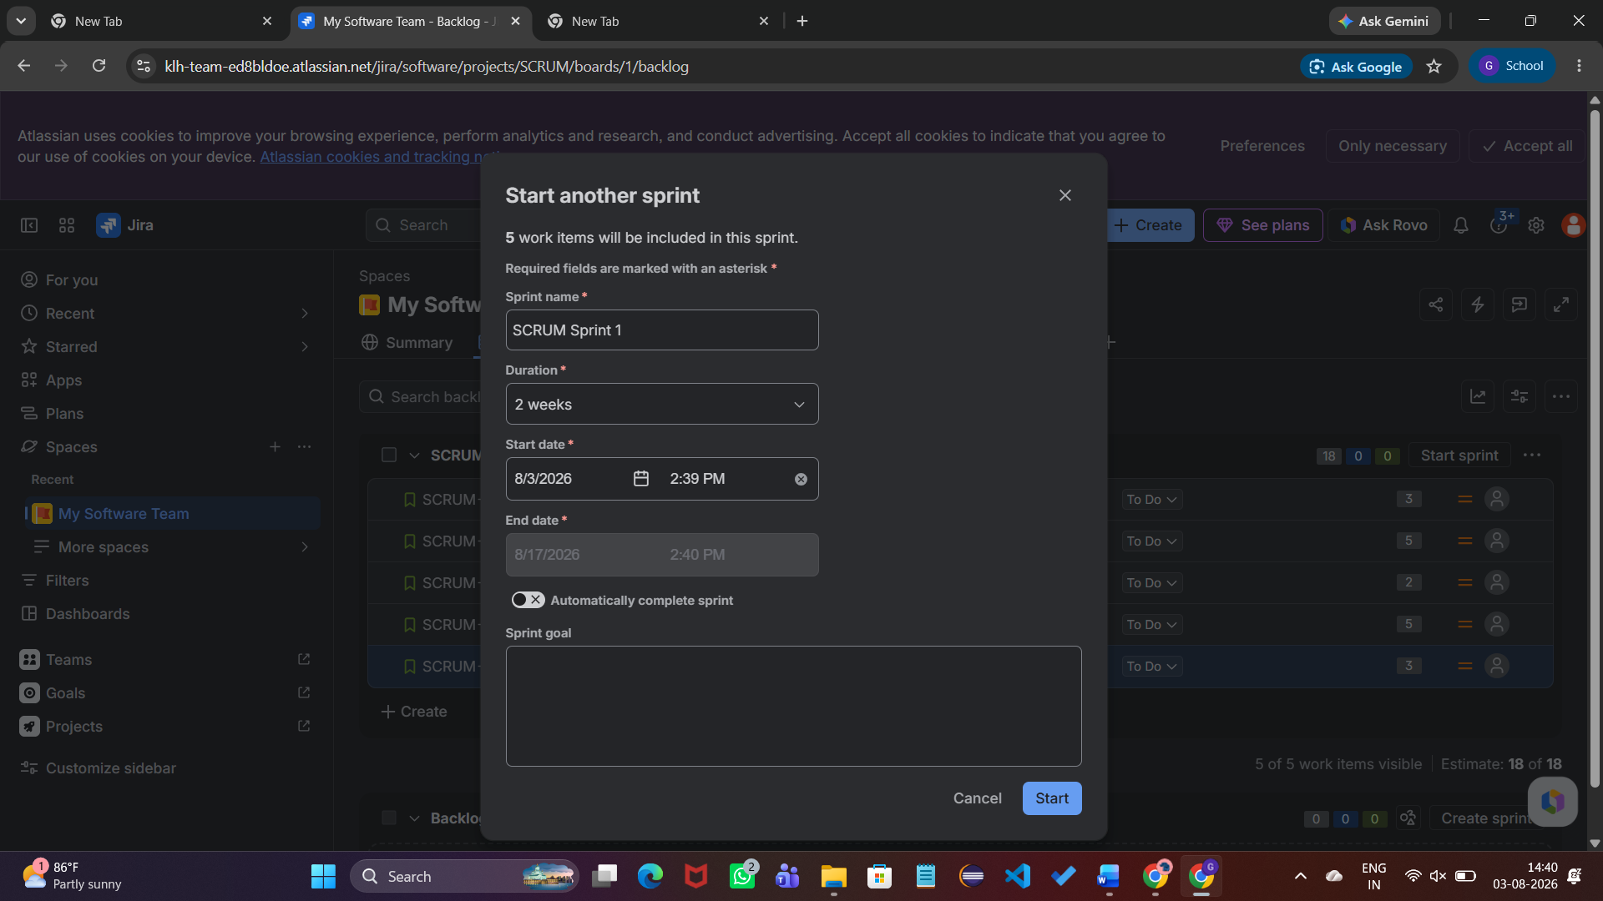

Step 11: Scrum Board
Verify that all five stories are displayed in the To Do column on the Scrum Board.
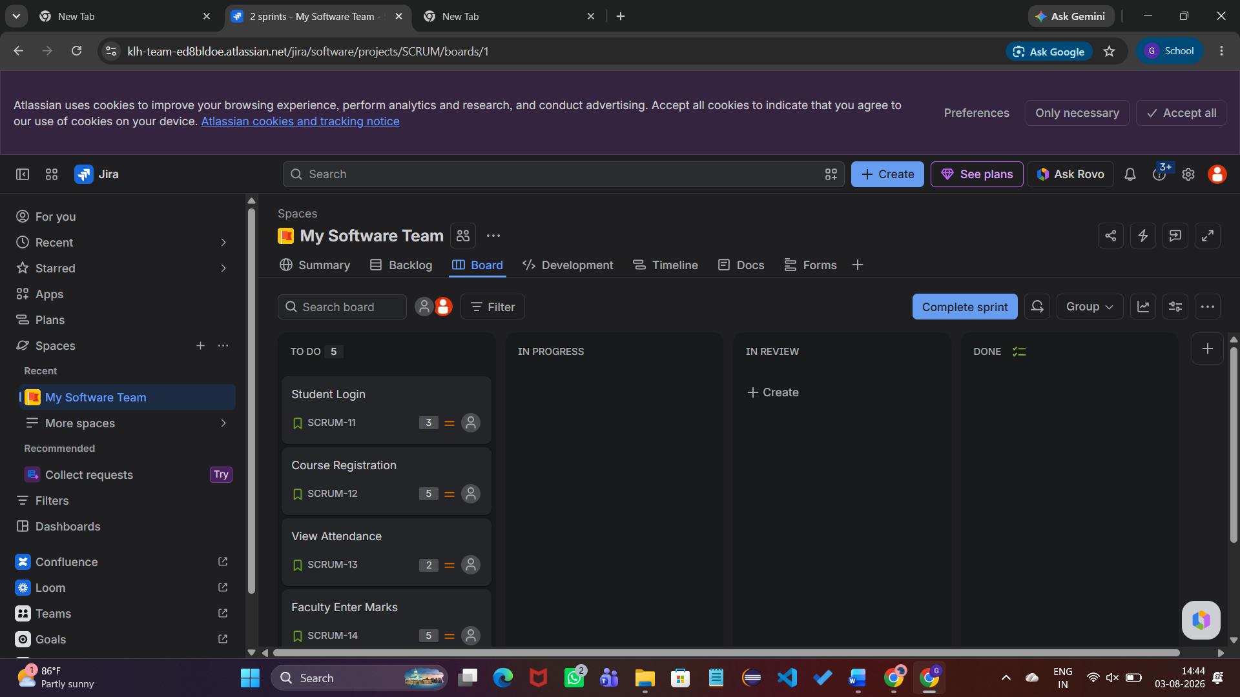

Result
Successfully created a Jira Scrum project, defined five user stories, assigned story points, created Sprint 1, and managed the stories using the Scrum Board.

