Name: ROOPESH CHALASANI
Roll no:2420030359
Task: 4
Create a Trello board with project boards, user stories, task assignments, and sprint workflows to demonstrate Agile project management and team collaboration.

Step 1: Open the Trello website
👉 Official website: https://trello.com

Step 2: Create a free account
- Click Sign up.
- You can use Google account (easiest) or email.
- After signing in, Trello will open your Home page.

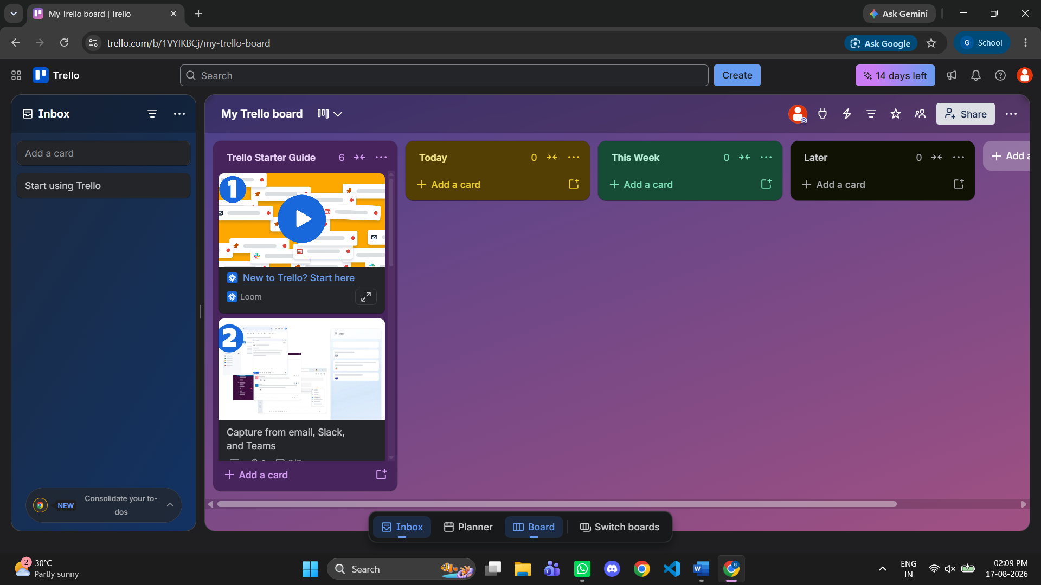

Step 3: Create your first Workspace
A Workspace is like a folder that contains multiple boards.

Do this
- Click Create (top-right).
- Select Create Workspace.
- Enter:
  - Workspace name: Agile Case Study
  - Type: Education
- Click Continue.
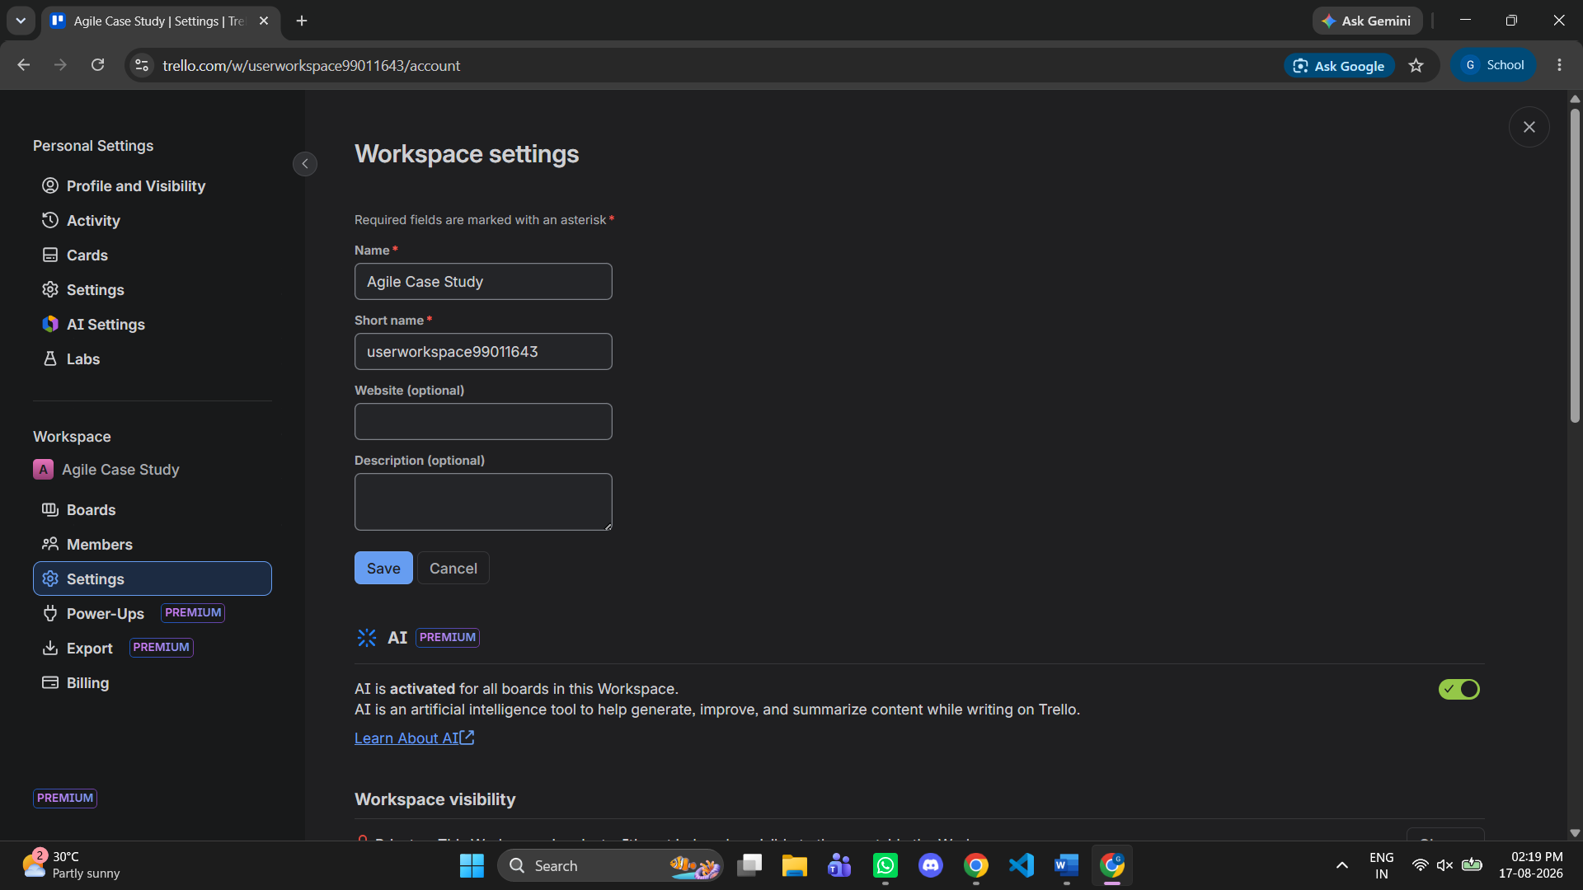
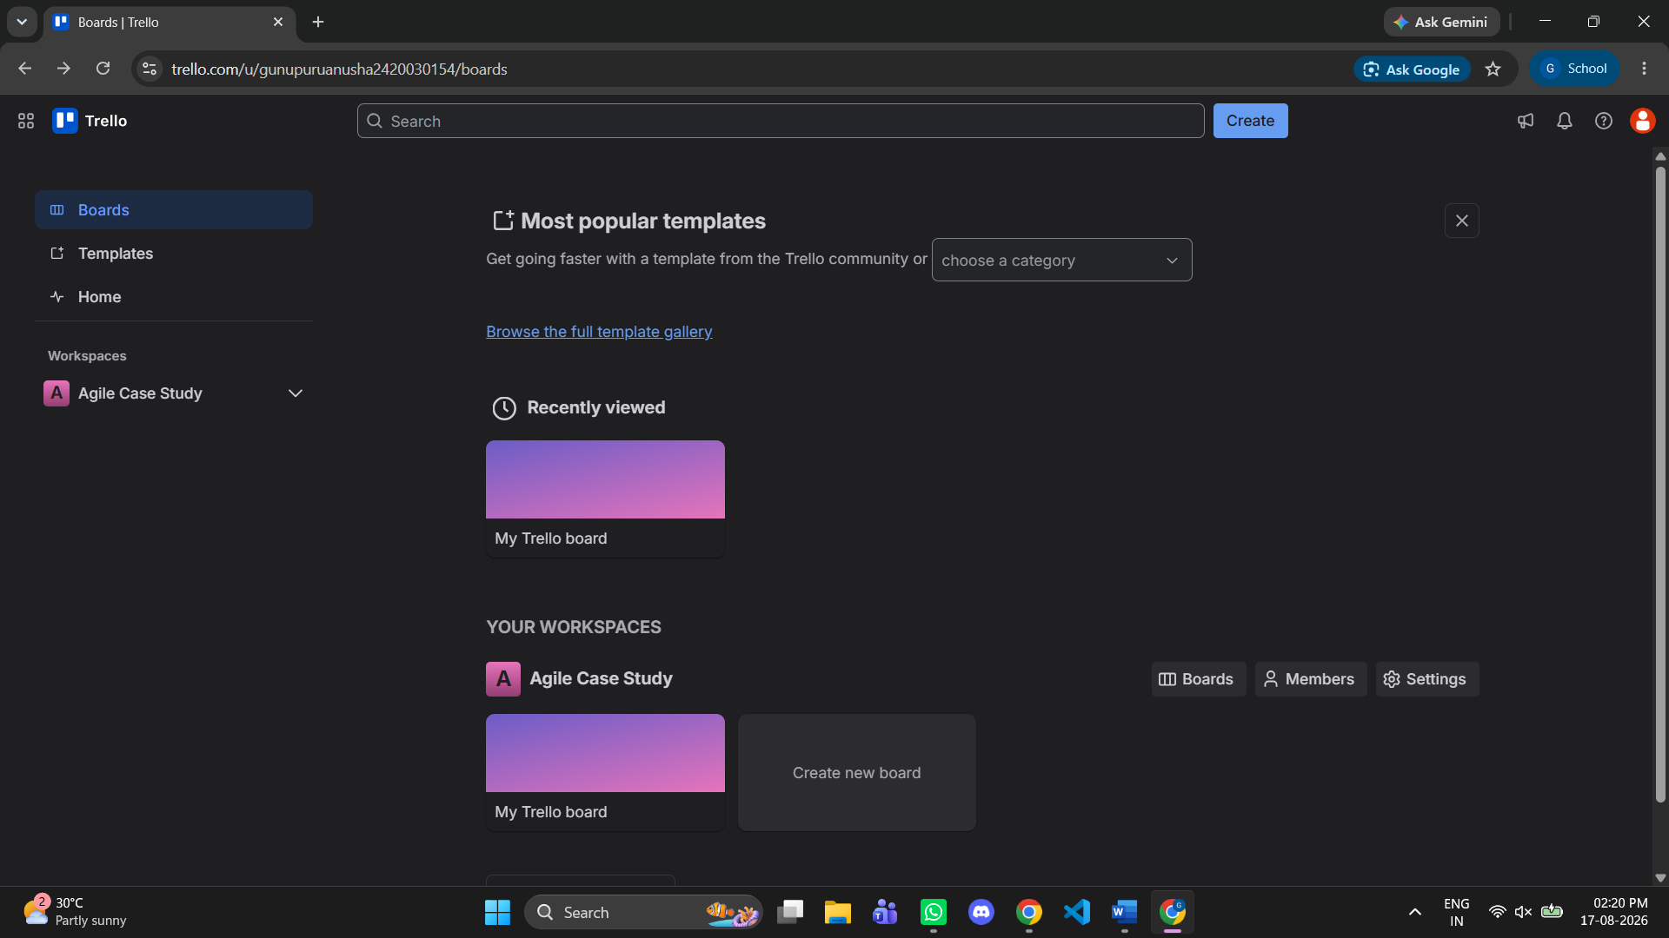

Step 4: Create the Project Board
Now create the board where all Agile activities will happen.
• Board name: College Event Management System
• Workspace: Agile Case Study
• Visibility: Workspace
Click Create.
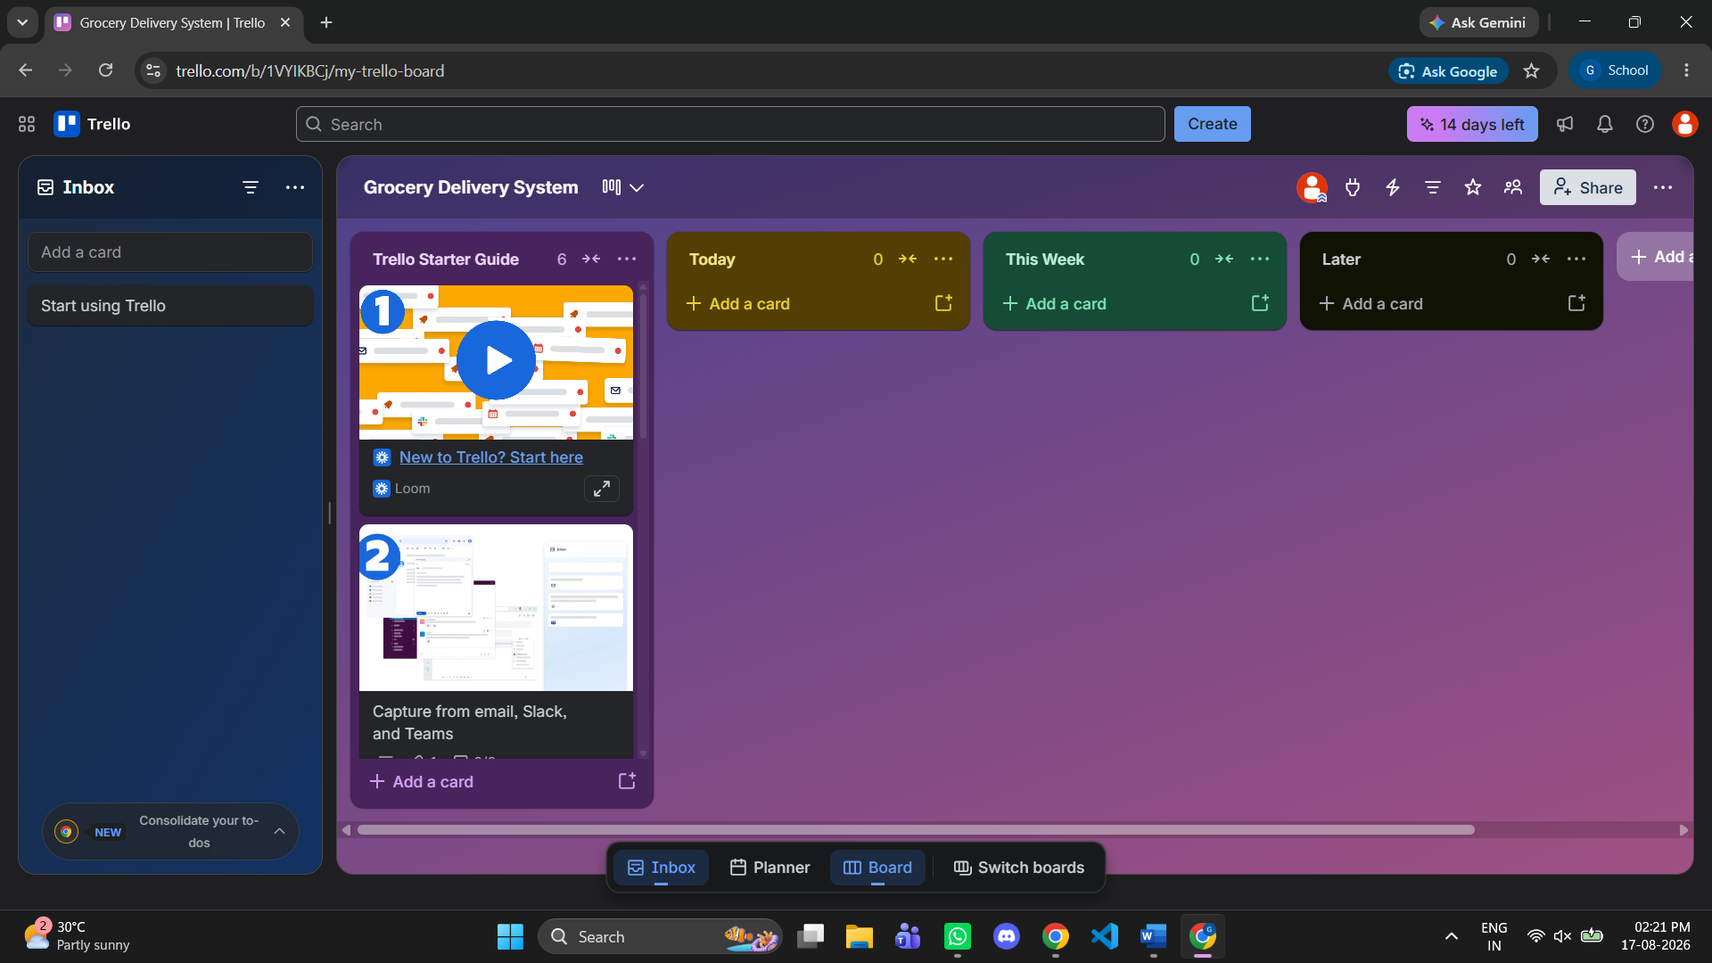

Step 5: Create Agile workflow lists
These lists represent the sprint workflow.

Create these lists in order
- Product Backlog
- Sprint Backlog
- To Do
- In Progress
- Testing
- Done

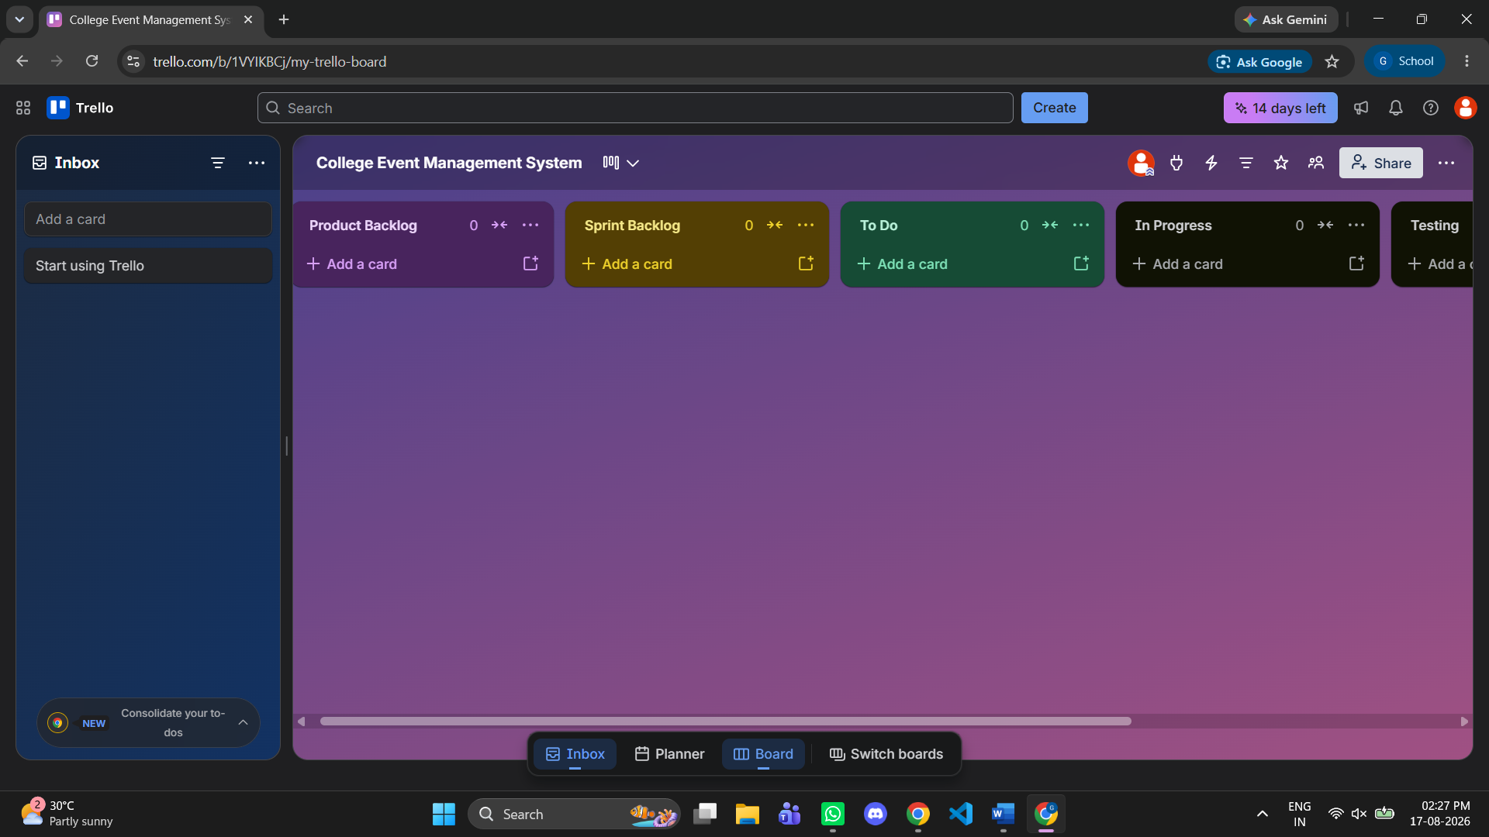

Step 6: Add User Stories (important for your assignment)
Click Add a card under Product Backlog and create these cards.

User stories
US-01: User Registration
As a student, I want to register for the event so that I can participate.
US-02: Event Schedule
As a participant, I want to view the event schedule so that I can attend sessions on time.
US-03: Admin Login
As an admin, I want to log in securely so that I can manage the event.
US-04: Email Notifications
As a participant, I want to receive confirmation emails after registration.
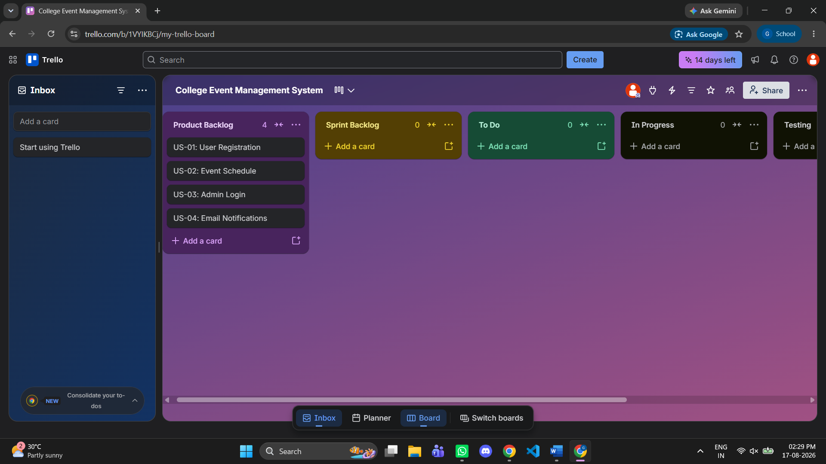
Drag Card (US) to product Backlogs)

Step 7: Create Sprint 1
Drag these cards from Product Backlog to Sprint Backlog:
- US-01 User Registration
- US-02 Event Schedule
This means these features are selected for Sprint 1.
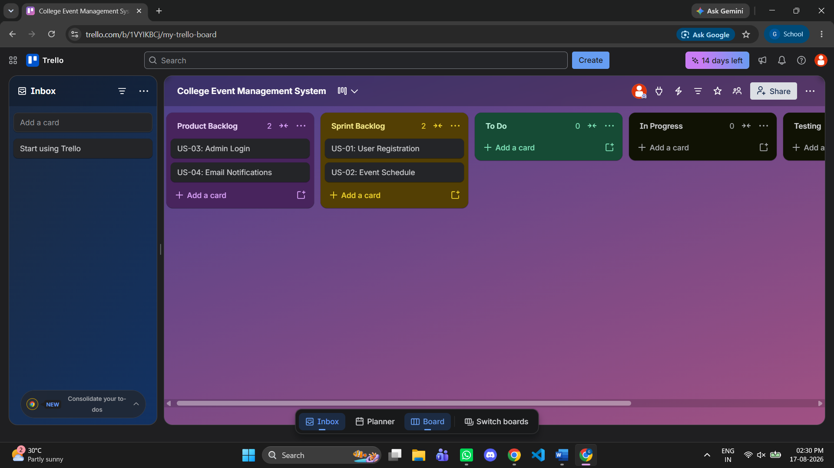

Step 8: Break a user story into tasks
Open US-01 User Registration and add a Checklist.

Checklist items
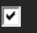Design registration form
Create database table
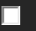Validate input fields
Save user data
You can even add all options which are needed
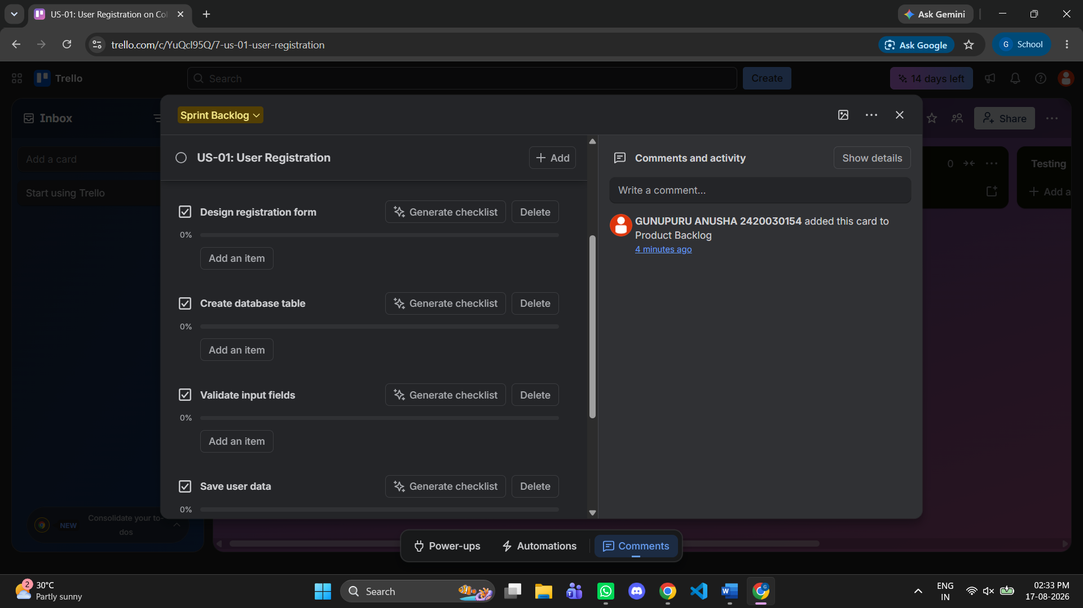

You can do similarly to all Agile workflow lists

Step 9: Assign team members
Inside the card:
- Click Members.
- Add yourself.
- If you have classmates, invite them using Share → Invite.
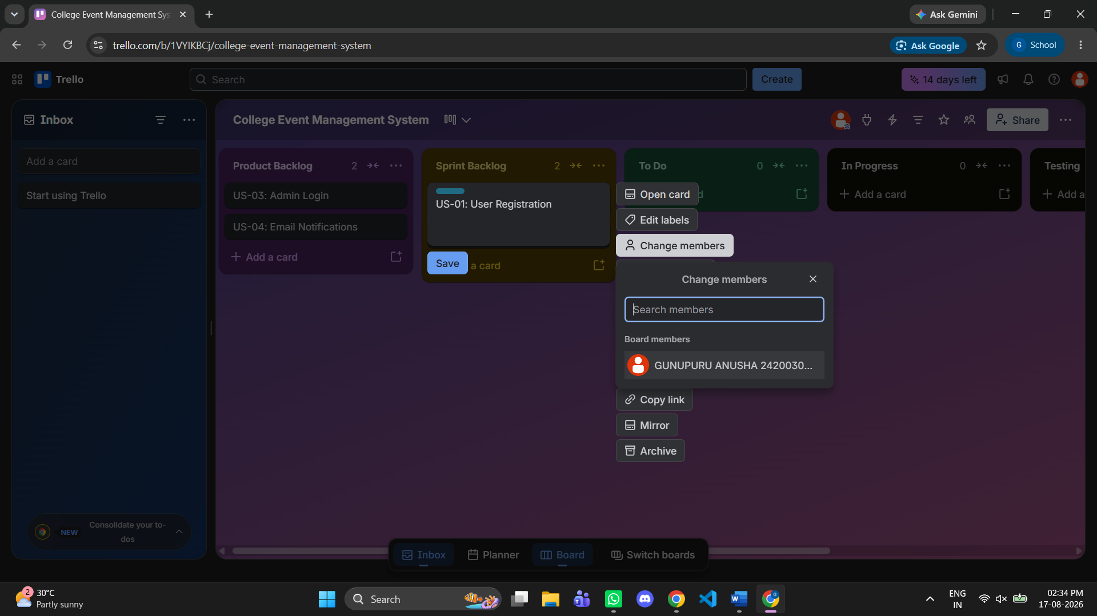

Example
Task | Assigned To
Registration form | Archana
Database setup | Rahul
Validation | Sneha

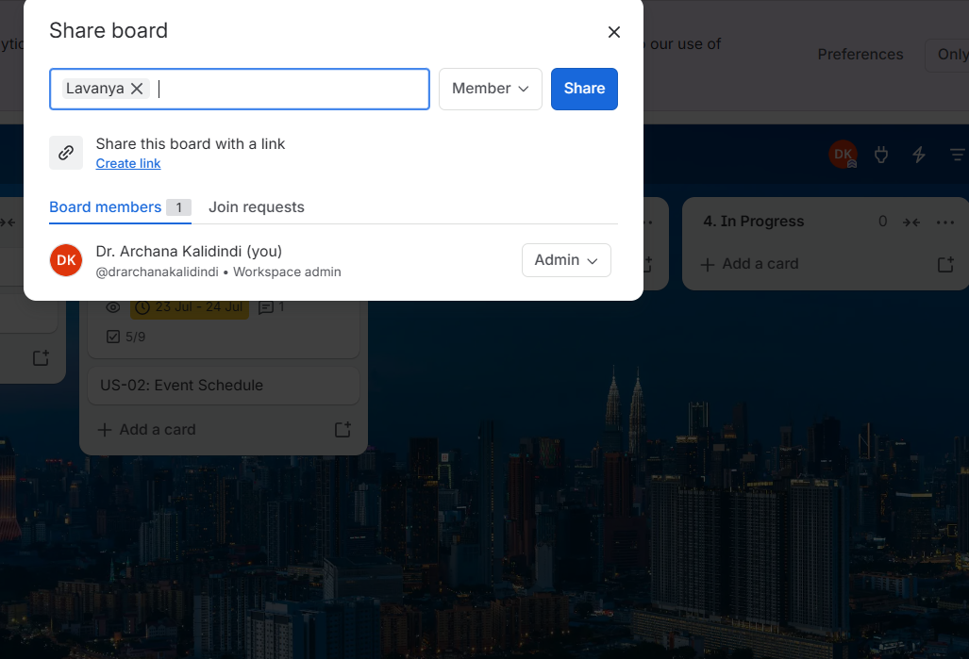

Step 10: Add Labels (priority)
Create these labels:
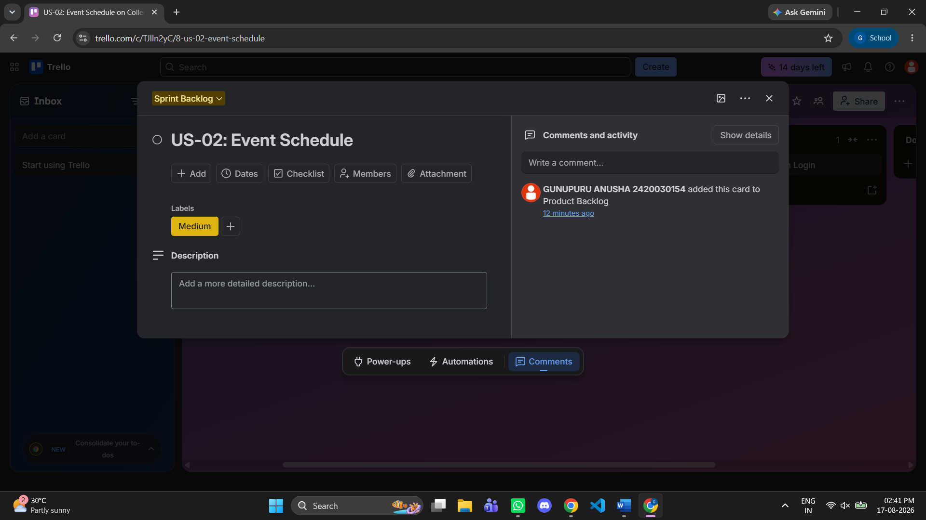
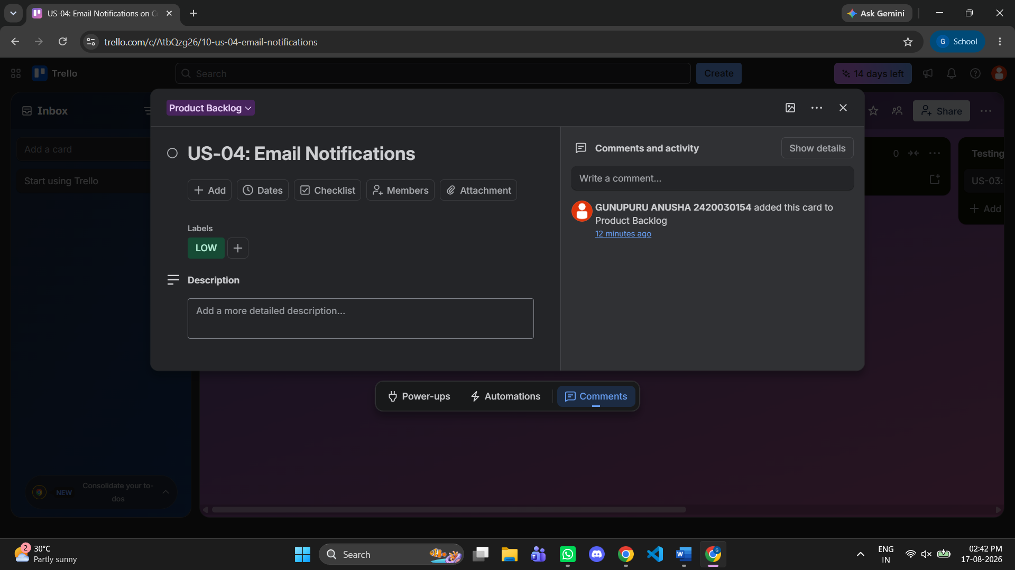
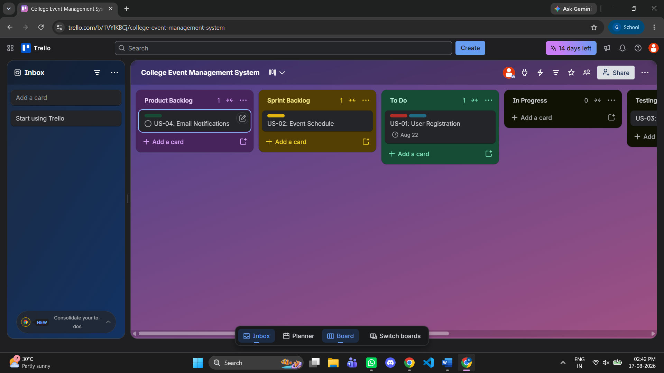

Step 11: Set Due Dates
Inside the card:
- Click Dates.
- Select a due date (for example, 20 July 2026).
- Enable Reminder.
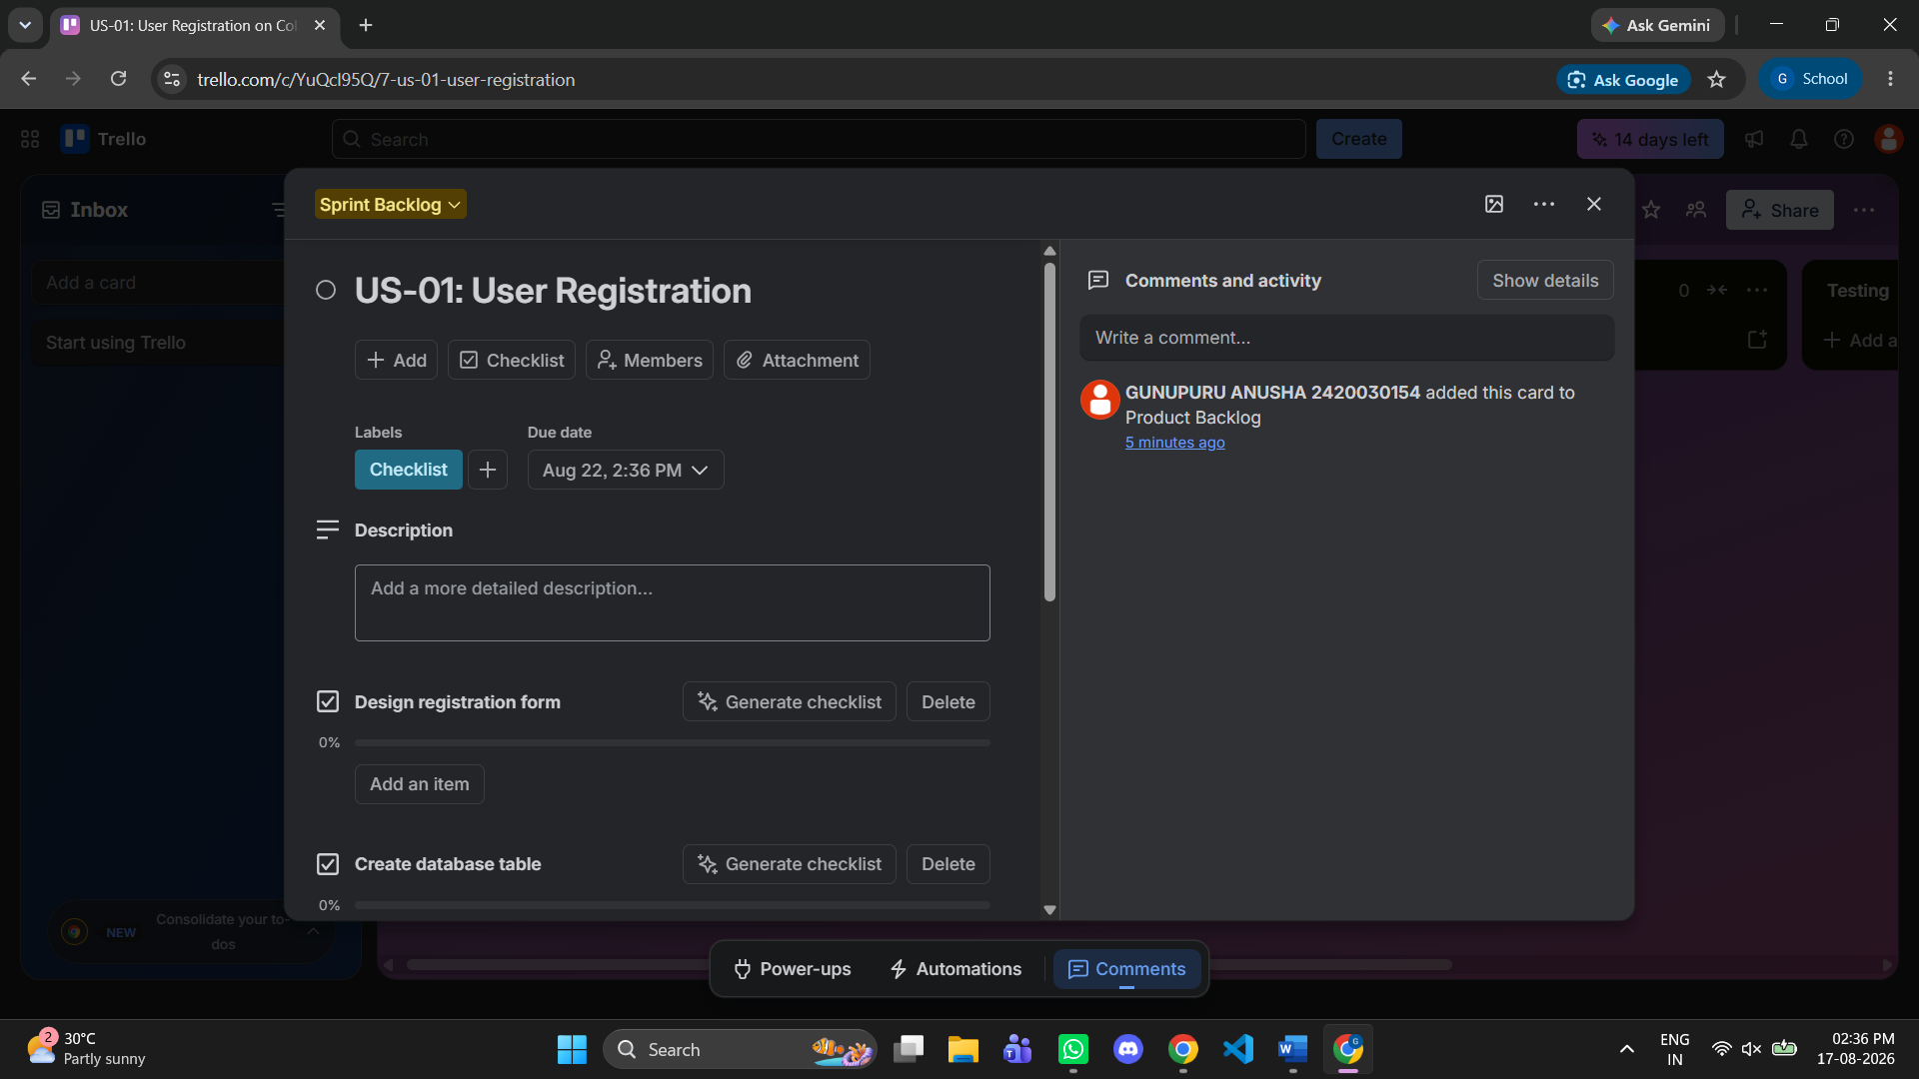

Step 12: Start the Sprint
Move cards through the workflow as work progresses.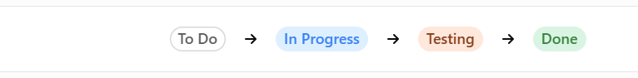
Output:
