Name: ROOPESH CHALASANI
Roll No: 2420030359
Task 2: Case Study
Problem Statement
Choose a real-world case study such as a Hotel Management System, create user stories, select an appropriate software development process model, identify a suitable programming language, and propose an implementation and evaluation strategy.
Real-World Case Study
Hotel Management System
A Hotel Management System (HMS) is a software application designed to simplify and automate the daily operations of a hotel. It enables guests to book rooms online, check room availability, make secure payments, and manage reservations efficiently. Hotel staff can handle check-in/check-out processes, room allocation, housekeeping, billing, and customer records, while administrators can monitor hotel operations, manage employees, and generate reports for better decision-making.

1. Functional Requirements
Guest
- Register and Login
- Search available rooms
- View room details
- Book hotel rooms
- Cancel or modify reservations
- Make online payments
- View booking history
- Track booking status
- Submit ratings and reviews
- Receive booking confirmations
Receptionist
- Login securely
- Manage guest check-in
- Manage guest check-out
- Allocate rooms
- Update room availability
- Generate bills
- Handle customer inquiries
Admin
- Manage hotel rooms
- Manage room categories
- Update room availability
- Manage customer records
- Manage staff information
- Generate occupancy reports
- Generate revenue reports
- Manage discounts and offers
Housekeeping Staff
- Login securely
- View assigned rooms
- Update room cleaning status
- Report maintenance issues

2. User Stories
User ID | User Story | Priority
US-01 | As a guest, I want to register so that I can book hotel rooms online. | High
US-02 | As a guest, I want to log in securely to access my bookings. | High
US-03 | As a guest, I want to search rooms based on availability and room type. | High
US-04 | As a guest, I want to book a hotel room online. | High
US-05 | As a guest, I want to modify or cancel my reservation. | Medium
US-06 | As a guest, I want to make secure online payments. | High
US-07 | As a guest, I want to view my booking history. | Medium
US-08 | As a guest, I want to rate my hotel stay. | Medium
US-09 | As an admin, I want to manage hotel rooms and room categories. | High
US-10 | As an admin, I want to manage customer records. | High
US-11 | As an admin, I want to generate occupancy and revenue reports. | Medium
US-12 | As a receptionist, I want to manage guest check-in and check-out. | High
US-13 | As a housekeeping staff member, I want to update room cleaning status. | High
US-14 | As a housekeeping staff member, I want to report maintenance issues. | Medium

3. Selected Software Development Process Model
Agile Scrum
Reason for Selection
- Hotel requirements may change based on customer feedback.
- New services and room types can be added continuously.
- Faster implementation of new features.
- Continuous testing and bug fixing.
- Regular customer and staff feedback.
- Suitable for both web and mobile hotel management applications.
Sprint Plan
Sprint | Features
Sprint 1 | User Registration & Login
Sprint 2 | Room Management & Search
Sprint 3 | Room Booking & Reservation
Sprint 4 | Check-in, Check-out & Billing
Sprint 5 | Online Payment & Notifications
Sprint 6 | Admin Dashboard & Report Management
Sprint 7 | Housekeeping & Maintenance Module
Sprint 8 | Testing & Deployment

4. Programming Language Selection
Backend
Java (Spring Boot)
Reasons
- Secure
- Scalable
- High Performance
- REST API Development
- Easy Database Integration
- Suitable for Enterprise Applications
Frontend
- HTML5
- CSS3
- JavaScript
- React.js
Database
- MySQL
Other Technologies
- REST API
- JWT Authentication
- Razorpay / Stripe Payment Gateway
- Email Notification Service
- Git & GitHub
- Docker
- AWS Cloud

5. System Architecture

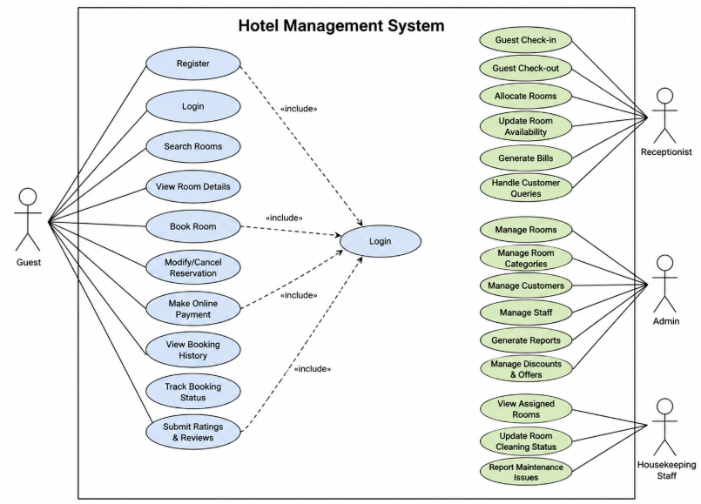

6. Implementation Strategy
Phase 1 – Requirement Analysis
- Gather guest, receptionist, admin, and housekeeping requirements.
- Create Software Requirement Specification (SRS).
- Identify functional and non-functional requirements.
- Prepare Use Case Diagrams.

Phase 2 – System Design
- Design database schema.
- Design user interface (UI) wireframes.
- Create UML diagrams.
- Develop system architecture.
- Design room booking and billing workflow.

Phase 3 – Development
- Implement user registration and authentication.
- Develop room search and booking module.
- Create reservation management.
- Implement check-in and check-out process.
- Integrate online payment gateway.
- Develop billing system.
- Build admin dashboard.
- Develop housekeeping management module.

Phase 4 – Testing
Unit Testing
- User Registration
- Login
- Room Search
- Room Booking
- Online Payment
Integration Testing
- Booking + Payment
- Reservation + Room Availability
- Billing + Check-out
- Housekeeping + Room Status
System Testing
- Complete Hotel Management System Testing
- Performance Testing
- Compatibility Testing
User Acceptance Testing (UAT)
- Verify guest requirements.
- Verify hotel staff workflows.
- Collect user feedback before deployment.

Phase 5 – Deployment
- Docker Container
- AWS EC2
- MySQL Database
- Nginx Web Server
- Cloud Deployment and Monitoring

7. Evaluation Strategy
Evaluation Parameter | Method
Functional Accuracy | Requirement verification
Performance | Load testing using JMeter
Security | Authentication and penetration testing
Reliability | Continuous monitoring
Usability | User feedback survey
Scalability | Concurrent user testing
Maintainability | Code review and documentation
Room Availability Accuracy | Verify room status after every booking
Booking Efficiency | Measure reservation processing time
Billing Accuracy | Verify invoice generation and payment records

8. Expected Outcomes
- Secure hotel room booking platform.
- Fast room search and reservation process.
- Reliable room allocation and booking management.
- Accurate room availability updates.
- Secure online payment system.
- Efficient check-in and check-out management.
- Improved housekeeping coordination.
- Better customer satisfaction through smooth hotel services.
- Scalable architecture for future hotel expansion.
- Easy management of rooms, bookings, staff, and reports by the administrator.

