SALES/DEMAND FORECASTING SYSTEM

A Project Report Submitted in the partial fulfillment of the requirements for the award of the degree of

BACHELOR OF TECHNOLOGY
In

DEPARTMENT OF CSE
By
Roopesh | :2420030359
Deepthi Anusha | :2420030448
Vyshnavi | :2420030449

Under the Esteemed Guidance of

Dr. N. SUNANDA
Associate Professor
Department of CSE

AY-2026-27




K L (Deemed to be) University
DEPARTMENT OF COMPUTER SCIENCE AND ENGINEERING

Declaration

The Project Report entitled “SALES/DEMAND FORECASTING SYSTEM” is a record of bonafide work of Roopesh – 2420030359, Deepthi Anusha – 2420030448 and Vyshnavi – 2420030449 submitted in partial fulfillment for the award of B. Tech in Computer Science and Engineering to K L University. The results embodied in this report are based on the design and development work carried out for the project.

Roopesh – 2420030359
Deepthi Anusha- 2420030448
Vyshnavi -2420030449

K L UNIVERSITY
DEPARTMENT OF COMPUTER AND SOFTWARENGINEERING

CERTIFICATE

This is to certify that the mini project based report entitled “SALES/DEMAND FORECASTING SYSTEM” is a bonafide work done and submitted by Roopesh – 2420030359, Deepthi Anusha – 2420030448 and Vyshnavi – 2420030449 in partial fulfillment of the requirements for the award of the degree of BACHELOR OF TECHNOLOGY in Computer Science and Engineering, K L (Deemed to be) University, during the academic year 2026-2027.

Signature of the Guide

Signature of the Course Coordinator Signature of the HOD

ACKNOWLEDGEMENT
The successful completion of this project would not have been possible without the timely help, support and guidance rendered by many people. We express our sincere thanks to everyone who assisted us directly or indirectly during the development of the Sales/Demand Forecasting System.

We express our deepest appreciation to our Course Coordinator and project guide for their valuable suggestions, continuous encouragement and guidance throughout the planning, implementation and documentation of this project.

We are grateful to the Head of the Department of Computer Science and Engineering and the university for providing the facilities and academic environment required to complete this project successfully.

We thank all teaching and non-teaching staff members, our teammates, friends and classmates for their cooperation. Finally, we sincerely thank our parents for their constant encouragement and support throughout the project.

Roopesh – 2420030359
Deepthi Anusha- 2420030448
Vyshnavi -2420030449

Abstract
Sales and demand forecasting is an important activity for businesses because it helps estimate future sales using previously observed data. Accurate forecasts support better planning, budgeting and operational decisions. However, analysing historical sales manually can be time-consuming and may not reveal patterns such as trends and seasonal variations.

The Sales/Demand Forecasting System is developed as a web-based application that allows users to work with historical date-wise sales data and generate forecasts. The system uses time-series forecasting techniques, mainly ARIMA and Prophet, and presents the forecast results through a dashboard. It also provides model evaluation measures so that users can compare forecasting performance.

The application is implemented with a React and TypeScript frontend and a Python FastAPI backend. The forecasting workflow prepares the date and sales data, trains the selected forecasting models, generates future predictions and displays the results. In the evaluated dataset, Prophet produced lower error values than ARIMA. The system is intended as a decision-support tool; forecasts are estimates and should be interpreted along with business knowledge.

Index
S. No. | Chapters | Topics | Page.no
 |  | Acknowledgement
 |  | Abstract
1 | Introduction | 1.1 Motivation1.2 Objective1.3 Scope of the project1.4 Importance of the application1.5 Target users / audience | 1-10
2 | Software Requirement | 2.1 Problem statement.2 Technologies used 2.3 Forecasting models .4 Development software | 11-20
3 | Software Design | 3.1 System architecture .2 Data flow diagram .3 Frontend and backend interaction | 21-30
4 | Implementation and User Interface | 4.1 Application page details.2 Detailed description of pages .3 Forecasting models and results | 31-42
5 | Conclusion and Future Aspects | 5.1 Conclusion\n5.2 Future aspects | 43-45
6 | Bibliography | References, frameworks, libraries and documentation used | 46
7 | Appendices | 7.1 Dashboard styling.2 Frontend structure7.3 Forecast workflow7.4 Model evaluation outputs7.5 Installation and execution notes | 47-55

CHAPTER 1
Introduction

  - Motivation

The main motivation of the Sales/Demand Forecasting System is to simplify the process of analysing historical sales and estimating future demand. Businesses need reliable estimates to plan operations, allocate resources and make informed decisions. A visual forecasting application makes time-series analysis easier to access and understand.

  - Objective
The objective of the Sales/Demand Forecasting System is to develop a web-based application that accepts historical date-wise sales data, applies ARIMA and Prophet forecasting methods, generates future sales estimates and displays the results in an understandable dashboard. The system also compares model performance using MAE, RMSE and MAPE to help users evaluate forecast accuracy.
1.3 Scope of the Project
The project focuses on time-series forecasting using historical records containing dates and corresponding sales values. Users can provide or load the sales data, select a forecasting approach and view predicted values through the application. The scope includes data preparation, model execution, forecast visualization and evaluation of forecasting errors.

The application separates the user interface from the forecasting service. The React and TypeScript frontend is responsible for presenting the dashboard and collecting user interactions, while the FastAPI backend handles requests and executes the forecasting logic using Python libraries.
The current implementation works with aggregate date-wise sales data. It does not include product-level identifiers or customer-level information; therefore, it does not claim product-specific forecasts. The results depend on the quality, quantity and consistency of the historical data supplied.

1.4 Importance of the Application
Sales forecasting helps organizations estimate likely future sales from historical observations. These estimates can support purchasing, staffing, budgeting and operational planning. A forecasting dashboard makes the analysis easier to review by presenting predicted values and model performance in a visual
The use of time-series models helps identify patterns in historical data that may be difficult to observe manually. Comparing more than one forecasting model also gives users a basis for understanding how different methods perform on the same dataset
The system is useful as a learning and decision-support application for students, analysts and small business users who want to explore sales trends and generate forecasts without manually implementing forecasting algorithms.

1.5 Target Users / Audience
The intended users include students learning time-series forecasting, business analysts who review sales trends and small business users who maintain historical sales records. The application is designed for users who need a clear interface for generating and interpreting forecasts
The forecasts should be treated as estimates rather than guaranteed future sales. Their usefulness depends on representative historical data and suitable model settings. External factors such as promotions, market changes and unexpected events are not automatically known to the current system.

CHAPTER 2
Software Requirement

2.1 Problem Statement
Businesses often maintain historical sales records but may find it difficult to estimate future sales manually. Spreadsheet-based calculations can become time-consuming, especially when users need to compare forecasting methods and evaluate their accuracy. The project addresses this problem by providing a web application that processes date-wise sales data, applies time-series forecasting models and presents the predictions and evaluation results in a dashboard.
  - Technologies Used

- React is a JavaScript library used to build the frontend user interface. In this project, React with TypeScript is used to create reusable dashboard components, manage application state and display forecast information. TypeScript adds type checking that helps organize the frontend code.
Frontend responsibilities:
1. Display the Sales/Demand Forecasting dashboard. Allow users to interact with the forecasting workflow. Present historical sales and forecast values. Display model comparison metrics and visualizations.

- FastAPI is a Python framework used to develop the backend API. It receives requests from the frontend, validates input data and connects the user interface to the forecasting logic. Python is used because it provides libraries suitable for data processing and time-series analysis.The backend prepares the date-wise sales series and executes the selected forecasting method. It returns forecast values and evaluation information in a structured response that can be consumed by the frontend dashboard.

Forecasting Models:
ARIMA (AutoRegressive Integrated Moving Average) is a statistical time-series model that uses past observations, differencing and moving-average terms to model temporal patterns. It is used in this project to generate future sales estimates from historical sales values.
Prophet is a time-series forecasting procedure designed to model trend and seasonality. It is used as a second forecasting approach so that its predictions and error measures can be compared with those produced by ARIMA.
Model evaluation is carried out using Mean Absolute Error (MAE), Root Mean Squared Error (RMSE) and Mean Absolute Percentage Error (MAPE). Lower values indicate smaller prediction errors on the evaluated test data. These metrics help compare models but do not guarantee future performance.
Python data-analysis libraries support the forecasting workflow. The backend uses the relevant time-series and data-processing packages to prepare the input series, fit the forecasting models and calculate evaluation metrics. The exact package versions depend on the project environment.
  - Development Software
Visual Studio Code / PyCharm can be used as development environments for editing and running the frontend and backend code. The frontend is developed with React and TypeScript, while the backend is developed in Python using FastAPI.
The project is organized into separate frontend and backend parts. The frontend communicates with the backend through HTTP API requests. The backend performs data preparation, model execution and evaluation, then sends the results back to the frontend for display.

CHAPTER 3
Software Design

3.1 DFD
A system architecture diagram represents the main components of the application and the flow of information between them. In the Sales/Demand Forecasting System, the user interacts with the React frontend, which sends the sales data and forecasting request to the FastAPI backend. The backend processes the data, runs the selected model and returns the forecast and evaluation results.

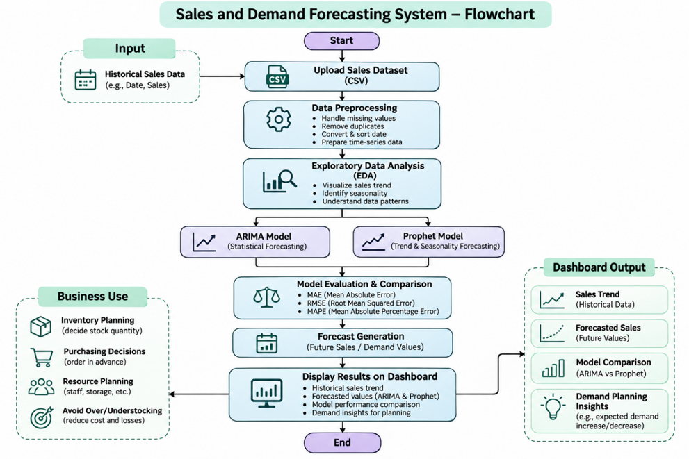

CHAPTER 4
Implementation and User Interface
4.1 Application Page Details
- Dashboard
- Sales Data Input
- Forecasting Model Selection (ARIMA / Prophet)
- Forecast Visualization
- Model Evaluation and Comparison

4.2 Detailed Description of Pages
1. Dashboard: The dashboard provides the main interface of the Sales/Demand Forecasting System. It presents the forecasting workflow and gives users access to the available features in one place.

2. Sales Data and Forecasting: The user supplies historical date-wise sales values and selects the forecasting method. The backend processes the input series and generates the requested future estimates using the selected time-series model.

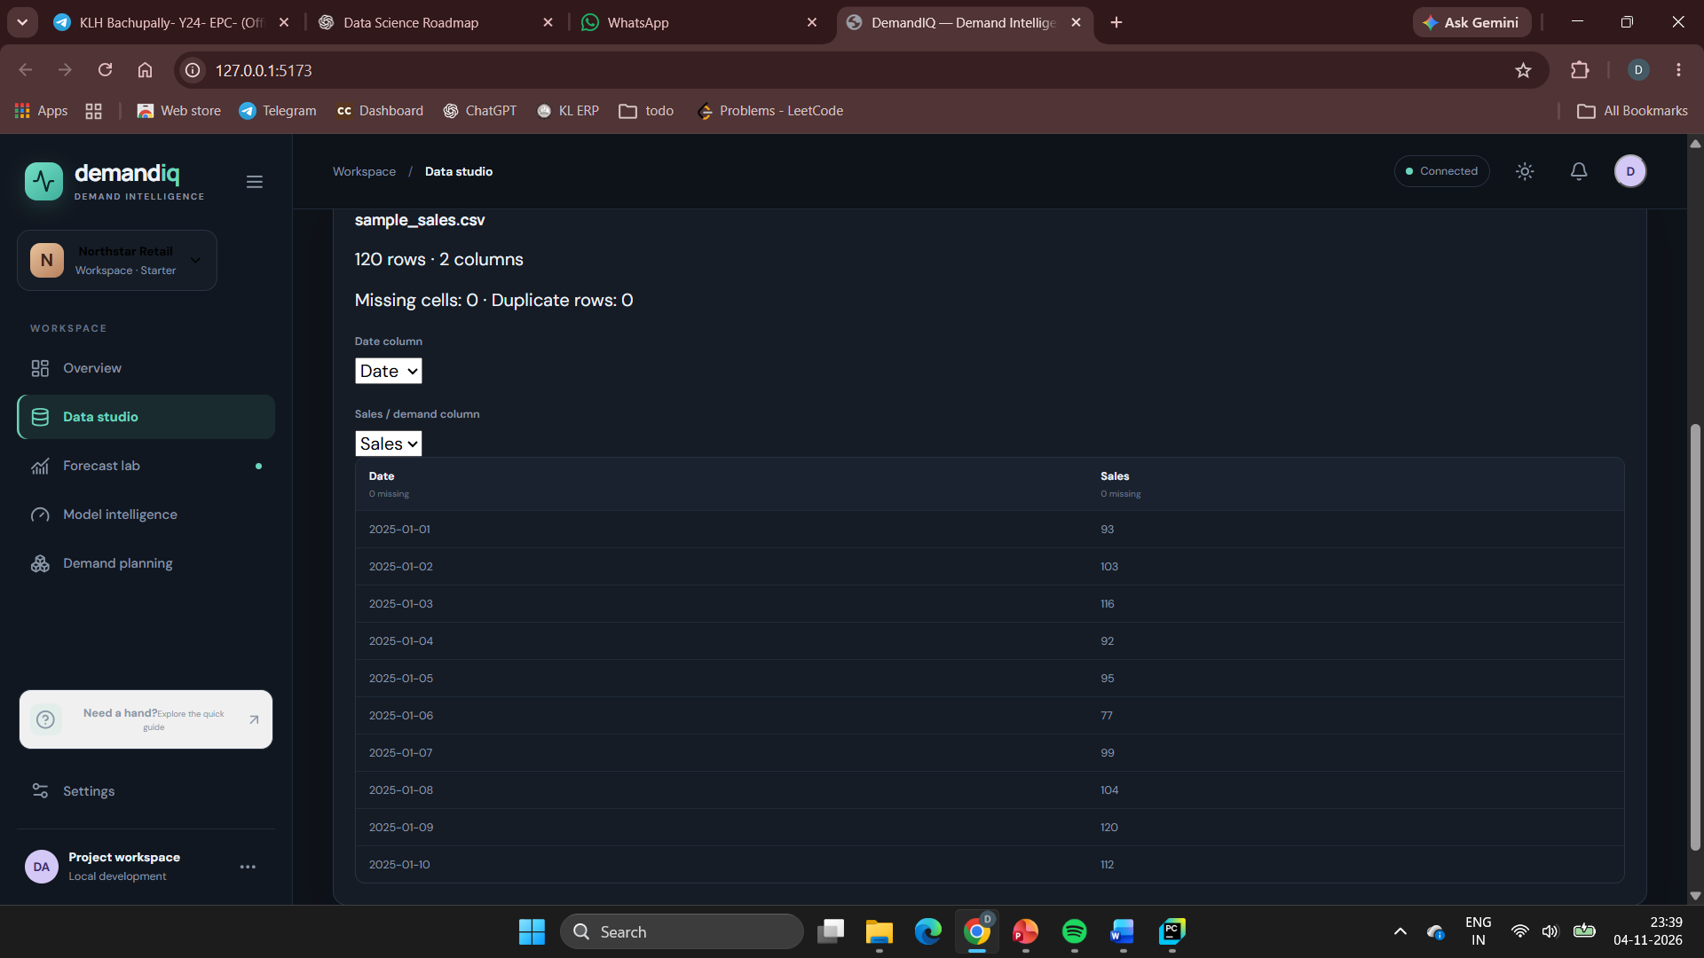

Fig No. 4.2 Forecasting Results
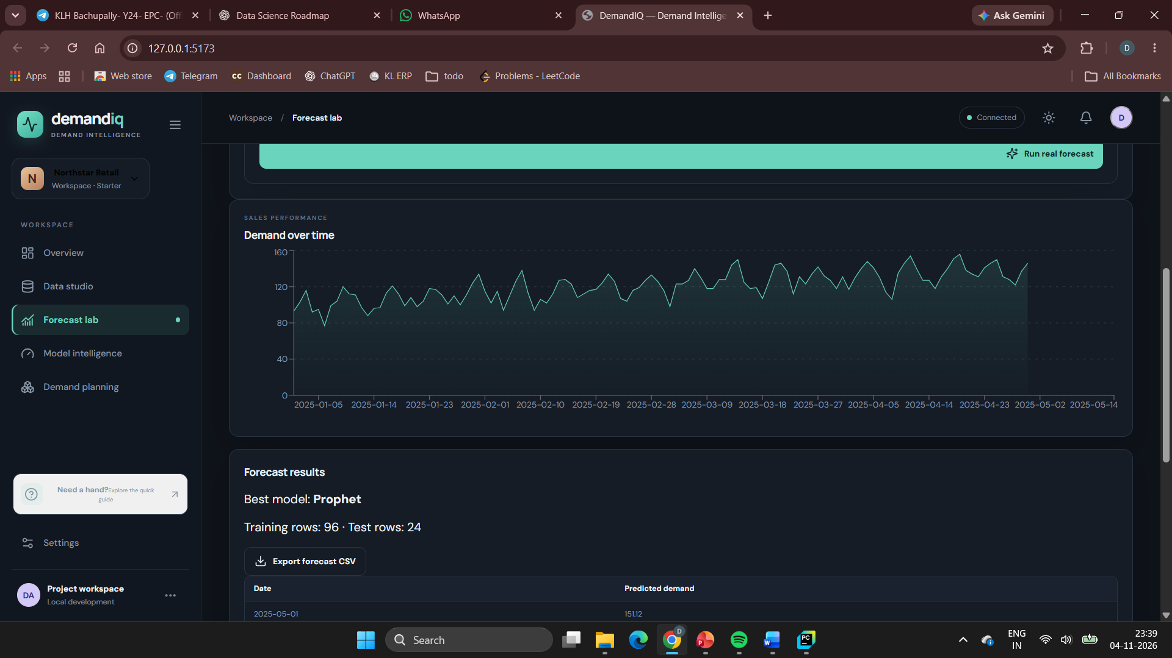

3. Forecast Visualization: The generated forecast is presented through visual elements so that users can understand the relationship between historical sales and predicted future values. The visualization helps identify the expected direction and pattern of sales over the forecast horizon.
4. Model Evaluation: The application displays error metrics for the forecasting models. For the evaluated dataset, ARIMA achieved MAE 19.81, RMSE 24.14 and MAPE 13.09%, while Prophet achieved MAE 16.99, RMSE 19.49 and MAPE 11.45%. Prophet therefore recorded lower errors on this test period.

Fig No. 4.4 Model Comparison

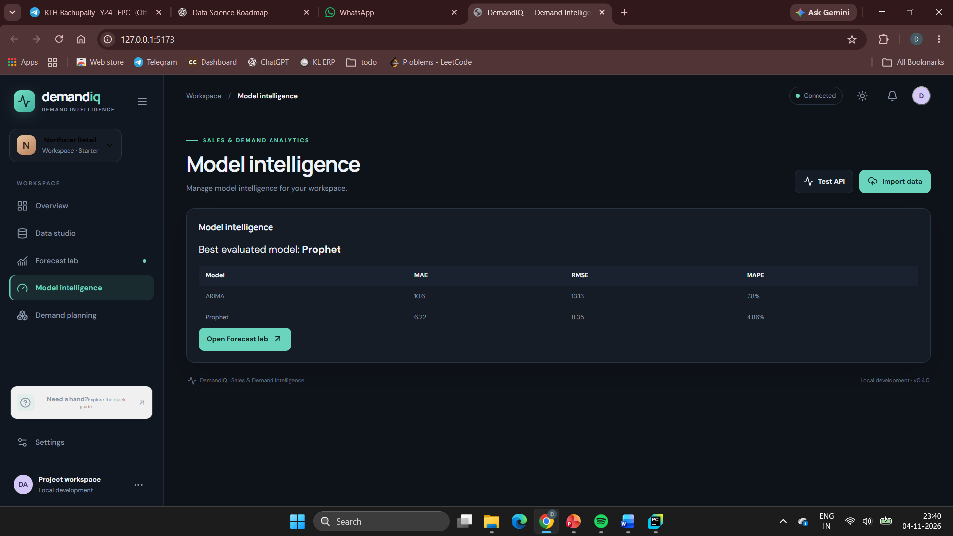

CHAPTER 5

Conclusion and Future Aspects

5.1 Conclusion
The Sales/Demand Forecasting System was developed as a web-based application for analysing historical date-wise sales data and generating future sales estimates. The project integrates a React and TypeScript frontend with a Python FastAPI backend and implements ARIMA and Prophet forecasting methods. Forecast results and model evaluation measures are presented through a dashboard, making the analysis easier to understand.
5.2 Future Aspects
- The system can be extended to support larger datasets and configurable forecast horizons.
- Additional forecasting models and automated model selection can be introduced to improve comparison and usability.
- Future versions can include product-wise data, database storage, user authentication and deployment on a hosting platform, subject to the availability of suitable data and infrastructure.
CHAPTER 6
Bibliography

[1] Taylor and Letham, Forecasting at Scale (2018).
[2] Hyndman and Khandakar, Automatic Time Series Forecasting: The forecast Package for R (2008).
[3] Performance of State Space and ARIMA Models for Consumer Retail Sales Forecasting (2015).
[4] Alon, Qi, and Sadowski, Forecasting Aggregate Retail Sales (2001).
[5] Ma and Fildes, Retail Sales Forecasting with Meta-Learning (2021).
[6] Retail Demand Forecasting: A Comparison between Deep Neural Network and Gradient Boosting Method for Univariate Time Series (2019).
[7] Hasan et al., A Comparative Study on Forecasting of Retail Sales (2022).
[8] Haque et al., Retail Demand Forecasting: A Comparative Study for Multivariate Time Series (2023).
[9] Makridakis et al., M5 Accuracy Competition: Results, Findings, and Conclusions (2022).
[10] Fildes, Kolassa, and Ma, Post-script—Retail Forecasting: Research and Practice (2022).

CHAPTER 7

Appendices

7.1 CSS
- /* Forecast dashboard layout styles */
- .dashboard {
- display: grid;
- grid-template-columns: 1fr 1fr;
- gap: 20px;
- padding: 24px;
- background: #f5f7fa;
- }
- }

- /* Forecast result panel */
- .forecast-panel {
- background: white;
- border-radius: 8px;
- padding: 20px;
- color: #202938;
- }

- /* Metric card styling */
- .metric-card
- {
- margin: 12px;
- background: white;
- text-align: center;
- min-height: 120px;
- font-size: 16px;
- overflow: hidden;
- border-radius: 10px;
- }
- }
- /* Styling for forecast information */

- .forecast-info{
- color: #202938;
- }

- /* Styling for chart and comparison section */

- .chart-section
- {
- margin: 12px;
- min-height: 300px;
- font-size: 16px;
- overflow: hidden;
- }

- .comparison-panel{
- margin: 20px;
- background: white;
- color: #202938;
- max-height: 950px;
- font-size: 16px;
- overflow: hidden;
- border-radius: 10px;
- }
- }
7.2 HEAD
- <!DOCTYPE html>
- <html lang="">
- <head>
- <meta charset="utf-8">
- <meta name="viewport" content="width=device-width, initial-scale=1.0">
- <title>Sales/Demand Forecasting System</title>
- <link rel="stylesheet" href="https://stackpath.bootstrapcdn.com/bootstrap/4.3.1/css/bootstrap.min.css" integrity="sha384-ggOyR0iXCbMQv3Xipma34MD+dH/1fQ784/j6cY/iJTQUOhcWr7x9JvoRxT2MZw1T" crossorigin="anonymous">
- <script src="https://code.jquery.com/jquery-3.2.1.slim.min.js" integrity="sha384-KJ3o2DKtIkvYIK3UENzmM7KCkRr/rE9/Qpg6aAZGJwFDMVNA/GpGFF93hXpG5KkN" crossorigin="anonymous"></script>
- <script src="https://cdnjs.cloudflare.com/ajax/libs/popper.js/1.12.9/umd/popper.min.js" integrity="sha384-ApNbgh9B+Y1QKtv3Rn7W3mgPxhU9K/ScQsAP7hUibX39j7fakFPskvXusvfa0b4Q" crossorigin="anonymous"></script>
- <script src="https://maxcdn.bootstrapcdn.com/bootstrap/4.0.0/js/bootstrap.min.js" integrity="sha384-JZR6Spejh4U02d8jOt6vLEHfe/JQGiRRSQQxSfFWpi1MquVdAyjUar5+76PVCmYl" crossorigin="anonymous"></script>
7.3 Navigation Bar

- <!-- Code for Navigation Bar-->
- <nav class="navbar navbar-expand-lg navbar-light bg-info navbar-dark">
- <a class="navbar-brand" href="#">Sales Forecasting</a>
- <button class="navbar-toggler" type="button" data-toggle="collapse" data-target="#navbarSupportedContent" aria-controls="navbarSupportedContent" aria-expanded="false" aria-label="Toggle navigation">
- <span class="navbar-toggler-icon"></span>
- </button>

- <div class="collapse navbar-collapse" id="navbarSupportedContent">
- <ul class="navbar-nav mr-auto">
- <li class="nav-item active">
- <a class="nav-link" href="#">Dashboard <span class="sr-only">(current)</span></a>
- </li>
- <li class="nav-item">
- <a class="nav-link" href="#">Forecast Lab</a>
- </li>
- <li class="nav-item dropdown">
- <a class="nav-link dropdown-toggle" href="#" id="navbarDropdown" role="button" data-toggle="dropdown" aria-haspopup="true" aria-expanded="false">
- Models
- </a>
- <div class="dropdown-menu" aria-labelledby="navbarDropdown">
- <a class="dropdown-item" href="#">ARIMA Forecast</a>
- <a class="dropdown-item" href="#">Prophet Forecast</a>
- <div class="dropdown-divider"></div>
- <a class="dropdown-item" href="#">Model Comparison</a>
- </div>
- </li>
- </ul>
- <form class="form-inline my-2 my-lg-0">
- <input class="form-control mr-sm-2" type="search" placeholder="Search" aria-label="Search">
- <button class="btn btn-outline-success my-2 my-sm-0" type="submit">Search</button>
- </form>
- </div>
- </nav>

7.4 Carousel Card
- <!-- Body Section for Image Carousel -->

- <div id="carouselExampleIndicators" class="carousel slide" data-ride="carousel">
- <ol class="carousel-indicators">
- <li data-target="#carouselExampleIndicators" data-slide-to="0" class="active"></li>
- <li data-target="#carouselExampleIndicators" data-slide-to="1"></li>
- <li data-target="#carouselExampleIndicators" data-slide-to="2"></li>
- </ol>
- <div class="carousel-inner">
- <div class="carousel-item active">
- <img class="d-block w-100" src="../Image/costa.jpg" height="450" width="80%" alt="First slide">
- </div>
- <div class="carousel-item">
- <img class="d-block w-100" src="../Image/food3.jpg" height="450" width="80%" alt="Second slide">
- </div>
- <div class="carousel-item">
- <img class="d-block w-100" src="../Image/food5.jpg" height="450" width="80%" alt="Third slide">
- </div>
- </div>
- <a class="carousel-control-prev" href="#carouselExampleIndicators" role="button" data-slide="prev">
- <span class="carousel-control-prev-icon" aria-hidden="true"></span>
- <span class="sr-only">Previous</span>
- </a>
- <a class="carousel-control-next" href="#carouselExampleIndicators" role="button" data-slide="next">
- <span class="carousel-control-next-icon" aria-hidden="true"></span>
- <span class="sr-only">Next</span>
- </a>
- </div>
7.5 Description About the Page
- <div class="container">
- <div class="row">
- <div class="col-md-12">
- <div class="description">
- <h5><p>
- The Sales/Demand Forecasting System helps users analyse historical sales records and estimate future sales using time-series forecasting. The dashboard brings the data input, forecasting workflow and results together in a single interface.
- Historical date-wise sales values are processed by the backend before the selected forecasting model is executed. ARIMA and Prophet provide alternative approaches to modelling the time series. The system presents predicted values so that users can review the expected sales pattern over the selected forecast horizon.
- Model performance is evaluated using MAE, RMSE and MAPE on the available test period. These measures help users compare the errors produced by the models. The current dataset contains aggregate date and sales values, so the application does not produce product-level or customer-level predictions.
- The application is intended to support learning and planning by making forecasting results easier to generate and interpret. Users should consider the quality of the input data and real-world business conditions when using the estimates.
- </p>
- </h5>

- </div>
- </div>
- </div>
- <!-- End of div tag for container class(description )-->
- </div>

4.2 Forecasting Models and Results
- <div class="container" >
- <div class="row">

- <div class="col-md-4">
- <div class="customdiv">
- <div class="info"><p>ARIMA Forecast<br>Statistical time-series model<br>Uses historical sales values<br>Models autoregression, differencing and moving average<br>
- <q>Generates future sales estimates from the historical series.</q><br></p></div>
- <div class="img">
- <img src="https://media-cdn.tripadvisor.com/media/photo-s/13/6d/67/99/two21-cafe-speedmart.jpg" height="160" width="200" style="border-radius:8px;margin-top: 8px;box-shadow: 3px 3px 3px white " alt="">
- </div>
- </div>
- </div>

- <div class="col-md-4">
- <div class="customdiv">
- <div class="info">
- <p>Prophet Forecast<br>Time-series forecasting model<br>Models trend and seasonality<br>Produces predicted values for future dates<br><q>Useful for analysing trend and seasonal patterns.</q><br></p></div>
- <div class="img">
- <img src="https://content3.jdmagicbox.com/comp/mathura/j4/9999px565.x565.160322114948.g9j4/catalogue/agrawal-restaurant-mathura-bypass-mathura-restaurants-3s2ca.jpg" height="130" width="200" style="border-radius:8px;margin-top: 8px;box-shadow: 3px 3px 3px white " alt="">
- </div>
- </div>
- </div>

- <div class="col-md-4">
- <div class="customdiv">
- <div class="info">
- <p>Model Evaluation<br>MAE, RMSE and MAPE<br>Calculated on the held-out test data<br>Lower error values indicate better fit on this evaluation period<br>
- <q>Metrics support comparison; they do not guarantee future accuracy.</q><br></p>
- </div>
- <div class="img">
- <img src="https://q-cf.bstatic.com/images/hotel/max1024x768/106/106538346.jpg" width="200" style="border-radius:8px;margin-top: 8px;box-shadow: 3px 3px 3px white " alt="">
- </div>
- </div>
- </div>
- <!-- End of the first row of forecasting model cards -->
- </div>

- <!-- Starting of 2nd Row-->
- <div class="row">

- <div class="col-md-4">
- <div class="customdiv">
- <div class="info">
- <p>Historical Sales<br>Date-wise observations<br>Input to the forecasting workflow<br>Used to understand past sales behaviour<br>
- <q>Consistent historical data improves the usefulness of forecasts.</q><br></p>
- </div>
- <div class="img">
- <img src="https://content3.jdmagicbox.com/comp/mathura/k4/9999px565.x565.181017163829.d1k4/catalogue/loft-cafe-mathura-0jnn2fwuu7.jpg" height="170" width="200" style="border-radius:8px;margin-top: 8px;box-shadow: 3px 3px 3px white " alt="">
- </div>
- </div>
- </div>

- <div class="col-md-4">
- <div class="customdiv">
- <div class="info">
- <p>Forecast Horizon<br>Future dates and predicted sales<br>Generated by the selected model<br>Displayed in the results section<br><q>Forecasts are estimates, not confirmed sales.</q><br></p>
- </div>
- <div class="img">
- <img src="https://media-cdn.tripadvisor.com/media/photo-s/12/f1/40/27/4-6-seater-tables.jpg" height="160" width="200" style="border-radius:8px;margin-top: 8px;box-shadow: 3px 3px 3px white " alt="">
- </div>
- </div>
- </div>

- <div class="col-md-4">
- <div class="customdiv">
- <div class="info">
- <p>Comparison Dashboard<br>ARIMA and Prophet results<br>Visual comparison of evaluation metrics<br>Supports model selection<br>
- <q>Compare models on the same test period.</q><br></p>
- </div>
- <div class="img">
- <img src="https://i2.wp.com/viriddesignworks.com/wp-content/uploads/2018/04/cam03_View01.jpg?fit=1200%2C675" width="200" height="140" style="border-radius:8px;margin-top: 8px;box-shadow: 3px 3px 3px white " alt="">
- </div>
- </div>
- </div>
- <!-- End of the Div tag for the next 3 Top Ratted Reastaurant-->
- </div>

7.7 Forecast Request and Result Workflow
- <!-- review centre -->
- <!-- The following section describes the forecast request and returned results -->
- <div class="row">

- <!-- FEEDBACK MATTERS-->
- <div class="col-md-8">

- <div class="review">
- <img ssrc="../Image/feedback-matters.png"s alt=""><br>
- <div class="Form">
- <div class="customdiv2">

- <h3>Forecast Input</h3><br>
- Historical data:

- <input type="text" name="sales_data" placeholder="Date-wise sales values"><br>
- Forecast model:
- <input type="text" name="model" placeholder="ARIMA or Prophet"><br>
- Forecast horizon:
- <input type="text" name="horizon" placeholder="Number of future periods"><br>
- <input type="text" name="metric" value="MAE / RMSE / MAPE">Model evaluation<br>
- <input type="text" name="output" value="Predicted sales values">Forecast output
- <input type="text" name="format" value="Chart / Table">Result presentation<br>
- <!-- Input validation and API request are handled by the frontend/backend implementation -->
- Historical sales series:
- <input type="text" name="date_sales" placeholder="Date, Sales"><br>
- Selected model:
- <input type="text" name="selected_model" placeholder="ARIMA / Prophet"><br>
- Forecast results:<br>
- <textarea name="forecast_result" cols="50" rows="5" placeholder="Predicted values and evaluation results...">
7.8 Model Evaluation and Comparison
- <!-- REVIEW OF THE DAY-->

- <div class="col-md-4">
- <div class="customdiv2">

- <div class="row">
- <div class="col-md-12">
- <img src="../Image/arima_forecast.png" alt="ARIMA forecast chart" height="100%" width="100%">
- </div>
- </div>

- <div class="row">
- <div class="col-md-12">
- <img src="../Image/prophet_forecast.png" alt="Prophet forecast chart" height="100%" width="100%">
- </div>
- </div>

- <div class="row">
- <div class="col-md-12">
- <img src="../Image/model_comparison.png" alt="Model comparison chart" height="100%" width="100%">
- </div>
- </div>

- </div>
- </div>
- </div>
- </div>

- <!-- The Following Code Shows some People review(testimonial)-->
- <div class="customdiv2">
- <h3 class="text-center">SALES FORECASTING MODEL COMPARISON</h3>
- <div class="container">
- <div class="row">
- <div class="col-md-4">

- <p>ARIMA achieved MAE 19.81, RMSE 24.14 and MAPE 13.09% on the evaluated test period.</p><br><br>
- <cite>ARIMA Model</cite>

- </div>

- <div class="col-md-4">

- <p>Prophet achieved MAE 16.99, RMSE 19.49 and MAPE 11.45% on the evaluated test period.</p>

- <cite>Prophet Model</cite>
- </div>

- <div class="col-md-4">

- <p>Prophet recorded lower MAE, RMSE and MAPE than ARIMA for this evaluation. This result applies to the available test dataset and should not be interpreted as a guarantee of future performance.</p>

- <cite>Evaluation Summary</cite>
- </div>
- </div>
- </div>

