**Screenshots of the front end:**

**Login_page:**

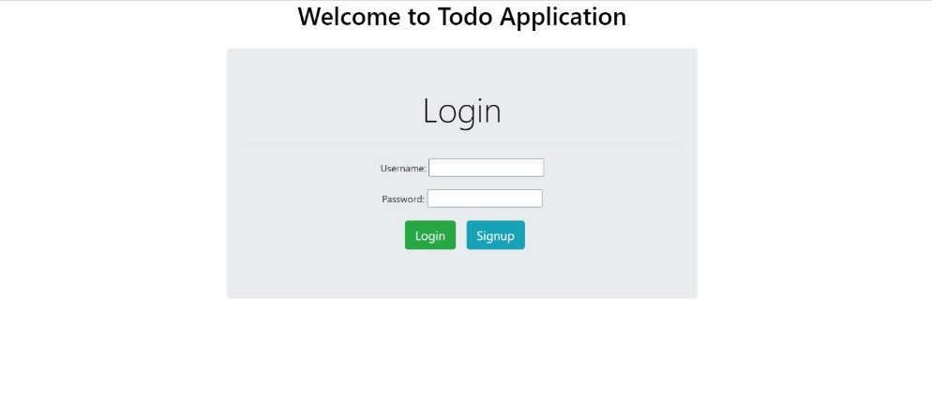

**Signup_page:**

**Homepage:**

**UpdateTask_page:**

**AddTask_page:**

