Smart Aquarium Controller

Roopesh Mathav 22BRS1147 NagaRitesh 22BRS1006

*Abstract*— This project aims to simplify the process of maintaining and monitoring aquariums. Automated operations like temperature, light, and water level monitoring can be performed using the Arduino NANO. The three primary functions of this project are light control, water level monitoring, and temperature monitoring. A feature of Wi-Fi is remote control; the Wi-Fi module serves as a server and connects to the Arduino serial port and a computer via a local Wi-Fi network. Through the personalized website, you can monitor and control the Arduino. You may adjust the light and see the current water temperature and level through the interface. The LCD panel shows the percentage of water level and the temperature reading.

Keywords— Arduino, ESP, LCD, Wi-fi, Temperature, light control, water level monitoring.

##### Introduction

The widespread use of Internet of Things (IoT) technology in recent times has resulted in notable progress in several fields, one of which is environmental monitoring. The implementation of IoT has significant implications for improving the sustainability and management of aquarium habitats within the domain of aquatic ecosystems. In order to do this, a unique method—the Smart Aquarium Controller—is presented in this study.

Aquariums house a variety of flora and wildlife in regulated surroundings, acting as miniature versions of real aquatic ecosystems. However sustaining ideal circumstances in these ecosystems is difficult and needs careful monitoring and control of important factors including water levels, temperature, and the ambient light around the aquarium. Conventional techniques frequently depend on periodic measurements and manual intervention, which allows for human error and unfavorable circumstances.

The integration of IoT technologies into aquarium management offers a paradigm shift, empowering aquarists with real-time data insights and automated control mechanisms. By leveraging sensors, actuators, and connectivity solutions, the Smart Aquarium Controller facilitates continuous monitoring and precise adjustment of environmental variables, thereby promoting the health and well-being of aquatic organisms while minimizing human intervention.

Aquarium controllers have been around since the early 2000s when simple devices were created to automate functions like lighting scheduling and temperature management. Smart aquarium controllers have been around for a while, thanks to developments in sensor technology, wireless communication, and data processing. These controllers can now monitor and manage a variety of factors, such as temperature, pH, salinity, dissolved oxygen, lighting, and fertilizer levels.

Contemporary smart aquarium controllers offer a broad array of functions aimed at improving control, accuracy, and convenience for aquarium hobbyists. These features include

* **Real-time Monitoring:** Sensors continuously measure key parameters, providing users with immediate feedback on the tank's status.
* **Automation:** Controllers can automate tasks such as temperature regulation, lighting scheduling, water changes, and nutrient dosing, reducing manual involvement and ensuring stability.
* **Remote Access:** Many controllers allow users to monitor and adjust settings from any location with an internet connection via web interfaces or mobile apps.
* **Data Logging and Analysis:** Built-in data logging features enable users to track historical trends, identify patterns, and make informed decisions about aquarium maintenance.
* **Notifications and Alerts:** Controllers can notify users of equipment failures, parameter deviations, or other issues that require attention through push notifications or email alerts.

The future of smart aquarium controllers likely includes further integration with advanced technologies such as artificial intelligence (AI), machine learning, and enhanced IoT connectivity. These advancements may enable controllers to predict and prevent issues before they occur, adaptively optimize aquarium conditions based on real-time data, and offer personalized recommendations based on individual user preferences and the specific needs of their aquatic organisms.

Efforts are also expected to focus on reducing costs, improving usability and reliability, and expanding the appeal of smart aquarium controllers to a broader range of enthusiasts.

This study aims to examine the conception, implementation, and evaluation of the Smart Aquarium Controller, highlighting its potential to revolutionize aquarium maintenance practices. Through a comprehensive review of relevant literature, case study analysis, and experimental validation, the paper seeks to elucidate the potential benefits, challenges, and future prospects of IoT-enabled systems in the context of aquatic environment monitoring. The project is designed to be remotely manageable from any location using a PC, smartphone, or other device, reducing labor time by facilitating communication between devices and automating routine or repetitive tasks.

##### overall schematic representation of the proposed work

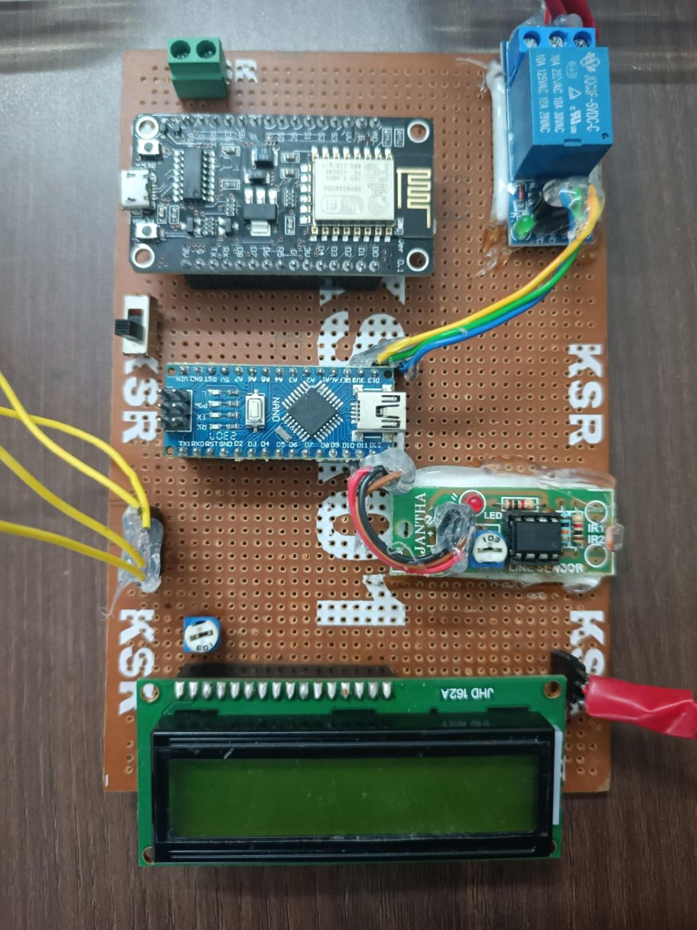

*FIGURE 1: SCHEMATIC REPRESENTATION*

The following is a description of the idea behind the creation of the smart aquarium:

HARDWARE REQUIREMENTS:

* Arduino nano
* Wi-Fi module ESP 8266-01
* DS18B20 digital temperature sensor
* 16x2 LCD
* 5V 1-Channel Relay Module
* Aquarium Lights -LED
* Wires, Resistors, etc.
* Water Level Sensor-2 float switches
* Light Sensor

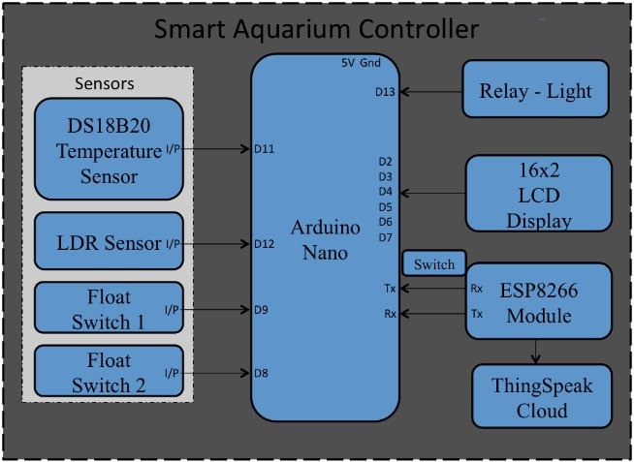

*FIGURE 2: BLOCK DIAGRAM*

* Connect the DS18B20 temperature sensor to the Arduino Nano using the OneWire library.
* Connect the 16x2 LCD to the Arduino Nano using the LiquidCrystal library.
* Connect the 5V 1-Channel Relay Module to control the aquarium lights.
* Connect the water level sensor (2 float switches) to detect the water level.

ESP8266-01 Wi-Fi Module:

* Connect the ESP8266-01 module to the Arduino Nano via UART communication for Wi-Fi connectivity. You can use the Software Serial library to communicate with ESP8266.
* Ensure proper power supply and voltage level conversion (if necessary) for ESP8266-01.

Light Sensor:

* Connect the light sensor to the Arduino Nano to measure ambient light levels.

Relay Light:

* This controls the aquarium lights and other electrical devices in the connection.

##### SYSTEM REALIZATION

Hardware Description:

1. Arduino:

The **Arduino Nano** is an [open-source](https://en.wikipedia.org/wiki/Open-source) breadboard-friendly [microcontroller board](https://en.wikipedia.org/wiki/Single-board_microcontroller) based on the [Microchip](https://en.wikipedia.org/wiki/Microchip_Technology) [ATmega328P](https://en.wikipedia.org/wiki/ATmega328P) [microcontroller](https://en.wikipedia.org/wiki/Microcontroller) (MCU). It has 14 digital input/output pins (6 can be used as PWM outputs). 8 analog inputs, a 16 MHz ceramic resonator, a USB connection, a power jack, an ICSP header, and a reset button.

1. Wi-Fi Module (ESP8266-01):

ESP8266-01 is an ultra-low power WIFI monolithic solution with a micro-processor core within the chip. In other words, only one single chip can achieve the WIFI + microcontroller function. The embedded system features the ubiquitous low-cost 32-bit ESP8266 System-on-chip (SoC) module interfaced with some sensors and actuators for interaction at home. The Wi-Fi module transforms the system into a server, connecting to the Arduino NANO via a local Wi-Fi network. This establishes a bridge for users to access and control the aquarium remotely.

1. Temperature Sensor:

The Temperature Sensor senses the temperature inside the aquarium. The DS18B20 is a 1-wire programmable Temperature sensor from Maxim integrated. It is widely used to measure temperature in hard environments like chemical solutions, mines, soil, etc. The constriction of the sensor is rugged and also can be purchased with a waterproof option making the mounting process easy.

The proposed system uses a temperature sensor DS182B0. We used an Arduino DS18B20, the waterproof temperature sensor shown in Fig. Operates within ±0.5°C, -10°C to +100°C. [3]

1. LCD Display:

The incorporation of a 16x2 LCD panel within the Smart Aquarium Controller architecture serves as a pivotal component for providing real-time feedback to aquarists regarding crucial parameters, particularly the percentage of water level within the aquarium because every aquarium is not see-through. This local display interface offers immediate visual feedback, enabling aquarists to quickly assess the current state of the aquarium environment without the need for external devices or interfaces.

1. LED Lights:

Certain fish and algae will not develop as naturally in the smart aquarium due to the dark atmosphere. It also has an impact on the aquarium's general look. The viability, development, and performance of the fish will all be impacted by too bright or dark lighting. Worse, it can result in the loss of and reduction in the original worth of the brighter marks on their bodies. As a result, the system will employ an LED strip to adjust the light to the proper value in aquarium situations for various fish species.

1. LDR Sensor:

An LDR (Light Dependent Resistor) sensor in an Internet of Things (IoT) smart aquarium controller tracks ambient light levels to control artificial lighting, replicate day-night cycles, save energy, manage algae growth, send out anomaly alerts, and record data for analysis—all of which contribute to maintaining a stable and healthy aquatic environment.

1. Float Switches:

Float switches can detect water levels within the aquarium. This information is crucial for ensuring that the water level remains within safe parameters for the health of aquatic organisms. The float switches are measured in bits (0 and 1) to get the appropriate water level.

* Low level – 00
* Mid level – 01
* High level – 11

Software Description:

The required software for this smart aquarium controller is:

1. Arduino IDE
2. Thingspeak Cloud
3. Arduino IDE:

The Arduino Integrated Development Environment (IDE) is a software program that allows users to write and upload code to an Arduino board. The IDE is open-source and supports C and C++ programming languages.

1. Thingspeak Cloud:

ThingSpeak is an IoT analytics platform service that allows you to aggregate, visualize, and analyze live data streams in the cloud. You can send data to ThingSpeak from your devices, create instant visualization of live data, and send alerts.

A typical data entry looks like this: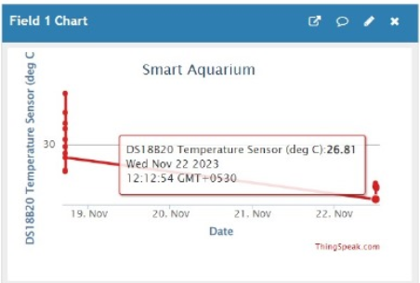

*FIGURE 3:*

##### IV. RESULT

When the aquarium monitoring and control system is built with the right hardware and programming, several positive outcomes can be expected. The values are shown on the Things Speak website, where we may use a mobile device/computer to view the most recent temperature and water levels and the time of ambient light turned on and off.

**Case 1: Low Water Level**

* Float Switch 1 (FS1): 0
* Float Switch 2 (FS2): 0

**Case 2: Mid Water Level**

* Float Switch 1 (FS1): 0
* Float Switch 2 (FS2): 1

**Case 3: High Water Level**

* Float Switch 1 (FS1): 1
* Float Switch 2 (FS2): 1

|  |  |  |  |  |  |
| --- | --- | --- | --- | --- | --- |
| | **Water Level** |  |  | | --- | --- | --- | | **Float Switch 1 (FS1)** | **Float Switch 2 (FS2)** |
| Low | 0 | 0 |
| Mid | 0 | 1 |
| High | 1 | 1 |

.

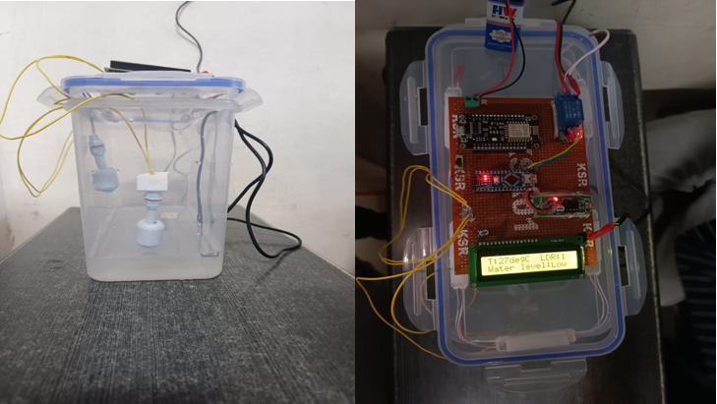

*Figure (4) FS1=0 and FS2=0: water level is very low*

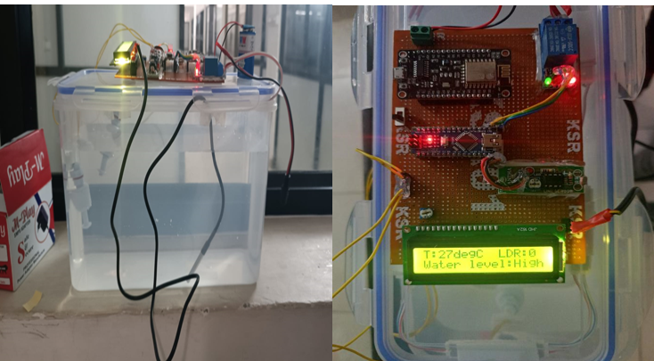

*Figure(5)FS1=1 and FS2=1 : water level is high and sufficient*

**Scenario of ambient lights:**

To create a night time environment within the aquarium hand is placed above the LDR sensor, it creates a shadow, effectively simulating a reduction in ambient light similar to night-time conditions.

In response, the system triggers the ambient light placed at the top of the aquarium to turn on.

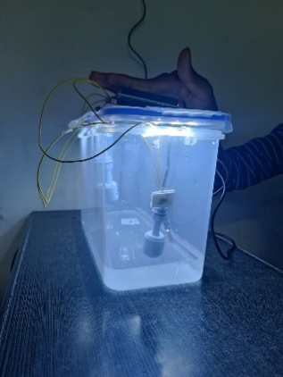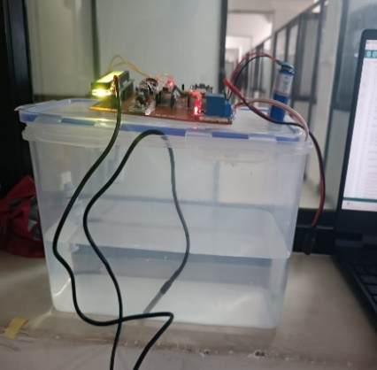*Figure(6)Ambient light when light is not available and available.*

**Results on the webpage:**



*FIGURE 7:*

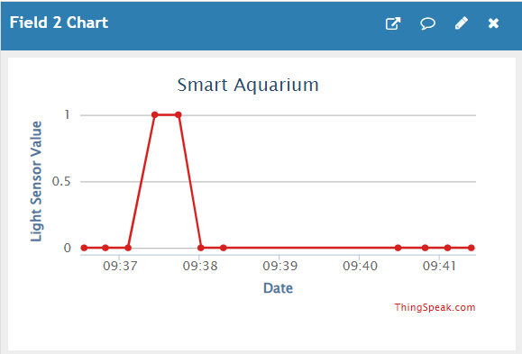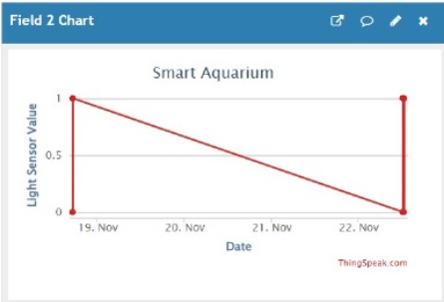

*FIGURE 8:*

##### V. CONCLUSION

If the parts of an aquarium are manually operated, they are hard to maintain. If the aquarium keeper wants to maintain a traditional aquarium, he will need to put in a lot of study and work. Many individuals are hesitant to have aquariums in their homes for this reason. The concept for the project came from the need to build a system that could look after the fish on its own and provide remote cloud management over these devices.[7]

Our idea aims to make aquarium maintenance more enjoyable and easy. With the help of these projects, users may get up-to-date information on the website on the aquarium's temperature and water level. where users may obtain information and make the required adjustments to preserve fish care. It can monitor these variables and visualize the data by utilizing the IoT platform.

Projects like this are in great demand on the market as an increasing number of individuals are having difficulty maintaining their aquariums, either because they lack the necessary time or because they are novice fish keepers.

##### References

[1] Dr. R. M. Rewatkar, Mr. Harish T. Mahajan, Mr. Pawan P. Mahajan, Ms. Gauri R. Dhage, Ms. Poonam A. Kapse, Ms. Sanchalika M. Dubale, Design and implementation of Automatic Aquarium System using IOT, International Journal on Future Revolution in Computer Science & Communication Engineering, 2018.

[2] Phanindra Sai, Y., & Alex, Z. C. (2022). Smart Aquarium. International Journal of Science and Research, 11(6), 449

[3] Jagtap, S., Jadhav, K., & Deshpande, P. (2024). Smart IoT Based Fish Tank Monitoring System. *International Journal of Innovative Research in Technology, 10*(8), ISSN: 2349-6002.

[4] Mohammad Fahmi Suhaimi, Nurul Huda Mat Tahir, Safuan Naim Mohamad, Suzanna Ridzuan Aw, "loT Based Automatic Aquarium Monitoring System for Freshwater Fish", International Journal of Synergy in Engineering and Technology, Vol. 2 No. 1 (2021) 125-33

[5] Weerasak Cheunta, Nitthita Chirdchoo and Kanittha Saelim, "Efficiency Improvement of Integrated Giant Freshwater White Prawn Farming in Thailand Using a Wireless Sensor Network", ResearchGate, Dec. 2014

[6] Daniel Patricko Hutabarat, Rudy Susanto, Bryan Prasetya, Barry Linando, Senanayake Mudiyanselage Namal Arosha, "Smart system for maintaining aquascape environment using internet of things based light and temperature controller", International Journal of Electrical and Computer Engineering (IJECE), Vol. 12. No. 1. Februby 2022, pp. 896-902 ISSN: 2088- 8708, DOI: 10.11591/ijece. v12i1. pp896-902.

[7] Phanindra Sai, Y., & Alex, Z. C. (2022). Smart Aquarium. International Journal of Science and Research, 11(6), 449