CHAPTER 1
INTRODUCTION
1.1 Background
Prenatal healthcare is very important for monitoring the growth and healthy development of a baby during pregnancy. Among various prenatal diagnostic techniques, ultrasound imaging is one of the most widely used methods because it is safe, non-invasive, cost-effective, and capable of providing real-time imaging of fetal organs and structures. Fetal brain assessment through ultrasound imaging is particularly important because abnormalities in the brain can lead to severe neurological disorders, developmental delays, and long-term health complications after birth. Fetal brain abnormalities may occur due to genetic disorders, infections, improper brain development, environmental conditions, or complications during pregnancy. Early detection of these abnormalities is extremely important because it enables doctors to take timely medical decisions, plan suitable treatments, and provide appropriate prenatal care. However, identifying fetal brain abnormalities from ultrasound images is a highly challenging task. Ultrasound images often contain speckle noise, low contrast, blurred boundaries, and variations in fetal position, which make manual diagnosis difficult even for experienced radiologists.
In most hospitals, fetal ultrasound analysis mainly depends on the knowledge and experience of radiologists and clinicians. Manual examination of ultrasound scans is time-consuming and may sometimes lead to inconsistent diagnoses due to differences in interpretation among experts. In addition, the increasing number of ultrasound examinations in hospitals and diagnostic centres creates a heavy workload for healthcare professionals. Therefore, there is a strong need for an intelligent automated system that can assist clinicians in detecting fetal brain abnormalities more accurately and efficiently. In recent years, Artificial Intelligence (AI) and Deep Learning technologies have created major improvements in the field of medical image analysis. Deep learning models, especially Convolutional Neural Networks (CNNs), have shown remarkable performance in automatically learning complex features from medical images. These models eliminate the need for manual feature extraction and are capable of identifying subtle abnormalities with high accuracy. Modern architectures such as EfficientNetV2 and ConvNeXt provide better feature extraction capabilities, faster training, and improved classification performance.
In this project, an advanced deep learning-based approach is proposed for automatic detection of fetal brain abnormalities from ultrasound images. The system utilizes advanced CNN architectures combined with attention mechanisms such as CBAM (Convolutional Block Attention Module) to improve focus on important brain regions. Preprocessing and data augmentation techniques are also applied to enhance image quality and improve model generalization. The proposed system aims to classify fetal brain ultrasound images into multiple abnormality categories such as Arnold Chiari Malformation, Arachnoid Cyst, Cerebellar Hypoplasia, Cisterna Magna abnormalities, Colpocephaly, Encephalocele, Holoprosencephaly, Hydranencephaly, Intracranial Hemorrhage, Intracranial Tumor, Mild Ventriculomegaly, Moderate Ventriculomegaly, Porencephaly, and Severe Ventriculomegaly with high accuracy while reducing manual effort and diagnostic errors. The integration of deep learning into prenatal healthcare can greatly support radiologists in making faster, more reliable, and consistent diagnostic decisions. This project contributes toward improving prenatal diagnosis by developing an intelligent and automated fetal brain abnormality detection system.
1.2 Motivation
The main motivation behind this project is the need for early and accurate detection of fetal brain abnormalities during pregnancy. Brain abnormalities in fetuses can lead to severe neurological disorders, cognitive impairments, developmental delays, and even life-threatening complications after birth. Early diagnosis is extremely important because it enables doctors and parents to make informed medical decisions and initiate proper treatment planning at the right stage. Ultrasound imaging is widely used in prenatal healthcare because it is safe and affordable. However, analysing ultrasound images manually is a difficult task due to image noise, poor contrast, fetal movement, and variations in imaging conditions. In many cases, the diagnosis depends completely on the expertise of radiologists, which can sometimes lead to human error, delayed detection, or inconsistent interpretation of medical images. Another major motivation for this project is the increasing workload in hospitals and diagnostic centres. With the rapid growth in medical imaging procedures, clinicians are required to analyze a large number of ultrasounds scans every day. Manual analysis consumes significant time and effort, making it challenging to maintain consistent accuracy for every patient. An automated system can help reduce this burden by assisting doctors in faster and more reliable diagnosis.
The rapid development of Artificial Intelligence and Deep Learning technologies has created new opportunities in medical image analysis. Deep learning models have achieved excellent performance in image classification, object detection, and disease diagnosis tasks. These technologies can automatically learn meaningful features from images and identify hidden patterns that may not be easily visible to the human eye. This project is also motivated by the need to improve prenatal healthcare accessibility in rural and underdeveloped regions where experienced radiologists may not always be available. An intelligent automated detection system can support healthcare professionals by providing accurate predictions and reducing dependency on expert interpretation. Furthermore, integrating attention mechanisms such as CBAM with advanced CNN architectures can significantly improve the model’s ability to focus on critical fetal brain regions. This enhances the overall detection accuracy and reliability of the system.
1.3 Problem Statement
Fetal brain abnormality detection using ultrasound imaging is a highly important yet challenging task in prenatal healthcare. Ultrasound images often suffer from speckle noise, low contrast, blurred boundaries, and inconsistent image quality, making accurate diagnosis difficult. In many cases, subtle abnormalities in fetal brain structures are not easily visible during the early stages of pregnancy, leading to delayed detection and treatment. Currently, diagnosis mainly depends on the experience and expertise of radiologists or clinicians. Manual interpretation of ultrasound images is time-consuming and may result in inconsistent analysis due to variations in human judgment. In addition, the increasing number of ultrasound examinations in hospitals creates a significant workload for healthcare professionals, increasing the possibility of human error and delayed reporting.
Traditional machine learning methods require manual feature extraction, which is complex and often fails to capture important hidden patterns in medical images. Existing systems may also struggle with limited datasets, class imbalance problems, and poor generalization capability. Therefore, there is a strong need for an automated system that can accurately detect fetal brain abnormalities from ultrasound images using advanced deep learning techniques. The system should improve detection accuracy, reduce manual effort, assist clinicians in faster diagnosis, and support early prenatal healthcare decisions.

1.4 Objectives of the System
The primary objective of this project is to develop a deep learning-based system for detecting fetal brain abnormalities from ultrasound images in an accurate and efficient manner. The system aims to provide automated, accurate, and reliable classification to assist clinicians in prenatal diagnosis.
Specific Objectives
- To Develop an Automated Detection System
The project aims to create an automated system capable of analysing fetal brain ultrasound images without requiring manual feature extraction. This helps reduce human effort and speeds up the diagnosis process.
- To Classify Normal and Abnormal Ultrasound Images
The system is designed to classify fetal brain ultrasound images into multiple abnormality categories including Arnold Chiari Malformation, Arachnoid Cyst, Cerebellar Hypoplasia, Cisterna Magna abnormalities, Colpocephaly, Encephalocele, Holoprosencephaly, Hydranencephaly, Intracranial Hemorrhage, Intracranial Tumor, Mild Ventriculomegaly, Moderate Ventriculomegaly, Porencephaly, and Severe Ventriculomegaly. This enables quick identification of potential brain abnormalities.
- To Utilize Advanced Deep Learning Models
The project uses modern CNN architectures such as EfficientNetV2 and ConvNeXt for effective feature extraction and classification. These models provide improved accuracy and learning capability.
- To Improve Detection Accuracy Using Attention Mechanisms
CBAM (Convolutional Block Attention Module) is integrated into the system to help the model focus on important regions of the fetal brain. This enhances the detection of subtle abnormalities.
- To Enhance Image Quality Through Preprocessing
Image preprocessing techniques are applied to reduce noise, improve contrast, and standardize ultrasound images before analysis.

- To Improve Model Generalization
Data augmentation and regularization techniques such as dropout and batch normalization are used to reduce overfitting and improve the model’s performance on unseen data.
- To Reduce Manual Diagnostic Errors
The automated system aims to support radiologists by providing consistent and accurate predictions, reducing the possibility of human error.
- To Support Early Prenatal Diagnosis
Early detection of fetal brain abnormalities can improve treatment planning and prenatal healthcare outcomes.
1.5 Scope of the Project
This project mainly focuses on developing a deep learning-based system for automatically detecting fetal brain abnormalities from ultrasound images. The project mainly concentrates on medical image classification techniques, deep learning architectures, and attention mechanisms for improving prenatal diagnostic accuracy. The proposed system is designed to process fetal brain ultrasound images and classify them into multiple fetal brain abnormality categories using advanced deep learning techniques. Image preprocessing techniques such as resizing, normalization, and noise reduction are included to improve image quality before analysis. Data augmentation methods are also applied to enhance dataset diversity and improve model robustness. The project utilizes advanced deep learning architectures such as EfficientNetV2 or ConvNeXt for feature extraction and classification. Additionally, CBAM attention mechanisms are integrated to improve the model’s focus on important fetal brain regions. The system is intended to assist radiologists and clinicians by providing automated predictions and reducing the workload associated with manual analysis. The project supports early diagnosis and improved prenatal healthcare decision-making.
The scope of the project is limited to:
- Detection and classification of multiple fetal brain abnormalities from ultrasound images including Arnold Chiari Malformation, Arachnoid Cyst, Cerebellar Hypoplasia, Cisterna Magna abnormalities, Colpocephaly, Encephalocele, Holoprosencephaly, Hydranencephaly, Intracranial Hemorrhage, Intracranial Tumor, Mild Ventriculomegaly, Moderate Ventriculomegaly, Porencephaly, and Severe Ventriculomegaly.
- Classification of fetal brain ultrasound images into multiple abnormality classes based on the dataset used in the project.
- Use of deep learning-based image analysis techniques.
- Application of preprocessing, augmentation, and attention mechanisms.
- Development and evaluation of the model using medical imaging datasets.

CHAPTER 2
LITERATURE SURVEY
The use of Artificial Intelligence and Deep Learning in medical image analysis has grown rapidly in recent years, especially in the field of prenatal healthcare. Researchers have proposed several machine learning and deep learning approaches for detecting fetal brain abnormalities using ultrasound and MRI images. These studies mainly focus on improving diagnostic accuracy, reducing manual effort, enhancing feature extraction, and supporting early prenatal diagnosis.
This chapter presents a detailed literature survey of research papers related to fetal brain abnormality detection, medical image analysis, convolutional neural networks, transfer learning, attention mechanisms, and deep learning-based prenatal diagnostic systems.
2.1 Deep Learning-Based Diagnosis of Fetal Ultrasound Images
Deepika et al. (2021) proposed a deep learning-based diagnosis method for detecting fetal abnormalities from ultrasound images. The study focused on improving abnormality detection accuracy using convolutional neural networks. The authors highlighted that deep learning models can automatically learn image features and reduce dependency on manual interpretation. The proposed approach achieved better classification performance compared to traditional image analysis techniques. The study also emphasized the importance of early diagnosis in reducing neonatal complications and improving prenatal healthcare outcomes.
2.2 Deep Learning for Genetic Disorder Detection in Fetal Ultrasound
Tang et al. (2023) developed a deep learning-based framework capable of detecting both common and rare genetic disorders from fetal ultrasound images. The research demonstrated that deep learning algorithms can identify subtle structural abnormalities that may not be easily visible during manual examination. The authors used advanced CNN models for feature extraction and classification. Their work highlighted the importance of automated diagnostic systems in supporting radiologists and improving diagnostic consistency.
2.3 Machine Learning Algorithms for Fetal Brain Classification
Gofer et al. (2022) proposed machine learning algorithms for classification of first-trimester fetal brain ultrasound images. The study focused on distinguishing normal and abnormal fetal brain structures using automated classification techniques. Different machine learning models were analysed to improve prediction accuracy and reduce human dependency. The research showed that automated systems can assist clinicians in making faster and more reliable diagnostic decisions.
2.4 Analysis of Machine Learning and Deep Learning Approaches
Shamya et al. (2024) conducted a comparative analysis of machine learning and deep learning approaches used for fetal brain abnormality detection using ultrasound images. The study discussed the advantages and limitations of different algorithms including CNN, ANN, SVM, and transfer learning models. The authors concluded that deep learning approaches provide higher accuracy and better feature extraction capability compared to traditional machine learning techniques.
2.5 Review of AI Models in Fetal Brain Imaging
Vahedifard et al. (2023) reviewed various Artificial Intelligence and deep learning models used in fetal brain magnetic resonance imaging and ultrasound analysis. The paper discussed different neural network architectures, segmentation models, and diagnostic systems used in prenatal healthcare. The authors highlighted the growing importance of AI-assisted medical imaging for improving diagnosis and reducing radiologist workload.
2.6 Multi-Centre Deep Learning Study for CNS Anomalies
Qi et al. (2025) proposed a multi-centre deep learning-assisted system for detecting and classifying fetal central nervous system anomalies using ultrasound imaging. The study used deep learning techniques to improve abnormality detection across multiple datasets collected from different healthcare centres. The research demonstrated that deep learning models can generalize effectively under different imaging conditions.
2.7 Artificial Intelligence for Fetal Brain and Heart Abnormality Prediction
Shiwlani et al. (2024) reviewed Artificial Intelligence algorithms used for predicting fetal brain and heart abnormalities. The paper discussed how AI-based systems can improve medical image interpretation and reduce diagnostic errors. Different neural network models and image processing techniques were analysed in the study. The authors concluded that deep learning methods offer promising results for prenatal diagnosis.

2.8 Fetal Brain Abnormality Classification Using Ultrasound Images
Sridharan (2023) proposed a classification framework for detecting fetal brain abnormalities from 2D ultrasound images. The study focused on automated classification techniques for identifying abnormal fetal brain structures. The research highlighted the importance of preprocessing and feature extraction in improving model accuracy.
2.9 Early Detection of Fetal Skull Anomalies Using CNN
Ture et al. (2024) developed a web-based convolutional neural network system for early detection of fetal skull anomalies. The system was designed to support real-time prenatal diagnosis and remote healthcare applications. The proposed model demonstrated good classification accuracy and reduced diagnosis time.
2.10 Prediction of Fetal Brain Anomalies Using Deep Learning Models
Subburaj and Pandiyarajan (2024) proposed deep learning models for predicting fetal brain anomalies from ultrasound images. The research focused on CNN-based feature extraction and automated classification. The study showed that deep learning models are capable of learning complex fetal brain structures and improving prenatal diagnosis accuracy.
2.11 Artificial Intelligence Applied to Fetal MRI
Meshaka et al. (2023) conducted a scoping review on Artificial Intelligence applications in fetal MRI analysis. The paper discussed AI-based segmentation, classification, and abnormality detection methods. The authors highlighted the growing role of AI in improving fetal imaging and prenatal diagnosis.
2.12 Intelligent Decision Support System for Fetal Morphology
Belciug et al. (2024) proposed the PARADISE framework, an intelligent decision support system for fetal morphology analysis using deep learning and statistical learning techniques. The system was designed to detect congenital fetal anomalies from ultrasound scans. The study emphasized the importance of AI-assisted clinical decision support systems in prenatal healthcare.
2.13 Prenatal Diagnostics Using Deep Learning
Vetriselvi and Thenmozhi (2025) proposed a dual deep learning approach for plane localization and cerebellum segmentation in ultrasound images. The study focused on improving prenatal diagnostics through automated image segmentation and localization techniques. The proposed approach improved visualization of fetal brain structures and enhanced diagnostic reliability.
2.14 Review of Deep Learning-Based Fetal Anomaly Detection
Mhatre and Bakal (2024) reviewed various deep learning approaches used for fetal anomaly detection from ultrasound images. The paper discussed CNN architectures, transfer learning methods, segmentation techniques, and preprocessing approaches used in prenatal diagnosis systems. The authors concluded that deep learning significantly improves detection accuracy and diagnostic efficiency.
2.15 Deep Learning System for Fetal Intracranial Malformations
Lin et al. (2023) proposed a deep learning system for detecting fetal intracranial malformations using ultrasound images. The study demonstrated that AI-assisted systems can significantly improve abnormality detection efficacy and reduce observer variability. The research highlighted the importance of automated fetal brain analysis in clinical diagnosis.

CHAPTER 3
TOOLS AND TECHNOLOGY SPECIFICATIONS
3.1 Software Requirement
Software plays an important role in the development and implementation of the proposed fetal brain abnormality detection system. The project uses various software tools, programming frameworks, deep learning libraries, and image processing technologies to perform preprocessing, feature extraction, model training, classification, and result generation. The selected software technologies help in building an efficient, reliable, and high-performance deep learning model for medical image analysis.
The software requirements used in this project are explained below.
3.1.1 Python Programming Language
Python is the primary programming language used for developing the entire system. It is widely used in Artificial Intelligence, Machine Learning, and Deep Learning applications because of its simplicity, flexibility, and large collection of libraries.
Python provides strong support for:
- Deep learning model development
- Medical image processing
- Data analysis
- Visualization
- Automation
- Scientific computing
One of the major advantages of Python is its readability and easy integration with modern AI frameworks such as TensorFlow and PyTorch. Python also supports rapid development and testing, which makes it suitable for research-oriented projects.
In this project, Python is mainly used for:
- Loading ultrasound image datasets
- Image preprocessing
- Data augmentation
- Building CNN architectures
- Training deep learning models
- Classification and prediction
- Accuracy evaluation
- Generating output reports
3.1.2 TensorFlow
TensorFlow is one of the main deep learning frameworks used in this project. It is an open-source platform developed by Google for machine learning and neural network applications.
TensorFlow provides:
- Efficient model training
- GPU acceleration
- Automatic differentiation
- High-level APIs
- Deployment support
The framework helps in designing and training advanced deep learning architectures such as EfficientNetV2 and ConvNeXt. TensorFlow also supports transfer learning, which allows pretrained models to be reused for medical image classification tasks.
In this project, TensorFlow is used for:
- Building CNN models
- Training neural networks
- Feature extraction
- Attention mechanism integration
- Model evaluation
- Prediction generation
TensorFlow improves computational efficiency and helps achieve better model performance during training.
3.1.3 Keras
Keras is a high-level deep learning API integrated with TensorFlow. It simplifies the process of building and training deep learning models.
Keras provides:
- Simple coding structure
- Fast model prototyping
- Easy layer implementation
- Built-in optimization functions
- Flexible neural network design
The main advantage of Keras is its user-friendly interface, which allows researchers and developers to design complex neural network architectures with less code.
In this project, Keras is used for:
- Designing CNN layers
- Model compilation
- Applying activation functions
- Adding dropout and batch normalization
- Training and testing the model
- Performance evaluation
Keras helps reduce development complexity and improves experimentation speed.

3.1.4 OpenCV
OpenCV (Open-Source Computer Vision Library) is used for image preprocessing and enhancement operations.
Medical ultrasound images often contain:
- Speckle noise
- Poor contrast
- Irregular brightness
- Blurred structures
OpenCV helps improve image quality before feeding images into the deep learning model.
In this project, OpenCV is used for:
- Image resizing
- Image normalization
- Noise reduction
- Contrast enhancement
- Filtering operations
- Image transformation
Proper preprocessing improves feature extraction accuracy and enhances overall classification performance.
3.1.5 NumPy
NumPy is a scientific computing library used for handling numerical operations and multidimensional arrays.
Deep learning applications require efficient mathematical operations on image data, tensors, and matrices. NumPy provides fast array processing and optimized mathematical computations.
In this project, NumPy is used for:
- Matrix operations
- Array manipulation
- Image data conversion
- Mathematical computations
- Numerical preprocessing
NumPy helps improve computational efficiency during training and preprocessing stages.
3.1.6 Pandas
Pandas is a data analysis and data manipulation library used for managing structured datasets.
In this project, Pandas is mainly used for:
- Dataset management
- Organizing image labels
- Handling CSV files
- Data analysis
- Performance result storage
Pandas simplifies dataset handling and improves data organization during training and evaluation.
3.1.7 Matplotlib
Matplotlib is a visualization library used for plotting graphs and performance metrics.
Visualization is important for understanding model performance and training behavior.
In this project, Matplotlib is used for:
- Accuracy graph plotting
- Loss graph visualization
- Confusion matrix visualization
- Performance comparison
- Result analysis
Graphs generated using Matplotlib help evaluate the effectiveness of the proposed deep learning model.
3.1.8 Scikit-learn
Scikit-learn is a machine learning library used for evaluation and performance measurement.
It provides various functions for:
- Accuracy calculation
- Precision evaluation
- Recall computation
- F1-score analysis
- Dataset splitting
- Confusion matrix generation
In this project, Scikit-learn is mainly used for evaluating the performance of the classification model.
3.1.9 EfficientNetV2
EfficientNetV2 is one of the advanced CNN architectures used in this project for feature extraction and classification.
It is designed to provide:
- High accuracy
- Faster training
- Better efficiency
- Reduced computational complexity
EfficientNetV2 can capture both low-level and high-level image features effectively, making it suitable for medical image analysis.
In this project, EfficientNetV2 is used to:
- Extract meaningful brain features
- Improve abnormality detection
- Enhance classification performance
3.1.10 ConvNeXt
ConvNeXt is a modern convolutional neural network architecture inspired by transformer-based design principles.
It provides:
- Better feature representation
- Improved learning capability
- High classification accuracy
- Strong generalization performance
ConvNeXt helps the system learn complex fetal brain structures more effectively.
In this project, ConvNeXt is used for:
- Deep feature extraction
- Multi-class classification
- Improving model robustness
3.1.11 CBAM Attention Mechanism
CBAM (Convolutional Block Attention Module) is an attention mechanism integrated into the CNN architecture.
The main purpose of CBAM is to help the model focus on important regions of the fetal brain.
CBAM consists of:
- Channel Attention
- Spatial Attention
These mechanisms improve the model’s ability to identify subtle abnormalities while reducing the influence of irrelevant background information.
In this project, CBAM is used for:
- Improving feature selection
- Highlighting important brain regions
- Enhancing detection accuracy
- Improving classification performance
3.2 Hardware Requirement
Hardware requirements are important for implementing and training the proposed deep learning model efficiently. Since deep learning operations involve large datasets and complex neural network computations, powerful hardware resources are necessary to achieve faster training and better performance.
The hardware components used in this project are described below.
3.2.1 Processor
A high-performance processor is required for executing preprocessing tasks, data handling, and deep learning operations.
Recommended Processor:
- Intel Core i5 / i7
or
- AMD Ryzen 5 / Ryzen 7
The processor helps perform:
- Data preprocessing
- Image loading
- Model execution
- Dataset handling
- General computation
A multi-core processor improves overall processing speed and system efficiency.
3.2.2 RAM
Random Access Memory (RAM) is important for handling large ultrasound image datasets and deep learning computations.
Recommended RAM:
- Minimum: 8 GB
- Recommended: 16 GB or higher
Higher RAM capacity improves:
- Dataset loading speed
- Training efficiency
- Multitasking capability
- Large batch processing
3.2.3 Storage
Storage is required for saving:
- Ultrasound image datasets
- Trained models
- Output reports
- Performance graphs
- Project files
Recommended Storage:
- Minimum: 256 GB SSD
- Recommended: 512 GB SSD
SSD storage improves:
- Faster data access
- Quick file loading
- Better system responsiveness

3.2.5 Display Monitor
A high-resolution display monitor helps in visualizing ultrasound images, training outputs, and performance graphs clearly.
Recommended Display:
- Full HD Monitor
- Resolution: 1920 × 1080
Better display quality improves image analysis and visualization.

CHAPTER 4
SYSTEM DESIGN
4.1 System Architecture
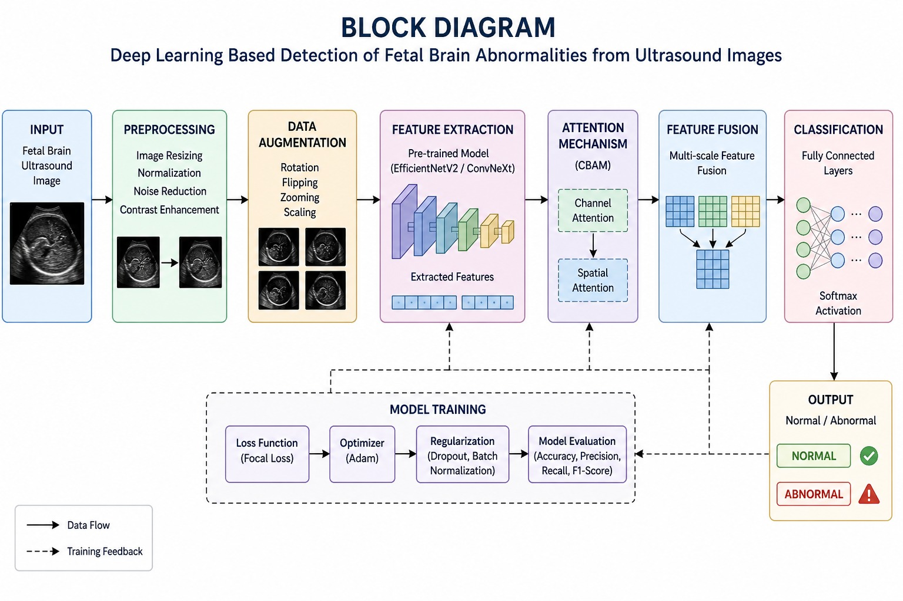

Fig.1.System Architecture
The system architecture shown in the PPT represents the complete workflow of the proposed fetal brain abnormality detection system. It explains how ultrasound images are processed step by step using deep learning techniques to identify and classify different fetal brain abnormalities. The architecture is designed in a structured manner so that each module performs a specific task and passes the processed information to the next stage. The architecture mainly focuses on improving image quality, extracting meaningful features, reducing unnecessary background information, and generating accurate classification results. The overall workflow begins with ultrasound image acquisition and ends with abnormality prediction and result generation. System design is one of the most important stages in the development of the proposed fetal brain abnormality detection system. It explains the overall structure, workflow, and interaction between different modules of the system. The proposed architecture is designed to automatically analyse fetal brain ultrasound images and classify them into multiple abnormality categories using advanced deep learning techniques.
The system architecture mainly consists of the following stages:
- Input Image Acquisition
- Image Preprocessing
- Data Augmentation
- Feature Extraction
- Attention Mechanism
- Feature Fusion
- Classification
- Prediction Output
Each stage performs a specific task in the detection pipeline to improve the overall accuracy and efficiency of the system.
4.1.1 Input Image Acquisition
The first stage of the system architecture is image acquisition. In this stage, fetal brain ultrasound images are collected from the dataset and provided as input to the system.
The dataset contains multiple fetal brain abnormality categories including:
- Arnold Chiari Malformation
- Arachnoid Cyst
- Cerebellar Hypoplasia
- Cisterna Magna Abnormalities
- Colpocephaly
- Encephalocele
- Holoprosencephaly
- Hydranencephaly
- Intracranial Hemorrhage
- Intracranial Tumor
- Mild Ventriculomegaly
- Moderate Ventriculomegaly
- Porencephaly
- Severe Ventriculomegaly
These ultrasound images act as the primary source of information for the deep learning model.
Ultrasound imaging is selected because it is:
- Safe
- Non-invasive
- Cost-effective
- Widely used in prenatal diagnosis
However, ultrasound images may contain noise and low contrast, which makes preprocessing necessary before analysis.
4.1.2 Image Preprocessing
According to the architecture diagram provided in the PPT, preprocessing is one of the most important stages in the system because ultrasound images usually contain speckle noise and low contrast. If raw images are directly provided to the deep learning model, the accuracy of abnormality detection may decrease.
Therefore, preprocessing improves image clarity and prepares the dataset for feature extraction.
Image preprocessing is an important stage that improves the quality of ultrasound images before feature extraction.
Medical ultrasound images often contain:
- Speckle noise
- Poor contrast
- Irregular brightness
- Blurred structures
These issues can reduce the performance of deep learning models if not handled properly.
The preprocessing stage includes the following operations:
Image Resizing
All images are resized into a fixed dimension suitable for CNN input. This ensures uniformity during training.
Normalization
Pixel values are normalized into a standard range to improve training stability and model convergence.
Noise Reduction
Filtering techniques are used to reduce speckle noise and improve image clarity.
Contrast Enhancement
Image contrast is enhanced to highlight important fetal brain structures.
The preprocessing stage improves image quality and helps the model learn meaningful features more effectively.
4.1.3 Data Augmentation
Deep learning models require large datasets for better generalization and performance. However, medical datasets are often limited. To overcome this problem, data augmentation techniques are applied.
Data augmentation artificially increases dataset size by generating modified versions of existing images.
The augmentation techniques used in this project include:
- Rotation
- Flipping
- Zooming
- Brightness adjustment
- Image shifting
The advantages of augmentation are:
- Reduces overfitting
- Improves model robustness
- Increases dataset diversity
- Enhances generalization capability
Data augmentation helps the model learn different fetal brain orientations and imaging conditions.
4.1.4 Feature Extraction
Feature extraction is the core stage of the proposed system. In this stage, deep learning models automatically learn important features from fetal brain ultrasound images.
The project uses advanced CNN architectures such as:
- EfficientNetV2
- ConvNeXt
These models are capable of learning:
- Low-level features
- High-level semantic features
- Structural brain patterns
- Texture information
- Abnormality indicators
Unlike traditional machine learning methods, CNN models automatically learn relevant features directly from images without manual feature engineering.
EfficientNetV2
EfficientNetV2 provides:
- Faster training
- Better accuracy
- Reduced computational complexity
- Efficient feature learning
ConvNeXt
ConvNeXt improves:
- Feature representation
- Learning capability
- Classification performance
- Generalization ability
The extracted features are forwarded to the attention mechanism stage for further refinement.
4.1.5 Attention Mechanism
The PPT architecture clearly highlights the use of the CBAM attention module between feature extraction and classification stages. This module plays an important role in improving the model’s focus on important fetal brain regions.
Instead of analysing the complete image equally, the attention mechanism helps the model concentrate more on suspicious and medically relevant areas.
Attention mechanisms help the model focus on the most important regions of the fetal brain.
In this project, the Convolutional Block Attention Module (CBAM) is integrated into the CNN architecture.
CBAM consists of two attention modules:
Channel Attention
Channel attention identifies which feature maps are more important for classification.
It helps the model focus on:
- Brain tissues
- Structural details
- Abnormal regions
Spatial Attention
Spatial attention identifies the exact location of important regions within the image.
It helps the model concentrate on:
- Suspicious brain areas
- Structural abnormalities
- Critical image regions
The CBAM attention mechanism improves:
- Detection accuracy
- Feature selection
- Classification performance
- Model reliability
It also helps reduce the effect of irrelevant background information.
4.1.6 Feature Fusion
Feature fusion combines important features extracted from different layers and attention modules.
The fusion process integrates:
- Texture features
- Structural features
- Spatial information
- Attention-based features
Combining these features improves:
- Information richness
- Learning capability
- Detection performance
- Classification accuracy
Feature fusion allows the system to capture both detailed and abstract fetal brain characteristics.
4.1.7 Classification
The classification stage is responsible for predicting the category of fetal brain abnormality.
The fused features are passed through:
- Fully connected layers
- Dense neural network layers
A SoftMax activation function is used in the final layer to assign probability scores to each abnormality category.
The system classifies images into multiple classes such as:
- Arnold Chiari Malformation
- Arachnoid Cyst
- Cerebellar Hypoplasia
- Colpocephaly
- Holoprosencephaly
- Ventriculomegaly categories
- Intracranial abnormalities
- Other fetal brain disorders
The class with the highest probability becomes the final prediction.
4.1.8 Prediction Output
In the final stage, the system generates the prediction result along with confidence scores.
Example Output:
- Mild Ventriculomegaly – 92% Confidence
- Intracranial Tumour – 89% Confidence
The output supports clinicians and radiologists in:
- Faster diagnosis
- Improved decision-making
- Early prenatal treatment planning
- Reducing manual effort
The prediction system helps improve consistency and reliability in fetal brain abnormality detection.
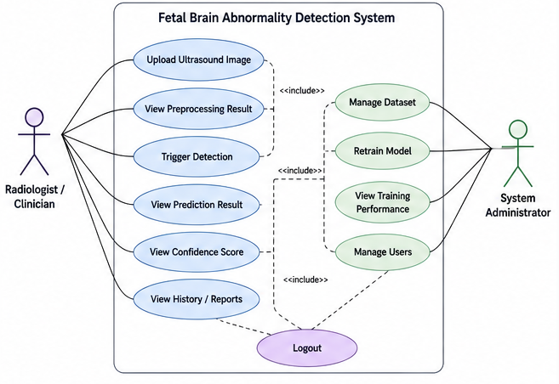
4.2 Use Case Diagram

Fig.2. Use Case Diagram
The Use Case Diagram shown in the PPT explains how the doctor or radiologist interacts with the proposed system. It visually represents the communication between the user and the different functions performed by the deep learning model. The diagram helps understand the operational flow of the system from image upload to prediction generation.
The Use Case Diagram represents the interaction between the user and the proposed fetal brain abnormality detection system. It explains how users interact with different functionalities of the system.
The primary actor in the system is:
- Doctor / Radiologist
The doctor interacts with the system to upload ultrasound images and receive prediction results.
Main Use Cases
Upload Ultrasound Image
The user uploads fetal brain ultrasound images into the system.
Preprocess Image
The system automatically performs image preprocessing operations such as resizing, normalization, and noise reduction.
Analyse Image
The deep learning model analyses the processed ultrasound image.
Detect Brain Abnormalities
The CNN model with CBAM attention detects abnormal fetal brain patterns.
Classify Abnormality
The system classifies the image into one of the abnormality categories.
Generate Prediction
The model generates the final classification result along with confidence scores.
View Result
The doctor views the output prediction for clinical analysis.
The Use Case Diagram helps explain the overall interaction flow between users and the proposed system.
4.3 Data Flow Diagram
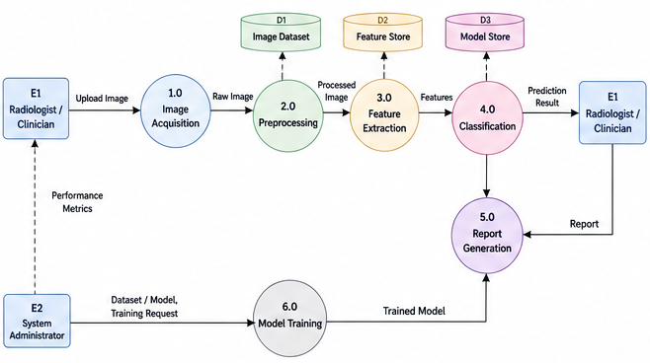
4.3.1 Data Flow Diagram (DFD)

Fig.3. Data Flow Diagram
The Data Flow Diagram provided in the PPT explains how image data moves through different processing stages inside the system. It gives a clear understanding of how information is transformed from raw ultrasound images into final prediction results.
The DFD contains multiple processes, data stores, and flow connections that represent the complete deep learning pipeline.
The Data Flow Diagram explains how data moves through different stages of the system.
The main data flow stages are:
Input Image
Fetal brain ultrasound images are provided as input.
Preprocessing Module
The images are enhanced using preprocessing techniques.
Augmentation Module
Dataset diversity is improved through augmentation techniques.
Feature Extraction Module
Deep learning models extract meaningful image features.
Attention Module
CBAM highlights important fetal brain regions.
Feature Fusion Module
Extracted features are combined for better learning.
Classification Module
The model predicts the abnormality category.
Output Module
The final prediction result is displayed.
The DFD also includes important data stores:
D1 – Image Dataset
D1 represents the ultrasound image dataset storage. It stores all fetal brain ultrasound images used for training and testing the model. The dataset includes multiple abnormality categories such as Arnold Chiari Malformation, Arachnoid Cyst, Ventriculomegaly categories, Intracranial Tumour, Holoprosencephaly, and other fetal brain disorders.
D2 – Feature Store
D2 stores the important features extracted by the CNN models during feature extraction. These features include texture information, structural patterns, and abnormality indicators learned from ultrasound images.
D3 – Model Store
D3 represents the trained deep learning model storage. After model training, the learned weights and parameters are stored here for future prediction and testing purposes.
The DFD also includes data stores:
- D1 – Image Dataset
- D2 – Feature Store
- D3 – Model Store
These data stores help manage datasets, extracted features, and trained deep learning models.
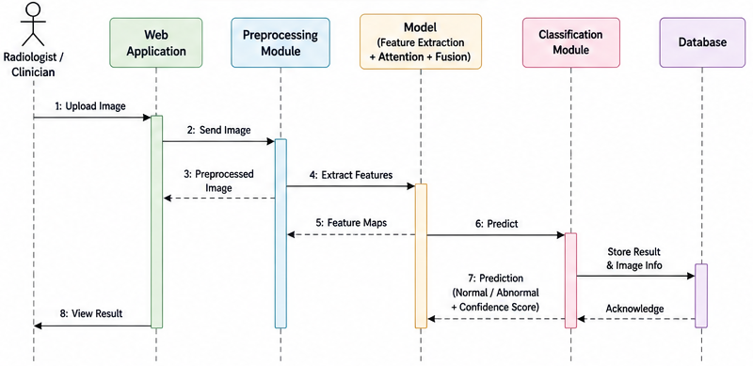
4.3.2 Sequence Diagram

Fig.4. Sequence Diagram
The Sequence Diagram shown in the PPT represents the order of communication between different modules of the proposed system. It explains how each process interacts step by step during abnormality detection.
This diagram helps understand the execution flow of the system from image upload until the final prediction output is displayed to the doctor.
The Sequence Diagram explains the order of interactions between system components.
The sequence begins when the doctor uploads a fetal brain ultrasound image into the system.
The interaction flow is as follows:
- User uploads image
- System receives image
- Preprocessing module processes image
- CNN model extracts features
- CBAM attention identifies important regions
- Classification layer predicts abnormality class
- Prediction result is generated
- Output is displayed to the user
The Sequence Diagram helps visualize the communication and execution order between system modules.
Advantages of the Proposed System
The proposed deep learning-based fetal brain abnormality detection system offers several advantages:
- Automated abnormality detection
- Reduced manual effort
- Faster diagnosis
- Improved classification accuracy
- Better feature extraction capability
- Enhanced focus on important brain regions
- Reduced human error
- Support for early prenatal diagnosis
- Multi-class abnormality classification
- Reliable and consistent predictions

CONCLUSION
The proposed project, “Advanced Deep Learning-Based Detection of Fetal Brain Abnormalities from Ultrasound Images,” focuses on developing an intelligent and automated system for identifying multiple fetal brain abnormalities using deep learning techniques. Early detection of fetal brain disorders is very important in prenatal healthcare because it helps doctors provide timely medical support and improves treatment planning during pregnancy. However, manual analysis of ultrasound images is often difficult due to speckle noise, low contrast, image quality variations, and dependency on expert interpretation. To address these challenges, the proposed system utilizes advanced Convolutional Neural Network (CNN) architectures such as EfficientNetV2 and ConvNeXt for automatic feature extraction and classification. The system also integrates the CBAM attention mechanism to help the model focus on important fetal brain regions and improve abnormality detection accuracy. Image preprocessing and data augmentation techniques are applied to enhance image quality, increase dataset diversity, and improve model generalization.
Unlike traditional systems that classify only normal and abnormal conditions, the proposed model is designed for multi-class classification of several fetal brain abnormalities, including Arnold Chiari Malformation, Arachnoid Cyst, Cerebellar Hypoplasia, Colpocephaly, Encephalocele, Holoprosencephaly, Hydranencephaly, Intracranial Hemorrhage, Intracranial Tumor, Mild Ventriculomegaly, Moderate Ventriculomegaly, Porencephaly, and Severe Ventriculomegaly. The developed system aims to assist radiologists and healthcare professionals by providing faster, more accurate, and more reliable diagnostic support. The proposed deep learning model helps reduce manual effort, minimize human error, and improve consistency in fetal brain abnormality detection. The project demonstrates how Artificial Intelligence and medical image analysis can be combined to support modern prenatal healthcare systems. Overall, the proposed system provides an effective and intelligent solution for automated fetal brain abnormality detection and has the potential to support future advancements in AI-based medical diagnosis and healthcare technology.

REFERENCES
[1] Deepika, P., Suresh, R. M., & Pabitha, P. (2021). Defending Against Child Death: Deep learning-based diagnosis method for abnormal identification of fetus ultrasound images. Computational Intelligence, 37(1), 128–154. https://doi.org/10.1111/coin.12394
[2] Tang, J., Han, J., Xue, J., Zhen, L., Yang, X., Pan, M., & Lu, L. (2023). A deep-learning-based method can detect both common and rare genetic disorders in fetal ultrasound. Biomedicines, 11(6), 1756. https://doi.org/10.3390/biomedicines11061756
[3] Gofer, S., Haik, O., Bardin, R., Gilboa, Y., & Perlman, S. (2022). Machine learning algorithms for classification of first-trimester fetal brain ultrasound images. Journal of Ultrasound in Medicine, 41(7), 1773–1779. https://doi.org/10.1002/jum.15860
[4] Shamya, A., Vijikala, V., & Dhas, A. S. (2024). Analysis of machine and deep learning-based approaches in fetal brain abnormality detection using ultrasound images. In 2024 International Conference on Integrated Intelligence and Communication Systems (ICIICS) (pp. 1–6). IEEE. https://doi.org/10.1109/ICIICS63763.2024.10859516
[5] Vahedifard, F., et al. (2023). Review of deep learning and artificial intelligence models in fetal brain magnetic resonance imaging. World Journal of Clinical Cases, 11(16), 3725–3745. https://doi.org/10.12998/wjcc.v11.i16.3725
[6] Qi, Y., Cai, J., Lu, J., Xiong, R., Chen, R., Zheng, L., & Ma, D. (2025). Multi-Center study on deep learning-assisted detection and classification of fetal central nervous system anomalies using ultrasound imaging. arXiv preprint arXiv:2501.02000. https://doi.org/10.48550/arXiv.2501.02000
[7] Shiwlani, A., et al. (2024). Prediction of fetal brain and heart abnormalities using artificial intelligence algorithms: A review. American Journal of Biomedical Science & Research, 22(3). https://dx.doi.org/10.34297/AJBSR.2024.22.002970
[8] Sridharan, K. (2023). Fetal Brain Abnormality Classification from 2D Ultrasound Images. Biomedical Journal of Scientific & Technical Research, 50(2), 41584–41585. https://doi.org/10.26717/BJSTR.2023.50.007939
[9] Ture, O. D., Pathan, A. A., Kawade, V. R., Patil, P. N., Bansode, N. V., & Sawant, S. Y. (2024). Early Detection of Fetal Skull Anomalies using Web-Based Convolutional Neural Networks. In 2024 8th International Conference on Computing, Communication, Control and Automation (ICCUBEA) (pp. 1–5). IEEE. https://doi.org/10.1109/ICCUBEA61740.2024.10774903
[10] Subburaj, V., & Pandiyarajan, P. (2024). Prediction of Fetal Brain Anomalies Using Deep Learning Models. In 2024 International Conference on IoT Based Control Networks and Intelligent Systems (ICICNIS) (pp. 1077–1084). IEEE. https://doi.org/10.1109/ICICNIS64247.2024.10823277
[11] Meshaka, R., Gaunt, T., & Shelmerdine, S. C. (2023). Artificial intelligence applied to fetal MRI: A scoping review of current research. The British Journal of Radiology, 96(1147), 20211205. https://doi.org/10.1259/bjr.20211205
[12] Belciug, S., Ivanescu, R. C., Serbanescu, M. S., Ispas, F., Nagy, R., Comanescu, C. M., & Iliescu, D. G. (2024). Pattern Recognition and Anomaly Detection in fetal morphology using Deep Learning and Statistical learning (PARADISE): protocol for the development of an intelligent decision support system using fetal morphology ultrasound scan to detect fetal congenital anomaly detection. BMJ Open, 14(2), e077366. https://doi.org/10.1136/bmjopen-2023-077366
[13] Vetriselvi, D., & Thenmozhi, R. (2025). Prenatal Diagnostics Using Deep Learning: A Dual Approach to Plane Localization and Cerebellum Segmentation in Ultrasound Images. Journal of Clinical Ultrasound, 53(4), 721–735. https://doi.org/10.1002/jcu.23924
[14] Mhatre, S. R., & Bakal, J. W. (2024). Fetal anomaly detection in ultrasound images: A review of deep learning-based approaches. In 2024 3rd International Conference on Automation, Computing and Renewable Systems (ICACRS) (pp. 936–942). IEEE. https://doi.org/10.1109/ICACRS62842.2024.10841653
[15] Lin, M., Zhou, Q., Lei, T., Shang, N., Zheng, Q., He, X., & Xie, H. (2023). Deep learning system improved detection efficacy of fetal intracranial malformations in a randomized controlled trial. NPJ Digital Medicine, 6(1), 191. https://doi.org/10.1038/s41746-023-00932-6
[16] Boppana, L., Shabnam, N., & Srivatsava, T. (2021). Deep Learning Approach for an early-stage detection of Neurodevelopmental Disorders. In 2021 IEEE 9th Region 10 Humanitarian Technology Conference (R10-HTC) (pp. 1–6). IEEE. https://doi.org/10.1109/R10-HTC53172.2021.9641691
[17] Xie, H. N., et al. (2020). Using deep-learning algorithms to classify fetal brain ultrasound images as normal or abnormal. Ultrasound in Obstetrics & Gynecology, 56(4), 579–587. https://doi.org/10.1002/uog.21967
[18] Viswanathan, R., Anirudh, N. M., Sagili, S. R., Suneel, M., Archana, C., & Keerthana, N. V. (2025). Detecting Fetal Brain Abnormalities from Ultrasound Images by Deep Learning Methods. Proceedings of the 7th International Conference on Innovative Data Communication Technologies and Application (ICIDCA-2025), IEEE.

