<SALES AND REVENUE ANALYTICS>

# **The domain of the Project:** Business Intelligence and Data Analytics

# 

# **Team Mentors (and their designation):**

# **Team Members:**

1. Roopika Kadaverla – pursuing Btech 4th year -Teamleader &Coordinator

# **Period of the project**

# **May 2025 to July 2025**

**Declaration**

**The project titled “Sales and Revenue Analytics” has been mentored by Siddhika Shah, organised by SURE Trust, from May 2025 to July 2025, for the benefit of the educated unemployed rural youth for gaining hands-on experience in working on industry relevant projects that would take them closer to the prospective employer. I declare that to the best of my knowledge the members of the team mentioned below, have worked on it successfully and enhanced their practical knowledge in the domain.**

**Team Member:**

1. **Ms. Roopika Kadaverla Signature** 

**Mentor’s Name :Siddhika Shah Mentor’s Name:Siddhika Shah**

**Designation—Software Engineer at HCL**

**Prof. Radhakumari**

**Executive Director & Founder**

**SURE Trust**

**Table of contents**

1. **Executive summary**
2. **Introduction**
3. **Project Objectives**
4. **Methodology & Results**
5. **Social / Industry relevance of the project**
6. **Learning & Reflection**
7. **Future Scope & Conclusion**

**Executive Summary**

This project presents a **Sales and Revenue Analytics Dashboard** developed using **Microsoft Power BI**. The primary objective is to enable **business stakeholders** to monitor key sales trends, regional performance, product demand, and shipping efficiency in a visually interactive and data-driven manner.

Using data visualization techniques, the dashboard consolidates key performance indicators (KPIs) such as **total sales, order volume, shipping cost, and profit**, and breaks them down by **region, shipping mode, and customer segment**. Advanced Power BI features such as **slicers, drill-through navigation, tooltips, and conditional formatting** have been used to provide deeper interactivity and insight.

**Recommendations:**

* **Optimize Shipping Strategy** in regions with high cost but low order volume.
* **Focus Sales Campaigns** on top-performing products and profitable regions.
* **Improve Customer Segmentation** by analyzing segment-wise order behavior.

**Key Highlights:**

* **Order Trend Analysis**: Line charts display fluctuations in order volume over time, helping to identify peak seasons and declining trends.
* **Shipping Mode & Cost Insights**: Stacked column and bar charts analyze shipping modes and their associated costs by region, revealing cost inefficiencies and high-performing zones.
* **Top Product Identification**: A focused visual showcases the top 10 products by sales, aiding in targeted marketing and stock management decisions.
* **Regional & Segment Contribution**: Tree maps and maps illustrate how different regions and customer segments contribute to overall sales performance.
* **Interactive Filtering**: Slicers for ship mode, order priority, and date range allow users to customize the view and conduct ad hoc analysis.

.

**Introduction**

* **Background and context of the project:**

In today's data-driven environment, organizations must continuously monitor key performance indicators to remain competitive. Businesses in the retail and distribution sectors deal with large volumes of transactional data — including orders, shipping logistics, and regional sales performance. However, this raw data is often scattered, underutilized, and difficult to interpret without proper tools.

This Power BI project was initiated to transform static sales and shipping data into a **dynamic, visual dashboard** that can be used by decision-makers for quick insights and strategy formulation.

* **Problem statement or goals of the project:**

The main challenge was the absence of a **centralized reporting system** that could give a unified view of sales, profit, order trends, and shipping efficiency across regions. Business users lacked the ability to:

* Quickly identify underperforming products or regions
* Analyze cost-to-profit efficiency in shipping modes
* Track order patterns over time

**Goals of the Project:**

* Develop a **user-friendly dashboard** that visualizes key business metrics
* Enable **drill-down and filtering** capabilities for deeper insights
* Support **data-driven decisions** in product sales, shipping strategy, and market focus
* **Innovation component in the project:**

**Scope:**

* Analysis is focused on sales, order volume, profit, shipping cost, and product performance.
* Data is segmented by region, ship mode, product category, and customer priority.
* Key visuals include KPIs, line/bar/column charts, maps, and tree maps.

**Limitations:**

* The project is based on a **static dataset** (e.g., Superstore) and does not include real-time or streaming data integration.
* Predictive modeling and external system integration (e.g., ERP, CRM) were out of scope.
* The dashboard is optimized for analytical review, not for operational task execution.

**Innovation Component in the Project:**

The project introduces several Power BI innovations that enhance usability and insight:

* **Drill-through features** allow users to move from summary-level data to detailed views.
* **Dynamic slicers and tooltips** enhance interactivity and customization.
* **Geo-visualizations** (maps) make regional analysis intuitive.
* **Conditional formatting and DAX measures** bring clarity to performance outliers and trends.

**Project Objectives**

**Clearly defined objectives and goals of the project :**

The primary objective of this Power BI project is to design and develop a **comprehensive and interactive business dashboard** that enables effective monitoring and analysis of sales, shipping, and product performance data. Specific goals include:

* To build a **centralized visualization platform** for analyzing order volume, sales trends, and regional performance.
* To uncover **hidden patterns and inefficiencies** in shipping cost and delivery modes.
* To help business stakeholders make **informed decisions** by providing clear, visual representations of KPIs.
* To implement **interactive elements** (like slicers, filters, and drill-throughs) for deep, customized data exploration.
* To improve the **accessibility and usability** of business reports for both technical and non-technical users.

**Expected outcomes and deliverables:**

A **multi-page Power BI dashboard** that presents:

* Executive-level KPI summaries (sales, profit, orders).
* Order trend analysis over time.
* Product-wise and category-wise performance.
* Regional and segment-based insights.
* Shipping cost and mode breakdowns.
* **Interactive features** such as slicers for ship mode, order priority, and date range selection.
* **Drill-through capabilities** for navigating from summary views to detailed transaction-level insights.

**Methodology and Results**

* **Methods/Technology used:**

The project employed data analytics methodologies combined with **interactive data visualization techniques**. Emphasis was placed on using **descriptive analytics** to derive patterns from historical data and presenting them in a business-friendly format.

Technologies and techniques applied include:

* **DAX (Data Analysis Expressions)** for calculated measures and KPIs.
* **Power Query** for data transformation and cleaning.
* **Hierarchical filtering and slicers** for drill-down analysis.
* **Conditional formatting** and **custom tooltips** to highlight performance insights.
* **Tools/Software used:**

• **Microsoft Power BI Desktop** – primary development and visualization tool.

• **Power Query Editor** – for ETL (Extract, Transform, Load) processes within Power BI.

• **DAX Formula Engine** – to create custom measures and logic for analytics.

• **Superstore Dataset** (assumed) – sample retail data for analysis.

* **Data collection approach:**

The project used a pre-existing dataset (likely the Superstore dataset), commonly used in analytics and Power BI case studies. The dataset contains information on:

* Orders
* Sales and Profit
* Ship Mode and Region
* Customer Segment
* Product Categories
* Order Priority and Quantity

The data was imported in CSV/Excel format and loaded into Power BI for modeling and visualization.

* **Project Architecture:**

The architecture followed a standard Power BI layered structure:

1. Data Layer (Import & Clean):
   * Raw dataset loaded from flat files.
   * Power Query used to clean nulls, rename columns, format dates, and transform columns (e.g., sales to revenue brackets).
2. Modeling Layer:
   * Relationships were created between relevant tables (e.g., Orders, Regions, Products).
   * DAX used to define key metrics like:
     + Total Sales
     + Total Profit
     + Order Volume
     + Shipping Cost per Region
     + YoY Growth
3. Visualization Layer:
   * Report built across multiple pages (e.g., Executive Overview, Sales Trends, Regional Insights).
   * Used visuals like:
     + KPI Cards
     + Line Charts
     + Stacked Column and Bar Charts
     + Tree Maps and Geo Maps
   * Filters, slicers, and drill-through pages enhanced user interactivity.

**Final project working screenshots along with supporting explanation:**

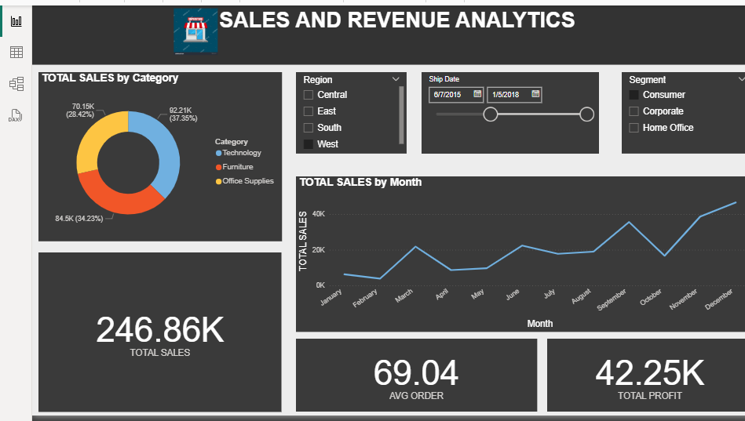

1. Donut Chart – Total Sales by Category

* Displays the distribution of total sales across three product categories:
  + Technology: 92.21K (37.35%)
  + Furniture: 84.5K (34.23%)
  + Office Supplies: 70.15K (28.42%)
* Insight: Technology is the leading category in terms of revenue.

**2. Line Chart – Total Sales by Month**

* Shows **monthly sales trend** over the selected date range.
* Helps identify **seasonal patterns**, peak months (e.g., December), and low sales periods (e.g., February).
* Insight: Sales are rising toward the end of the year, with strong peaks in October and December.

**3. KPI Cards:**

* **Total Sales:** 246.86K  
  → Represents the **total revenue** generated in the filtered time period.
* **Average Order Value:** 69.04  
  → Reflects the **mean value per order**, useful for pricing and sales volume strategies.
* **Total Profit:** 42.25K  
  → Indicates the **net profit** after costs.

**4. Slicers (Interactive Filters):**

* **Region Selector:** Central, East, South, West  
  → Lets users analyze sales data region-wise.
* **Ship Date Range:** 6/7/2015 – 1/5/2018  
  → Timeline filter for narrowing down the dataset.
* **Customer Segment:** Consumer, Corporate, Home Office  
  → Filters metrics based on the type of customer.

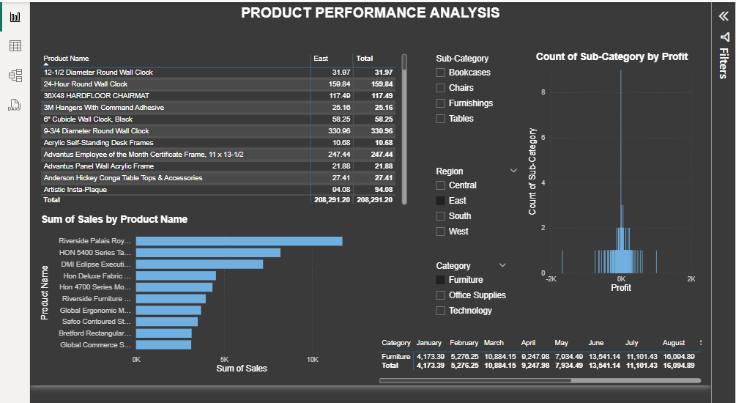

1. Table – Product Name-wise Sales by Region

* Lists individual products with sales figures split by the selected region (e.g., “East”).
* Helps identify top-selling and underperforming products in specific markets.
* Total sales for all listed products are aggregated at the bottom.

2. Bar Chart – Sum of Sales by Product Name

* A horizontal bar chart ranks products by total sales volume.
* Easily highlights top revenue-generating products, like:
  + Riverside Palais Royal (Highest)
  + HON 5400 Series Task Chairs
  + DMI Eclipse Executive Chairs
* Useful for stock planning and marketing focus.

**3. Column Chart – Count of Sub-Category by Profit**

* Shows the **number of product entries per sub-category**, plotted against **profit**.
* This chart helps detect **profit distribution** across different sub-categories like:
  + **Bookcases**
  + **Chairs**
  + **Furnishings**
  + **Tables**
* Outliers (very high or very low profits) can be visually identified.

**4. Filters (Slicers) for Dynamic Exploration**

* **Sub-Category Filter:** Allows narrowing down analysis by furniture sub-types.
* **Region Filter:** Enables comparison of product performance by geography.
* **Category Filter:** Switches between Furniture, Office Supplies, and Technology.

**5. Monthly Sales by Category Table (Bottom)**

* Displays sales by **month and category** for trend analysis:
  + **Furniture** has consistent performance from January to August.
  + Useful for analyzing **seasonal patterns** and category contribution over time

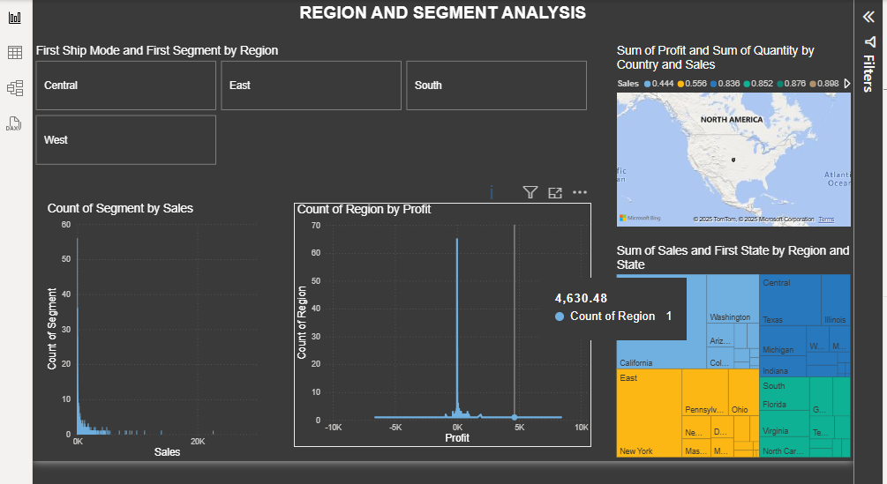

* **Region Tiles**: Quickly filter the report by region (Central, East, South, West).
* **Bar Charts**:

**Count of Segment by Sales**: Shows how many segments fall into different sales ranges.

* **Count of Region by Profit**: Highlights profitability distribution across regions.
* **Map Visual**: Plots **sum of profit and quantity by country**, focusing on North America.
* **Tree Map**: Shows **state-wise sales and region breakdown**, helping identify:
* High sales states like California, Texas, and New York.
* Which regions contribute most to total sales.

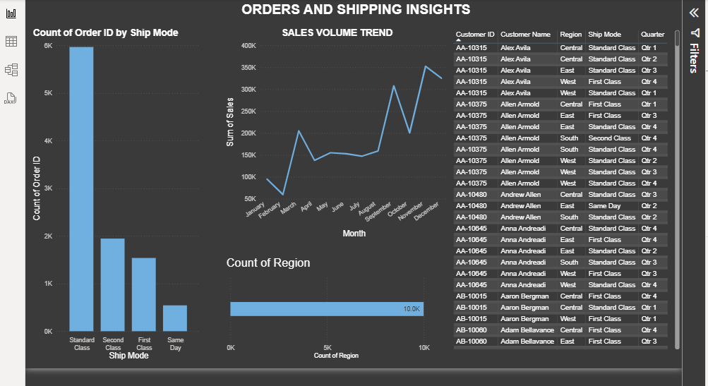

**📊 Count of Order ID by Ship Mode**:

* **Standard Class** dominates with the highest number of orders (~6K).
* Other modes: Second Class, First Class, and Same Day (least used).
* Helps assess **shipping preferences and logistics demand**.

**📈 Sales Volume Trend (Line Chart)**:

* Tracks **monthly sales** over the year.
* Noticeable peaks in **March, August, and December**, suggesting seasonal demand.
* Useful for **forecasting and planning inventory**.

**📍 Count of Region (Bar Chart)**:

* Measures **order distribution by region**.
* Shows the **total number of orders** from all regions (e.g., 10K overall).

**📋 Customer-Level Table**:

* Detailed view of each order with:
  + Customer ID and Name
  + Region
  + Ship Mode
  + Quarter of Order
* Enables **drill-down analysis** on customer behavior and order history.
* **Project GitHub Link:**

https://github.com/Roopika-Kadaverla/Major-project

**Learning and Reflection**

**New Learnings**

**Technology/Tools:**

* **Power BI (Desktop)**: Gained in-depth knowledge of designing interactive dashboards, using visuals such as bar charts, maps, KPIs, treemaps, and line charts.
* **DAX (Data Analysis Expressions)**: Learned to write complex DAX functions for creating custom measures like YoY Sales, Profit Ratio, and more.
* **Power Query Editor**: Improved data transformation and cleansing skills by handling nulls, renaming columns, data type changes, and filtering.

**Data Visualization & Design:**

* Learned best practices for choosing appropriate visuals for KPIs, trends, category-wise distribution, and geographical representation.
* Understood the importance of *color themes*, *dynamic tooltips*, and *slicers* to enhance dashboard interactivity and user experience.

**Project Management:**

* Developed self-discipline by independently planning the project flow, from requirement gathering to final dashboard publishing.
* Learned to prioritize visual storytelling and business-relevant metrics in report design.

**Overall Experience:**

* Working as a **solo contributor** on the MAJOR.pbix project was a rewarding experience that helped build both **technical** and **analytical** skills.
* The process helped me transition from simply analyzing data to telling a compelling **data story** using Power BI.
* Gained confidence in presenting insights from raw datasets to stakeholders through meaningful dashboards.
* This project has strengthened my foundation for a future role in **data analytics/business intelligence**, especially within MNC environments.

**Conclusion and Future Scope**

**Conclusion:**

The primary objective of this Power BI project was to **analyze business performance** through interactive dashboards and provide meaningful insights into sales, profit, orders, shipping, and regional contributions. Working independently, I successfully achieved the following:

* Developed **multi-page interactive dashboards** using Power BI, showcasing:
  + Year-over-Year (YoY) Sales Trends
  + Top-performing products and categories
  + Region-wise and segment-wise sales insights
  + Shipping cost analysis by mode and region
* Implemented advanced **DAX functions** to create custom KPIs and calculated measures.
* Integrated **filters/slicers, dynamic tooltips**, and conditional formatting to enhance dashboard interactivity and usability.
* Cleaned and transformed data using **Power Query Editor**, ensuring accuracy and reliability in reporting.

**Future Scope**

To enhance this project further, several future improvements and expansions are possible:

* **Real-time Data Integration**: Connect with live data sources (SQL databases, APIs, Excel on OneDrive) to allow real-time dashboard updates.
* **Predictive Analytics**: Integrate forecasting using **Power BI’s AI visuals** (like decomposition tree, forecasting, and Q&A) for sales predictions and trends.
* **User Role-Based Dashboards**: Implement row-level security to create customized views for different business roles (e.g., Sales Manager vs. CEO).
* **Mobile Optimization**: Design mobile-friendly layouts to make dashboards accessible across devices.
* **Export & Alerts**: Enable automated email reports or alerts based on thresholds (e.g., low sales, high shipping costs).
* **Data Expansion**: Include additional data such as customer demographics, marketing spend, or competitor pricing for richer analysis.