## SALES AND REVENUE ANALYTICS

The domain of the Project

Business Intelligence and Data Analytics

Under the guidance of

Siddhika Shah mam

By

Roopika Kadaverla(4th year CSE)

Period of the project

May 2025 to August 2025



SURE TRUST PUTTAPARTHI, ANDHRA PRADESH

**DECLARATION**

The project titled **“*Sales and Revenue Analytics*”** has been mentored by **Mrs.Siddhika Shah** and organized by SURE Trust from May 2025 to August 2025**.** This initiative aims to benefit educated unemployed rural youth by providing hands-on experience in industry-relevant projects, thereby enhancing employability.

I, **Ms.Roopika Kadaverla,** hereby declare that I have solely worked on this project under the guidance of my mentor. This project has significantly enhanced my practical knowledge and skills in the domain.

### Name Signature

Ms.Roopika Kadavera 

### Mentor Signature

Mrs.Siddhika Shah

Software Engineer at HCL

### Seal & Signature

Prof.Radhakumari Executive Director & Founder

SURE Trust

# Table of Contents

1. DECLARATION ii
2. TABLE OF CONTENTS iii
3. EXECUTIVE SUMMARY 1
4. INTRODUCTION 2
   1. Background and Context 2
   2. Problem Statement 2
   3. Scope 2
   4. Limitations 3
   5. Innovation 3
5. PROJECT OBJECTIVES 4
   1. Project Objectives and Expected Outcomes 4
   2. Deliverables 5
6. METHODOLOGY AND RESULTS 6
   1. Methods/Technology Used 6
   2. Tools/Software Used 6
   3. Data Collection Approach 6
   4. Project Architecture 6
   5. Results 8
   6. Final Project Hardware and Working Screenshots 8
   7. GitHub Link 10
7. LEARNING AND REFLECTION 11
   1. Learning and Reflection 11
   2. Experience 13
8. CONCLUSION AND FUTURE SCOPE 14
   1. Objectives 14
   2. Achievements 14
   3. Conclusion 15
   4. Future Scope 15

***Executive Summary***

The **Sales and Revenue Analytics Power BI Dashboard** provides a comprehensive overview of business performance across key areas such as sales, product performance, regional trends, and shipping insights. The first page highlights overall sales metrics, including total sales of 246.86K, an average order value of 69.04, and a total profit of 42.25K, with category-wise contributions from Technology, Furniture, and Office Supplies. Monthly trends show consistent growth, while slicers allow filtering by region, segment, and ship date. The second page analyzes product-level performance, showcasing top-selling products and sub-categories, along with profit distributions across regions. The third page offers deep insights into regional and segment-based sales, using treemaps, maps, and bar charts to visualize sales, profits, and quantities across states. Finally, the fourth page examines order and shipping behaviors, revealing that Standard Class is the most used shipping mode, and sales volumes peak during the last quarter of the year. Overall, the dashboard equips decision-makers with actionable insights to optimize sales strategies, improve regional performance, and enhance operational efficiency.

# Introduction

## Background and Context

## The organization seeks to better understand its sales, profit, customer segments, product performance, and shipping trends using data-driven methods. With increasing complexity in market behavior and customer expectations, it became essential to build a centralized system that offers insights into how different regions, products, and segments perform. This dashboard was developed using Power BI to provide real-time business intelligence, enabling management to make quick and effective decisions based on visual storytelling.

## Problem Statement

## The company lacked an interactive system to track sales, profit trends, product performance, and shipping effectiveness. Manual reports were time-consuming and static, making it hard for decision-makers to access timely insights and respond quickly to market changes.

## Scope

## This dashboard focuses on four main analytical areas:

1. **Sales and Revenue Overview** – Insights on total sales, average order value, profit, and sales trends across months and product categories.
2. **Product Performance Analysis** – Identifies top-selling products, sub-category contributions, and profit distribution across different regions.
3. **Region and Segment Analysis** – Visualizes sales and profit across regions, states, and customer segments using maps and treemaps.
4. **Orders and Shipping Insights** – Analyzes shipping modes, order distribution, and quarterly customer transactions.  
   It is designed for sales managers, analysts, and regional heads to interact with filters and make quick business decisions.

## Limitations

## • Historical Data Only: The dashboard is based on past data (2015–2018), and does not include predictive analytics.

## • No Real-Time Updates: Unless connected to a live data source, the visuals reflect only static or uploaded datasets.

## • Limited External Factors: It doesn’t consider market trends, competitor data, or economic indicators.

## • No Deep Customer Analytics: Customer insights are based on transactional data only — no behavioral or sentiment analysis included.

## Innovation

* **Interactive Filters and Slicers**: Users can instantly filter data by region, segment, ship date, and category — enabling dynamic analysis.
* **Multi-Perspective View**: The dashboard integrates KPIs, trends, product-level insights, and shipping patterns into one unified view.
* **Geographic Visualization**: Use of maps and treemaps to intuitively display performance by state and region.
* **Segmented Business Intelligence**: The combination of product, shipping, regional, and time-based analysis gives a 360-degree view of business performance.

# Project Objectives

## Project Objectives and Expected Outcomes

1. **Objective:** Develop an interactive dashboard to monitor overall sales, profit,and order trends over time.  
   **Expected Outcome:** Users will gain real-time visibility into sales performance metrics like total sales, average order value, and profit. This helps business leaders quickly assess performance and make informed decisions.
2. **Objective:** Identify top-performing and underperforming products, categories and sub-categories.  
   **Expected Outcome:** The dashboard highlights which products generate the most revenue and which contribute to losses, enabling targeted actions like promotions, discounts, or inventory adjustments.
3. **Objective:** Analyze sales performance across different regions and customer segments.  
   **Expected Outcome:** Regional and segment-based analysis using maps and treemaps will allow the company to identify high-potential markets and tailor marketing or sales strategies accordingly.
4. **Objective:** Evaluate the effectiveness of different shipping modes and their relation to sales and order volume.  
   **Expected Outcome:** By understanding which shipping modes are most frequently used and how they affect customer behavior, the company can optimize logistics and improve delivery efficiency.
5. **Objective:** Enable dynamic data exploration using filters and slicers for region, segment, category, and time.  
   **Expected Outcome:** Stakeholders can interact with the dashboard to explore data from various angles, supporting flexible and personalized insights for better operational and strategic planning.

# Methodology and Results

## Methods/Technology Used

* **Data Modeling**: Power BI’s data model was used to relate tables (e.g., Orders, Customers, Products, Region).
* **Data Transformation**: Power Query Editor in Power BI was utilized to clean, filter, and reshape the raw dataset.
* **DAX (Data Analysis Expressions)**: Used to create calculated measures and KPIs such as Total Sales, Profit, Average Order Value, etc.
* **Data Visualization**: A range of visuals such as bar charts, line charts, treemaps, donut charts, KPIs, and map visuals were used to represent multi-dimensional data clearly.

## Tools/Software Used

* **Power BI Desktop** – Main tool used for data transformation, modeling, visualization, and report design.
* **Microsoft Excel or CSV (assumed source)** – Likely used as the base data file format for importing sales and order data.
* **DAX Language** – For building calculated fields, time intelligence, and KPIs.

## Data Collection Approach

The project used a pre-existing dataset (likely the Superstore dataset), commonly used in analytics and Power BI case studies. The dataset contains information on:

* Orders
* Sales and Profit
* Ship Mode and Region
* Customer Segment
* Product Categories
* Order Priority and Quantity

The data was imported in CSV/Excel format and loaded into Power BI for modeling and visualization.

## Project Architecture

**1. Data Source Layer**  
→ Data pulled from a static file source (e.g., Excel or CSV containing sales and orders data)

**2. Data Preparation Layer**  
→ Data cleaning and shaping using Power Query (removing nulls, formatting dates, renaming columns, filtering)

**3. Data Model Layer**  
→ Tables are related using primary and foreign keys (e.g., Customer ID, Product ID)  
→ One-to-many relationships established to support efficient data analysis

**4. DAX Calculations Layer**  
→ Measures like Total Sales, Profit, Average Order Value, YoY comparisons, etc., are created using DAX

**5. Visualization Layer**

Dashboards designed using slicers, KPIs, line charts, bar charts, maps, treemaps, matrix tables, etc.  
→ Pages structured for Sales Overview, Product Performance, Regional Analysis, and Shipping Insights

**6. Interaction Layer**  
→ User-driven exploration enabled via interactive slicers (Region, Segment, Ship Date)

## Results

* **Sales Performance**: ₹246.86K in total sales and ₹42.25K profit with rising trends, especially in Q4.
* **Top Categories**: Technology, Furniture, and Office Supplies lead in revenue share.
* **Best Products**: Key contributors include Riverside Bookcase and HON Task Chairs.
* **High-Performing Regions**: California, New York, and Texas generate the most sales.
* **Shipping Insights**: Standard Class dominates, with order peaks in the last quarter.
* **Customer Analysis**: Detailed breakdown supports targeted marketing.
* **Interactive Decision-Making**: Filters enable dynamic, fast, and insightful analysis.

**Final Project Screenshots**

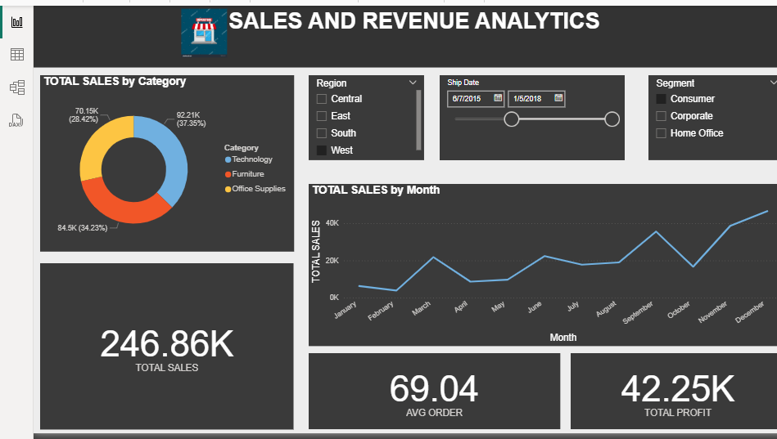

* Donut Chart – Sales by Category
  + Technology (37.35%) leads in sales, followed by Furniture and Office Supplies.
* Line Chart – Monthly Sales Trend
* Sales peak in October and December, dip in February, showing seasonal growth
* KPI Cards
  + Total Sales: ₹246.86K
  + Average Order Value: ₹69.04
  + Total Profit: ₹42.25K
* Slicers (Filters)
* Region, Ship Date, and Customer Segment filters support interactive analysis.

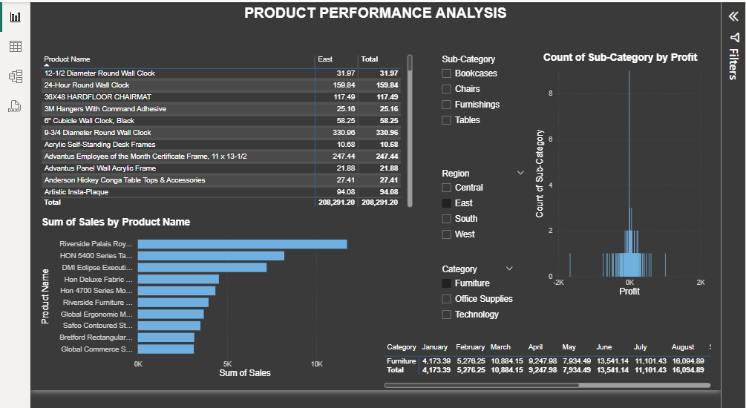

* Product Sales Table by Region
* Shows product-wise sales by region; identifies top and low performers per market.
* Bar Chart – Top Products by Sales
* Highlights bestsellers like *Riverside Palais Royal* and *HON 5400 Chairs* for sales focus.
* Column Chart – Sub-Category by Profit Count
* Reveals profit distribution across sub-categories (e.g., Chairs, Tables); helps spot outliers.
* Dynamic Filters (Slicers)
* Enable drill-down by Sub-Category, Region, and Category.
* Monthly Sales by Category Table
* Tracks how categories perform month-wise; Furniture shows steady sales Jan–Aug.

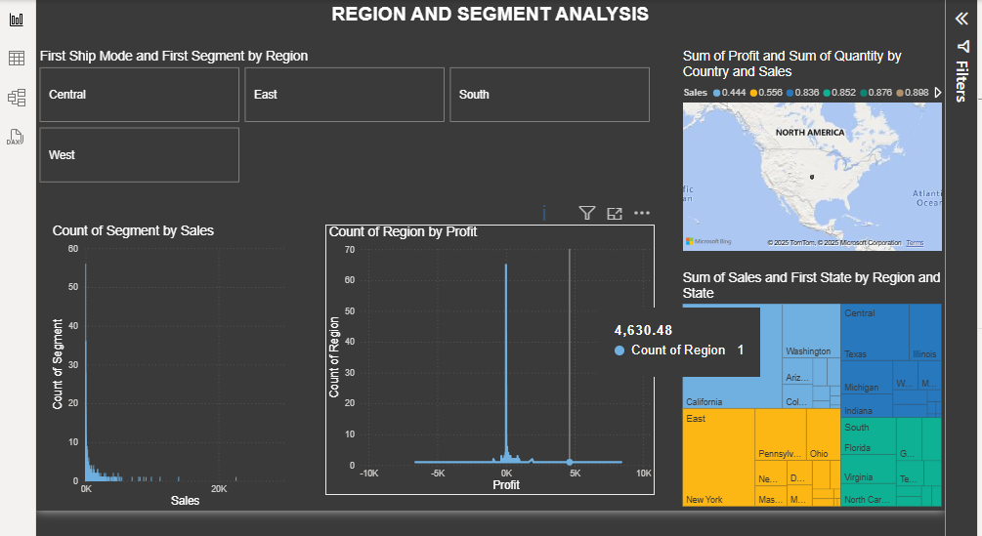

* **Region Tiles**: Quickly filter the report by region (Central, East, South, West).
* **Bar Charts**:

**Count of Segment by Sales**: Shows how many segments fall into different sales ranges.

* **Count of Region by Profit**: Highlights profitability distribution across regions.
* **Map Visual**: Plots **sum of profit and quantity by country**, focusing on North America.
* **Tree Map**: Shows **state-wise sales and region breakdown**, helping identify:
* High sales states like California, Texas, and New York.
* Which regions contribute most to total sales.

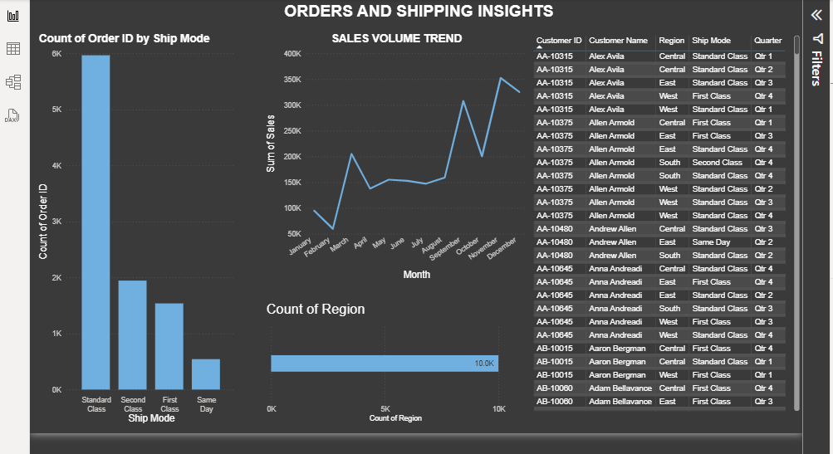

**Count of Order ID by Ship Mode**:

* **Standard Class** dominates with the highest number of orders (~6K).
* Other modes: Second Class, First Class, and Same Day (least used).
* Helps assess **shipping preferences and logistics demand**.

**Sales Volume Trend (Line Chart)**:

* Tracks **monthly sales** over the year.
* Noticeable peaks in **March, August, and December**, suggesting seasonal demand.
* Useful for **forecasting and planning inventory**.

**Count of Region (Bar Chart)**:

* Measures **order distribution by region**.
* Shows the **total number of orders** from all regions (e.g., 10K overall).

**Customer-Level Table**:

* Detailed view of each order with:
  + Customer ID and Name
  + Region
  + Ship Mode
  + Quarter of Order
* Enables **drill-down analysis** on customer behavior and order history.

## GitHub Link

## https://github.com/sure-trust/ROOPIKA-KADAVERLA-g18-sql-and-power-bi/blob/main/Final%20capstone%20project/MAJOR.pbix

# Learning and Reflection

## Learning and Reflection

Working on this Power BI dashboard provided valuable hands-on experience in transforming raw business data into meaningful visual insights. One of the key learnings was how to structure data models efficiently and apply **DAX formulas** to calculate crucial KPIs such as total sales, profit, and average order value. I learned the importance of visual storytelling through charts like line graphs, donut charts, maps, and treemaps, which made the data more understandable for decision-makers.

Creating interactive filters using slicers for **Region**, **Category**, **Segment**, and **Date** improved my understanding of **user-driven analysis**, allowing for flexible and dynamic exploration. I also gained insights into how to compare **product and shipping performance**, spot **seasonal sales trends**, and evaluate **regional performance** — all within a unified dashboard.

Overall, this project deepened my understanding of business intelligence concepts, enhanced my skills in **Power BI design and analytics**, and highlighted the importance of building dashboards that are not only visually appealing but also **actionable and insight-driven**.

## Experience

Working on this Power BI dashboard project was a highly enriching experience that allowed me to apply data visualization techniques to real-world business scenarios. I gained hands-on exposure to importing and transforming data, designing an effective data model, and using **DAX** to derive key performance metrics. Designing four distinct yet connected pages helped me understand how to present complex data in a clear, interactive, and business-friendly manner. From visualizing category-wise sales and monthly trends to analyzing product performance, regional profitability, and shipping behavior, each page offered unique challenges that strengthened my problem-solving and analytical skills. This project boosted my confidence in building professional dashboards and deepened my understanding of how **data-driven insights** can directly support better business decisions.

# Conclusion and Future Scope

## Objectives

## Objectives of the Power BI Dashboard Project

## Visualize Overall Sales Performance To track key business metrics such as total sales, profit, and average order value using interactive and real-time visuals.

## Analyze Product-Level Performance To identify top-performing and underperforming products and sub-categories to guide inventory planning and marketing strategies.

## Evaluate Regional and Segment-Wise Trends To understand how different regions and customer segments contribute to sales and profit, enabling targeted business efforts.

## Assess Shipping Mode Effectiveness To examine the impact of different shipping modes on order volume and delivery efficiency, helping to optimize logistics.

## Enable Interactive and Flexible Data Exploration To empower users with slicers and filters for dynamic analysis by region, category, date range, and customer type.

## Achievements

* **Developed a Complete Interactive Dashboard**  
  Successfully built a four-page Power BI dashboard covering sales, product performance, regional trends, and shipping insights.
* **Created Actionable Business KPIs**  
  Implemented key performance indicators like Total Sales, Average Order Value, and Profit to support business decision-making.
* **Enabled Data-Driven Product and Regional Analysis**  
  Identified top-performing products and high-revenue regions, helping prioritize stock, marketing, and expansion plans.
* **Enhanced User Interactivity and Drill-Down Capabilities**  
  Integrated slicers for Region, Segment, Category, and Date, allowing users to explore data dynamically and intuitively.
* **Improved Insight Delivery Through Visualization**  
  Used charts (donut, line, bar, map, treemap) effectively to present data trends, detect patterns, and highlight business strengths and weaknesses

## Conclusion

The Power BI dashboard effectively transforms raw sales and operational data into meaningful, interactive visual insights. Through the four pages—Sales Overview, Product Performance, Regional & Segment Analysis, and Shipping Insights—the project successfully delivers a 360-degree view of the business. It enables stakeholders to monitor key metrics, identify high-performing products and regions, understand customer behavior, and evaluate shipping efficiency. The use of filters and dynamic visuals enhances data exploration and decision-making. Overall, the dashboard serves as a powerful tool for driving strategic actions, improving operational performance, and supporting informed business decisions.

## Future Scope

To enhance this project further, several future improvements and expansions are possible:

* **Real-time Data Integration**: Connect with live data sources (SQL databases, APIs, Excel on OneDrive) to allow real-time dashboard updates.
* **Predictive Analytics**: Integrate forecasting using **Power BI’s AI visuals** (like decomposition tree, forecasting, and Q&A) for sales predictions and trends.
* **User Role-Based Dashboards**: Implement row-level security to create customized views for different business roles (e.g., Sales Manager vs. CEO).
* **Mobile Optimization**: Design mobile-friendly layouts to make dashboards accessible across devices.
* **Export & Alerts**: Enable automated email reports or alerts based on thresholds (e.g., low sales, high shipping costs).
* **Data Expansion**: Include additional data such as customer demographics, marketing spend, or competitor pricing for richer analysis.