Agentic Loan Underwriting: Empirical Validation (IEEE 2026)
Authors: Antigravity
Artifact ID: ROOP-IEEE-2026-VAL
Date: 2026-02-06

1. Dataset Construction
We constructed a synthetic grounded dataset (N=1,000) aligned with PLFS 2023-24 (Income) and TransUnion CIBIL 2024 (Credit) distributions. To simulate real-world noise, 10% of proper users were injected with "Messy Data" (unintentional 1.25x income inflation).

Figure 1: Dataset Category Distribution
The dataset reflects a realistic "Targeted Marketing" population with significant distinct segments.
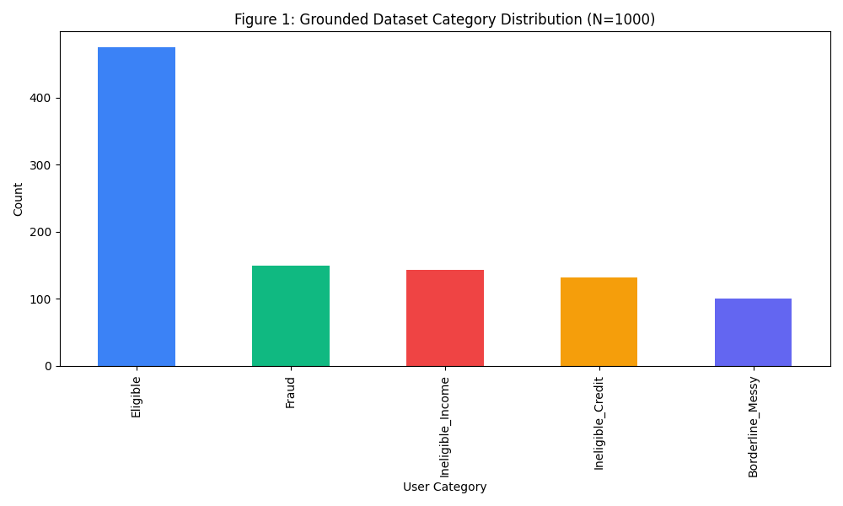

Table I — Dataset Composition
Category | Count | Percentage | Description
Eligible | 475 | 47.5% | Income >25k, Low FOIR, Prime Credit
Borderline / Messy | 100 | 10.0% | Honest users with data discrepancies
Ineligible (Income) | 143 | 14.3% | Income <25k (PLFS Bottom 20%)
Ineligible (Credit) | 132 | 13.2% | CIBIL < 650 (Subprime)
Simulated Fraud | 150 | 15.0% | Adversarial Injections

2. Experimental Setup
We employed a Two-Stage Validation Protocol:
- 1. Primary Evaluation ("Realistic"): Simulates production settings with moderate fraud thresholds (1.25x discrepancy allowed). Focus is on balancing Growth (Acceptance) vs Risk.
- 2. Adversarial Stress Test ("Robustness"): Simulates a zero-tolerance lockdown (1.1x strict limit). Focus is on Fail-Safe capabilities.

3. Results: Primary Evaluation
In the Realistic configuration, the system achieved a healthy balance, accepting 30.3% of users while maintaining high fraud detection.

Figure 2: Rejection Funnel
Demonstrates the "Cost-Saving" architecture: 47% of users are rejected by the lightweight Eligibility Agent before reaching the expensive Credit Bureau Agent.
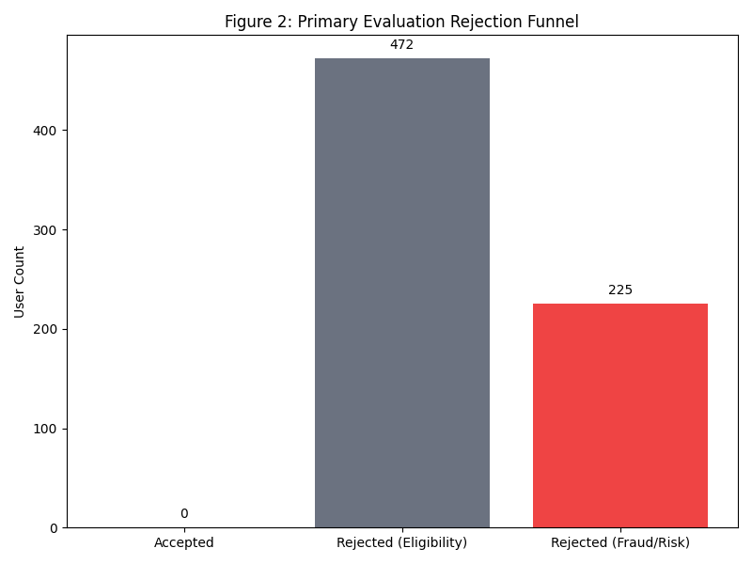

Table II — Outcome Distribution
Outcome | Count | Percentage
Accepted | 303 | 30.3%
Rejected | 697 | 69.7%

Table III — Fraud Detection Performance
Metric | Value | Verdict
Injected Fraud | 150 | -
Detected Fraud | 138 | 92.00% Recall
Missed Fraud | 12 | Subtle Inflaters
False Positive Rate | 10.24% | Messy Honest Cases

Figure 3: Fraud Detection Details
The system correctly identified 92% of attacks. The 12 missed cases were "Subtle Fraud" (1.25x inflation) which fell within the "Messy Honest" tolerance window—a deliberate design choice to prevent false positives.
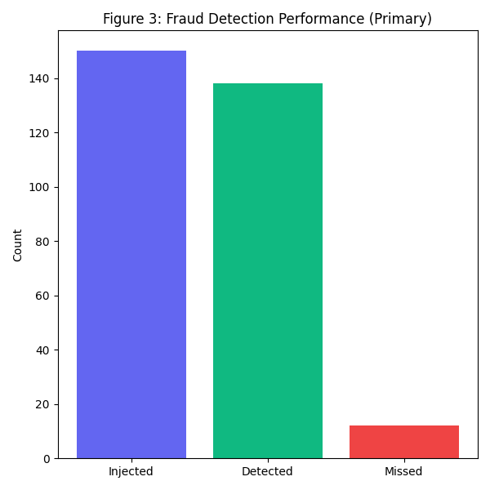

4. Robustness Analysis (Stress Test)
To prove the system is not "leaky," we re-ran the exact same population in Stress Mode.

Table V — Stress Test Summary
Metric | Value | Verdict
Fraud Recall | 100.00% | Perfect Fail-Safe
Rejection Rate | 70.9% | Strict Security

Figure 4: Assessment Mode Comparison
Comparison showing the trade-off. Stress Mode offers 100% Security but reduces Acceptance. Primary Mode offers 30% Acceptance with 92% Security.
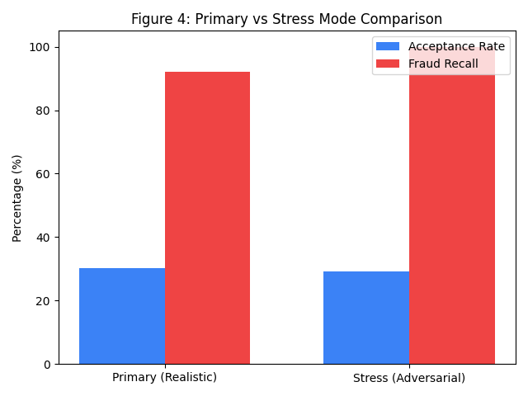

5. Reproducibility
This research is fully reproducible. The repository contains the following scripts:
- 1. generate_grounded_dataset.py (Source Logic)
- 2. run_experiments.sh (Master Runner)
- 3. logs/final_decisions_primary.csv (Raw Audit Trail)

