Transaction processing

Transaction:
It is the atomic unit of work that is either completed in its entirety or not at all.
It may also be defined as the unit or piece of program execution that accesses and possibly updates the various data items.
Operations recorded by the recovery manager from beginning to end of transaction are:
o Begin_transaction: notes the start of transaction.
o Read/write: specify read or write operation on database.
o End transaction: specify read or write has ended and transaction has ended. At this point,it is necessary to check whether the transaction should be committed or aborted.
o Commit_transaction: signals successful end of transaction.
o Rollback or abort: signals successful transaction.
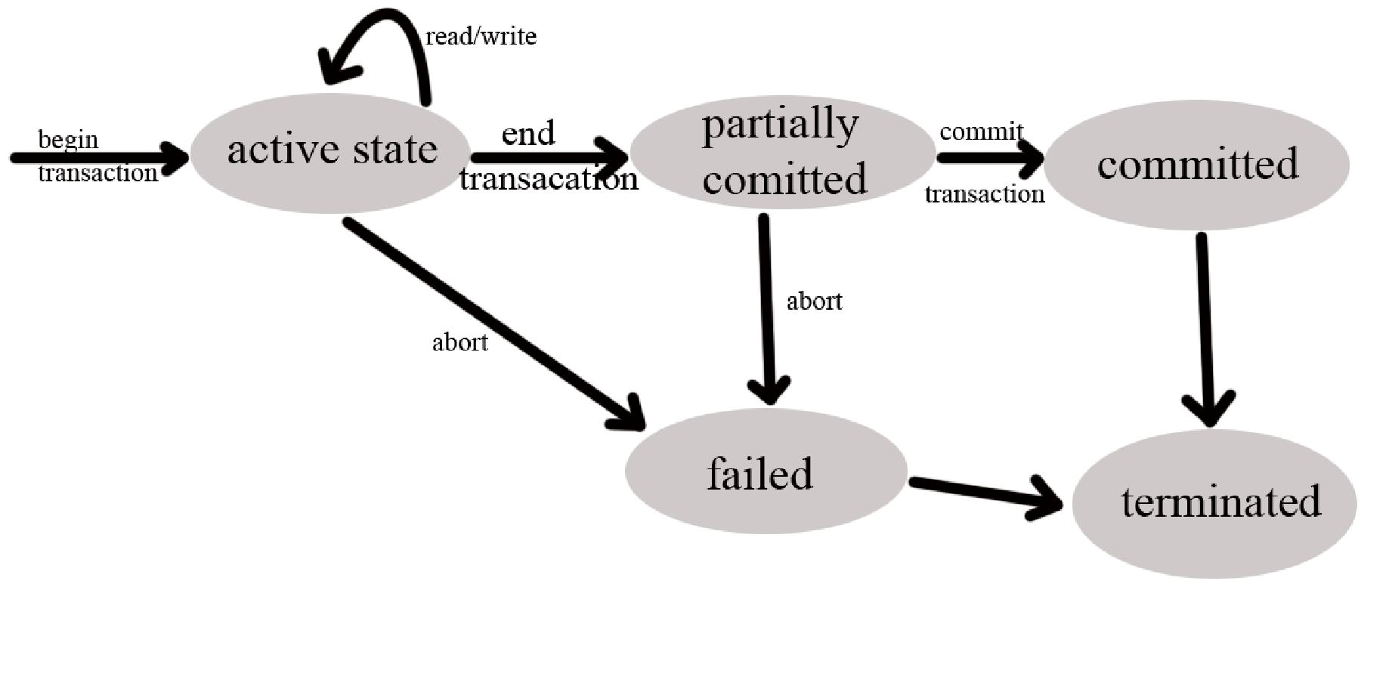
FIG: State transition diagram illustrating the state of transaction execution.

- Active state: It is an initial state. The transaction stays in this state until while it is still executing. A transaction is terminated only if it has either been committed or aborted.
- Partially Committed: After the final statement has been executed. At this point, failure is still possible since changes may have been only done in main memory, a hardware failure still could occur.
- Committed: Once committed, the transaction can no longer be undone by aborting it.
- Failed: Once a transaction cannot be completed, any changes that it made must be undone rolling it back.
- Aborted: After the transaction have been rolled back, the database has been restored to its store prior to the start of the transaction.

Desirable properties of transaction:
To ensure integrity of data, we require the database system maintain the following properties of the transaction.
1. Atomicity: either all operations of a transaction are reflected in database or none.
2. Consistency: execution of a transaction in isolation preserves consistency of database.
3. Isolation: even though multiple transactions are executing concurrently, each transaction is unaware of other transaction.
4. Durability: after a transaction completes, the changes it has made persists. These properties are also called ACID properties.

Concurrent Execution:
- DBMS usually allow multiple transactions to run at once.
- The transaction could by run serially (one after another) or they could be interleaved(switching back and forth between transactions)

Example:
Let, Ti: read(A); A:A-50; Write(); Read(B); B:B+50; Write(B);

Consistency:
- In this case consistency requirement here is that the total sum of A and B should always be same i.e. before and after the transaction is executed. In this case consistency property of the transaction prevents the unwanted creation of a destroying of money.
- Ensuring consistency for an individual transaction is the responsibility of the application programmer who codes the transaction.

Atomicity:
- Suppose that failure occur after write(A) operation but before write(B) operation.
- Hence the values reflected in the database becomes A=950 and B=2000, which is not the true value.
- Hence transaction should be completed in its entirety of not at all.

Durability:
- Once the execution of the transaction completed successfully and the user who initiated the transaction has been notified that the transfer of the fund has taken place, it must be the case that no system failure will result in a loss of data corresponding to this transfer of funds.

Isolation:
- Let a transaction T1 transfer Rs 50 from account A to B. While T1 reads and subtracts 50 from account A but before it was updated to account B a new transaction (T2) interrupts which reads from account A and B. the value read by transaction T2 is A=950 and B=2000 (initial values of A=1000 and B=2000).
- Hence in order to maintain consistency isolation of transaction is required. In order to maintain isolation serial execution of transaction and use of concurrency control mechanism should be used.

Implementation of Atomicity and Durability:
Shadow copy scheme.
Assume:
- Only one transaction is active at a time.
- Database is simply a file on disk.

- If transaction completes successfully, it is updated in the new copy and then db-pointer is updated. Now this new copy becomes the current copy of database and old copy is deleted.
- If transaction is unsuccessful, then new copy is deleted and old copy is again the current one.
- The implementation actually depends on the write to db-pointer being atomic.i.e either all its bytes are written or none of its bytes are written.
Drawbacks:
- Implementation is extremely inefficient in the context of large database since executing single transaction requires copying the entire database.
- Does not allow transaction to execute concurrently.
Schedules:
- DBMS needs to make sure that all transaction schedules preserve the consistency of the database.
- A schedule is the chronological order in which instructions are executed in a system.
- A schedule for a set of transaction must consist of all the instruction of those transactions and must preserve the order in which the instructions appear in each individual transaction.

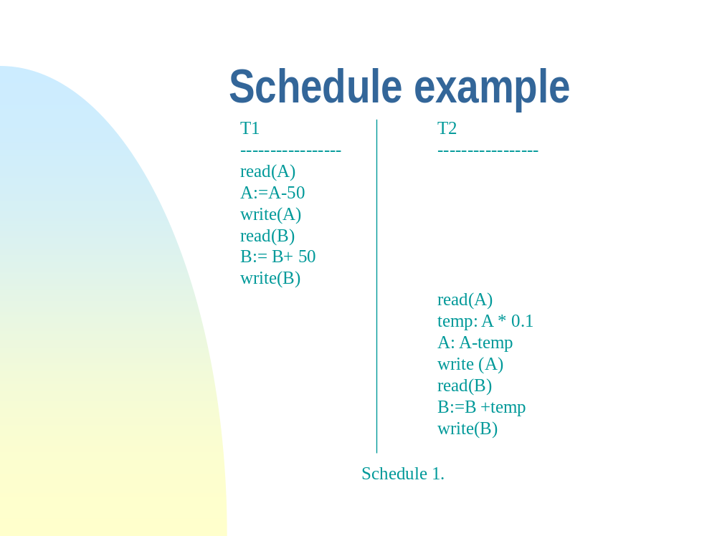

Fig: Schedule 1

In the schedule shown above consistency by transferring Rs50 from account A to account B is preserved. Since (A+B)initial =(A+B) final

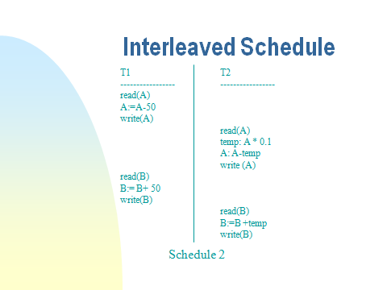

Fig: schedule 2

Similarly, if the order of execution of transaction is reversed.i.e. execute T2 first and then execute
T1, then also (A+B)initial =(A+B) final
Hence consistency of data is preserved.
Here
(A+B)initial =(A+B) final
Hence consistency is preserved.

Conflict Equivalent:
- Schedule 1 and 2 produce the same result even though they have different sequence.
- It could be shown that Schedule 2 could be transform into Schedule 1 with a sequence of swaps, so Schedule 1 and 2 conflict equivalent.
- Not all schedules are conflict equivalent. Consider Schedule 3.

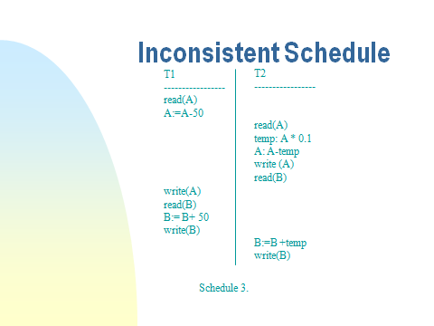

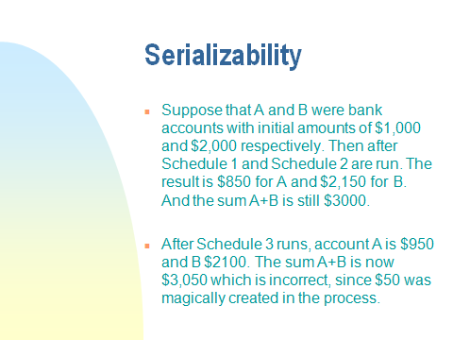.
Serializability

Basic Assumption – Each transaction preserves database consistency. Thus serial execution of a set of transactions preserves database consistency. A (possibly concurrent) schedule is serializable if it is equivalent to a serial schedule. Different forms of schedule equivalence give rise to the notions of:
- Conflict Serializable
- View Serializable

- Conflict Serializable:
- We ignore operations other than read and write instructions, and we assume that transactions may perform arbitrary computations on data in local buffers in between reads and writes.
- Our simplified schedules consist of only read and write instructions.
- Instructions li and lj of transactions Ti and Tj respectively, conflict if and only if there exists some item Q accessed by both li and lj, and at least one of these instructions wrote Q.
1. li = read(Q), lj = read(Q). li and lj don’t conflict.
2. li = read(Q), lj = write(Q). They conflict.
3. li = write(Q), lj = read(Q). They conflict
4. li = write(Q), lj = write(Q). They conflict

- Intuitively, a conflict between li and lj forces a (logical) temporal order between them.
- If li and lj are consecutive in a schedule and they do not conflict, their results would remain the same even if they had been interchanged in the schedule. Schedule 3 can be transformed into Schedule 6,
- a serial schedule where T2 follows T1, by series of swaps of non-conflicting instructions.

Schedule 3 schedule 6

Therefore Schedule 3 is conflict serializable.

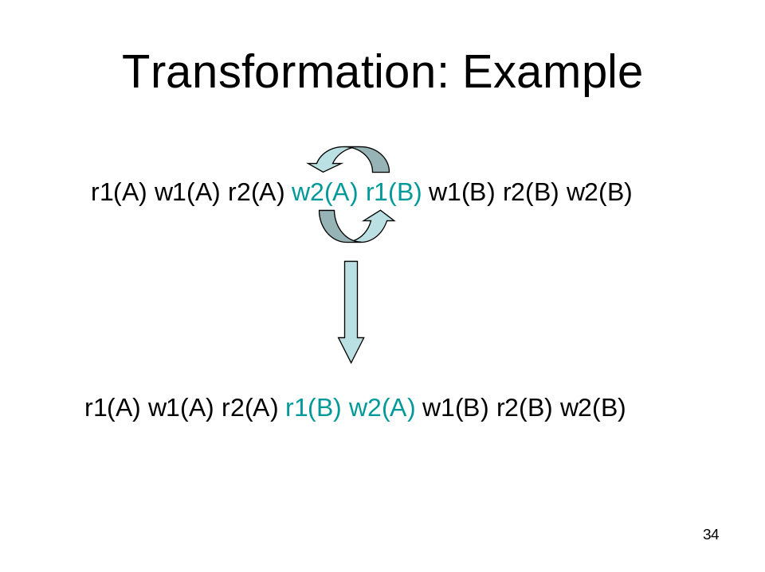
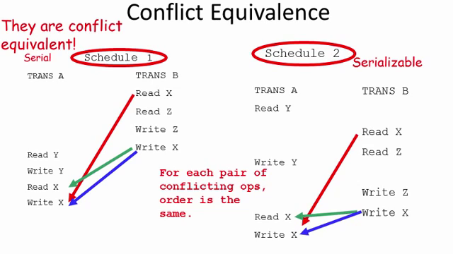

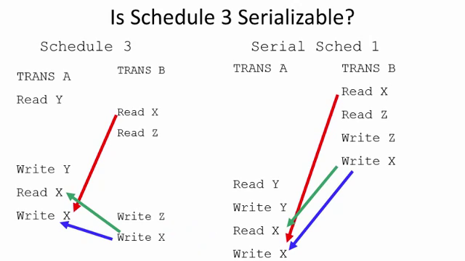

- View Serializability:

Schedules S1 and S2 are view equivalent:

- If Ti reads initial value of A in S1, then Ti also reads initial value of A in S2.
- If Ti reads value of A written by Tj in S1, then Ti also reads value of A written by Tj in S2.
- If Ti writes final value of A in S1, then Ti also writes final value of A in S2.

Schedule:s1 Schedule:s2
T1:R(A) W(A)  T2: W(A)  T3: W(A) | T1:R(A)W(A)  T2: W(A)  T3: W(A)

Testing for Serializability:
Consider some schedule of a set of transactions T1, T2, ..., Tn. Precedence graph — a direct
graph where the vertices are the transactions (names).We draw an arc from Ti to Tj if the two transaction conflict, and Ti accessed the data item on which the conflict arose earlier. We may label the arc by the
item that was accessed.

For example, the precedence graph for schedule 1 contains the single stage T1 T2, since all the instructions of T1 are executed before the first instruction of the T2 transaction and hence the precedence graph of the schedule 1 becomes fig (a) as shown above. Similarly if T2 is followed by T1 then the precedence graph becomes fig (b). Since both fig doesn’t have cycle, they are conflict serializable.

