Pushdown Automata
Introduction:

The context free languages have a type of automaton that defines them. This automaton is called “pushdown automaton” which can be thought as a Є-NFA with the addition of stack. The presence of a stack means that, the pushdown automata can remember infinity amount of information. However, the pushdown automaton can only access the information on its stack in a Last-in-first-out way.

Thus, PDA is an abstract machine determined by following three things:
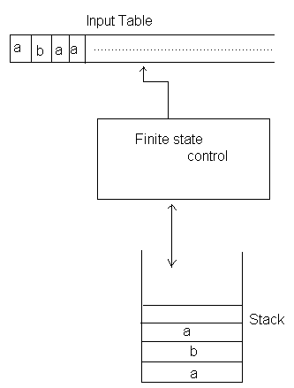
- Input table
- Finite stack control
- A stack

Each moves of the machine is determined by three things;
- The current state
- Next input symbol
- Symbol on the top of stack

The moves consist of;
- Changing state | staying on same state
- Replacing the stack top by string of zero or more symbols.

Popping the top symbol off the stack means replacing it by Є.

Pushing Y on the stack means replacing stack’s top, say X, by YX. Assuming the left end of stack corresponds to stack‘s top. The single move of the machine contains only one stack operation either push or pop.

Replacing the stack symbol X by the string α can be accomplished by a sequence of basic moves (a pop followed by sequence of 0 or more pushes).

Formal Definition:

A PDA is defined by seven tuples;
(Q, Σ, Г, δ, q₀, z₀, F)
Where,
Q- Finite set of states.
Σ- Finite set of input symbols | alphabets.
Г- Finite set of stack alphabet
q₀- Start state of PDA q₀ ε Q
z₀- Initial stack symbol; z₀ ε Г
F- Set of final states; FQ
δ- Transition function that maps;
Q × (Σ U {Є}) × Г → Q × Г*
Thus, moves of PDA can be interpreted as;
δ(q, a, z) = {(P₁, r₁) (p₂, r₂) …………….(p_{m}, r_{m})} here q, p_{i} ε Q, a ε Σ & z ε Г, r_{i} ε Г*

Let us trace for w= aabbbaab

S.N State unread string Stack Transition Used
1 q₀ aabbbaab Є --
2 q₁ aabbbaab z₀ 1
3 q₁ abbbaab a z₀ 2
4 q₁ bbbaab aa z₀ 4
5 q₁ bbaab a z₀ 7
6 q₁ baab z₀ 7
7 q₁ aab b z₀ 3
8 q₁ ab z₀ 6
9 q₁ b az₀ 2
10 q₁ Є z₀ 7
11 q₂ Є Є 8

Finally we have q₂ state. Hence accepted.

Try for abbaba

Graphical notation of PDA

We can use transition diagram to represent a PDA, where
- Any state is represented by a node in graph (diagram)
- Any arc labeled with “start” indicates the start state and doubly circled states are accepting / final states.
- The arc corresponds to transition of PDA as:
  - Arc labeled as a, x | α means;
δ(q, a, x) = (p,α) for arc from state p to q.

It means that the PDA in state q with input symbol a and stack top z will go into state p_{i} and replace z by r_{i} and advances a next input symbol.
If a = Є
δ(q, Є, z) = (p, Є)

A PDA accepting a string over {a, b} such that number of a’s and b’s are equal.
i.e. L={w | w ε {a, b}* and a’s and b’s are equal}.
For this, let us construct a PDA as;
P = {Q, Σ, Г, δ, q₀, z₀, F} be the PDA recognizing where, let us suppose
Q = {q₀, q₁, q₂}
Σ = {a, b}
Г = {a, b, z₀}
z₀ = z₀
q₀ = q₀
F = {q₂}
Now δ is defined as;
- δ(q₀, Є, Є) = (q₁, z₀)
- δ(q₁, a, z0) = (q₁, az₀)
- δ(q₁, b, z0) = (q₁, bz₀)
- δ(q₁, a, a) = (q₁, aa)
- δ(q₁, b, b) = ( q₁, bb)
- δ(q₁, a, b) = (q₁, Є)
- δ(q₁, b, a) = (q₁, Є, a)
- δ(q₁, Є, z0) = (q₂, Є)
So, the graphical notation for the PDA constructed in example 1 can be constructed as;
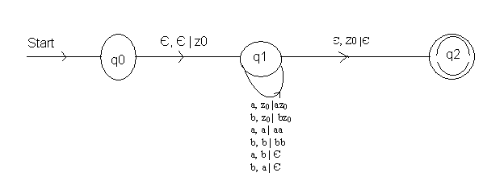

Construct a PDA accepting Language;
L = {ww^{R} | w ε ( 0+1)* and w^{R} is reversal of w}

Let us construct the PDA for L as;
P = {Q, Σ, Г, δ, q0, z0, F} where,
Q = {q₀, q₁, q₂}
Σ = {a, b}
Г = {a, b, z₀}
z₀ = z₀
q₀ = q₀
F = {q₂}
Now, δ is defined as;
1. δ(q₀, Є, Є) = (q₀, z₀)
- δ(q₀, 0, z₀) = (q₀, 0z₀)
- δ(q₀, 1, z₀) = (q₀, 1z0)
- δ(q₀, 0, 0) = (q₀, 00)
- δ(q₀, 1, 1) = ( q₀, 11)
- δ(q₀, 0, 1) = (q₀, 01)
- δ(q₀, 1, 0) = (q₀, 10)
- δ(q₀, Є, z₀) = (q₁, z₀)
- δ(q₀, Є, 0) = (q₁, 0)
- δ(q₀, Є, 1) = (q₁, 1)
- δ(q₁, 0, 0) = (q₁, Є)
- δ(q₁, 1,1 ) = (q₁, Є)
- δ(q₁, Є, z₀) = ( q₂, Є)
The graphical notation for the PDA is as;

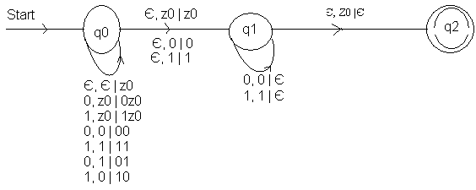
Acceptance of any string can also be shown using parse tree. Consider any string 1001;
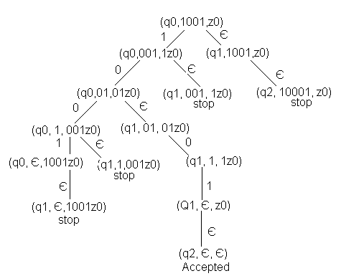

Now for 1011

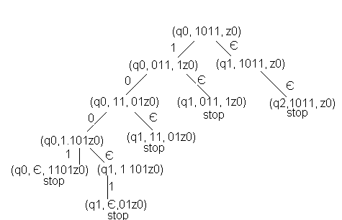

Hence, is not accepted.

Instantaneous Description of PDA (ID)

Any configuration of a PDA can be described by a triplet (q, w, r).
Where,
q- is the state.
w- is the remaining input.
γ- is the stack contents.
Such a description by triple is called an instantaneous description of PDA (ID).

For finite automaton, the notation was sufficient to represent sequences of instantaneous description through which a finite automaton moved, since the ID for a finite automaton is just its state. However, for PDA’s we need a notation that describes changes in the state, the input and stack. Thus, we adopt the notation of instantaneous description.
Let P = {Q, Σ, Г, δ, q₀, z₀, F} be a PDA. Then, we define a relation ├, “yields as;
(q, aw, zα)├ (p, w, βα) if δ(q, a, z) contains (p, β, and may be Є)
This move reflects the idea that, by consuming “a” from the input, and replacing z on the top of stack by β, we can go from state q to state p. note that what remains on the input w, and what is below the top of stack, β, do not influence the action of the PDA.

For the PDA described earlier accepting language ww^{R}, [see example 2] the accepting sequence of ID’s for string 1001 can be shown as;
(q₀, 1001, z₀) ├ (q₀, 001, 1z₀)
├ (q₀, 10, 01z₀)
├ (q₁, 01, 01z₀)
├ (q₁, Є, z₀)
├ (q₂, Є, Є) Accepted
Therefore (q₀, 1001, z₀) ├* (q₁, 01, 01, 01z₀) ├* (q₂, Є, Є)

Language of a PDA

We can define acceptance of any string by a PDA in two ways;
- Acceptance by final state:
  - Given a PDA P, the language accepted by final state, L(P) is;
{w | (q, w, z₀) ├* (P, Є, γ)} where P ε F and γ ε Г*.
- Acceptance by empty stack:
  - Given a PDA P, the language accepted by empty stack, L(P), is
{w | (q, w, z₀) ├* (P, Є, Є)} where P ε Q.

Deterministic Pushdown Automata (DPDA)

A pushdown automata P = (Q, Σ, Г, δ, q₀, z₀, F) is deterministic pushdown automata if there is no configuration for which P has a choice of more than one moves.
i.e. P is deterministic if following two conditions are satisfied;
1) For any q ε Q, x ε Г,
If δ(q, a, x) ≠Φ for any a ε Σ then δ(q, Є, x) = Φ
i.e. if δ(q, a, x) is non-empty for some a, then δ(q, Є, x) must be empty.
2) For any q ε Q, a ε Σ U {Є} and x ε Г
δ(q, a, x) has at most one element.

Example: A DPDA accepting language L = {w c w^{R} | w ε (0+1)*} is constructed as;
P = ({q₀, q₁, q₂}, {0, 1}, {0, 1, z₀}, δ, q₀, z₀, {q₂}) where δ is defined as;

- δ(q₀, Є, Є) = (q₀, z₀)
- δ(q₀, 0, z₀) = (q₀, 0z₀)
- δ(q₀, 1, z₀) = (q₀, 1z₀)
- δ(q₀, 0, 0) = (q₀, 00)
- δ(q₀, 1, 1) = (q₀, 11)
- δ(q₀, 0, 1) = (q₀, 01)
- δ(q₀, 1, 0) = (q₀, 10)
- δ(q₀, C, 0) = (q₁, 0)
- δ(q₀, C, 1) = (q₁, 1)
- δ(q₀, C, z₀) = (q₁, z0)
- δ(q₁, 0, 0) = (q₁, Є)
- δ(q₁, 1, 1) = (q₁, Є)
- δ(q₁, Є, z₀) = (q₂, Є)
The general notation is as:
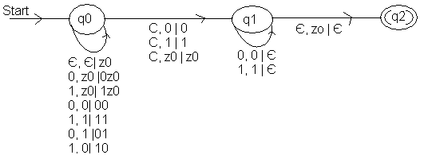

Example: A DPDA accepting strings of balanced ordered parenthesis P;
Q = (q₀, q₁, q₂), Σ = {{,}, (,), [,]}, Г = Σ U {z₀}, δ, q₀, z₀, {q₂}
Where δ is defined as:
- δ(q₀, Є, Є) = (q₀, z₀)
- δ(q₀, {, z₀) = (q₁, {z₀)
- δ(q₀, [, z₀) = (q₁, [z₀)
- δ(q₀, (, z₀) = (q₁, (z₀)
- δ(q₁, {, { ) = (q₁, {{ )
- δ(q₁, [, [ ) = (q₁, [[ )
- δ(q₁, (, ( ) = (q₁, (( )
- δ(q₁, {, { ) = (q₁, Є)
- δ(q₁, ], [ ) = (q₁, Є)
- δ(q₁, ), ( ) = (q₁, Є)
- δ(q₁, ), { ) = (q₁, ({ )
- δ(q₁, {, [ ) = (q₁, {[ )
- δ(q₁, Є, z₀) = (q₂, Є)

Evaluate [{ }]

(q₀, [{ }], z₀) ├ (q₁, { }], [z₀)
├ (q₁,}], {[z₀)
├ (q₁,], [z₀)
├ (q1, Є, z₀)
├ (q₂, Є, Є) Accepted

Evaluate [{ ]}

(q₀, [{ ]}, z₀) ├ (q₁, {]}, [z₀)
├ (q₁,]}, {[z₀)
Stop (as (q₁,],{ ) is not defined) so not accepted.
Equivalence of CFG and PDA
- From CFG to PDA:
Given a CFG, G = (V, T, P and S), we can construct a push down automaton, M which accepts the language generated by the grammar G, i.e. L(M) = L (G).
The machine can be defined as;
M = ({q₀}, T, V U T, δ, q₀, S, Φ)
Where,
Q = {q₀} is only the state in the PDA.
Σ = T
Г = V U T (i.e. PDA uses terminals and variables of G as stack symbols)
z₀ = S (initial stack symbol is start symbol in grammar)
F = Φ
δ can be defined as;
    - δ(q, Є, A) = {q, α) / A→ α is a production P of G.
    - δ(q, a, a) = { (q, Є), for all a ε T}
Alternatively, we can define push down automata for the CFG with two states p & q, where p being start state. Here idea is that the stack symbol initially is supposed to be Є, and at first PDA starts with state P and reading Є, it inserts start symbol ‘S’ of CFG into stack and changes the state to q.
Then all transitions occur in state q.
i.e. the PDA can be defined as;
M = ( {PA}, T, V U T, δ, p, {q}); stack top is Є.
Then δ can be defined as;
δ(p, Є, Є) = {(q, S) / S is start symbol of grammar G.
δ(p, Є, A) = {(q, α) / A→ α is a production P of G.
δ(p, a, a) = {(q, Є), for all a ε Σ.

Consider an example;
Let G = (V, T, P and S) where,
P is
E→ T | E + T
T→ F | T*F
F→ a | (E)
We can define a PDA equivalent to this grammar as;
M = ({q₀}, {a, *, +, (, )},{a, *, +, (, ), E, T, F}, δ, q₀, E, Φ}
Where δ can be defined as;
δ(q₀, Є, E) = {(q₀, T), (q₀,E + T)}
δ(q₀, Є, T) = {(q₀, F), (q₀,T*F)}
δ(q₀, Є, F) = {(q₀, a), (q₀,(E))}
δ(q₀, a, a) = {(q₀, Є)}
δ(q₀, *, *) = {(q₀, Є)}
δ(q₀, +, +) = {(q₀, Є)}
δ(q₀, (, ( ) = {(q₀, Є)}
δ(q₀, ),) ) = {(q₀, Є)}

Now with this PDA, M, let us trace out acceptance of a + (a*a);
(q₀, a + (a*a), E) ├ (q₀, a + (a*a), E + T)
├ (q₀, a + (a*a), T + T)
├ (q₀, a + (a*a), F + T)
├ (q₀, a + (a*a), a + T)
├ (q₀, + (a*a), + T)
├ (q₀, (a*a), T)
├ (q₀, (a*a), F)
├ (q₀, (a*a), (E))
├ (q₀, a*a), E))
├ (q₀, a*a), T))
├ (q₀, a*a), T*F)
├ (q₀, a*a), F*F)
├ (q₀, a*a), a*F)
├ (q₀, *a), *F)
├ (q₀, a), F))
├ (q₀, a), a))
├ (q₀,),))
├ (q₀, Є, Є) Accepted (acceptance by empty stack).
In CFG
E → E + T
→ E + T
→ T + T
→ F + T
→ a + T
→ a + F
→ a + (E)
→ a + (T*F)
→ a + (F*F)
→ a + (a*F)
→ a + (a*a)
Convert the grammar defined by following production into PDA;
S→ 0S1 | A
A→ 1S0 | S | Є
Let G = (V, T, P and S) defined by following productions;
S→ 0S1 | A
A→ 1S0 | S | Є
Then we can define PDA equivalent top this grammar as
M = ({q₀}, {0, 1}, {0, 1, S, A}, δ, q₀, S, Φ)
Where; Q = {q₀}
Σ = {0, 1}
Г = {0, 1, S, A}
z₀ = S
F = Φ
And δ is defined as;
δ(q₀, Є, S) = {(q₀, 0S1), (q₀, A)}
δ(q₀, Є, A) = {(q₀, 0S1), (q₀, S), (q₀, Є) }
δ(q₀, 0, 0) = {(q₀, Є)}
δ(q₀, 1, 1) = {(q₀, Є)}

Construct a PDA equivalent to following grammar defined by;
S→ aAA
A→ aS | bS | a
Let G = (V, T, P and S) be the grammar defined by the production;
S→ aAA
A→ aS | bS | a
Now, we can define the PDA equivalent to the grammar as;
M = ({q₀}, {a, b}, {a, b, S, A}, δ, q₀, S, Φ}
Where δ is defined as
δ(q₀, Є, S)= {q₀,aAA}
δ(q₀, Є, A)= {(q₀,aS), (q₀, bS), (q₀, a)}
δ(q₀, a, a)= {q₀, Є }
δ(q₀, b, b)= {q₀, Є }
Now, we trace acceptance of aaabaaaaa
(q₀, aaabaaaaa, S)├ (q₀, aaabaaaaa, aA)
├ (q₀, aabaaaaa, A)
├ (q₀, aabaaaaa, AA)
├ (q₀, aabaaaaa, aSA)
├ (q₀, abaaaaa, SA)
├ (q₀, abaaaaa, aAAA)
├ (q₀, baaaaa, AAA)
├ (q₀, baaaaa, bSAA)
├ (q₀, aaaaa, SAA)
├ (q₀, aaaaa, aAAAA)
├ (q₀, aaaa, AAAA)
├ (q₀, aaaaa, aAAA)
├ (q₀, aaa, AAA)
├ (q₀, aaa, aAA)
├ (q₀, aa, AA)
├ (q₀,aa, aA)
├ (q₀, a, A)
├ (q₀, a)
In CFG
S→ aAA→ aaSA
→ aaaAAA
→ aaabSAA
→aaabaAAAA
→aaabaaAAA
→ aaabaaaAA
→ aaabaaaaA
→ aaabaaaaa

- From PDA to CFG:

Given a PDA M = (Q, Σ, Г, δ, q₀, z₀, F); F = Φ, we can obtain an equivalent CFG, G = (V, T, P and S) which generates the same language as accepted by the PDA M.

The set of variables in the grammar consists of;
  - The special symbol S, which is start symbol.
  - All the symbols of the form [p ×q]; p, ε Q and X ε Г
i.e. V = {S} U {[p ×q]}
The terminal in the grammar T = Σ
The production of G is as follows;
- For all states q ε Q, S→ [q₀, z₀, q] is a production of G.
- For any states p, q ε Q, x ε Г and a ε Σ U {Є}
if δ(q, a, x) = (p, Є) then [p × q]→ a
- For any states p, q ε Q, x ε Г and a ε Σ U {Є},
if δ(q, a, x) = (p, Y₁, Y₂,……..Y_{k}); where Y₁, Y₂, ……Y_{k} ε Г and k ≥ 0
Then for all lists of states P₁, P₂, …………..P_{k}, G has the production [p × q ] → a [ pY₁P₁][P₁Y₂P₂]…………..[P_{k-1}Y_{k}P_{k}]
This production says that one way to pop x and go from stack q to state P_{k} is to read “a” (which may be Є), then use some input to pop Y₁ off the stack while going from state P to P₁, then read some more input that pops Y₂ off the stack and goes from P₁ t oP₂ and so on………

Note: Each of the variables [p ×q] represents an event in PDA.
- The next popping of some symbol x from the stack,
- A change in state from some p at beginning to a q when x has finally been replaced by Є on the stack.

For Example: Let a PDA that recognizes a language
L = {a^{n}b^{n} | n >0} be defined as;
1. δ(q₀, a, z₀) =(q₁, az₀)
2. δ(q₀, a, a) =(q₁, aa)
3. δ(q₀, b, a) =(q₁, Є)
4. δ(q₀, Є, z₀) =(q₁, Є)
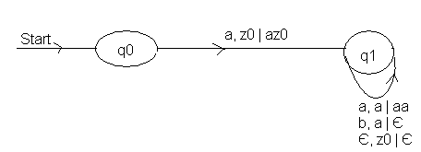
Let G = (V, T, P and S) be the equivalent CFG for the given PDA where,
V= {S} U {[p × q] / p, q ε Q, x ε Г}
S= is the start state.
T= Σ
And P is defined by following production;
- S→[q₀ z₀ q₀] | [q₀ z₀ q₁]
i.e. S→ [q₀ z₀ r₂]; for r₂ in {q₀, q₁}
- From the fact that δ(q₀, a, z₀) contains (q₁, az₀), we get production
[q₀ z₀ r₂]→ a[q₁ ar₁][r₁ z₀r₂]; for r_{i} in{q₀, q₁}
- From the fact that δ(q₁, a, a) contains (q_{1,} aa), we get productions
[q₁ ar₂]→ a[q₁ ar₁][r₁ a r₂] for r_{i} in {q₀, q₁}
- From the fact that δ(q₁, b, a) contains (q₁, Є), we get
[q₁aq₁]→ b
- From the fact that δ(q₁, Є, z₀) contains (q₁, Є), we get
[q₁ z₀ q₁]→ Є
Now acceptance of aaabbb can be shown as;
S➔ [q₀ z₀ r₂]
➔ a [q₁ a r₁] [r₁ z₀ r₂]
➔ aa [q₁ z₀ r₁] [r₁ a r₂] [r₁ z₀ r₂]
➔ aaa[q₁ a r₁] [r₁ ar₂] [r₁ ar₂] [r₁ z₀ r₂]
➔ aaab[r₁ ar₂] [r₁ ar₂] [r₁ z₀ r₂]
➔ aaabb[r₁ ar₂] [r₁ z₀ r₂]
➔ aaabbb[r₁ z₀ r₂]
➔ aaabbb Є = aaabbb

Convert the PDA P = ({p, q}), {0, 1}, {x, z₀}, δ, q ,z₀) to a CFG if δ is given by
- δ(q, 1, z₀) = (q, xz₀)
- δ(q, 1, x) = (q, xx)
- δ(q, 0, x) = (q, x)
- δ(q, Є, z₀) = (q, Є)
- δ(q, 1, x) = (p, Є)
- δ(q, 0, z₀) = (q, z₀)
Now, the equivalent grammar can be written as;
G = (V, Σ, P, S) where P consists of productions as;
S→ [qz₁r₂]; r₂ in {p, q}
[qz₀r₂] → 1[q × r₁] [r₁ z₀r₂]; for r_{i} in {p,q}
[q × r₂] → 1[q × r₁] [r₁ × r₂]; for r_{i} in {p,q}
[q × r₂] → 0[p × r₂]; for r₂ in {p,q}
[q × q] → Є
[p × p] → 1
[pz₀r₂] → 0[qz₀r₂]; for r₂ in {p,q}

