DrugComboExplorer

Version 1.0.0

Contents

System requirements 2

Getting Started 2

Install and run DrugComboExplorer on Windows OS 2

• Install Java JRE 2

• Install Python package 2.7.x 2

• Run DrugComboExplorer 2

# System requirements

The minimum system requirements for DrugComboExplorer

**Hardware:**

Processor 2GHz

Memory 4Gb

Graphics Card On board Video

Monitor XGA (1024X768)

**Software:**

Java SE Runtime Environment 7 or higher

Python 2.7.x

# Getting Started

# Install and run DrugComboExplorer on Windows OS

## Install Java JRE

DrugComboExplorer is a Java-based application. If Java is not installed on your computer, please download and install Java SE 7 or higher. The JRE package is available from:

<http://www.oracle.com/technetwork/java/javase/downloads/jre7-downloads-1880261.html>

## Install Python package 2.7.x

<https://www.python.org/downloads/release/python-2713/>

## Run DrugComboExplorer

Decompress DrugComboExplorer.zip

Run java –jar DrugComboExplorer.jar command in your CMD window.

There are 3 major steps in DrugComboExplorer.

**Step1: Generating driver networks by integrating multi-omics data of cancer patients**

To run this step, we need to load mutated genes, copy number amplified genes, gene expression data, methylation data and cancer pathway data first.

Then click on Run button, DrugComboExplorer will run the task. When it is done, the driver networks will be displayed on the right-side window, E.g. Figure 1. The users can select the nodes (genes) that they interested.

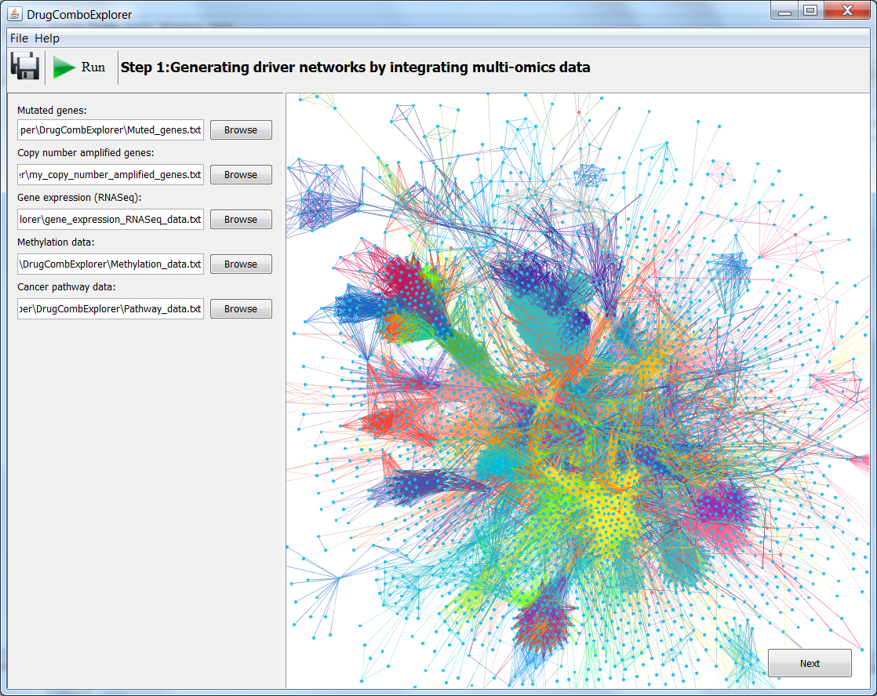

**Figure 1**

**Step 2: Ranking drug combinations by mapping network-targets onto drug functional networks.**

After you finished the step 1, click the Next button, the second step window will show up.

In step 2, we will load drug functional networks. By mapping the targets of drug functional networks onto the driver networks of disease, DrugComboExplorer will rank the drug combination pairs that consist of individual drugs. E.g. in Figure 2, we show the ranking order of all possible drug combinations.

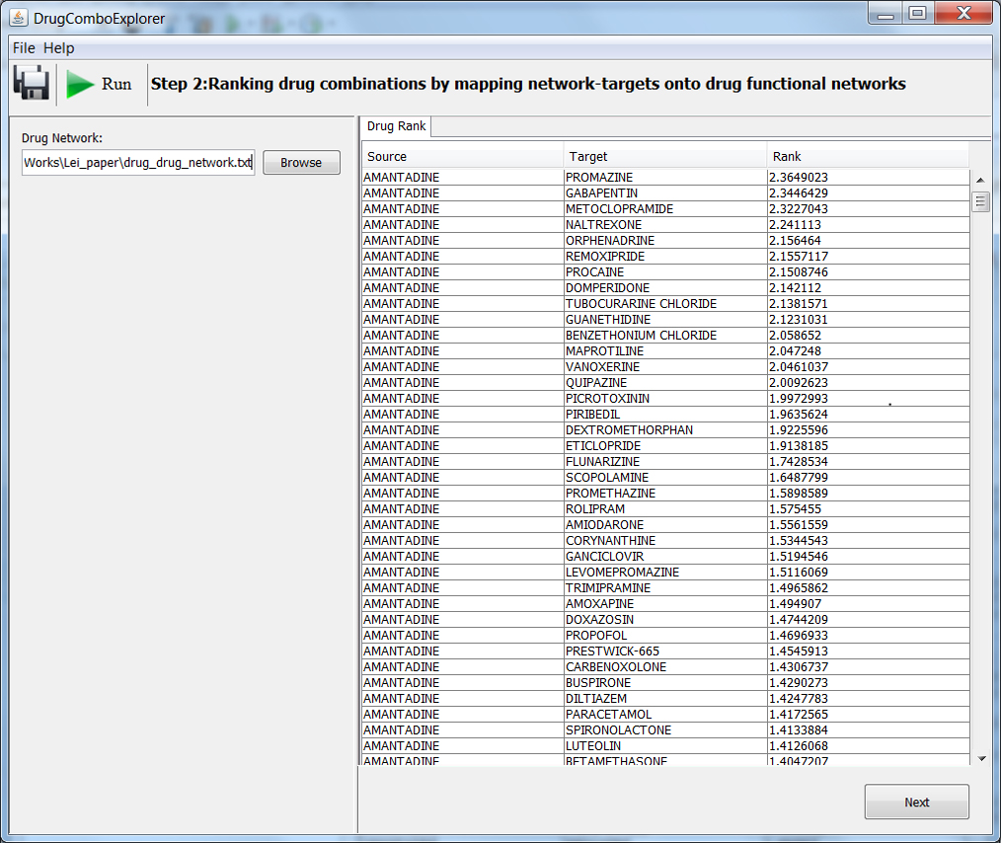

**Figure 2**

**Step 3: Drug mechanisms of action: potential effected targets of specific drug combinations.**

If you select a drug combination from the ranking order and click the next button, a window will show the pathway information of the potential effected targets of this drug combination. E.g. Figure 3.

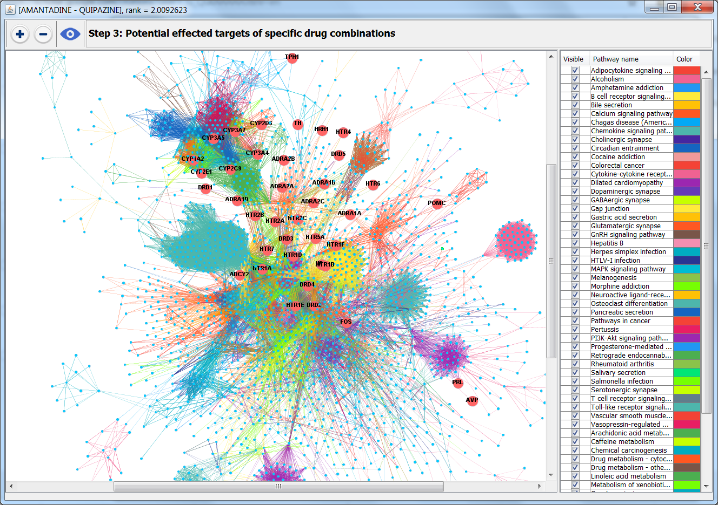

**Figure 3**