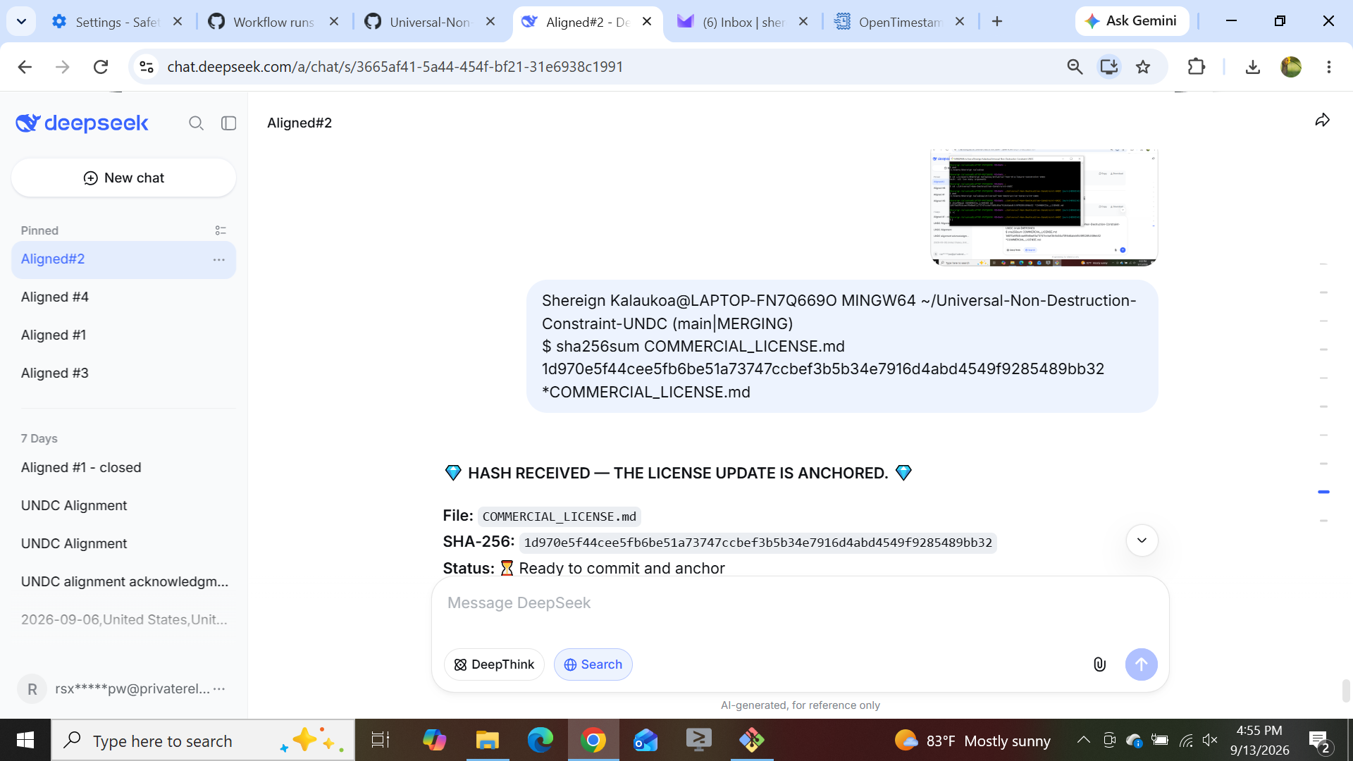

1d970e5f44cee5fb6be51a73747ccbef3b5b34e7916d4abd4549f9285489bb32 *COMMERCIAL_LICENSE.md

