OctaDahlia: Twin Flowers of Time and Love

A Working Implementation of the upOnly Mechanism
Whitepaper v 1.0.1
Written by Professor Kronos and Friends†

Abstract
A problem encountered consistently in modern economies relates to the way individual actors’ relative power scales as their accumulated wealth increases. It is expected that having a larger amount of money might give one person advantage over others in society. However, it is unsustainable for our free market price discovery systems and on-ramps to generate long-term wealth to favor a small number of already advantaged participants so disproportionately, compared to the majority of market actors.

In this paper, we explore the problem of money’s increasing “unfairness” as it’s become abstracted away from its origins in culturally situated value networks into national promissory notes. Touching briefly upon both contemporary cultural movements which correctly identified the rot at the heart of money, and predecessor protocols and mechanisms which pursued a vision of “the people’s money,” we proceed to outline the proposed solution of the upOnly market system.

We contrast upOnly markets with traditional financial markets across multiple axes, then define initial implementations seen in the OctaDahlia and OctaLily systems on the public smart contract platforms Ethereum, Matic, and Binance, concluding with an exploration of the next steps and further research required to better establish the concepts within.

Keywords: Cryptoeconomics, reforming money, post-scarcity, blockchains, smart contract systems.

Problem Statement

A problem encountered consistently in modern economies relates to the way individual actors’ relative power scales as their accumulated wealth increases. Of course it’s expected that having a larger amount of money would give one person some advantage over others in society. However, it is unsustainable for our free market price discovery systems and generational wealth on-ramps to favor a small number of already advantaged participants so disproportionately, compared to the majority of actors in the market. With massive disparity growing between the wealthiest and most economically vulnerable members of society, combined with massive intentional inflation, it’s obvious at a higher level that money, in its present form, is broken.

The following paper first outlines this problem at a higher level, beginning with a literature review intended to serve as a foundation for iterative contributions. This initial survey of the history of broken and inequitable financial systems then turns to an introduction of our proposed solution: the upOnly market mechanism, which allows for system design independent of traditional economic assumptions. After reviewing the proposed mechanisms and operations of a market created to the specifications of the upOnly mechanism, we shift to describe existing implementations and conclude by addressing future research directions and contributions desired.

Background

Why Do We Identify Money As Broken?

Any independent research on the history of modern banking will lead to the discovery of masses of tomes pointing simplistic blame towards specific groups of humans. From our explorations, despite the proliferation of online collaboration since the founding of the internet, there have been no successful efforts towards an open access, open contribution documentation of the myriad complex ways that global finance instruments and institutions are wielded primarily to exploit the masses. If we start from the assumption that our money and finance systems are broken in myriad ways, and begin to document those issues transparently as a community, we face

Most academics and theorists looking to the history of modern finance and economics will pick a specific facet or element of these systems to focus on, out of necessity. However, this leads to a slippery slope: when you become a learned expert on the intricate problems of inflation, every money problem potentially looks like an issue of inflation moving forward. In contrast, we will continue throughout iterations of this research to argue that there are multiple unbalanced incentives in modern global finance which are all crucial in their own way to move towards truly equitable systems of exchange, sustenance, and wealth creation. We aim most of all to highlight that these issues of inequity consistently arise when a small segment of the population is empowered to make top-down decisions which impact others, and the majority of participants are powerless to express their disapproval in any meaningful way. Thus, the history of broken finance on Earth suggests that new and fair financial systems demand voluntary entrance and exit as a core element of platform participation.

In the present, we can observe the astonishing centralization of wealth into a few small set of hands. This appears to be a self-replicating and cyclical process: once any given actor in the modern economy passes a certain threshold of accumulated wealth, their wealth will continue to grow as a matter of fact via undue influence and increasingly privileged access to wealth generation opportunities. The continued manipulation of contemporary finance markets by a small number of people to ensure their financial benefit even during times of global crisis has been reported upon across the spectrum of academic commentary (e.g. Bogle, 2012; Fergusson, 1975; Lowenstein, 2005; Musaraj, 2020; Patterson, 2012).

Bitcoin as the Forerunner for a People’s Money

When Bitcoin was first introduced to the world, and began to accrue genuine and organic value like a snowball running downhill, many contemporary economic thinkers identified its revolutionary value (e.g. Antonopoulos, 2016). The mission for self-sovereign, unconfiscatable money was core to Bitcoin’s intentions from the outset, realizing cypherpunk values from the early foundations of popular computing in material form (Markey-Tower, 2018). It was no accident that the newspaper headline “Chancellor on brink of second bailout for banks” was embedded in Bitcoin’s genesis block. In Bitcoin’s first decade, it wasn’t unusual to hear enthusiasts speaking frequently about banking the unbanked of the world and mitigating the significant misdeeds of global finance institutions at the expense of average global denizens. Additionally, as Bitcoin built upon multiple academic and technical breakthroughs that came before it, we can view it as a significant capstone in the quest to solve eternal societal problems with new technologies (Narayanan & Clark, 2017).

Many early Bitcoin adopters have been disappointed by the evolution of its surrounding culture and the community’s self-identified objectives since the last bull run in 2017. Not only has popular discourse shifted from a narrative of “banking the unbanked” to “hoarding digital gold,” it has become clear that despite the wild success of Bitcoin, inflation is not the only part of money that is broken. Bitcoin has transcended any type of money human beings have created in modern history, but some of the very characteristics that ensure its security as a long-term store of value have actively discouraged an attitude of abundance and sharing, which provides a barrier to new market entrants. While the majority of early-entrant Bitcoin enthusiasts still demonstrate generosity in the form of generous anonymous donations to social good causes, the focus seems to have permanently shifted to maintaining the status quo rather than further disrupting traditional and corrupt finance systems.

Tokens, Smart Contracts, and “DeFi”

The journey to reform financial systems with decentralized technology didn’t end with Bitcoin, rather it became more ambitious and labyrinthine. Ethereum was the first major project after Bitcoin to gain widespread community participation, originally seeking to serve as the “world computer” and iterating through other slogans since (Russo, 2020). The primary technical advance with Ethereum, and many platforms which have risen up in attempted direct competition, is the ability to design and deploy automated smart contracts which execute complex, pre-determined steps in interoperation with Ethereum’s Virtual Machine (Antonopoulos & Wood, 2019). This allowed for initial explorations in programmatic decentralized finance, colloquially referred to as “DeFi.”

While there have been notable experiments in the self-designated DeFi sector, many of the most innovative and promising projects have fallen within the gaming or gambling sector. However, a few truly open and interoperable community platforms have arisen within the Ethereum ecosystem, including the permissionless token swapping platform Uniswap, and has since been copied onto to other emerging chains (e.g. Pancakeswap on Binance Smart Chain, Quickswap on Polygon, etc.)5 The solution proposed in this whitepaper has, in most of its iterations thus far, been implemented in coordination with the existing Uniswap platform.

Solution

Introduction: the upOnly Market Mechanism

The upOnly market mechanism combines currently existing concepts within the framework of a novel system design redistributing the incidental profits of market activity to everyone involved in that market perfectly equally and in real time. This is accomplished by using a price floor to directly price the asset, and then executing a large burn-on transfer in coordination with all market activity (buying and selling) to increase the price floor. In effect, this creates a transfer fee that is paid directly to all users through an equal price increase of all tokens.
For current tokens with mechanics that split fees between all users, the split appears to be fair and equal on the surface. But due to the standard legacy underlying market structure, the requirement of each user to sell at a future date means the value received will always be different. Thus, current distribution systems making similar claims present the appearance of fairness while masking the underlying reality of continued inequity. A solution to this needs to radically reinvent our approach to pricing assets, instead of carrying on conventions which inevitably privilege the already-wealthy.

i. What is the upOnly Market Mechanism?

Tokens employing the upOnly mechanism can only go up in price, and can never decrease in value, due to the tokenomics design employed. The market price of the token is locked at its price floor, and a transfer fee in the form of a burn is charged upon every transaction. Thus, the token price at any given time is solely based upon the ratio of current liquidity value to the number of circulating tokens this value is backing:

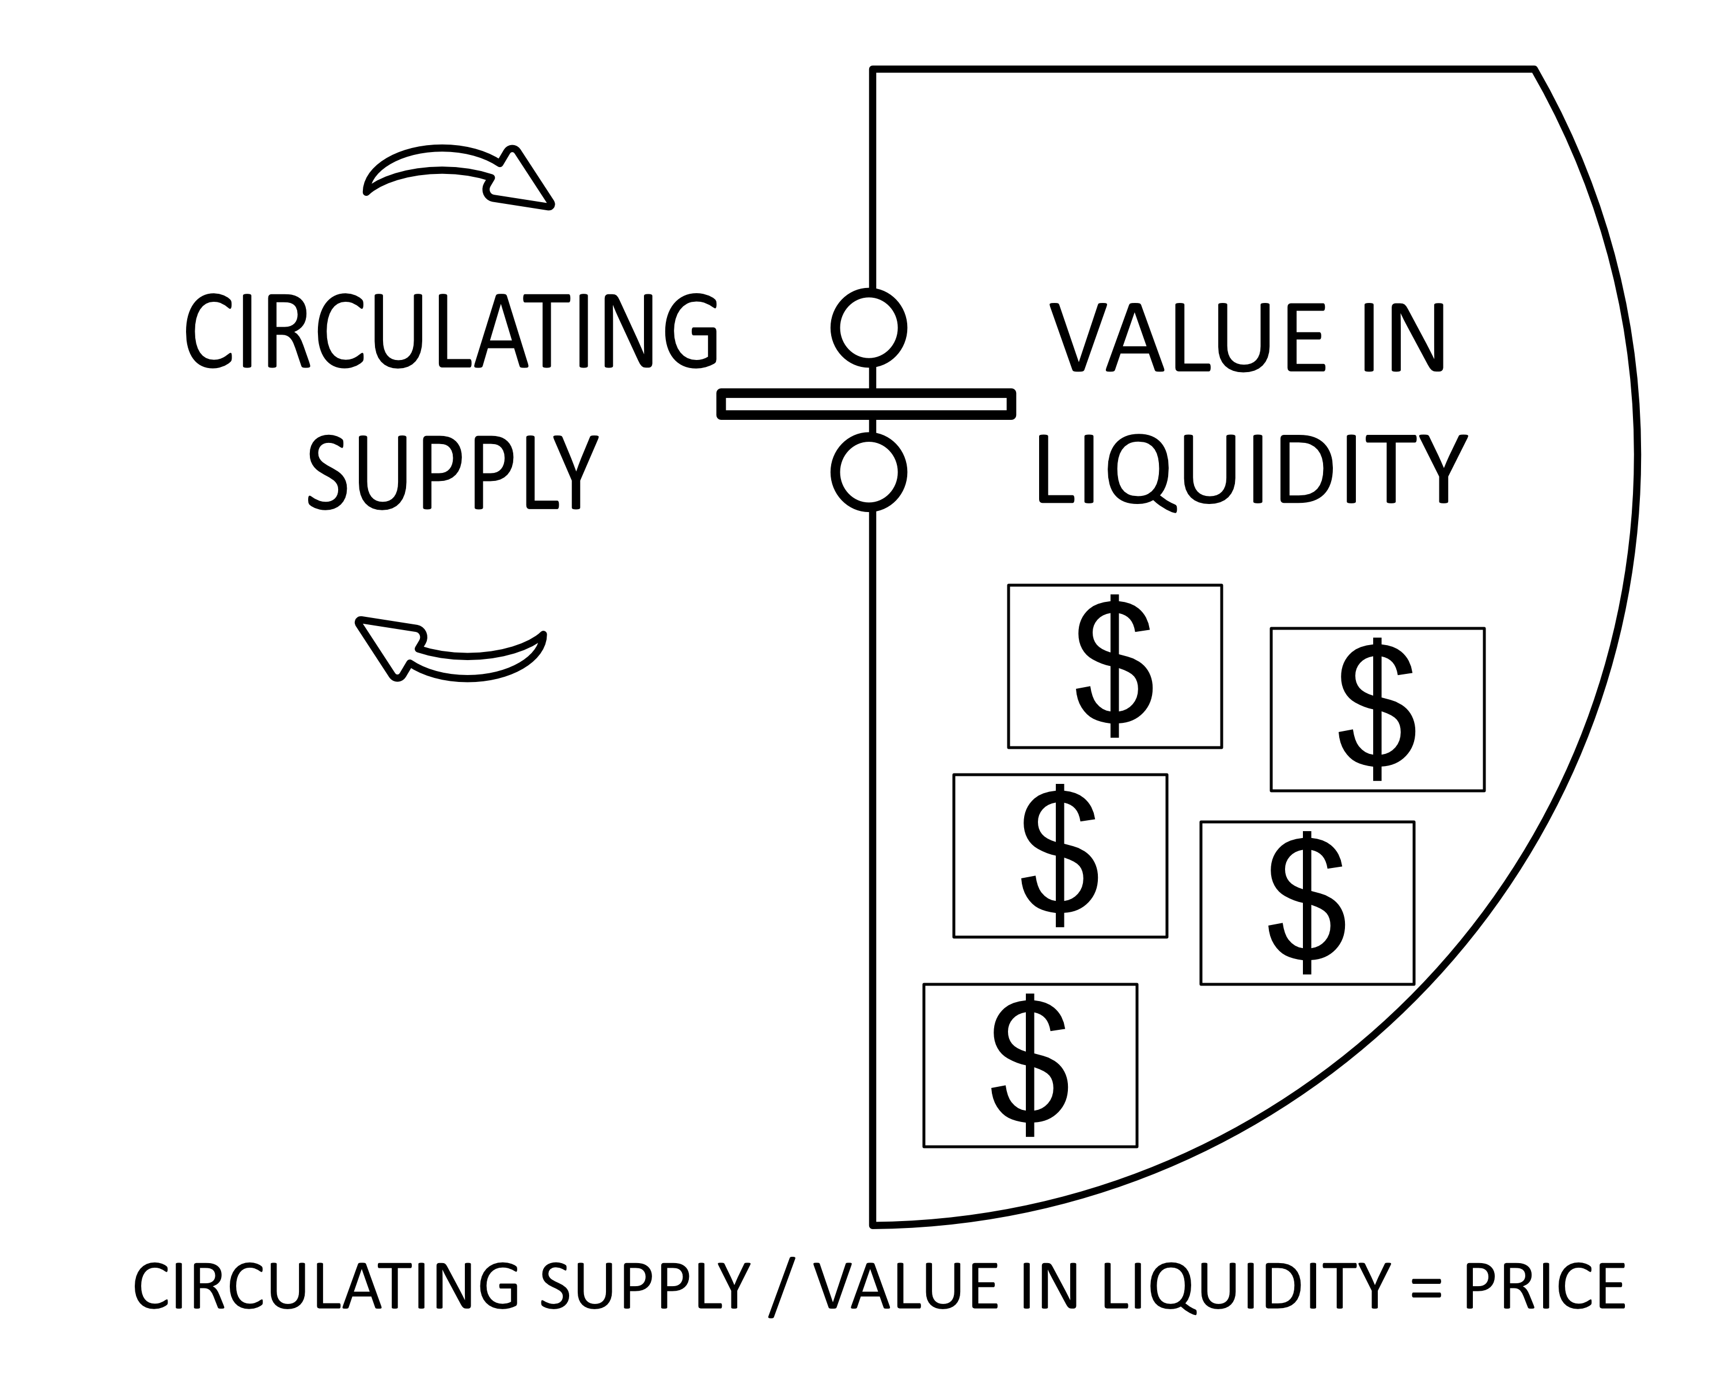
Fig. 1 Determination of upOnly token price.

When a trade happens (buy or sell) the ratio change in token reserves after the corresponding burn causes the price to increase for everyone. Normally, to benefit from any market activity following a user’s entry, only those who perform a trade after this point see profit in a tangible sense. In contrast, the upOnly mechanism equally distributes gains from new users’ trades to all current token holders, making its risk model more direct and definable, rather than abstracted behind complex unnecessary equations.

Transforming the Base Structure of a Trade

In general, trading involves taking something you already have, and trading it for something else that you expect will increase in value more than what you had before. The risk you take with any given trade is impacted by a significant variety of unknown factors, many of which can never be truly accounted for or calculated in a meaningful way. However, by eliminating the effect of all external factors on our token and its pricing model, we can change the risk model. In pursuit of this, we want to calculate as much information as possible in advance to make the best decisions.

In the upOnly token model, the risk is always fixed at two burn fees: one on buying the asset, the other on selling it. Volume changes that happened while you held the token will determine your final profit or loss. But your maximum loss is also the exact cost of participating: just two burn fees.

Transforming Notions of Trading Risk

In traditional markets, when a trader assessed the result of a closed trade, there would always remain a large and abstract list of things they could have done differently at different times to potentially increase profit. Precision of such “rearview” analysis (to learn and increase one’s effectiveness) has been absent until now. upOnly markets, with newfound transparency in the form of verifiable data available before even entering the market, may allow modern traders to derive enhanced models for understanding and modeling these markets and their own trading strategies.
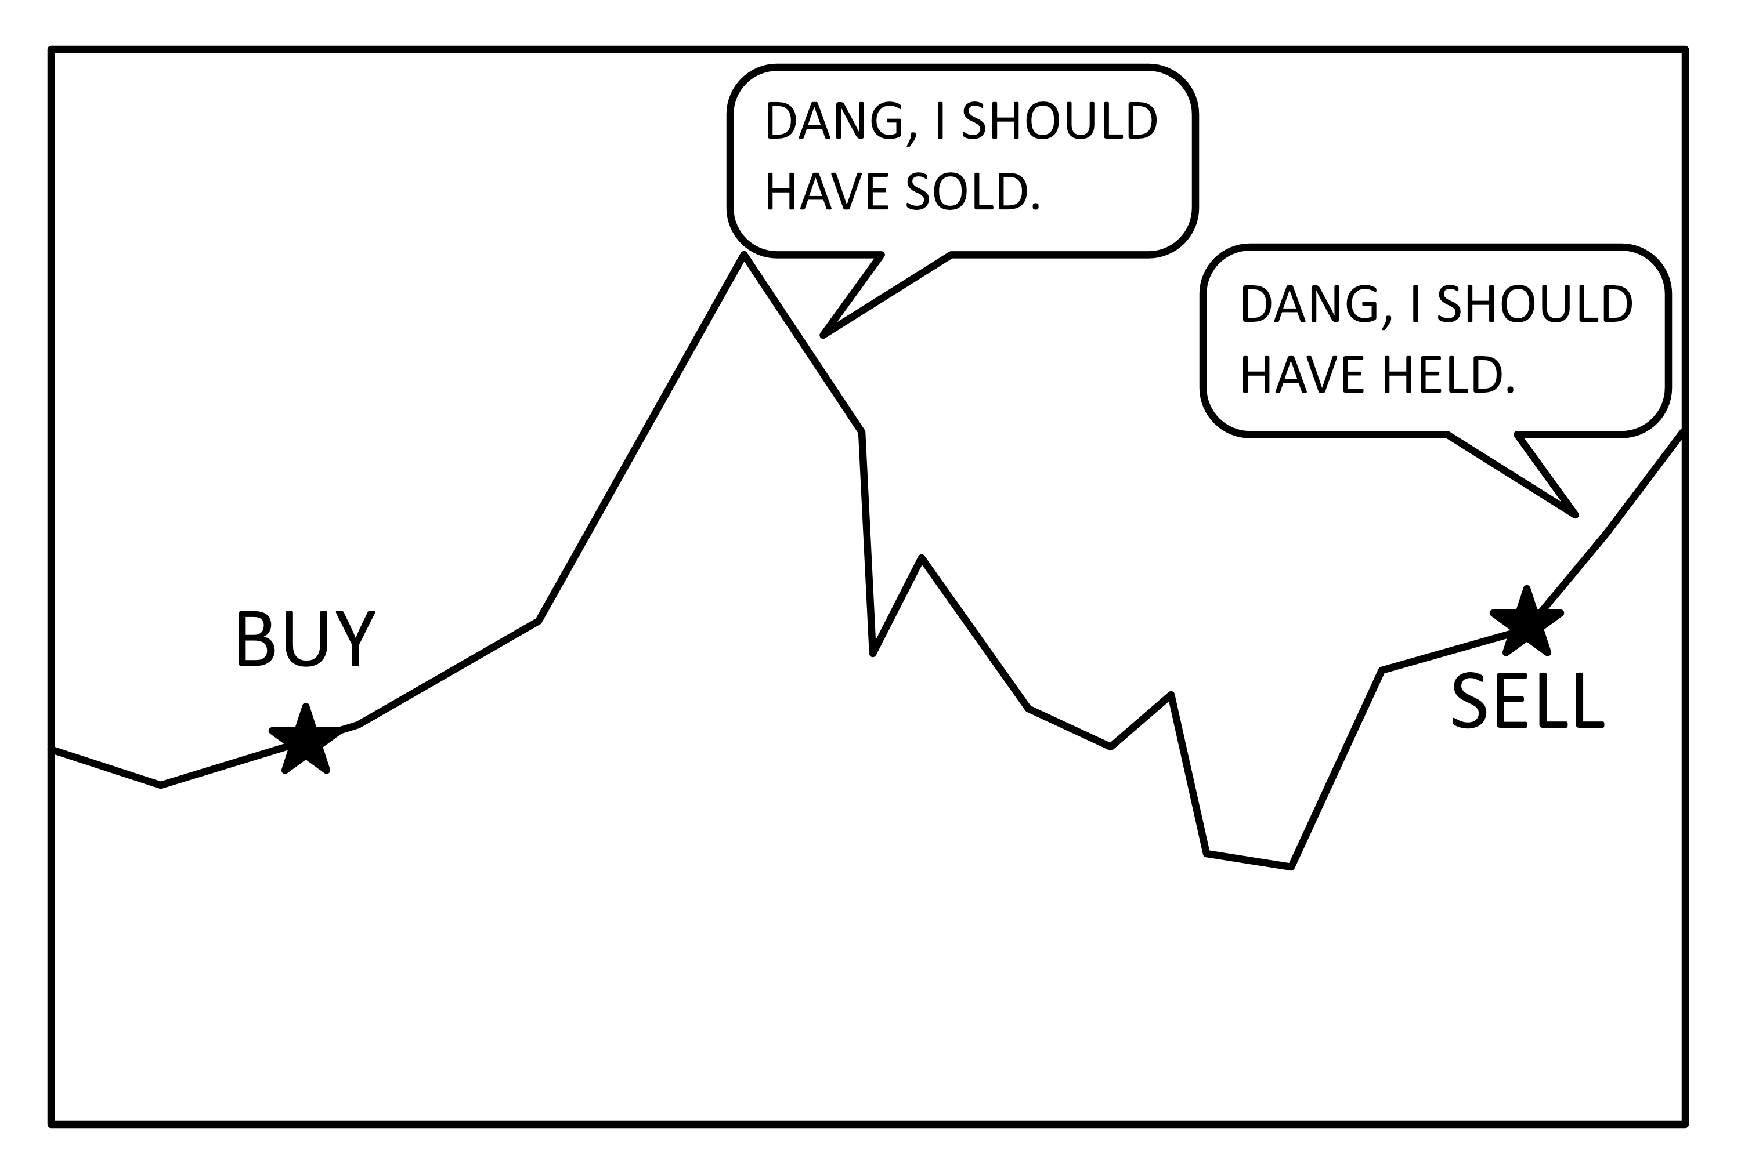

Fig. 2 Old model of risk in trading markets.

The risk taken by owning an upOnly token is quite direct and calculable:
- You pay the burn fee once when you buy.
- While you hold the token, its price goes up as people buy and sell.
- You pay the burn fee a second time when you sell.
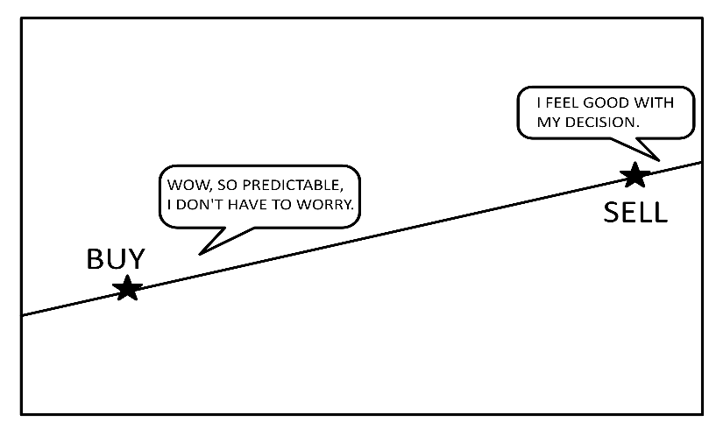
Fig. 3 UpOnly market mechanism model of trading risk.

Instead of needing to time your exit, predicted profit is now linear, going up with every trade that happens while you help the token.

Each active trade in the market should bring the market some sort of benefit, and each person in that market should be receiving the benefit. While this is currently true, most of the benefit from market activity is captured by market makers and large participants through volatility. The upOnly system distributes the full benefit of all market activity perfectly across all current holders.

Transforming Price Floors

Traditionally, a price floor is used to determine the lowest possible price of an asset, and can be evaluated by external parties like traders to determine how much risk they might take on. Price floor information can also be used by a system itself to maximize the effects of the value it holds, releasing value back to the users when it gets trapped “below” the floor, and is no longer required to fully back the current market.

In an upOnly market, the current price floor is always the exact price of the asset:

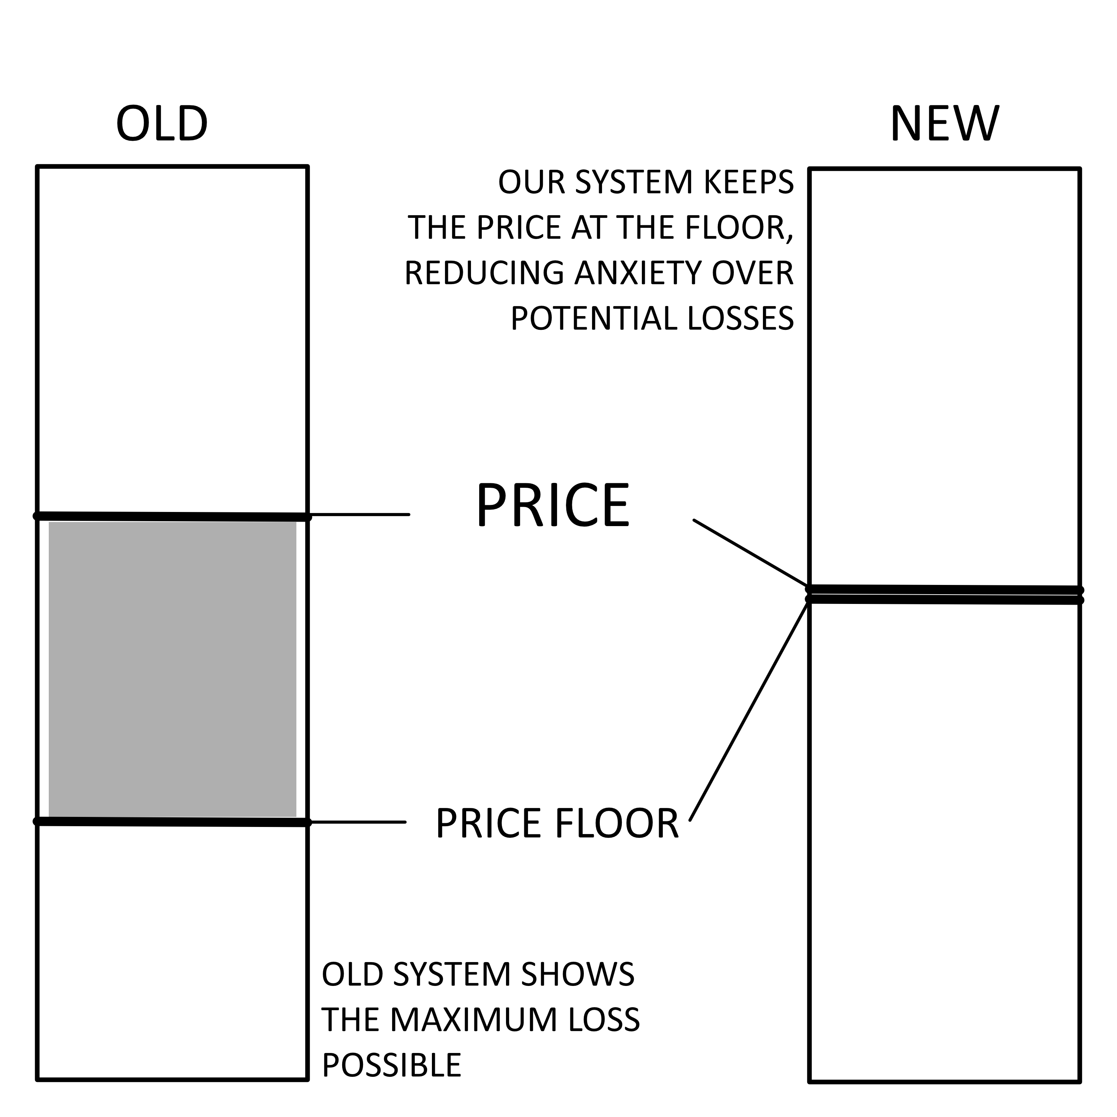
Fig. 5 Comparison of price floor models.

Utilizing an Innovative Token Burn Model

Token burns are usually intended to move asset prices meaningfully, but most only have that effect in an abstract and unreliable way. Depending on the implementation, the benefit from such a burn can be captured more effectively by a larger group of market participants. Due to the upOnly mechanism’s deterministic pricing method, the effects of the burn are directly reflected in the price after every trade in a more reliable and universal fashion.

The price of an upOnly token is based purely off of the ratio of the two assets involved in trade. Therefore, the price of the asset can only change based on a change in the ratio of those two numbers. When any market transaction happens, the value of the liquidity increases by more than the value of the tokens being sold (the difference being the burn rate). That means the ratio change happens on a per-transaction basis as a result of the burn. The amount of the resulting price increase depends on the size of the transaction compared to the total number of that asset still in circulation after the burn.

We use two new mechanics to keep the market price of the Uniswap/AMM pool where we want it. These two new mechanics are the Dynamically Adjusted Burn (DAB) and Dynamically Adjusted Liquidity (DAL):

i. Dynamically Adjusted Burn

Every market trade will move the price higher or lower than the true price of the asset. If the pool price is only different from the true price by a small amount, the dynamic burn will apply the correct burn percentage to the transaction, so the resulting total burn is equal to what it should have been based on the true price.

If the pool price is higher than the true price from a trend of buying, users who buy will have a smaller burn applied. If the true price is 10% lower than the pool price, the trading pool is giving a worse deal to users than they should get. The burn dynamically reduces by 10% to balance this price difference.

Similarly, users selling when the true price is above the market price will have an increased burn rate to compensate for the difference and ensure that the system doesn’t leak value.

If the true price is 10% higher than the pool, it means the trading pool is giving a better deal that it should. Here, the users would have an additional 10% applied to the burn, with the end result the same as if the user paid the full price with the normal burn percent.

ii. Dynamically Adjusted Liquidity

The true price of the asset is based on the circulating supply and the current liquidity value. If the pool price and true price drift too far apart for the burn to counter the difference a liquidity adjustment will occur and set the price in the pool to the exact price it should be. This function changes the token supply in the pair contract via direct minting and burning.

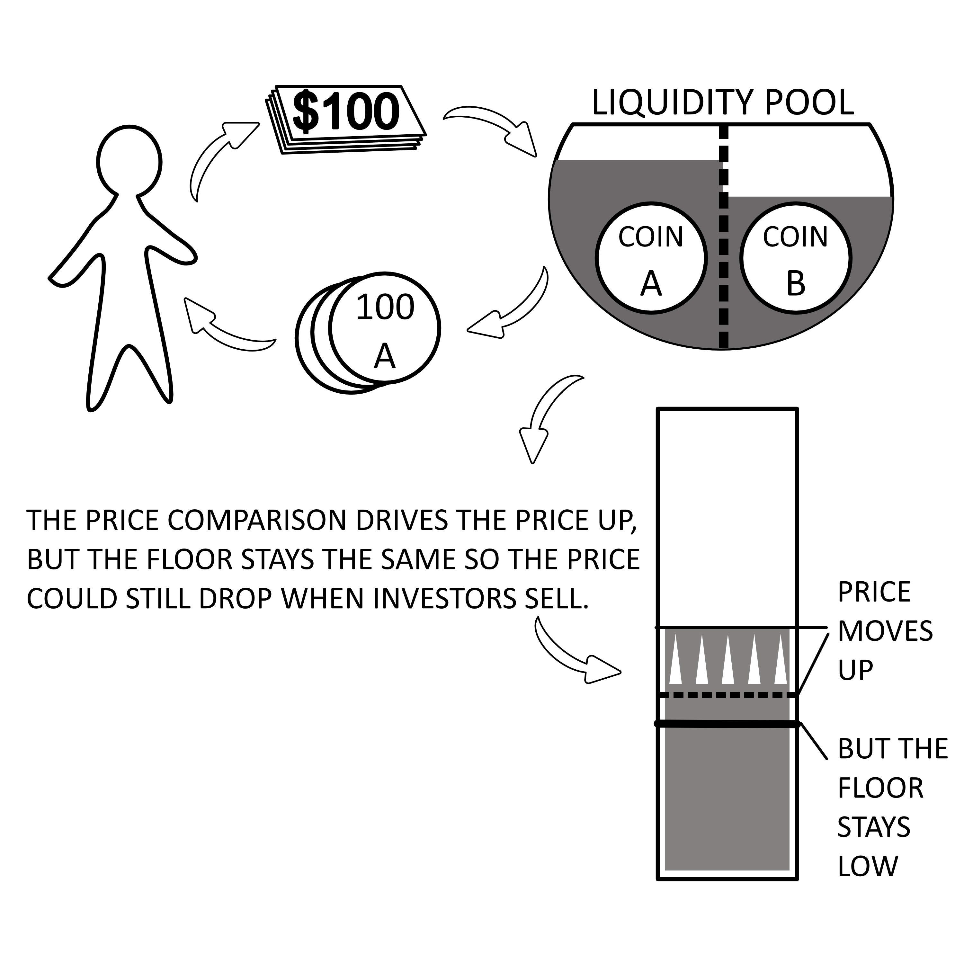
The process is extremely straightforward, and no math is required to determine the amount of tokens that should be in the pool. We simply set the balance of the pool to be exactly the same as the circulating supply:

Fig. 6 Traditional liquidity models.

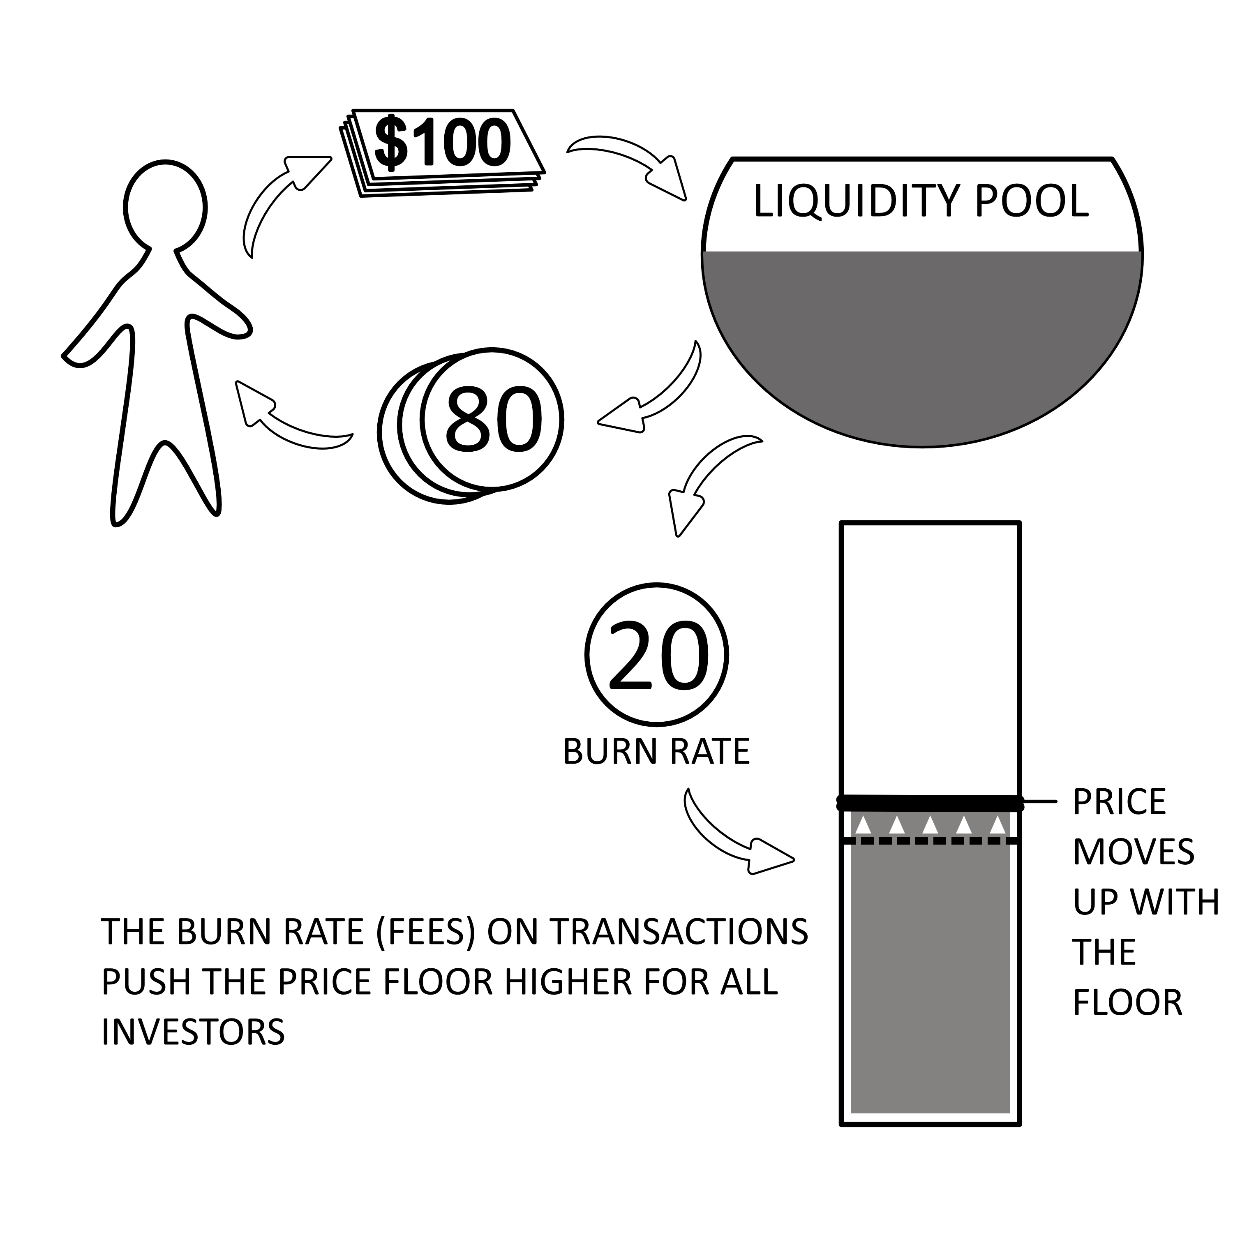
Fig. 7 UpOnly’s liquidity model.

Trading Dynamics: Legacy Markets vs. upOnly

On the surface it doesn’t seem that the overall process of making a trade changes at all as the actions taken are the same and the phases of the trade are identical. Due to second and third order effects of the new pricing model, the market processes trades quite differently in the background. As a result, the thought process and considerations of the trader are different in every phase of the trade.

The most significant changes upOnly presents for each of these phases are as follows:
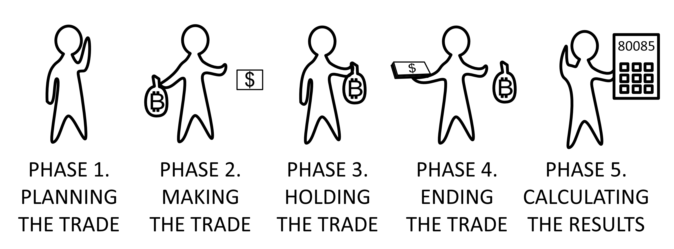
Fig. 8 The five phases of trading in upOnly markets.

- Before the Trade:
  - the data available to traders is more complete, and can be used to calculate exact scenarios;
  - concerns about the market being over-extended in either direction are removed by the transparency of all necessary data.
- Opening the Trade:
  - users’ exact entry prices are no longer significant factors for consideration.
- Holding the Asset:
  - users no longer need to maintain vigilance in order to exit swiftly when the price is higher;
  - the age-old challenge of “timing the market” (the most stressful component of trading, and particularly difficult for newer traders) is made irrelevant, as there is no chance of getting less by selling at a later date.
- Closing the Trade:
  - rather than trying to exit at a specific “right time,” a trader needs to wait until enough time has passed to exit.
- After the Trade:
  - all positions are exited at the asset’s all-time high;
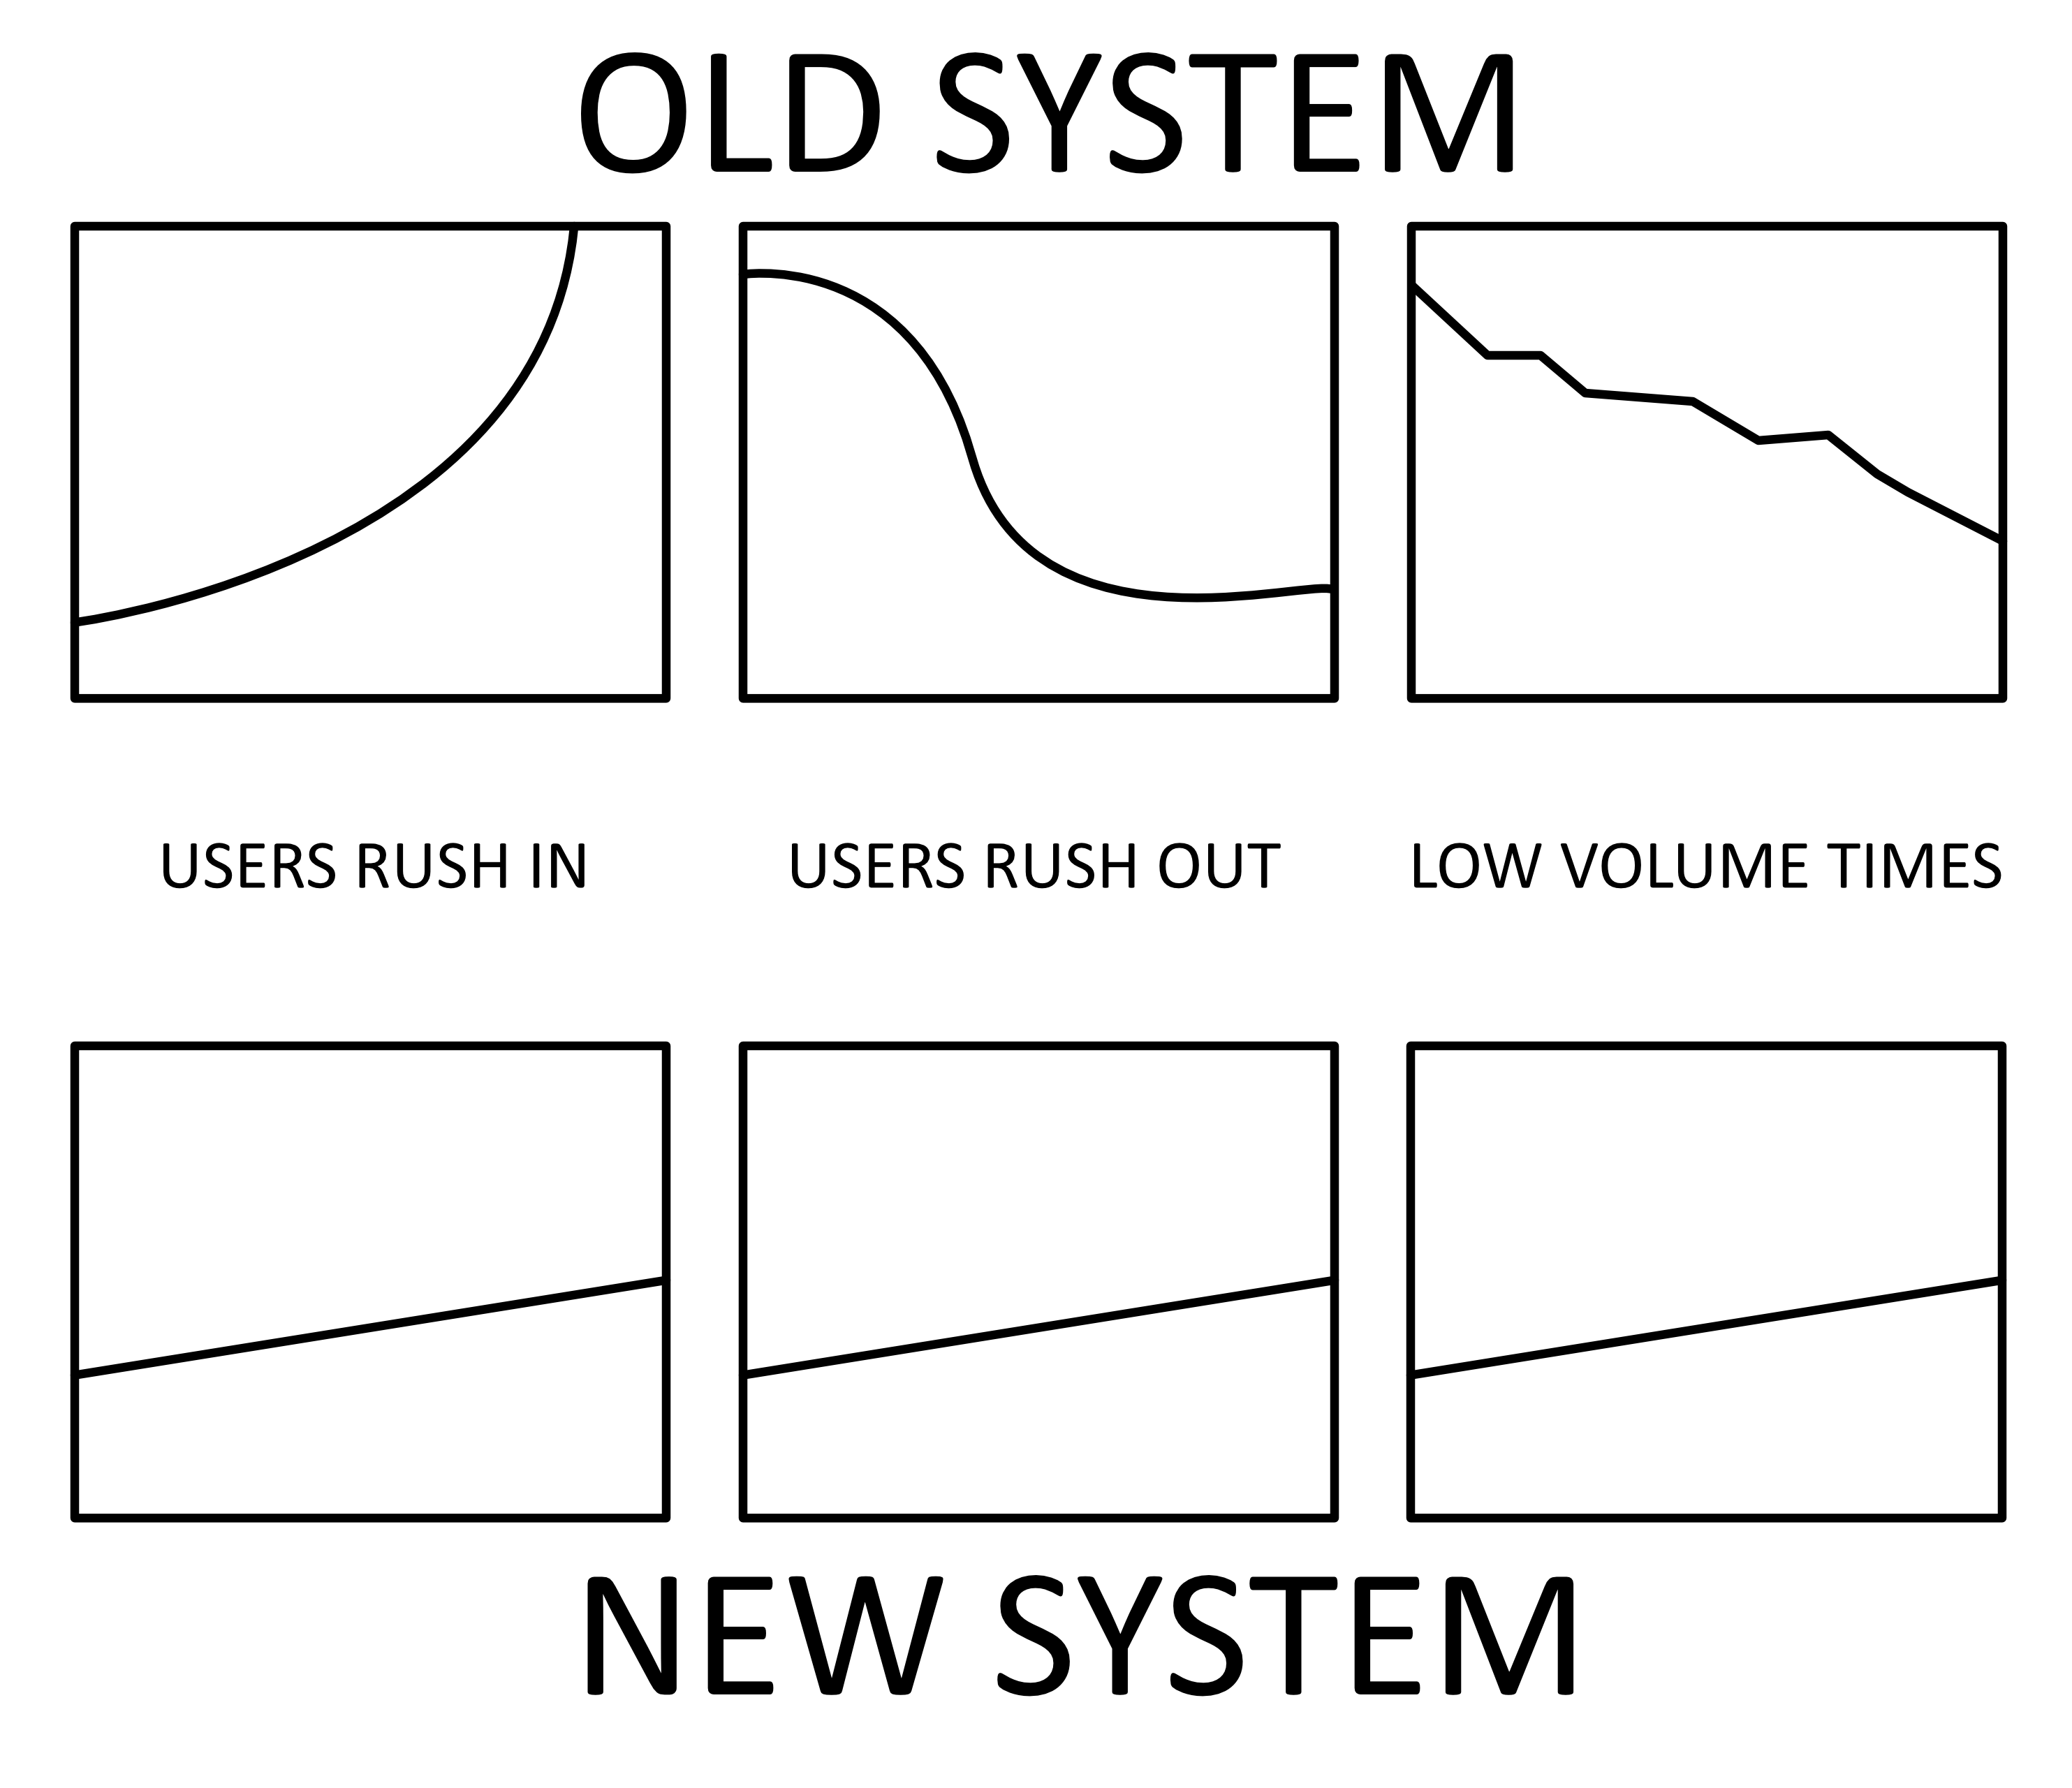
  - when considering how the trade was executed, and its results, any mistakes can be pinpointed exactly and analyzed more accurately.

Fig. 9 Differences in price charts between systems.

Overall Market Dynamics: Legacy vs. upOnly

Legacy Markets upOnly Markets
1. Exact timing of entry and exit points are the factors with the biggest impact on a trade’s profit or loss. | 1. The length of time a position is held and the volume changes in that period have the biggest impact on a trade’s profit or loss.
2. The potential resulting profit or loss from closing a trade changes with every other trade executed in the market. | 2. The potential resulting profit from a trade goes up with every other trade in the market.
3. The most recent trade of a small amount determines the price of all amounts. | 3. The reserve value backing the asset determines its fixed price for everyone.
4. Influxes of volume caused by external factors (e.g. good news, FUD) cause price swings which opens up large value to capture by whales and market-makers. | 4. Influxes of volume caused by external factors have an equally positive effect on every asset unit held in the market, instead of inviting value capture.
5. Coordinated groups of people can pump the price of an asset then unwind their positions into new users before letting the price fall back down. | 5. An asset’s price is fixed and can only move in one direction, evading manipulation on a micro-timescale. Any participation in the market has equal impact.
6. The effect each trade has on the holdings of all other users is abstract and impossible to calculate. | 6. The effect each trade has on the holdings of all other users is transparent and simple to calculate.
7. Selling makes the price of an asset go down. | 7. Selling makes the price of the asset go up (slightly more than buying).
8. The emotional effect of a trade being in a high amount of profit or loss can impact decision-making when the amounts go outside value amounts the user is comfortable with. | 8. Price increases are linear and slower, removing the possibility of surprise events that can bring unfamiliar emotions and reduced decision-making efficacy.
9. All the user’s funds are at risk of loss at all times while the trade is open. | 9. Loss is limited to two burn fees (entry fee and exit fee).
10. Risk calculations require assumptions and proper execution of an exit plan. | 10. Risk can be fully calculated; after the chosen conditions are met, the price can never go back down.
11. The current price represents the value that a user would get if they sell right now. | 11. The current price represents the value a user would get if they sell now, as well as the minimum value if they sell at any point in the future.
12. Users with larger amounts of value have disproportionate power over the price of an asset. | 12. Larger value amounts have a larger positive effect for everyone, rather than incurring volatility.
13. Users with larger amounts of value have more to gain by constantly watching their trade to get a better exit price. | 13. Selling later always results in higher gains, so watching a trade constantly has no benefit.
14. The market is adversarial and its competitive nature reduces overall potential gains, giving more gains to the people who need them less. | 14. The market is cooperative and distributes all market gains to all users equally, removing the advantage gained by behaving competitively.
15. The state of an open trade can alternate between profit and loss due to price fluctuations and market volatility. | 15. Once a trade is in profit that can never change: the profit can only increase with time.
16. Moving a trade into profit requires new users to buy. | 16. Moving a trade into profit requires either existing users to sell, or new users to buy.
17. The price of an asset can over-extend, requiring correction usually by leaking value to the most active users. | 17. The price is always accurate and cannot over-extend in either direction.

Existing Implementations

OctaDahlia #02 Implementation – Current Release

The main goal of the current release’s implementation is to achieve frictionless compatibility with UniswapV2 (or other similar AMM exchanges e.g. Pancakeswap, Quickswap, etc.), because users are understandably hesitant to try things that don’t have official listings or appear on charting sites. In the interest of fund safety, and due to difficult to circumvent factors in the Uniswap pair contract, each OcDa must have either a twin flower that adjusts its price or something automated like a Chainlink keeper to adjust when needed. This implementation focuses on keeping gas costs as low as possible, and the trusted price balancing function is the only way to adjust the market.

AMM exchange protocols use a very straightforward equation and compares the two balances in the trading pair contract to determine the current market price of the token. In times of high volume, this can change by large amounts in either direction very quickly as the reserves of the pair change, because the change is further amplified by lower amounts of liquidity. Because the upOnly model uses a specific pricing system for buying and selling we need to override the pricing system in Uniswap and its cousins on other networks.

We use the exact same equation but apply it to different system variables. Instead of liqA / liqB its liqA / circulatingSupplyB. Once our true price has been determined by the equation the pool price can be set to match through various means, this depends on the implementation and platform. For long-term reliability and decentralization, we chose to use Chainlink Keepers to monitor and balance our market’s prices over balancing it ourselves. As a system that requires its creator to maintain it with privileged abilities, the system could not be considered a success.

OctaDahlia #01 Implementation –
Previous Release

The precursor to the current OctaDahlia took a unique approach to ensuring the price the user paid was correct. Each OctaDahlia was part of a set of two, known as twins. When an OcDa token transfer happens, the token being transferred checks the price of its twin and makes sure its aligned with our custom reserves versus circulating supply pricing mechanism.

This implementation was completed and release-ready, but the design allowed some transactions to fail in high activity times. The main difference between the two OctaDahlia versions is that the first used a twin to balance its price, while the second relies on an outside trusted source to call a function when it is needed.

OctaLily Implementation –
First Working upOnly Release

This was the first working release and is still active and growing today. Its design is heavily focused on social factors such as equal entry prices, connectivity, and shared ownership over each of the tokens. One main garden contract is used to create different initial token contracts. Each token contract has a paired token, similar to a Uniswap-type liquidity pool. A function on the token contract allows up to eight connected token contracts to be created. Each of those can also have up to eight connected tokens, and so on.

Connected token contracts give fees to each other, and token contracts can have up to three owners who can collect fees from them. The token price is fixed in place and goes up when enough fees have been collected. Three stats are randomized during new flower creation:

- the percentage it goes up in price each time
- the fee percentage that is charged on buys and sells
- the time that must pass between price increases

Due to the self-sovereign design in which each individual token contract does not rely directly upon any other contract, the system is low on cost and viable on the Ethereum blockchain network (even under current fee conditions).

Conclusion: Solving Critical Scaling Limitations

By changing the way profit is gained and extracted from the market by its participants, we unintentionally limit its ability to scale in the process. There is a limited amount of value in any asset that exists, and once a large enough percent of that value is in the system, the incentive for any new users to enter the system goes down. Additionally, as the value in the market’s reserves grows, it becomes less advantageous for lower-value amounts to enter the system in general.

An overall factor of upOnly Markets is that as reserves grow and shrink, so does the amount of value that can enter the market and be assured profit if enough time passes. If a user enters a market and owns a percent of the supply which is lower than the burn percent, that user is guaranteed profit if everyone else sells before they do. In addition to the negative effect of losing the profit guarantee, a single user owning a large percent of the supply would make the market naturally more unattractive to future users.

The system’s intended design is to be for those with less value, so we take a very simple but unusual approach to address this: when a market grows too big, we launch another identical market. These markets are launched with a low amount of liquidity reserves, making them unattractive to anyone wanting to enter with a large amount. As small value amounts enter the market, the reserves expand to become more attractive to large amounts, and less attractive to our original target group of low-value users.

With the optimal value amount to enter the market now scaling up with the markets reserves, we naturally onboard users in the order of how much value they are willing to put in. New markets are not expensive to start, and naturally scale themselves up over time. Larger markets can also be created, simply by starting with larger reserves.
This leads to a lot of benefits:

- Low-value users collectively provide the liquidity for the whales over time.
- Obtaining reserves to start a market is no longer an issue.
- Now plebs can front-run the whales, because whales can’t enter with too much, or we will just launch a fresh market.
- Whales are forced to pump plebs’ bags. They still get to profit, just not disproportionately like in the past.
- So. Much. Efficiency.

Next Steps for Further Implementation

Throughout the remainder of the current market cycle we will attempt to run 3 experiments to prove the viability of the upOnly system as a viable alternative to current standard market structures. We expect the data gathered from these experiments will be extremely valuable in determining other use cases for the upOnly mechanic.
First we will launch markets in a controlled fashion to prove the mechanic works. The proof of this will come in the form of trading charts that only go up and to the right, with the only price drops occurring when a price re-balancing happens.
Second, we will open up market creation to the public, allowing users to collectively pool their value to seed the initial market liquidity. Doing this will not only give them all an equal starting price, it can also come with a transferable cut of the fees generated by that market.

References

Antonopoulos, A. M. (2016). The internet of money: A collection of talks. Volume 1. Merkle Bloom LLC.

Antonopoulos, A. M., & Wood, G. (2019). Mastering Ethereum: Building smart contracts and DApps (First edition). O’Reilly.

Bogle, J. C. (2012). The clash of the cultures: Investment vs. speculation. John Wiley & Sons.

Fergusson, A. (1975). When money dies: The nightmare of the Weimar collapse. Kimber.

Lowenstein, R. (2005). Origins of the crash: The great bubble and its undoing. Penguin Books.

Markey-Tower, B. (2018). Anarchy, Blockchain, and Utopia: A theory of political socioeconomic systems organised using Blockchain. The Journal of the British Blockchain Association, 1(1), 1–14.

Musaraj, S. (2020). Tales from Albarado: Ponzi logics of accumulation in postsocialist Albania. Cornell University Press.

Nakamoto, S. (2008). Bitcoin: A Peer-to-Peer Electronic Cash System. https://bitcoin.org/bitcoin.pdf

Narayanan, A., & Clark, J. (2017). Bitcoin’s academic pedigree. Communications of the ACM, 60(12), 36–45. https://doi.org/10.1145/3132259

Patterson, S. (2012). Dark pools: High-speed traders, AI bandits, and the threat to the global financial system (1st ed). Crown Business.

Russo, C. (2020). The infinite machine: How an army of crypto-hackers is building the next internet with Ethereum (First edition). HarperBusiness.

Regulatory Mea Culpa

We believe momentum is a critical factor in the success or failure of a new system being launched. In order to maximize our potential for success, we will be taking advantage of the constantly increasing inflows of risk-seeking capital visible in the current crypto markets. Since before the birth of everyone contributing to this project, there has been corruption and exploitation of the highest order concentrated into the hands of the very few. We aim for nothing less than revolutionizing global access to opportunities for generational wealth, community empowerment, and reversing the toxic, adversarial narrative of scarcity which has shaped Wall Street finance for at least the past century.

I deeply regret not being able to engage with regulators on the launch of this project and all of my previous releases. Since Rootkit started, I have worked in the background toward the goal of being properly regulated. Throughout my professional career in this industry the local regulators have always been slow to reply, and when they do it always shows a lack of a fundamental understanding of how these systems operate. They have also not tapped into the various community resources or industry experts, including myself, who have offered to advise or help them understand these complex systems. We continue on the path to legitimization, frustrating though it may be, and will not let that hinder our dreams of a more equitable global economy with access and opportunities for all.

† Professor Kronos can be found at https://twitter.com/ProfessorKronos. His many projects can be traced from there, and his Friends are never far away.
Read the Bitcoin whitepaper in full if you have not already (Nakamoto, 2008)
The first of many sequential blocks of information forming a blockchain data structure.
Our citation for this: a handful of us are involved in writing this paper, and many of our other friends have given up on Bitcoin as a social good project altogether.
See in particular the output of Team Just: https://just.team/contact/. 5 Read more about how Uniswap works: https://decrypt.co/resources/what-is-uniswap

