**SIV Assignment**

In the SIV submission folder, there are two versions of SIV system (one for Python2.7 and another for the Python3.7), but their functions are the same. When I used test_siv.py script to test my SIV code, I found it needs to do some modifications that can be compatible with my SIV. This README.pdf introduces what should be adjusted to follow the real circumstance.

1. **Test_siv.py**
   1. **For Python2.7 (Ref. siv2/test_siv.py)**

-**Change the way that print the message into file.** For example,



-**Function 'print' in Python2 instead of the 'print()' in Python 3.0.** Example,



-Add **'python2'** pre-command into siv_init(sivexec, envdir) and siv_verify(sivexec, envdir) to compatiable with my SIV





It should also depend on how many versions you have installed in your Ubuntu server. If you just have one default python in your server, please specify the ‘python’ as the first command place. If your testing sever contains Python2 and Python3, please specify the version, in this case is ‘python2’. If you are using Python3, please refer 1.3.

Use the command to change your python version:

`sudo vi ~/.bashrc`



Save and quit, then ` . ~/.bashrc`

Testing use ` python –V`

-**Function 'raw_input()' in Python2 instead of 'input()' in Python3**



-Function **subprocess.call()** in Python2 instead of the function subprocess.run() which run in Python3



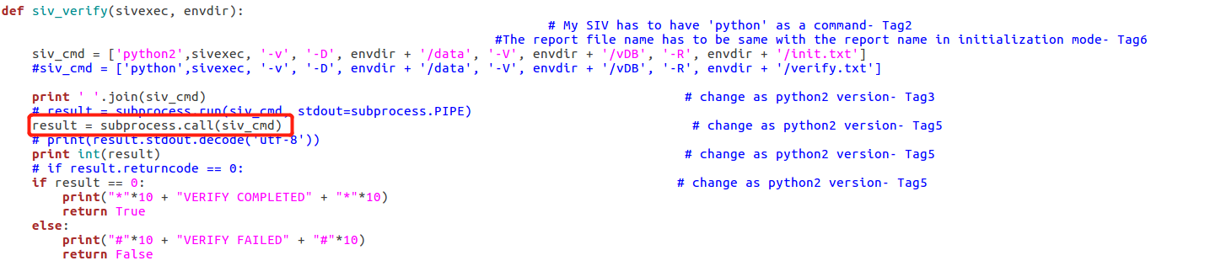

-**Make the report file name is the same in two modes**

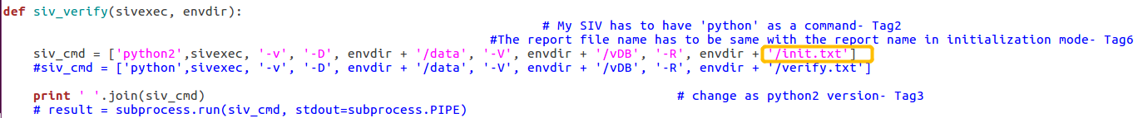

For the system security reason, there is logic judgement: the report file name should be the same as the one which created in verification mode. Because the initialization mode one contains the verification file path, it can help judge whether the verification file has modified or not.

* 1. **For Python3.5 (Ref. siv3/test_siv.py)**

Change the version as Python3.5, and source it.



-Modify functions siv_init and siv_verif, supplement **'python3'** as pre-command.

If your server has downloaded and installed two version Python, it might need to specify the ‘python3’/’python’. For example,

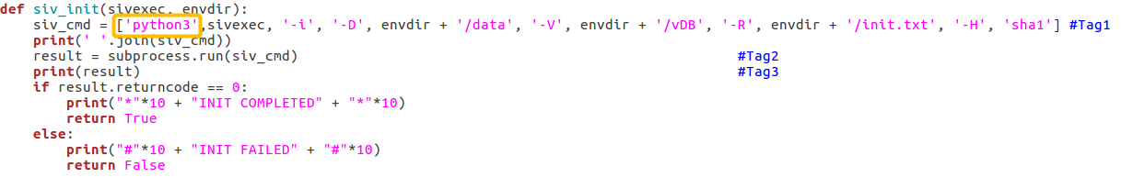

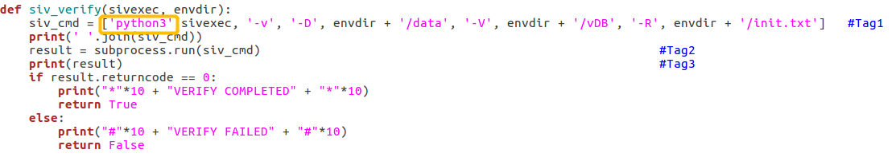

For example, you face the following issue:

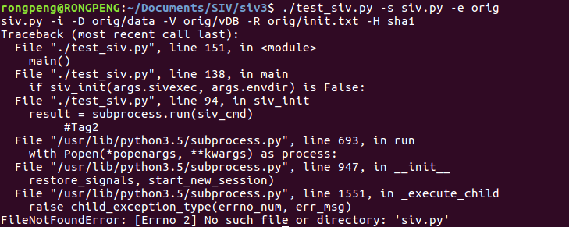

It must lack of the ‘python3’/’python’ in siv_init and siv_verif **siv_cmd.**

-Modify the subprocess.run() function, **remove the stdout=subprocess.PIPE** subprocess.PIPE actually provides a buffer for the text stream. But it doesn’t really require, specify in here will influence the program running.

And the ‘result’ print doesn’t need to decode as ‘utf-8’, just let it be simple print.

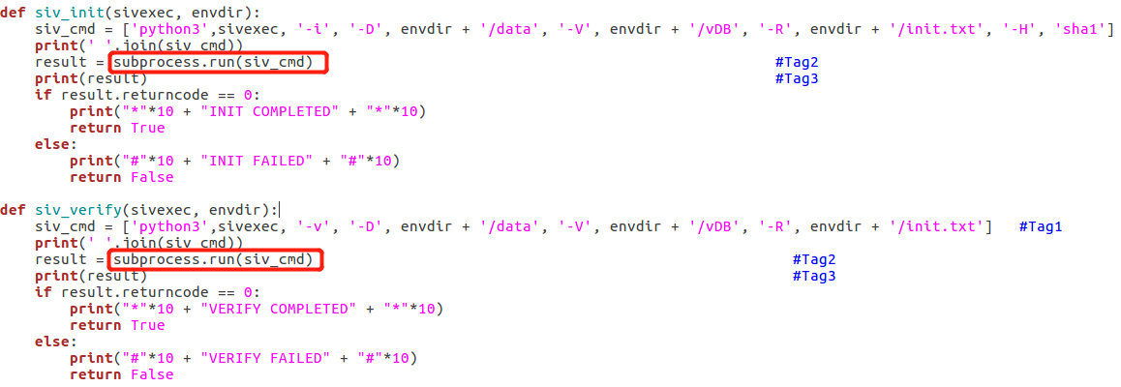

**Execution:**

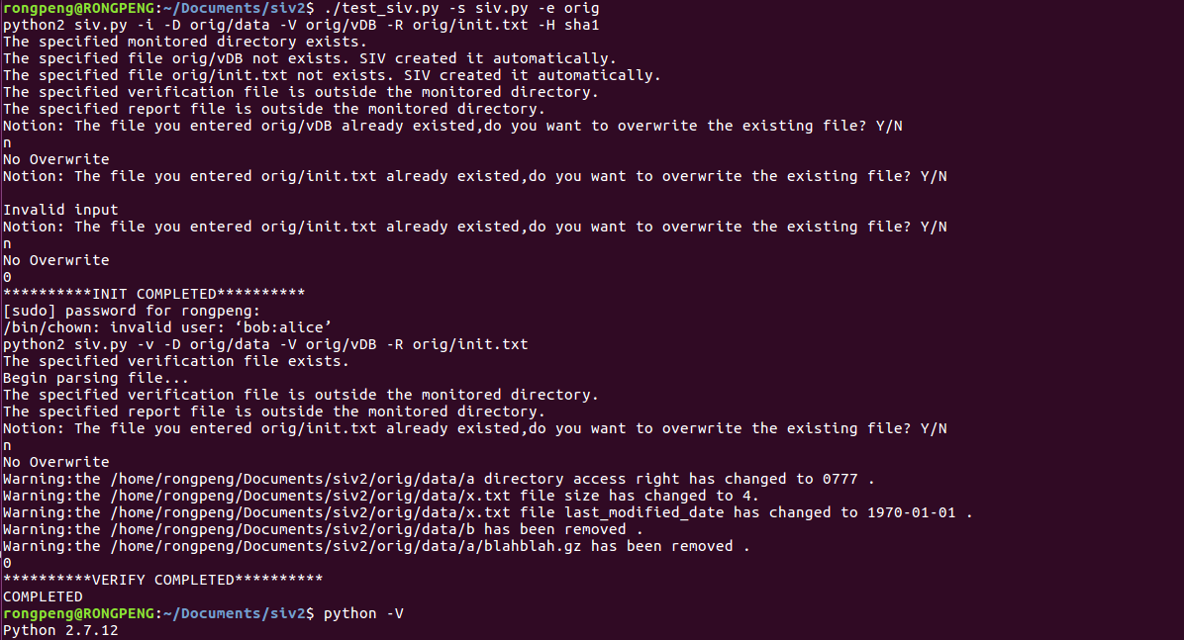

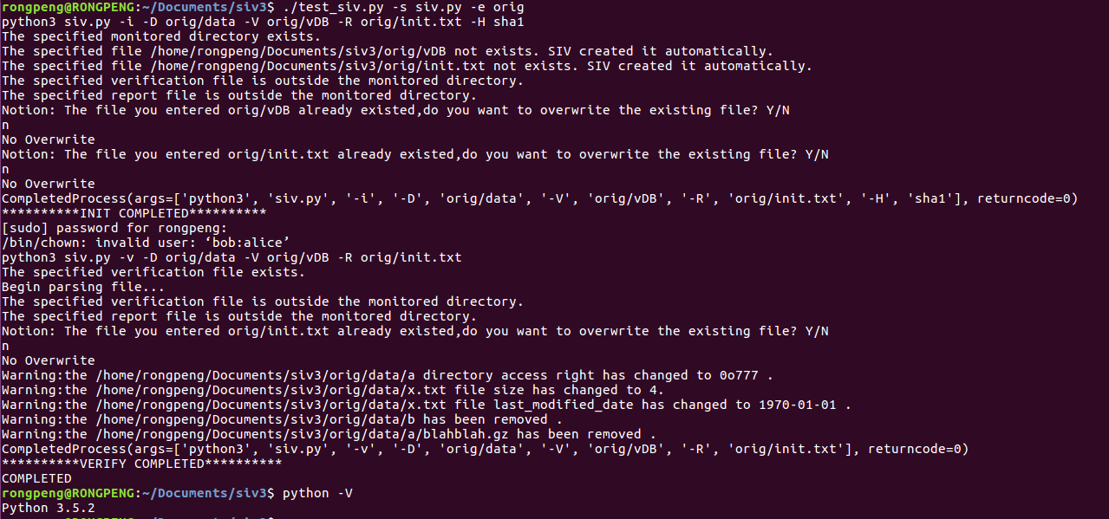

1. **Decision Choice**

In the SIV code, if you want to see the initial record which written in verification file and report.txt, please choose **‘N’/’n’** for most of cases when ask if want to overwrite the file.

1. **Command format**

For initialization mode,

python siv.py –i –D <Mon_Dir> -V <Ver_Path> -R <Rep_Path> -H sha1/md5

For verification mode,

python siv.py –v –D <Mon_Dir> -V <Ver_Path> -R <Rep_Path>

-----------------------------------------------------------------------------------------------------------------------

If still contain issue, you can check Test Cases Excel for reference.

Or contact my email: ropeaudrey@gmail.com