How to create a holiday closure list for a new holiday
Note: Be VERY careful in following this procedure and do not make any alterations to the copied spread where there are “build codes.” Always be ready to CTRL+Z your actions especially on Google Sheets.

- Log into Google Sheets / Google Docs
  - Nyp.lab.outreach@gmail.com
  - ed0csNYP525
- Find the most recent Sheet/Holiday as it would have the locations which were updated most recently by Brian Weeks/Client Services. We’ll use “Christmas 2019” as the example. Click to open.
- File > Make a Copy
  - Name: Select an appropriate HOLIDAY NAME
  - Folder: keep as “HOLIDAYS”
  - Do not check any of the options “Share…” or “Copy…”
  - Press “OK”
- The spreadsheet will make copy of the desired spreadsheet.
- - - - - - - - - - - - - - - - - - - - - - - - - - - - - - - - - - - - - - - - - - - - - - - - - - - - - - - - - - - -
- You will now need to change the data entry point of the spreadsheet. Click on one of the SET SCHEDULE links for any of the locations.
- Upper right-hand corner, click on the PENCIL icon. Click “Leave” site to confirm.
- Click on RESPONSES tab on the upper middle of the page.
- On the right side, click on the VERTICAL ELLIPSIS icon designated by three vertical dots
- Click “Select response destination”
  - Change the text - Create a new spreadsheet: “Holiday Closure Data Entry – Holiday nameYEAR - Responses
  - Lower left-hand side should be loading [Linking spreadsheet . . . spreadsheet linked]
  - Click on GOOGLE SHEET PRESENT BOX ICON
  - New window will open with the Closure Data Entry list.
- DELETE all data from Row 2 downward. *TIP* DO NOT delete Row 1, columns “A – M”
- - - - - - - - - - - - - - - - - - - - - - - - - - - - - - - - - - - - - - - - - - - - - - - - - - - - - - - - - - - -
- We will now go back to the DATA entry point “Holiday Closure Data Entry” and make necessary alterations
  - Go back to the newly created Holiday spreadsheet, and select “SET SCHEDULE” link on any of the locations.
  - Click the PENCIL icon on the upper right-hand side once again
  - Underneath the heading text “Holiday Closure Data Entry”, click on the smaller text of the actual holiday name. Example: Change “Christmas 2019” to “MLK 2020” or appropriate holiday. Click outside of the text field once completed. Autosave, so just close the window out.
- - - - - - - - - - - - - - - - - - - - - - - - - - - - - - - - - - - - - - - - - - - - - - - - - - - - - - - - - - - -
- Next following steps will fix the main sheet so that it can be deployed for use by Client Services. You will know if you are on the correct spreadsheet if you see 7-9 tabs on the bottom (PUBLIC, OPEN, CLOSED, INFO, MASTER, UNKNOWN, RESPONSES, etc)
- PUBLIC – this will need to be cleaned out, but be very careful as changing build codes can destroy the critical functions of the spreadsheet
  - Navigate to row 269 which should be the following:
  - All data in row 270, columns “E through M” are all inputted/typed in manually, and must be reverted to UNKNOWN or cleared out completely to blank. Anything before 268 and above will populate based on the data provided; DO NOT TOUCH OR IT WILL ERROR. Brian Weeks/Clinical coordinator will be familiar with this and adds the final touches once they have all the data from the responses sheet. See below for examples on how the finished rows should look when completed:
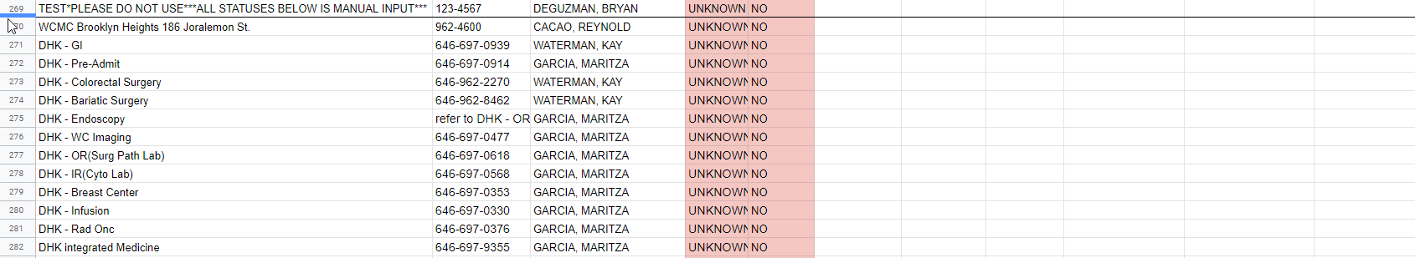
- OPEN
  - On this sheet tab and others, we will alter existing Google Sheets Javascript codes based on the data that being imported. The coding point starts on Row 2 and applies for columns “A” through “M”. See example below:
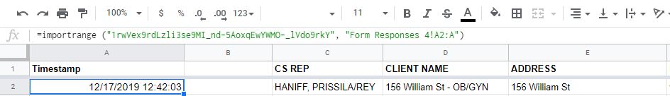
  - You will ONLY need to change the address for the data to input correctly. The generated jibberish example between the parenthesis “____________” from above
  - To obtain this jibberish, open the data spreadsheet from the Closure sheet: “Holiday Closure Data Entry – HolidaynameYEAR – Responses”
  - When you are on the URL of the sheet, it will be between /d/ and the /edit#. . .
For instance:
  - Copy and paste this in each column of Row 2. If you got the address correctly, it will show BLANK. If you did it incorrectly, it will show up as “#REF!” Be ready to CTRL+Z if you panic and it is wrong.
Tip: The Form Responses tab name can also be incorrect. Check the name so it matches the Tab.
  - Once completed, we will have the filter tool ready: 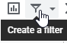
Data must be populated in order for this to take effect. You will highlight the entire “STATUS” G column, and click the Filter icon. A tornado icon will show up to the right of the STATUS. Click on it and designate the appropriate filter [OPEN in this case]
- CLOSED
Please refer to previous step “14” above for the same walkthrough details, except the filter being CLOSED
- INFO
In Row 2, column B, the date will need to be changed to the same day as the intended holiday. In this example, MLK2020 lands on the date 01/20/2020
- RESPONSES
This tab will basically be the same as the steps referred to in 14, but no filters will be used as ALL DATA should be viewable. The only data input would be in Row 2, Column A as the entire spreadsheet region is mapped directly. Row 1, A1 will be for the header in case you want to map an extra step, but does not change and remains uniform across all spreadsheets.
- Return to the PUBLIC sheet tab change all dates manually from Row 270 downward.
  - Highlight “SET SCHEDULE” and the hyperlink code will show with manual but full data entries for the closure lists.
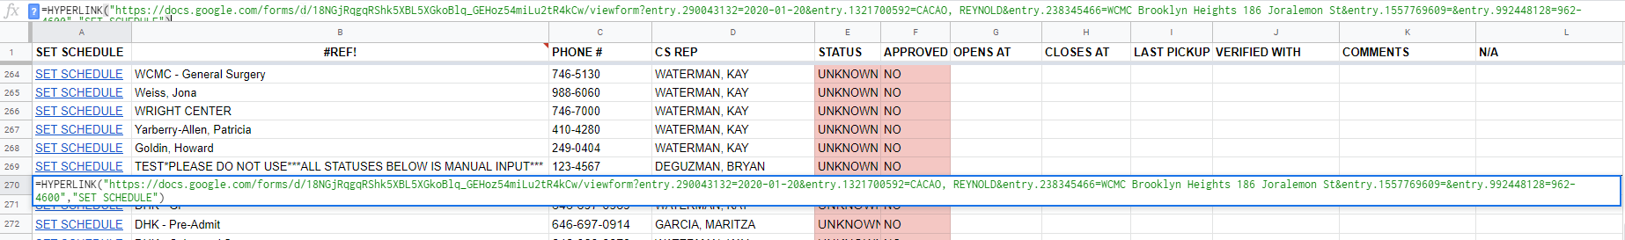
  - Change all dates to the appropriate Holiday date; the date input should be towards the middle of the address as seen below:
  - As of 01/07/2020, this manual input in code will need to be done for Rows 270-307.

Once this is all completed, you will email Brian Weeks, Courtney, Dreama, Nelkis, and CC Marc G.
Two links that you will need to share are as follow:
- The new Holiday sheet [Shareable link]
- The Holiday Closure Data Entry – HolidaynameYEAR – Responses sheet [shareable link]

