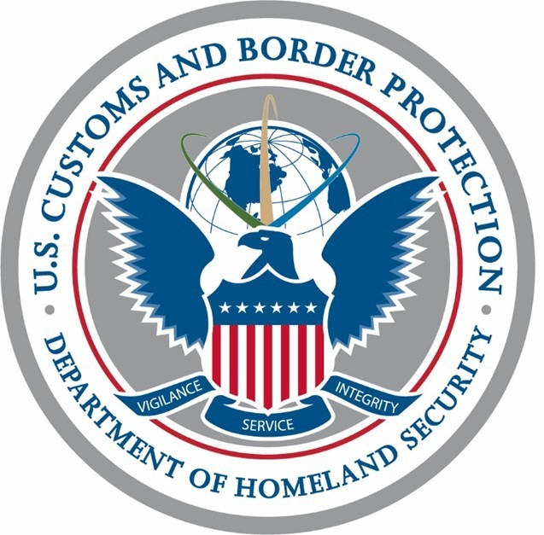 DEPARTMENT OF HOMELAND SECURITYOMB CONTROL NUMBER: 1651-0002

EXPIRATION DATE: 05/31/2024

U.S. Customs and Border Protection

**GENERAL DECLARATION**

**(Outward/Inward)**

**AGRICULTURE, CUSTOMS, IMMIGRATION, AND PUBLIC HEALTH**

19 CFR 122.43,122.52,122.54,122.73,122.144

|  |  |
| --- | --- |
| N/A | N/A |

**CBP Form 7507 (05/24)**

**Owner or Operator N/A**

**Flight No. 0000**

**Date 00/00/0000**

**Marks of Nationality and Registration N/A**

**Arrival at N/A**

**Departure from N/A**

)

Place

(

**FLIGHT ROUTING**

**''Place'' Column always to list origin, every en-route stop and destination**

**)**

**(**

**NUMBER OF PASSENGERS**

**ON THIS STAGE (1)**

**TOTAL NUMBER OF CREW**

**PLACE**

**Departure Place:**

Embarking N/A

Through on

same flight

**Arrival Place:**

Disembarking Click or tap here to enter text.

NUMBER OF SED's AND AWB's

AWB's

SED's

**For official use only**

**Declaration of Health**

Persons on board known to be suffering from illness other than airsickness or the effects

of accidents, as well as those cases of illness disembarked during the flight:

Any other condition on board which may lead to the spread of disease:

Details of each disinsecting or sanitary treatment (place, date, time, method) during the

flight. If no disinsecting has been carried out during the flight give details of most recent

disinsecting:

Signed, if required

*(*

*Sign in ink)*

Crew Member Concerned

I declare that all statements and particulars contained in this General Declaration, and in any

supplementary forms required to be presented with this General Declaration are complete, exact

and true to the best of my knowledge and that all through passengers will continue/have

continued on the flight.

**SIGNATURE**

Authorized Agent or Pilot-in-Command

*(*

*Sign in ink*

*)*

1)

Not to be completed when passenger manifests are presented.

Place

(

)

Through on

same flight

Page 1 of 2

**GENERAL DECLARATION**

Notes and Specifications

|  |  |
| --- | --- |
| NOTE 1. | An arrival-departure card (CBP Form I-94) for each passenger on board shall be presented to the immigration officer at the port of first arrival. |
| NOTE 2. | List surname, given name and middle initial of each crew member in the column headed "Total Number of Crew." |
| NOTE 3. | Air cargo manifests shall be attached hereto. |
| NOTE 4. | If copies of air waybills/consignment notes are attached, their numbers shall be entered on separate cargo manifest CBP Form 7509 to be attached hereto. If copies of air waybills/ consignment notes are not attached to this form, a separate cargo manifest CBP Form 7509 completed to show the full information required shall be furnished. |
| NOTE 5.  NOTE 6.  NOTE 7. | If the airline or operator consolidates a shipment with other shipments, or encloses the goods in other wrappers or containers, either separately or with other goods, the changes in packing and/or marks and numbers must be clearly stated in the air way-bill/consignment note.  Declaration of Health (U.S. Public Health Service requirements):  This section is to be completed only as directed by the U.S. Centers for Disease Control and Prevention (CDC) in the event of a public health emergency.    Conveyance operators should follow established procedures for reporting deaths/ill persons onboard an aircraft as required by 42 CFR Part 71.  **Third item--** If entry is duplicated, it is to be (a) initialed by person signing the general declaration or (b) signed by his authorized agent having knowledge of measures applied.  This General Declaration and/or attached manifests or air waybills should not bear erasures or corrections except those approved by the proper public authorities concerned nor contain interlineations or several listings on the same line. As many extra sheets may be added as necessary. |

The information requested by the official General Declaration may be furnished on ICAO Annex 9, Appendix 1, provided the form approximates (but does not exceed) 8 1/2" x 14", and is printed on white paper of appropriate quality.

This form may be printed by private parties provided it conforms to official form in size, wording, arrangement, and quality and color of paper.

**Paperwork Reduction Act Statement**: An agency may not conduct or sponsor an information collection and a person is not required to respond to this information unless it displays a current valid OMB control number and an expiration date. The control number for this collection is 1651-0002. The obligation to respond is mandatory. The estimated average time to complete this application is 5 minutes. If you have any comments regarding the burden estimate you can write to U.S. Customs and Border Protection, Office of Regulations and Rulings, 90K Street, NE, Washington DC 20002.

**CBP Form 7507 (05/24) Page 2 of 2**