**Project Name: GiKart**

**Project Member -**

**Rohit Yadav (220343120116)**

**Pravin Ghatage (220343120035)**

**Avinash Autade (220343120017)**

**Arjun Jagtap (220343120015)**

**Project Guide – Mrs. Harshita Maheshwari**

**Abstract:**

This project is a web-based shopping system for an existing shop. An Online Shopping Management System where the admin can Add, Update and Delete products. The Products are divided into various categories like goods, Handlooms, Textiles, handicrafts, etc. A user can select a particular item to view the details, choose the number of items and fill in details like Name, Address, etc. to buy a product the project objective is to deliver the online shopping application to the web platform. Online shopping is the process whereby consumers directly buy goods or services from a seller in real-time, without an intermediary service, over the Internet. It is a form of electronic commerce. This project attempts proto vide the advantages of online shopping to customers of a real shop. Thus, the customer will get the service of online shopping and home delivery from his favorite shop.

The objective of the project is to make a Web Application to purchase geographically indicated items in an existing shop. To build such an application complete web support, need to be provided. A complete and efficient web application that can provide an online shopping experience is the basic objective of the project.

**Implementation Technologies:**

1. **Spring Framework:**

Spring Framework is a Java platform that provides comprehensive infrastructure support for developing Java applications. Spring handles the infrastructure so you can focus on your application.

Spring enables you to build applications from “plain old Java objects” (POJOs) and to apply enterprise services non-invasively to POJOs. This capability applies to the Java SE programming model and full and partial Java EE.

**1.1 Features of Spring Framework:**

**1. Lightweight**

Spring is a modular lightweight framework that allows you to selectively use any of its modules on top of Spring Core.

**2. Inversion of Control (IOC)**

This is another top feature of the Spring framework where application dependencies are satisfied by the framework itself. The framework creates the object in runtime and satisfies application dependencies.

**3. Aspect Oriented Programming (AOP)**

Aspect Oriented Programming (AOP) is very popular in the programming world and in Spring it is well implemented. Developers can use Aspect Oriented Programming (AOP feature of Spring to develop applications in which business logic is separated from system services.

**4. Container**

Spring provides its container for managing the bean lifecycle.

**5. MVC Framework**

Spring MVC Framework is used for developing MVC-based web applications.

**6. Transaction Management**

Spring framework provides a generic Transaction Management layer which can be used with or without a J2EE(JEE) environment.

**7. JDBC Exception Handling**

Spring provides its abstraction of JDBC exception which further simplifies the exception handling in the program.

**1.2 Advantages of Spring Framework:**

**1. Solving difficulties of Enterprise application development**

Spring is solving the difficulties of development of complex applications, it provides Spring Core, Spring IoC and Spring AOP for integrating various components of business applications.

**2. Support Enterprise application development through POJOs**

Spring supports Enterprise application development using the POJO classes, which removes the need to import heavy Enterprise containers during development. This makes application testing much easier.

**3. Easy integration other frameworks**

Spring designed to be used with all other frameworks of Java, you can use ORM, Struts, Hibernate and other frameworks of Java together. Spring framework do not impose any restriction on the frameworks to be used together.

**4. Application Testing**

Spring Container can be used to develop and run test cases outside enterprise container which makes testing much easier.

**5. Modularity**

Spring framework is modular framework and it comes with many modules such as Spring MVC, Spring ORM, Spring JDBC, Spring Transactions etc. which can used as per application requirement in modular fashion.

**6. Spring Transaction Management**

Spring Transaction Management interface is very flexible it can configure to use local transactions in small application which can be scaled to JTA for global transactions.

**2.** **MySQL**

MySQL, the most popular Open Source SQL database management system, is developed, distributed, and supported by Oracle Corporation.

**2.1 Features of MySQL:**

* **MySQL is a database management system.**

A database is a structured collection of data. It may be anything from a simple shopping list to a picture gallery or the vast amounts of information in a corporate network. To add, access, and process data stored in a computer database, you need a database management system such as MySQL Server. Since computers are very good at handling large amounts of data, database management systems play a central role in computing, as standalone utilities, or as parts of other applications.

* **MySQL databases are relational.**

A relational database stores data in separate tables rather than putting all the data in one big storeroom. The database structures are organized into physical files optimized for speed. The logical model, with objects such as databases, tables, views, rows, and columns, offers a flexible programming environment.

* **MySQL software is Open Source.**

Open Source means that it is possible for anyone to use and modify the software. Anybody can download the MySQL software from the Internet and use it without paying anything.

* **The MySQL Database Server is very fast, reliable, scalable, and easy to use.**

MySQL Server was originally developed to handle large databases much faster than existing solutions and has been successfully used in highly demanding production environments for several years. Although under constant development, MySQL Server today offers a rich and useful set of functions. Its connectivity, speed, and security make MySQL Server highly suited for accessing databases on the Internet.

* **MySQL Server works in client/server or embedded systems.**

The MySQL Database Software is a client/server system that consists of a multithreaded SQL server that supports different back ends, several different client programs and libraries, administrative tools, and a wide range of application programming interfaces (APIs).

**2.2** **React**

The main objective of ReactJS is to develop User Interfaces (UI) that improves the speed of the apps. It uses virtual DOM (JavaScript object), which improves the performance of the app. The JavaScript virtual DOM is faster than the regular DOM. We can use ReactJS on the client and server-side as well as with other frameworks. It uses component and data patterns that improve readability and helps to maintain larger apps.

**2.2.1 Features of React :**

* **JSX**

JSX stands for JavaScript XML. It is a JavaScript syntax extension. Its an XML or HTML like syntax used by ReactJS. This syntax is processed into JavaScript calls of React Framework. It extends the ES6 so that HTML like text can co-exist with JavaScript react code. It is not necessary to use JSX, but it is recommended to use in ReactJS.

* **Components**

ReactJS is all about components. ReactJS application is made up of multiple components, and each component has its own logic and controls. These components can be reusable which help you to maintain the code when working on larger scale projects.

* **One-way Data Binding**

ReactJS is designed in such a manner that follows unidirectional data flow or one-way data binding. The benefits of one-way data binding give you better control throughout the application. If the data flow is in another direction, then it requires additional features. It is because components are supposed to be immutable and the data within them cannot be changed. Flux is a pattern that helps to keep your data unidirectional. This makes the application more flexible that leads to increase efficiency.

### Virtual DOM

A virtual DOM object is a representation of the original DOM object. It works like a one-way data binding. Whenever any modifications happen in the web application, the entire UI is re-rendered in virtual DOM representation. Then it checks the difference between the previous DOM representation and new DOM. Once it has done, the real DOM will update only the things that have actually changed. This makes the application faster, and there is no wastage of memory.

### Simplicity

ReactJS uses JSX file which makes the application simple and to code as well as understand. We know that ReactJS is a component-based approach which makes the code reusable as your need. This makes it simple to use and learn.

### Performance

ReactJS is known to be a great performer. This feature makes it much better than other frameworks out there today. The reason behind this is that it manages a virtual DOM. The DOM is a cross-platform and programming API which deals with HTML, XML or XHTML. The DOM exists entirely in memory. Due to this, when we create a component, we did not write directly to the DOM. Instead, we are writing virtual components that will turn into the DOM leading to smoother and faster performance.

1. **Hardware and Software Requirements (Minimum):**

**Hardware:**

1. Intel i3 processor 3rd generation or later / AMD Ryzen 200 2nd generation or later

2. 2 GB ddr3 ram.

3. Windows 7 Home edition or later.

4. 200 GB Sata HDD Space

5. Data Connection 200 kbps

**Software:**

1. Eclipse 4.7 Oxygen
2. MySQL 5.7 with Workbench 8.0
3. Google Chrome version 79.0
4. Apache Tomcat Server 8.5
5. Maven Dependencies
6. **ER Diagram:**

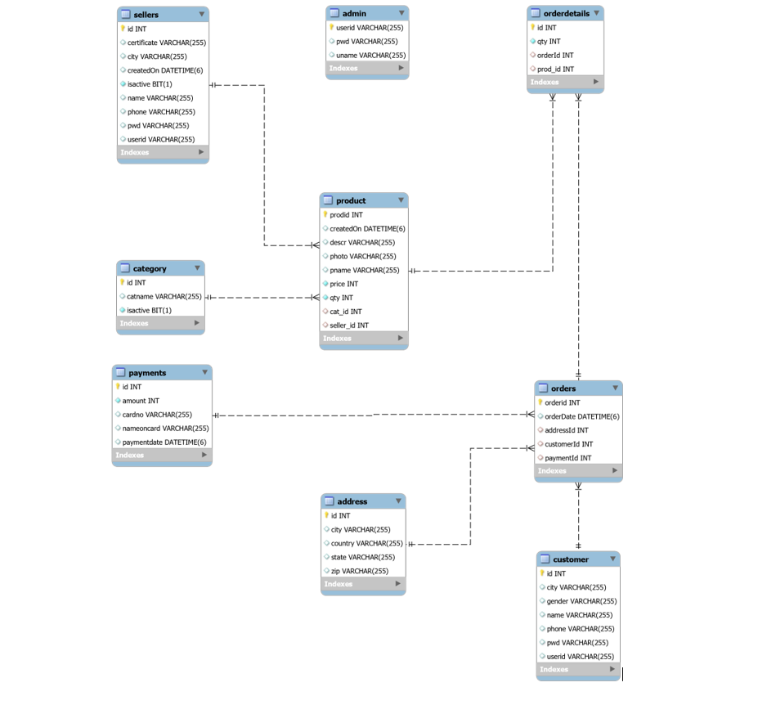

Figure 1: ER Diagram

1. **Table Structures:**
2. **Table name: Seller**

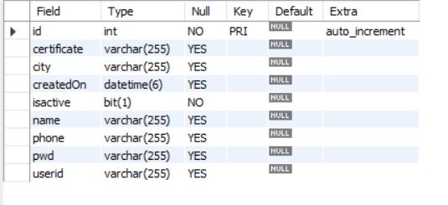

1. **Table name: Product**

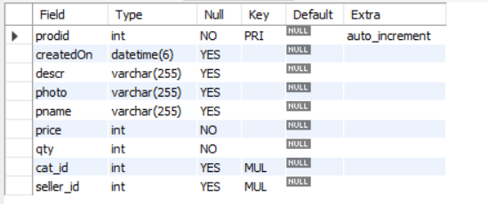

1. **Table name: Customer**

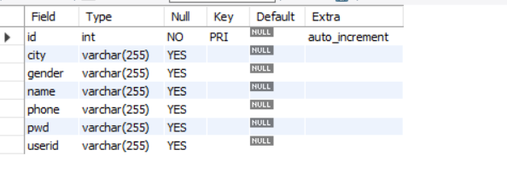

1. **Table name: Order Details**

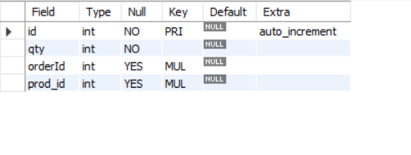

1. **Table name: Addresses**

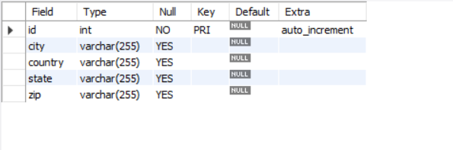

1. **Table name: Oders**

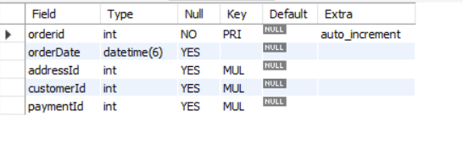

1. **Table name: Admin**

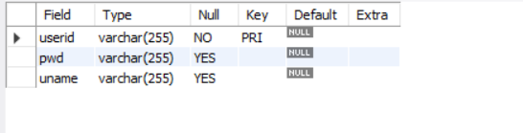

1. **Table name: Payments**

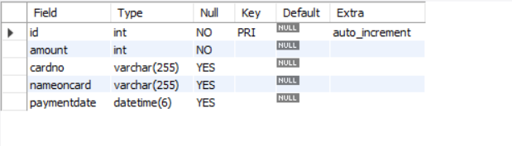

1. **Table name: Category**

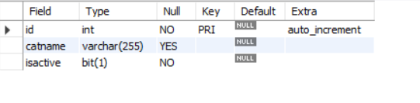

1. **UML Diagrams:**

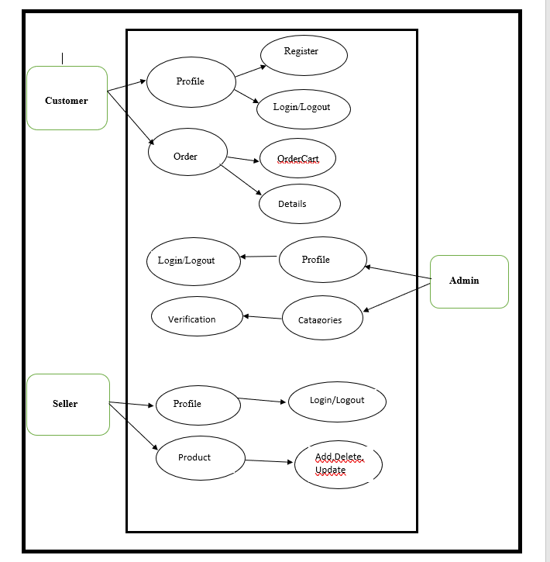

Figure 2: Use Case

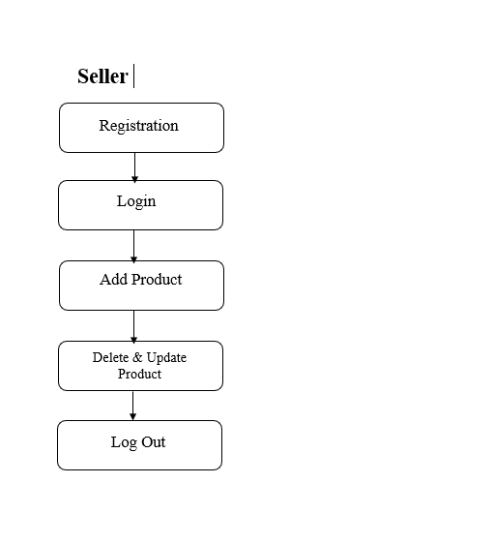 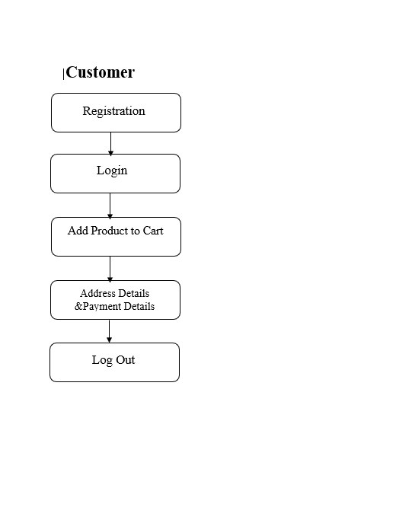

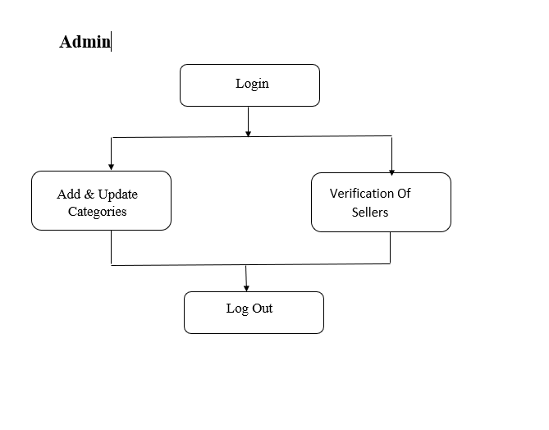

Figure 3: State Diagram

1. **End-to-End Flow of Application:**

There are three actors in the GiKart application:

* Admin
* Seller
* Customer

**Admin:**

1. Admin will log in from the admin login page.
2. After the login, the admin will create different types of categories. also, he is able to delete categories in the application.
3. Admin can see all the sellers with their G.I. certificates.
4. After verification of the G.I. Certificate he will update the status of the seller [ i.e. ACTIVE or DEACTIVE]
5. Admin can see the customers and their orders…

**Seller:**

1. Seller will register from the ‘Supplier Register Form’ page with G.I Certificate.
2. Admin will verify seller G.I. Certificate and update respective seller status as ‘ACTIVE’.
3. After the verification, the seller will log the in from seller login page.
4. Seller will add their product with photo, price, description, and categories.
5. Seller has the right to edit or delete the product.

**Customer:**

1. Customer will register from the ‘ customer registration form’ page…
2. After successfully registering customer will log in from the customer login page.
3. Finally, customers will buy verified G.I tags products.
4. **Future Scope of Project**

* Verification of Customer.
* Improvement in design.
* Mobile Application
* UPI payment
* Chat BOT
* Integration of International G.I. Products.

**Thank You!**