





**On-demand Traffic light control**

Prepared for

**Embedded Systems Professional Nanodegree Program**

Prepared by

**Roqaia Khalid Wagih**

**Roqiawagih2000@gmail.com.com**

**September 9, 2022**

**Executive Summary**

**About Us**

**Scope of Work**

1. **Job Description**

In normal mode:

Cars' LEDs will be changed every five seconds starting from Green then yellow then red then yellow then Green.

The Yellow LED will blink for five seconds before moving to Green or Red LEDs.

In pedestrian mode:

Change from normal mode to pedestrian mode when the pedestrian button is pressed.

If pressed when the case Red LED is on, the pedestrian's Green LED and the cars' Red LEDs will be on for five seconds, this means that pedestrians can cross the street while the pedestrian's Green LED is on.

If pressed when the access Green LED is on or the car’s Yellow LED is blinking, the pedestrian Red LED will be on then both Yellow LEDs start to blink for five seconds, then the cars' Red LED and pedestrian Green LEDs are on for five seconds, this means that pedestrian must wait until the Green LED is on.

At the end of the two states, the cars' Red LED will be off and both Yellow LEDs start blinking for 5 seconds and the pedestrian's Green LED is still on.

After five seconds the pedestrian Green LED will be off and both the pedestrian Red LED and the cars' Green LED will be on.

Traffic light signals are going to normal mode again.

1. **system description**

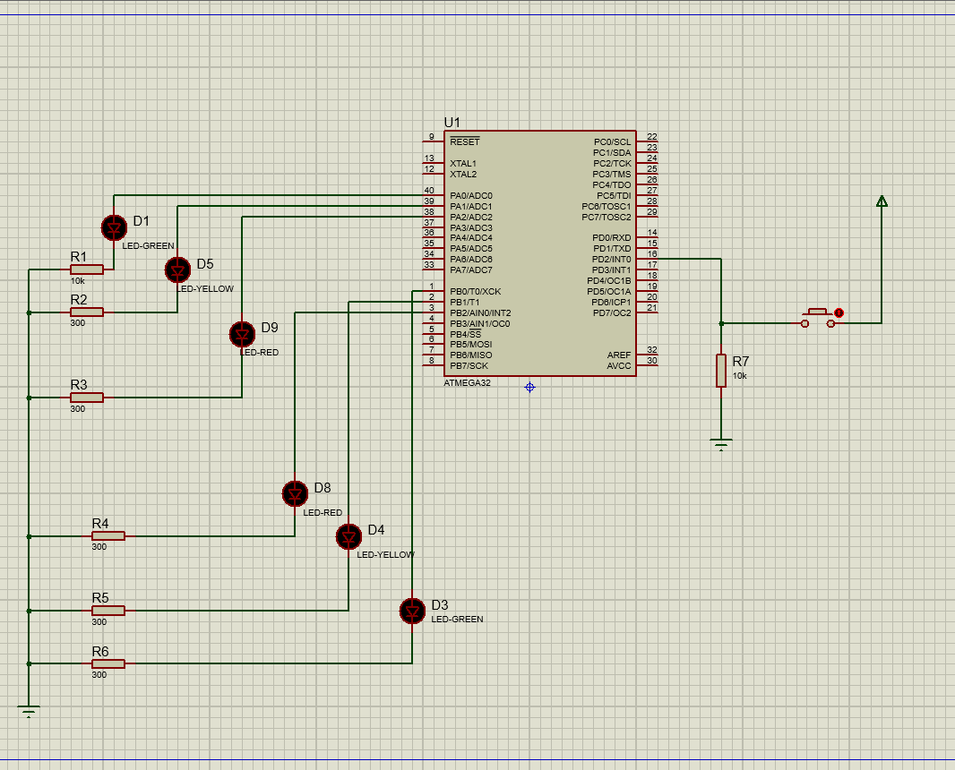

1. **system design**

