The following tables define the registers on the GBT-SCA that need to be accessed for monitoring and control of the CCV2.

Control Registers:

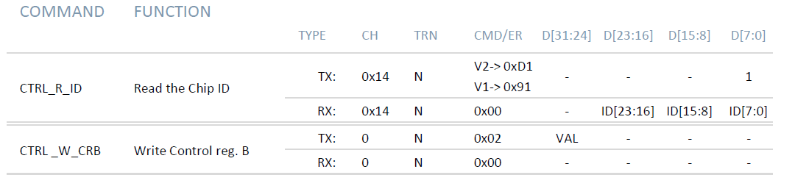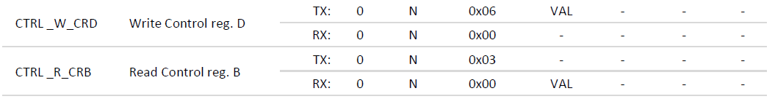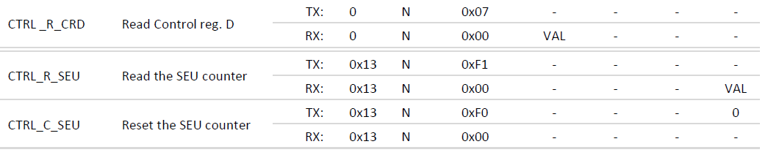

I2C Registers

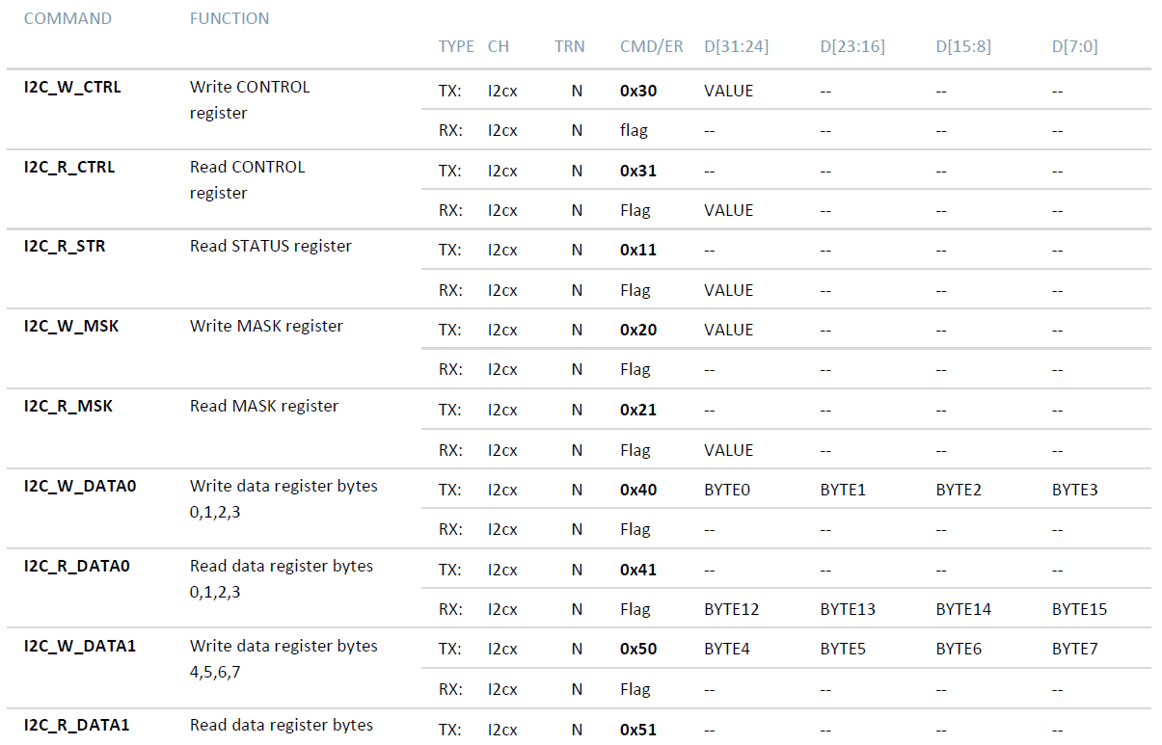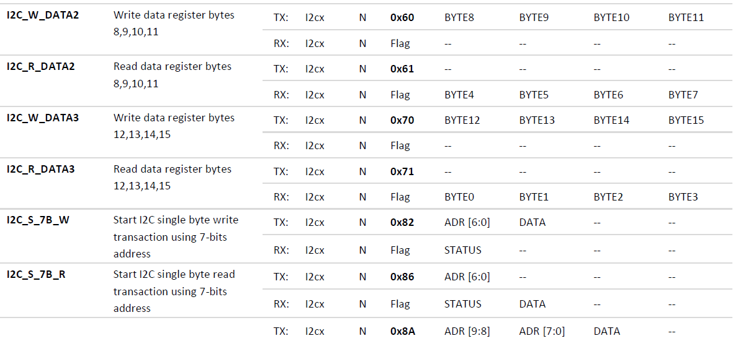

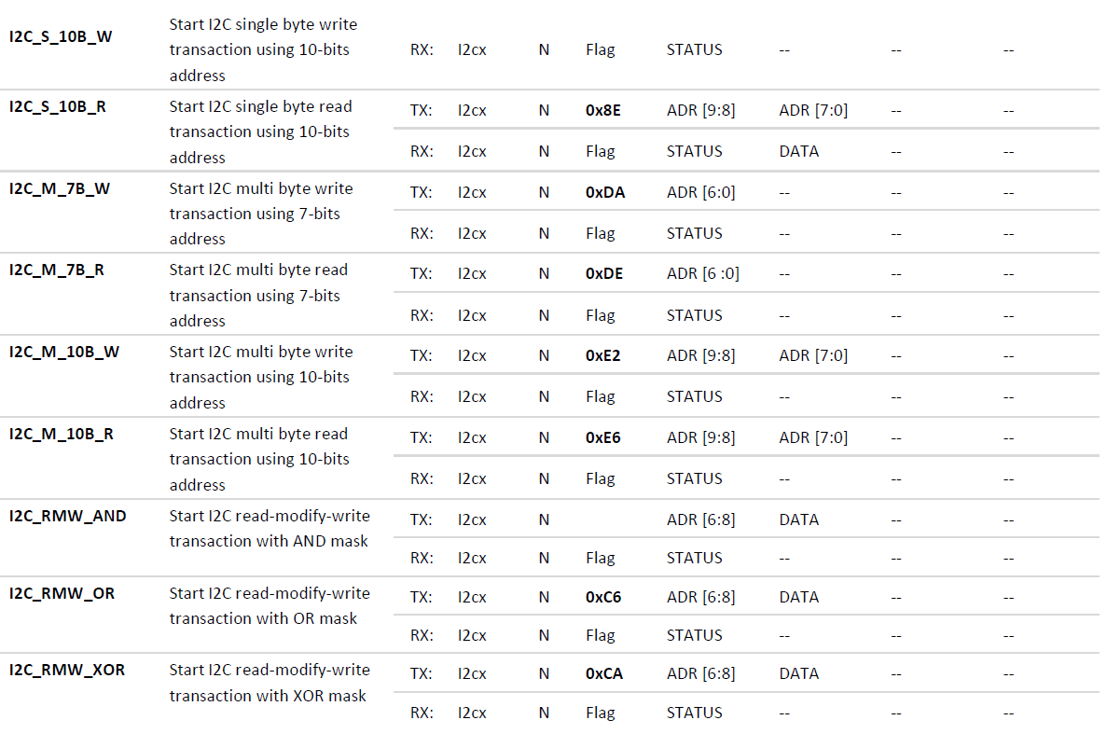

GPIO

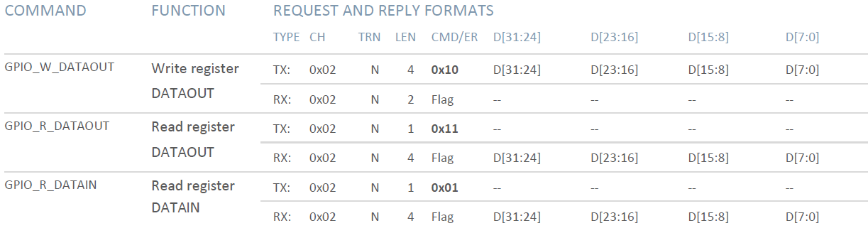

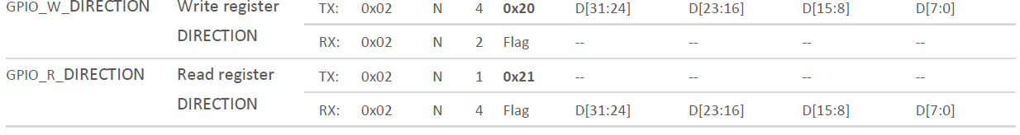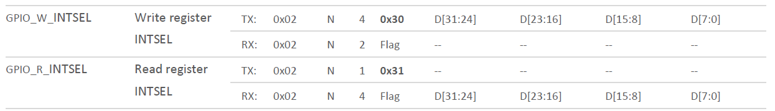

ADC

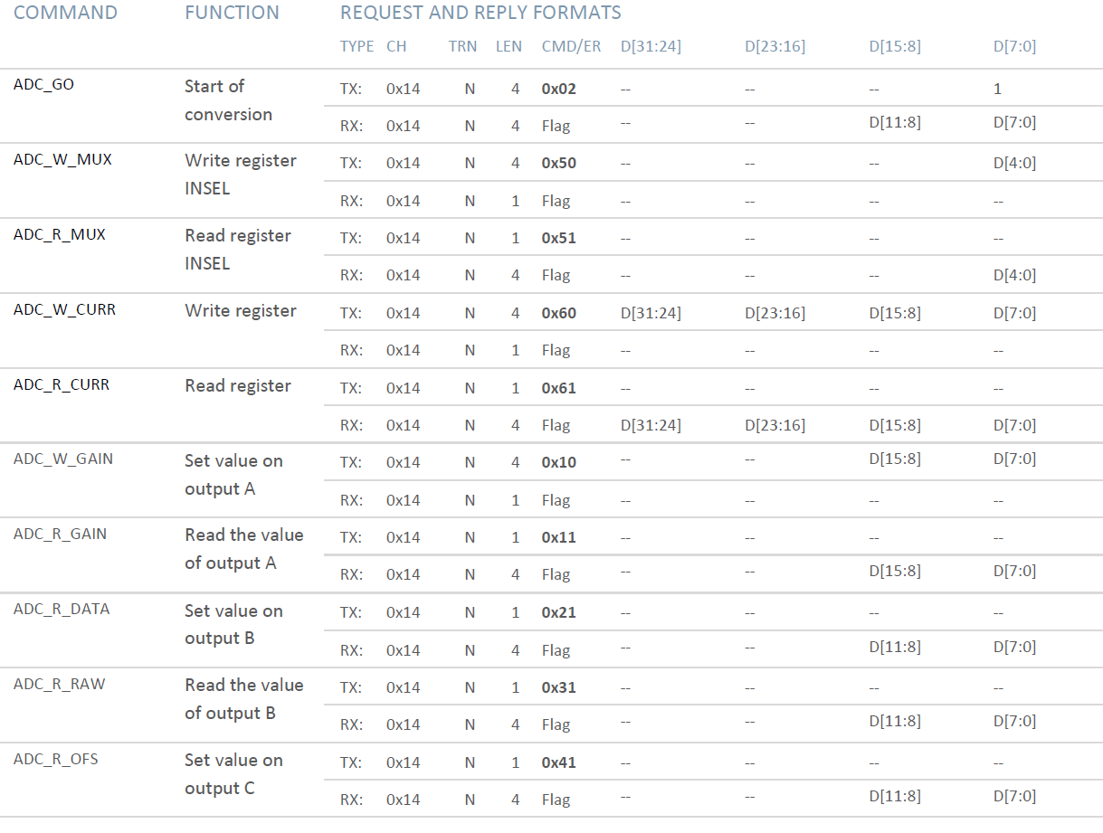

The following registers of the LpGBT need to be accessed for readout and monitoring of the CCV2.

Read/Write/Fuse registers:

|  |
| --- |
| 0x052 PIODirH |
| 0x053 PIODirL |
| 0x054 PIOOutH |
| 0x055 PIOOutL |
| 0x056 PIOPullEnaH |
| 0x057 PIOPullEnaL |
| 0x058 PIOUpDownH |
| 0x059 PIOUpDownL |
| 0x05a PIODriveStrengthH |
| 0x05b PIODriveStrengthL |
| 0x06a CURDACValue |
| 0x06b CURDACCHN |

Read/Write Registers

|  |
| --- |
| 0x111 ADCSelect |
| 0x112 ADCMon |
| 0x113 ADCConfig |

Read Registers

|  |
| --- |
| 0x1b8 ADCStatusH |
| 0x1b9 ADCStatusL |
| 0x19f PIOInH |
| 0x1a0 PIOInL |