- Init
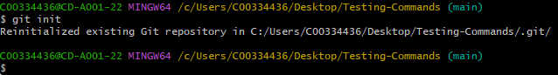
- Add
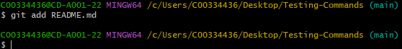
- Status
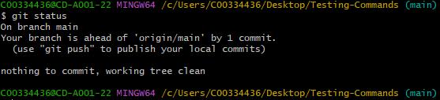
- Commit
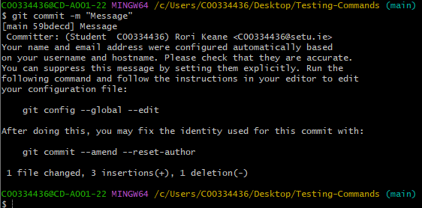
- Remote
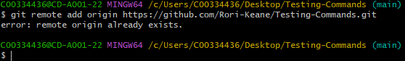
(it seems like a remote was created automatically by GitHub when I made this test repository on there … regardless, under normal circumstances this would add a remote)
- Push
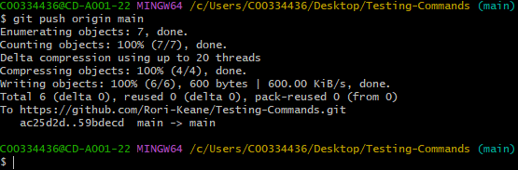
- Branch
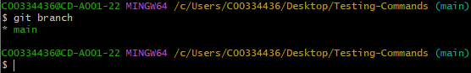
- Checkout
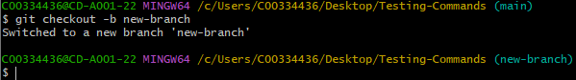
- Merge
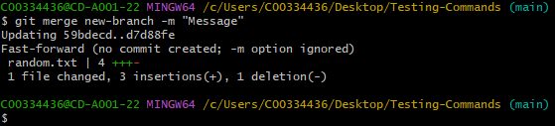
- Log
