**Completion and Recipe application**

**Here we are going to compile our application and what features need to be added to run our application:**

Step 1: Make sure that visual studio 2022 is installed on your computer.

Step 2: Open visual studio 2022 and create a new project called Recipe-application.

Step 3: Inside that project application add a class called recipe.

Step 4: In the recipe class, you will need to add the following properties called ingredients, quantities, units and steps.

Step 5: In the recipe class is where you will add codes for the display of all the functionalities when it comes to how the application should work and all its entities.

Step 6: Import all the functionalities mentioned for the program so that there is a clear link between recipe class and program.cs and add the necessary codes to the program.cs.

Step 7: Once application is compiled, user should run it from console.

Here is the link to the repository: [RorisangRalekwa/PROG-PART1 (github.com)](https://github.com/RorisangRalekwa/PROG-PART1)

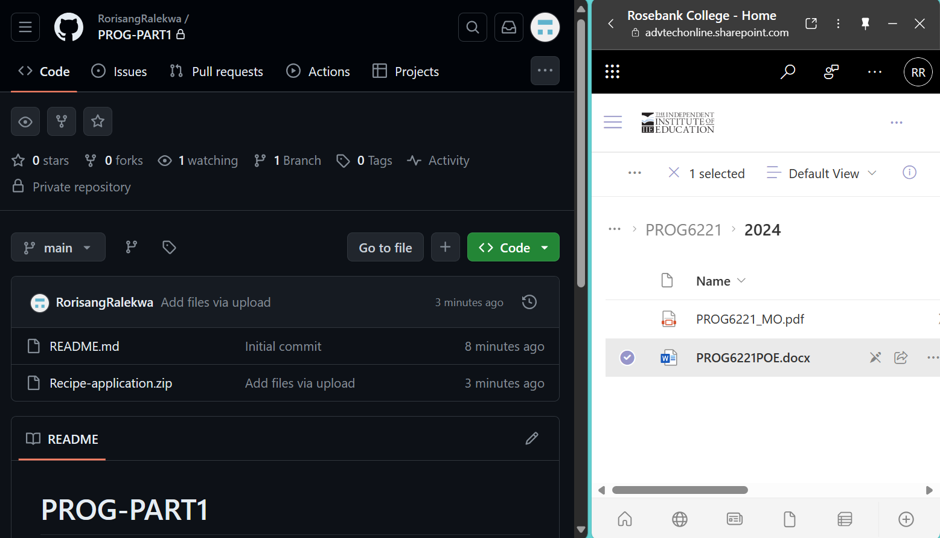

PROGRAMMING PART2

* In this section we are now taking our part1 and editing it with accordance with what is required for part2 meaning that we have now added a code that will make each recipe fall under a certain group of the food pyramid. This means that calories that accede a certain amount will be detected and give the user a notice of it.