Main Takeaways

the new version fix most of things (problem of different extraction date in previous version causing duplicate/spikes and mapping between one item to multiple categories)
- the difference between soda away and at home closes but still different from Leo (8 times larger instead of 5-6 for 2023);
- Leo's level (2,859,563,677 versus 477,718,593.9), here (4,115,420,727.33 versus 513,453,321.20);
- soda away is similar but soda at home is 1.4 time larger than Leo's number;
- either there are other changes/caveats that I did not notice or the weight is different from Leo's (as Heather from Kilts says trend factor could be wrong);
- And national factor is constant between household, so the closure of gap could be mostly due to trend factor;
- Increasing trend in expenditure; seasonal effect around end of year (increase in food spending and relative proportion of total spending on food); same for soda spending;
- Could be due to inflation
- this seasonal effect (around December) is not shown in Nielsen's trend analysis -> limited capture of food away from home?
- No significant increasing trend in Nielsen (measured in volume instead of monetary unit)
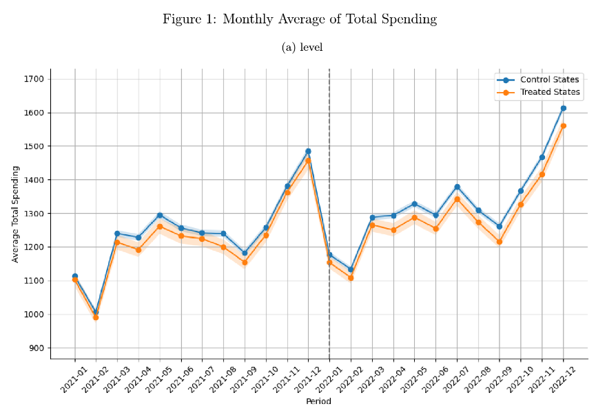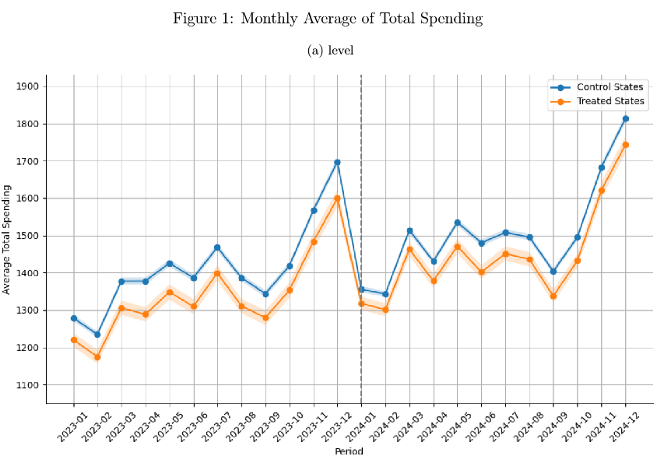
- Trend in EBT spending -> policy changes in SNAP benefits (see Numerator's estimates of SNAP benefit issued by month; SNAP benefit increased in Sep 2022 and decreased in Jan 2023)
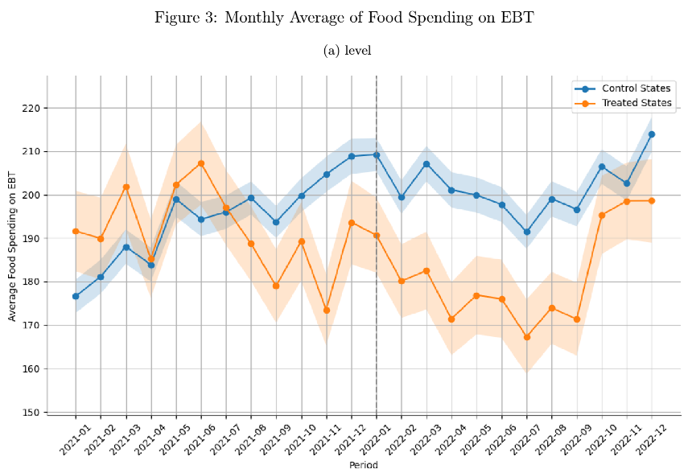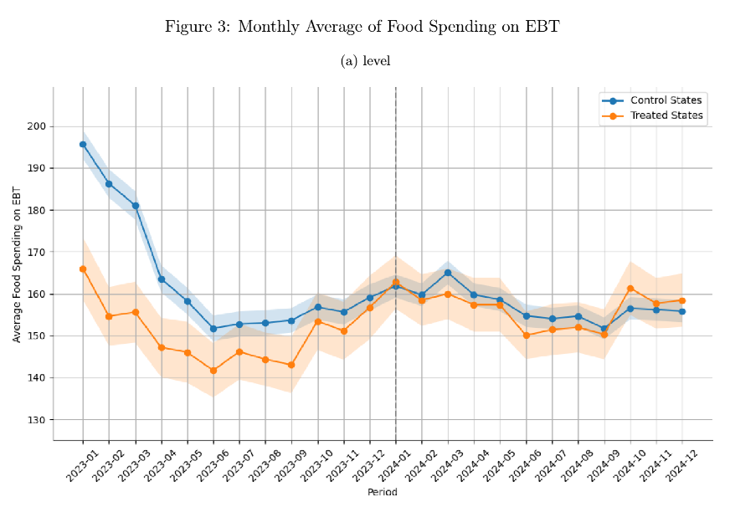
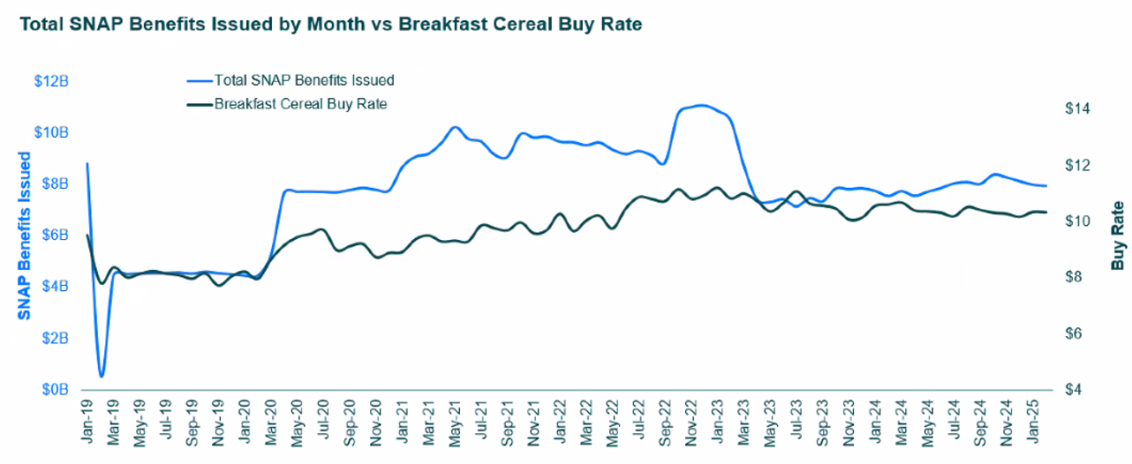
- bin scatter -> much closer to 1 after conditional on those with consecutive SNAP spell >= 12
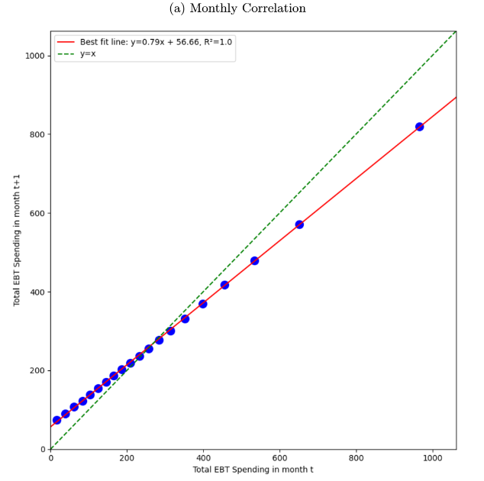
- working on consumption by household attributes (diabetes): people with diabetes spend (report) more on food and soda and have higher EBT spending, but they have a lower share of soda paid by EBT than those without diabetes (are less likely to pay soda by EBT cash than those without diabetes); 18% if SNAP household having diabetes, 16% of all having diabetes
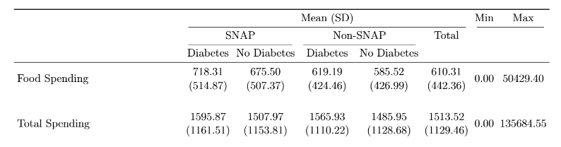
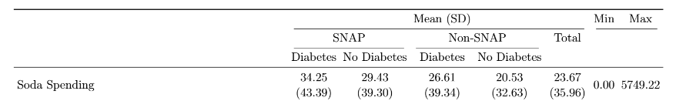
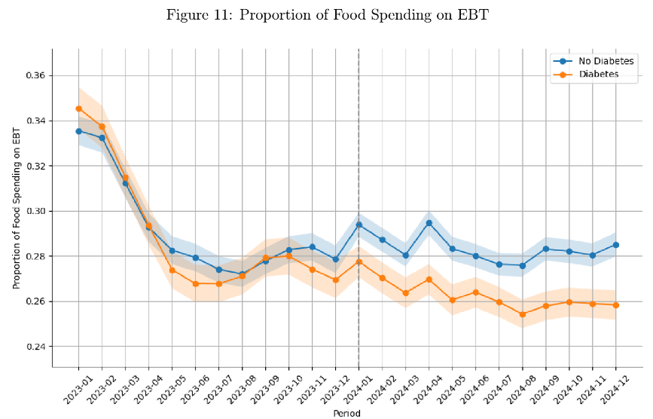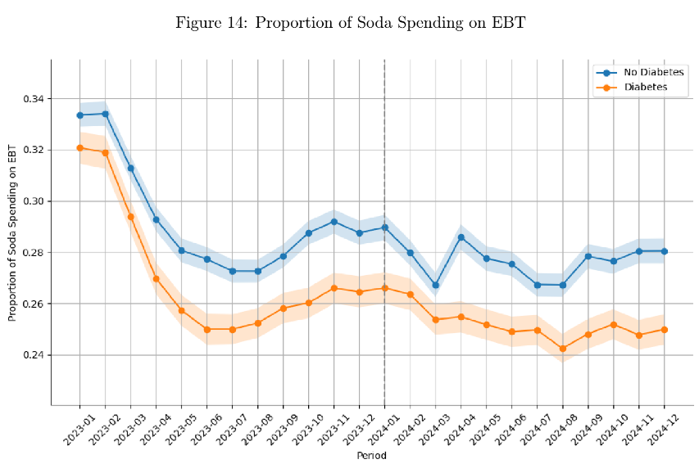
- compare to CEX
- Annual total expenditure is severely underestimated but the difference between food spending are much smaller -> Numerator capture more on grocery and food expenditure than other type of expenditure; richer household’s expenditure is more severely underestimated than others
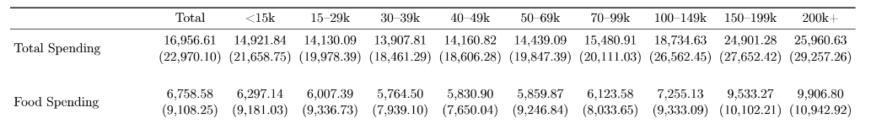
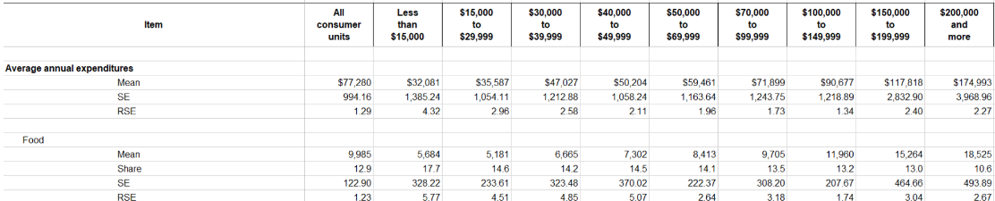
- In Numerator, share of food is more constant over income than in CEX (could be result of financial incentives distributed by Numerator; poorer household have more incentive to scan receipts; expenditure of richer household is not well captured)
- FAH more precise than FAFH -> in general QSR receipts are assigned with less financial reward; full restaurant services not well captured according to Numerator
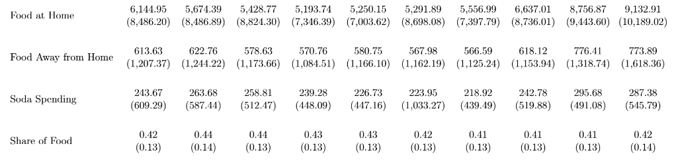
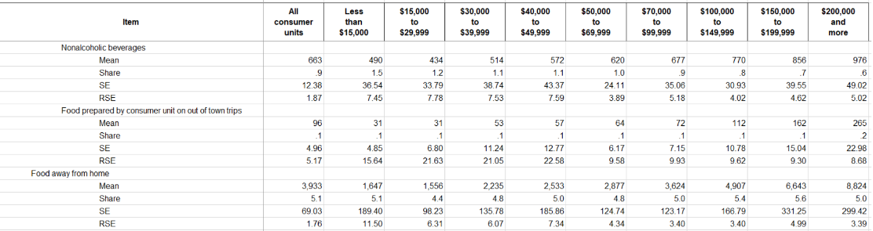
- Nielsen only scan barcodes, so possibly only grocery no QSR or other FAFH
- In model estimates
- pre-trend significantly reduced after being weighted (WLS)
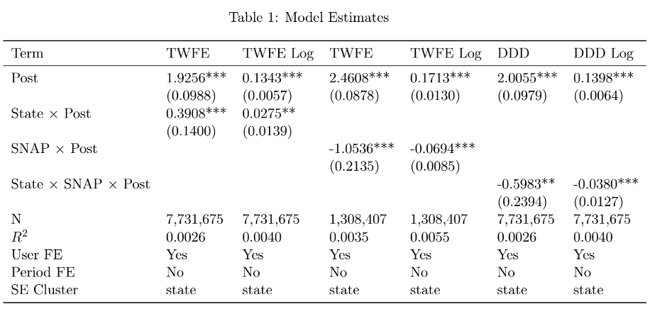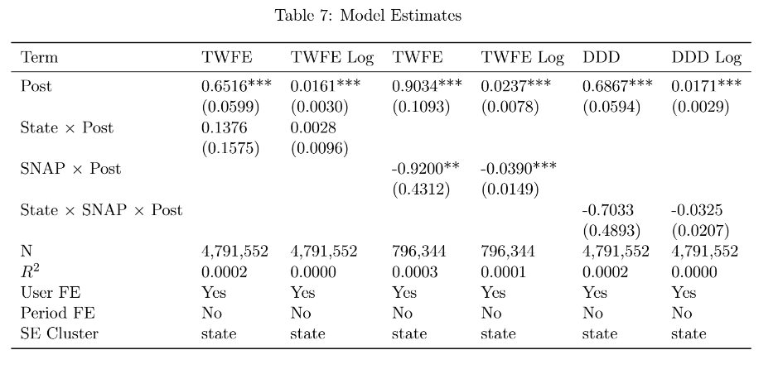
- on average 17% household on SNAP each month; but when aggregate at annual level, 38% household ever used SNAP benefit

- Some 0 food spending and total spending; 22 incidences (out of all month-hhd observations) with 0 spending in static panel; not sure why Numerator still include them in the static panel
- Average Number of Months per User & 17.88 & 18.06 & 18.03 -> because around 30 percent households are replaced between cohort

