Room8
Design doc

Scope
Renting a house or an apartment in Israel can be very expensive. This is why many people look to rent a place with roommates.
There are different platforms that help people look for a home, based on location, amenities and price. But finding roommates you feel comfortable sharing a household with, is an issue that the popular sites don’t address. There are essential living conditions that roommates must share, and if there’s a disagreement on those conditions it can often be a ‘deal breaker’.
The idea is to create a ‘match’ app (like ‘ok cupid’ or ‘tinder’), but for roommates.

Notes:
- At this time, the focus is on creating an algorithm that matches roommates. Additional variables, such as house attributes, may be added to the equation later on.
- The target audience is Jewish Israelis- religious and non religious. I hope the project grows and will also become a useful platform for people of many other backgrounds in Israel.

General Flow
Login
The user creates an account with an email and password. They can log in or create a new account.

User personal information
Once they sign up, they need to create a profile: they fill information about themselves. Different categories are provided and the user must choose from a list answers that fit them. The information they give will be able to be viewed by other roommate seekers. If there’s additional info the user would like to share, there’s space to type in whatever they’d like (COMMENTS).
The user is also asked to choose roommate preferences: the attributes the user looks for in a roommate. Here, too, there are different categories and the user must choose from given answers.

Accommodation Status
If the user already has a home, but is looking for a new roommate, the user can provide information about the location (city, neighborhood) of their home.
If the user does not have a home, they can provide info about the location they’re looking in.

Matching:
Once all the needed information is saved, the user starts to receive ‘matches’. The program displays a match one at a time [first name, age, general location they live in/ looking in, picture (optional) and matching percentage].
The user can choose to view the rest of the match profile.
The user can ‘like’ or ‘dislike’ a match.
If both the user and the match ‘like’ each other, they are given the option to CHAT.

Chat:
The chat is where two users who are interested in each other can talk and discuss further details.
*This is a feature for future development*

Admin User
The admin user has the ability to:
- Collect user’s feedback/ratings
- Block or disconnect users who are reported
- Collect data on amount of ‘likes’ and ‘dislikes’

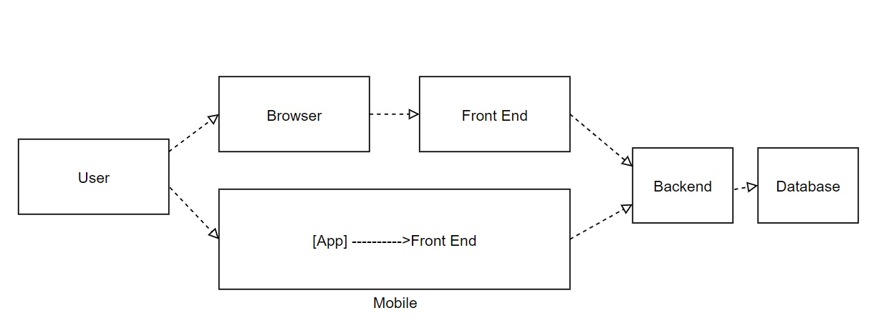
Architecture

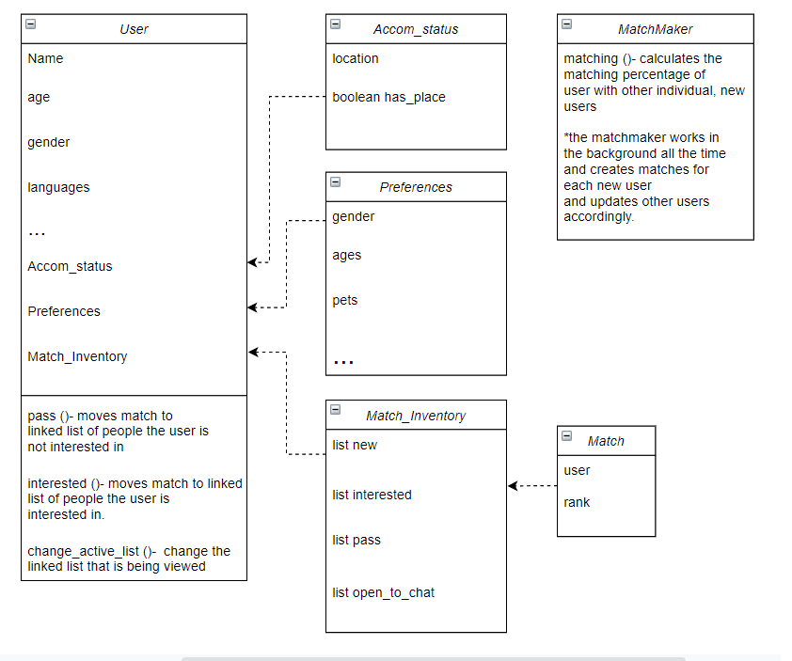Classes

