**实验一、简单的程序设计**

**1、2截图**

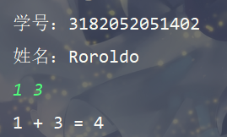

**源代码**

package test;

import java.util.Scanner;  
public class Test *{* public static void main*(*String*[] args) {  
 // 第一题输出自己的学号加姓名* System.*out*.println*(*"学号：" + "3182052051402"*)*;  
 System.*out*.println*(*"姓名：" + "Roroldo"*)*;  
 *// 第二题两个数加法* Scanner in = new Scanner*(*System.*in)*;  
 int a = in.nextInt*()*;  
 int b = in.nextInt*()*;  
 int sum = a + b;  
 System.*out*.println*(*a + " + " + b + " = " + sum*)*;  
 in.close*()*;  
 *}  
}*

**3.截图**

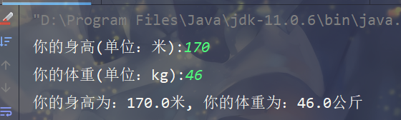

**源代码**

package test;

import java.util.Scanner;  
public class MyInfo *{* public static void main*(*String*[] args) {* Scanner in = new Scanner*(*System.*in)*;  
 System.*out*.print*(*"你的身高(单位：米):"*)*;  
 double height = in.nextDouble*()*;  
 System.*out*.print*(*"你的体重(单位：kg):"*)*;  
 double weight = in.nextDouble*()*;  
 System.*out*.print*(*"你的身高为：" + height + "米, "  
 + "你的体重为：" + weight + "公斤"*)*;  
 in.close*()*;  
 *}  
}*

**4.截图**



**源代码**

package test;

import java.util.Scanner;  
public class BMI *{* public static void main*(*String*[] args) {* Scanner in = new Scanner*(*System.*in)*;  
 System.*out*.print*(*"你的身高(单位：米):"*)*;  
 double height = in.nextDouble*()*;  
 System.*out*.print*(*"你的体重(单位：kg):"*)*;  
 double weight = in.nextDouble*()*;  
 double bmi = weight / Math.*pow(*height, 2*)*;  
 if *(*bmi <= 18*) {* System.*out*.print*(*"你的BMI是: " + bmi + ", 你属于轻重~"*)*;  
 *}* else if *(*bmi > 18 && bmi <= 25*) {* System.*out*.print*(*"你的BMI是: " + bmi + ", 你属于正常体重~"*)*;  
 *}* else if *(*bmi > 25 && bmi <= 30*) {* System.*out*.print*(*"你的BMI是: " + bmi + ", 你属于超重~"*)*;  
 *}* else if *(*bmi > 30 && bmi <= 35*) {* System.*out*.print*(*"你的BMI是: " + bmi + ", 你属于轻度肥胖~"*)*;  
 *}* else if *(*bmi > 35 && bmi <= 40*) {* System.*out*.print*(*"你的BMI是: " + bmi + ", 你属于中度肥胖~"*)*;  
 *}* else *{* System.*out*.print*(*"你的BMI是: " + bmi + ", 你属于重度肥胖~"*)*;  
 *}* in.close*()*;  
 *}  
}*

**5.截图**

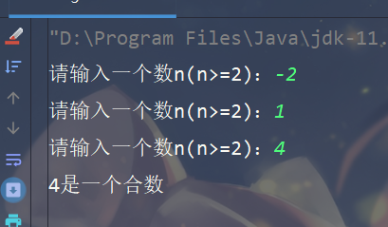

**源代码**

package test;

import java.util.Scanner;  
  
public class JudgeNumber *{* public static void main*(*String*[] args) {* Scanner in = new Scanner*(*System.*in)*;  
 while *(*true*) {* System.*out*.print*(*"请输入一个数n(n>=2)："*)*;  
 int n = in.nextInt*()*;  
 if *(*n >= 2*) {* if *(isPrime(*n*)) {* System.*out*.println*(*n + "是一个质数"*)*;  
 *}* else *{* System.*out*.println*(*n + "是一个合数"*)*;  
 *}* break;  
 *}  
 }* in.close*()*;  
 *}* private static boolean isPrime*(*int *n) {* for *(*int i = 2; i <= Math.*sqrt(n)*; i++*) {* if *(n* % i == 0*) {* return false;  
 *}  
 }* return true;  
 *}  
}*