桂 林 理 工 大 学
实 验 报 告
班级 软件18-3班 学号 3182052051402 姓名黄亿军 同组实验者 黄亿军
实验名称 数组 日期 2020年 06 月06 日
一、实验目的：

1、学会使用一维与二维数组管理简单数据。
2、学会编写简单的菜单驱动(命令行式)的Java程序

二、实验环境：
IDEA
三、实验内容：
1.
运行截图
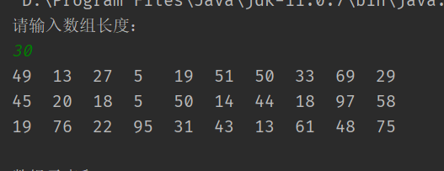
源代码
public class Emm {
public static void main(String[] args) {
Scanner in = new Scanner(System.in);
System.out.println("请输入数组长度：");
int len = in.nextInt();
int[] arr = new int[len];
int count = 1;
for (int i = 0; i < arr.length; i++) {
arr[i] = (int)(Math.random() * 100 + 1);
System.out.print( arr[i] + "\t");
if (count % 10 == 0) {
System.out.println();
}
count++;
}
System.out.println("\n数组元素和：" + sum(arr));
showMaxElement(arr);
in.close();
}
private static int sum(int[] arr) {
int sum = 0;
for (int temp : arr) {
sum += temp;
}
return sum;
}
private static void showMaxElement(int[] arr) {
int max = arr[0];
int pos = 0;
for (int i = 0; i < arr.length; i++) {
if (arr[i] > max) {
max = arr[i];
pos = i;
}
}
System.out.println("数组最大元素是： " +max + " 数组下标是: " + pos);
}
}

2.
运行截图
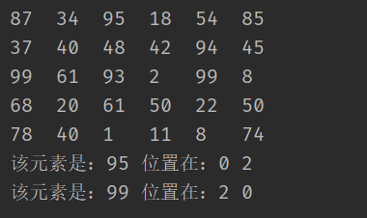
源代码
import java.util.Scanner;
public class Emm {
private static int colPos;
private static int rowPos;
private static int[][] data = new int[5][6];
public static void main(String[] args) {
Scanner in = new Scanner(System.in);
for (int i = 0 ; i < data.length; i++) {
for (int j = 0; j < data[i].length; j++) {
data[i][j] = (int)(Math.random() * 100 + 1);
System.out.print(data[i][j] + "\t");
}
System.out.println();
}
boolean flg = false;
for (int i = 0; i < data.length; i++) {
int maxRow = findRowMax(i);
if (isColMax(maxRow)) {
flg = true;
rowPos = i;
System.out.println("该元素是：" + maxRow + " 位置在：" + rowPos + " "+ colPos);
}
}
if (flg == false) {
System.out.println("没有这样的元素！");
}
in.close();
}
private static int findRowMax(int row) {
int max = -1;
for (int j = 0; j < data[row].length; j++) {
if (data[row][j] > max) {
max = data[row][j];
colPos = j;
}
}
return max;
}
private static boolean isColMax(int maxRow) {
for (int i = 0; i < data.length; i++) {
if (maxRow < data[i][colPos]) {
return false;
}
}
return true;
}
}

3.
运行截图
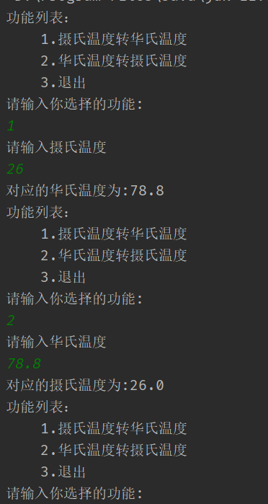
源代码
public class Emm {
public static void main(String[] args) {
Scanner in = new Scanner(System.in);
while (true) {
System.out.println("功能列表：");
System.out.println("\t1.摄氏温度转华氏温度");
System.out.println("\t2.华氏温度转摄氏温度");
System.out.println("\t3.退出");
System.out.println("请输入你选择的功能:");
int choice = in.nextInt();
switch (choice) {
case 1:
System.out.println("请输入摄氏温度");
double t = in.nextDouble();
tConvertH(t);
break;
case 2:
System.out.println("请输入华氏温度");
double h = in.nextDouble();
ConvertT(h);
break;
case 3:
return;
default:
System.out.println("别捣乱~~~");
}
}
}
private static void tConvertH(double t) {
double f = 9 * t / 5 + 32;
System.out.println("对应的华氏温度为:" + f);
}
private static void ConvertT(double h) {
double t = 5 * (h - 32) / 9;
System.out.println("对应的摄氏温度为:" + t);
}
}

4.
运行截图

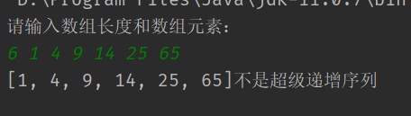
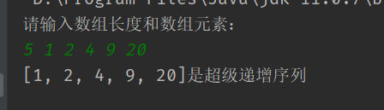
源代码
package test;
import java.util.Arrays;
import java.util.Scanner;
public class Emm {
public static void main(String[] args) {
Scanner in = new Scanner(System.in);
System.out.println("请输入数组长度和数组元素：");
int len = in.nextInt();
int[] arr = new int[len];
for (int i = 0; i < arr.length; i++) {
arr[i] = in.nextInt();
}
if (isSuperIncrementSeq(arr)) {
System.out.println(Arrays.toString(arr) + "是超级递增序列");
} else {
System.out.println(Arrays.toString(arr) + "不是超级递增序列");
}
in.close();
}
private static boolean isSuperIncrementSeq(int[] arr) {
int sum = 0;
for (int i = 0; i < arr.length; i++) {
int temp = arr[i];
for (int j = 0; j < i; j++) {
sum += arr[j];
}
if (temp < sum) {
return false;
}
sum = 0;
}
return true;
}
}

5.
运行截图
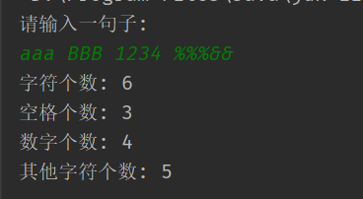
源代码
import java.util.Scanner;
public class Emm {
public static void main(String[] args) {
Scanner in = new Scanner(System.in);
System.out.println("请输入一句子:");
String msg = in.nextLine();
char[] msgArr = msg.toCharArray();
int num = 0;
int space = 0;
int ch = 0;
int other = 0;
for (int i = 0; i < msgArr.length; i++) {
if (msgArr[i] >= '0' && msgArr[i] <= '9') {
num++;
} else if (msgArr[i] == ' ') {
space++;
} else if (Character.toUpperCase(msgArr[i]) >= 'A' && Character.toUpperCase(msgArr[i]) <= 'Z') {
ch++;
} else {
other++;
}
}
System.out.println("字符个数: " + ch);
System.out.println("空格个数: " + space);
System.out.println("数字个数: " + num);
System.out.println("其他字符个数: " + other);
in.close();
}
}

四、心得体会：

无

