桂 林 理 工 大 学
实 验 报 告
班级 软件18-3 学号 3182052051402 姓名 黄亿军 同组实验者
实验名称 多线程 日期 2020年 07 月1 日
一、实验目的：
1.掌握线程的两种创建方式
2 掌握进程的同步的解决方法.

二、实验环境：
IDEA

三、实验内容：
1.运行截图：
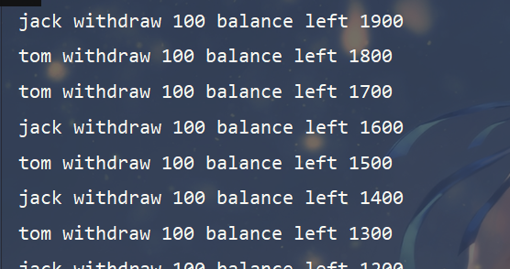
源代码：
package test.thread;
public class BankAccount {
private int money;
public BankAccount(int money) {
this.money = money;
}
public synchronized void withdraw(int count) {
if (money > 0) {
System.out.println(Thread.currentThread().getName() + " withdraw " + 100
+ " balance " + "left " + (getBalance() - count));
money -= count;
}
}
public int getBalance() {
return money;
}
}

package test.thread;
public class ATMWithDraw {
public static void main(String[] args) {
BankAccount bc = new BankAccount(2000);
new User("jack", bc).start();
new User("tom", bc).start();
}
}
class User extends Thread {
private BankAccount bc;
public User(String name, BankAccount bc) {
super(name);
this.bc = bc;
}
@Override
public void run() {
while (true) {
if (bc.getBalance() > 0) {
bc.withdraw(100);
try {
Thread.sleep(20);
} catch (InterruptedException e) {
e.printStackTrace();
}
}
}
}
}

2.运行截图：
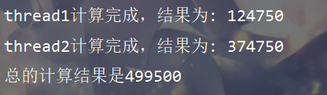
源代码：
package test.thread;
/**
* 信号量
* @author 落霞不孤
*/
public class Semaphore {
// 线程1和线程2通信的信号量，假设flg = false Thread1在计算
private boolean flg;
public Semaphore(boolean flg) {
this.flg = flg;
}
public void setFlg(boolean flg) {
this.flg = flg;
}
public boolean isFlg() {
return flg;
}
}

package test.thread;
public class TestSum {
public static void main(String[] args) throws InterruptedException {
Semaphore s = new Semaphore(false);
Thread1 thread1 = new Thread1("thread1", s);
Thread2 thread2 = new Thread2("thread2", s);
thread1.start();
thread2.start();
// main线程也参与cpu的竞争
// join方法的作用在这里的就是等thread1，thread2线程执行完毕，main线程才执行计算和
thread1.join();
thread2.join();
System.out.println("总的计算结果是" + getSum(thread1, thread2));
}
public static int getSum(Thread1 thread1, Thread2 thread2) {
return thread1.getSum1() + thread2.getSum2();
}
}
class Thread1 extends Thread {
private final Semaphore s;
private int sum1;
public Thread1(String name, Semaphore s) {
super(name);
this.s = s;
}
@Override
public void run() {
synchronized (s) {
if (s.isFlg() == true) {
try {
s.wait();
} catch (InterruptedException e) {
e.printStackTrace();
}
}
for (int i = 0; i < 500; i++) {
this.sum1 += i;
}
System.out.println(this.getName() + "计算完成，结果为" + ": " + sum1);
s.setFlg(true);
s.notify();
}
}
public int getSum1() {
return this.sum1;
}
}
class Thread2 extends Thread {
private final Semaphore s;
private int sum2;
public Thread2(String name, Semaphore s) {
super(name);
this.s = s;
}
@Override
public void run() {
synchronized (s) {
if (s.isFlg() == false) {
try {
s.wait();
} catch (InterruptedException e) {
e.printStackTrace();
}
}
for (int i = 500; i <= 999; i++) {
this.sum2 += i;
}
System.out.println(this.getName() + "计算完成，结果为" + ": " + sum2);
s.setFlg(false);
s.notify();
}
}
public int getSum2() {
return this.sum2;
}
}

3.运行截图：

源代码：
package test.thread;
public class Ticket implements Runnable {
private int ticket;
Object lock = new Object();
public Ticket(int ticket) {
this.ticket = ticket;
}
@Override
public void run() {
while (true) {
synchronized (lock) {
if (ticket >= 0) {
try {
Thread.sleep(50);
} catch (InterruptedException e) {
e.printStackTrace();
}
System.out.println(Thread.currentThread().getName() + " 剩余" + ticket-- + "张票！");
}
}
}
}
}

package test.thread;
public class TestTicket {
public static void main(String[] args) {
Ticket ticket = new Ticket(100);
new Thread(ticket, "窗口1").start();
new Thread(ticket, "窗口2").start();
new Thread(ticket, "窗口3").start();
new Thread(ticket, "窗口4").start();
}
}

4.运行截图：
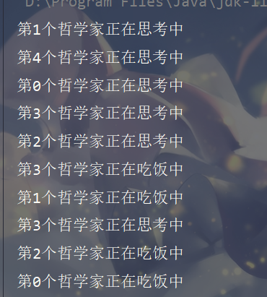
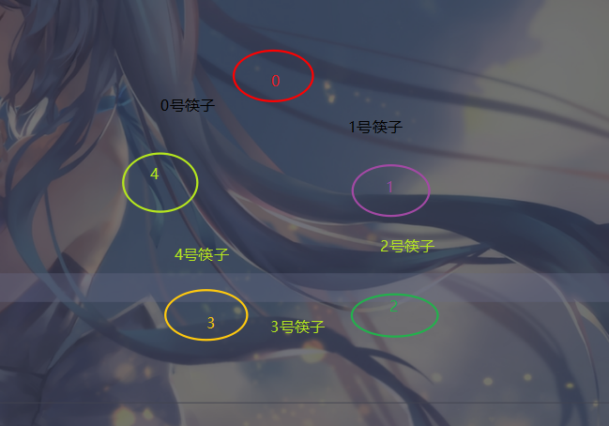
源代码：
package test.thread;
public class Philosopher extends Thread {
private int index;
private Chopsticks chop;
public Philosopher(int index, Chopsticks chop) {
this.index = index;
this.chop = chop;
}
@Override
public void run() {
while (true) {
try {
thinking();
chop.takeChop(index);
eating();
chop.putChop(index);
} catch (InterruptedException e) {
e.printStackTrace();
}
}
}
private void eating() throws InterruptedException {
System.out.println("第" + index + "个哲学家正在吃饭中");
sleep(2000);
}
private void thinking() throws InterruptedException {
System.out.println("第" + index + "个哲学家正在思考中");
sleep(1000);
}
}
class Chopsticks {
private Boolean[] chops = {false, false, false, false, false};
public synchronized void takeChop(int index) throws InterruptedException {
// 哲学家两旁的筷子被使用中，即为true状态
while (chops[index] || chops[(index+1) % 5]) {
wait();
}
// 两旁的筷子没有被使用中，修改筷子的状态为true
chops[index] = true;
chops[(index+1) % 5] = true;
}
public synchronized void putChop(int index) {
// 放下筷子，修改筷子的状态为false
chops[index] = false;
chops[(index+1) % 5] = false;
// 唤醒所有的思考中的哲学家线程
notifyAll();
}
}

package test.thread;
/**
* 破坏请求和保持条件，即一次分配好筷子
* @author 落霞不孤
*/
public class PhilosopherTest {
public static void main(String[] args) {
Chopsticks chops = new Chopsticks();
new Philosopher(0, chops).start();
new Philosopher(1, chops).start();
new Philosopher(2, chops).start();
new Philosopher(3, chops).start();
new Philosopher(4, chops).start();
}
}

四、心得体会：
无

