桂 林 理 工 大 学
实 验 报 告
班级 软件18-3班 学号 3182052051402 姓名黄亿军 同组实验者 黄亿军
实验名称 类与对象 日期 2020年 06 月10 日
一、实验目的：

1、学会定义并实现类。
2、学会定义并创建类的对象，通过类的对象访问类的成员属性与方法。
3、学会定义并实现派生类，学会使用派生类的对象。
4、理解并学会使用类的多态性。

二、实验环境：
IDEA

三、实验内容：
1.
源代码
package test;
public class Cube {
private int length;
private int width;
private int height;
public Cube(int length, int width, int height) {
this.length = length;
this.width = width;
this.height = height;
}
public int calVolume() {
return length * width * height;
}
public int calArea() {
int area = (length *width + length * height + width * height) * 2;
return area;
}
public static void main(String[] args) {
Cube c = new Cube(2, 3, 6);
System.out.println("V: " + c.calVolume());
System.out.println("S: " + c.calArea());
}
}

运行截图
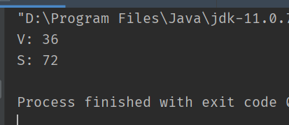

2.
运行截图
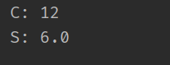
源代码
package test;
public class Triangle {
private int edg1;
private int edg2;
private int edg3;
public Triangle(int edg1, int edg2, int edg3) {
this.edg1 = edg1;
this.edg2 = edg2;
this.edg3 = edg3;
}
public boolean isTrianle() {
if ((edg1 + edg2 < edg3) || (edg1 + edg3 < edg2) || (edg2 + edg3 < edg1)) {
return false;
}
return true;
}
public int calPerimeter() {
if (isTrianle()) {
return edg1 + edg2 + edg3;
} else {
throw new IllegalArgumentException("参数不合法");
}
}
public double calArea() {
double p = this.calPerimeter() * 1.0 / 2;
double area = Math.sqrt(p * (p - edg1) * (p - edg2) * (p - edg3));
return area;
}
public static void main(String[] args) {
Triangle t = new Triangle(3, 4, 5);
System.out.println("C: " + t.calPerimeter());
System.out.println("S: " + t.calArea());
}
}

3.
源代码
package test;
public class Complex {
private double real;
private double image;
public Complex(double real, double image) {
this.real = real;
this.image = image;
}
public void add(Complex c) {
this.real += c.real;
this.image += c.image;
}
public void multiply(Complex c) {
this.real = this.real * c.real - this.image * c.image;
this.image = this.real * c.image + this.image * c.real;
}
public void print() {
if (image > 0) {
System.out.println(real + "+" + image + "i");
} else {
System.out.println(real + image + "i");
}
}
public static void main(String[] args) {
Complex c1 = new Complex(3, 4);
Complex c2 = new Complex(4,3);
c1.add(c2);
c1.print();
c1.multiply(c2);
c1.print();
}
}

运行截图
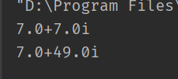

4.
源代码
package test;
import java.util.Scanner;
public class Person {
protected String name;
protected int code;
public Person(String name, int code) {
this.name = name;
this.code = code;
}
public void showInfo() {
System.out.println(toString());
}
@Override
public String toString() {
return "Person: " +
"name=" + name +
", code=" + code;
}
}
class Student extends Person {
private double math;
private double english;
private double java;
public Student(String name, int code) {
super(name, code);
}
public void inputInfo() {
Scanner in = new Scanner(System.in);
System.out.println("请依次输入数学、英语和java成绩");
double math = in.nextDouble();
double english = in.nextDouble();
double java = in.nextDouble();
this.math = math;
this.english = english;
this.java = java;
in.close();
}
public double calAverage() {
return (math + java + english) / 3;
}
@Override
public void showInfo() {
System.out.println("Student: name " + this.name + " Id " + this.code + " Average " + calAverage());
}
public static void main(String[] args) {
Person p = new Person("小明", 1);
p.showInfo();
Student s = new Student("大头", 2);
s.inputInfo();
s.showInfo();
}
}

运行截图
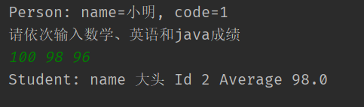

5.
源代码
package test;
public class Circle {
protected double radius;
public Circle(double radius) {
this.radius = radius;
}
public double calPerimeter() {
return 2 * Math.PI * radius;
}
public double calArea() {
return Math.PI * Math.pow(radius, 2);
}
public void showInfo() {
System.out.println("Circle: radius " + radius + " perimeter " + calPerimeter() + " area " + calArea());
}
}
class Cylinder extends Circle{
private double height;
public Cylinder(double radius, double height) {
super(radius);
this.height = height;
}
@Override
public double calArea() {
return 2 * super.calArea() + calPerimeter() * height;
}
public double calVolume() {
return super.calArea() * height;
}
@Override
public void showInfo() {
System.out.println("Cylinder: radius " + radius + " area " + calArea() + " volume " + calVolume());
}
public static void main(String[] args) {
Circle c = new Circle(3);
c.showInfo();
Cylinder cy = new Cylinder(3, 2);
cy.showInfo();
}
}

运行截图
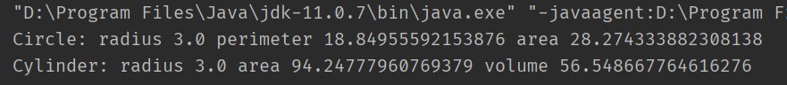

6. 7
源代码
package test;
public abstract class AbstractShape {
abstract double calArea();
}
class Rectangle extends AbstractShape {
private double length;
private double width;
public Rectangle(double length, double height) {
this.length = length;
this.width = height;
}
@Override
double calArea() {
return length * width;
}
}
class Cube extends Rectangle {
private double height;
public Cube(double length, double width, double height) {
super(length, width);
this.height = height;
}
@Override
public double calArea() {
return super.calArea();
}
public double calVolume() {
return this.calArea() * height;
}
}
class Circle extends AbstractShape {
private double radius;
public Circle(double radius) {
this.radius = radius;
}
@Override
double calArea() {
return Math.PI * Math.pow(radius, 2);
}
public static void main(String[] args) {
Rectangle r = new Rectangle(3 ,4);
System.out.println("rectangle area: " + r.calArea());
Circle c = new Circle(3);
System.out.println("circle area: " + c.calArea());
Cube cu = new Cube(3, 4, 5);
System.out.println("cube area: " + cu.calArea() + " volume: " + cu.calVolume());
}
}

运行截图
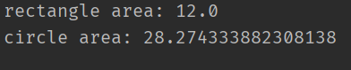
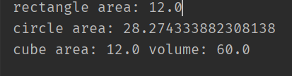

四、心得体会：

无

