桂 林 理 工 大 学
实 验 报 告
班级 软件18-3班 学号 3182052051402 姓名黄亿军 同组实验者 黄亿军
实验名称 常用的API 日期 2020年 06 月10 日
一、实验目的：

学会使用一些常用的API，查看底层源码
二、实验环境：
IDEA

三、实验内容：
1.
源代码
package test;
import java.util.Scanner;
public class SentenceConvert {
public static void main(String[] args) {
Scanner in = new Scanner(System.in);
System.out.print("please input a sentence: ");
String rec = in.nextLine();
char[] recArr = rec.toCharArray();
for (int i = 0; i < recArr.length; i++) {
if (Character.isLowerCase(recArr[i])) {
recArr[i] = Character.toUpperCase(recArr[i]);
} else if (Character.isUpperCase(recArr[i])) {
recArr[i] = Character.toLowerCase(recArr[i]);
}
}
System.out.println("result: " + new String(recArr));
in.close();
}
}

运行截图
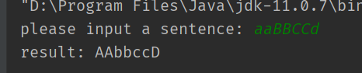

2.
运行截图
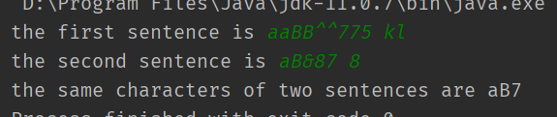
源代码
package test;
import java.util.HashSet;
import java.util.Scanner;
import java.util.Set;
public class FindSameCharacters {
public static void main(String[] args) {
Scanner in = new Scanner(System.in);
Set<Character> sameChar = new HashSet<>();
System.out.print("the first sentence is ");
String firstStr = in.nextLine();
System.out.print("the second sentence is ");
String secondStr = in.nextLine();
for (int i = 0; i < firstStr.length(); i++) {
for (int j = 0; j < secondStr.length(); j++) {
if (firstStr.charAt(i) == secondStr.charAt(j) && !Character.isSpaceChar(firstStr.charAt(i))) {
sameChar.add(firstStr.charAt(i));
}
}
}
System.out.print("the same characters of two sentences are ");
for (Character c : sameChar) {
System.out.print(c);
}
in.close();
}
}

3.
源代码
package test;
import java.util.Scanner;
import java.util.regex.Pattern;
public class MatchMail {
public static void main(String[] args) {
Scanner in = new Scanner(System.in);
System.out.print("please input a email: ");
String mail = in.nextLine();
String pattern = "^[0-9a-zA-Z_]*@[0-9a-zA-Z]*.[0-9a-zA-Z]*" ;
if (Pattern.matches(pattern, mail)) {
System.out.println("your email account is valid.");
} else {
System.out.println("your email account is invalid！");
}
}
}

运行截图
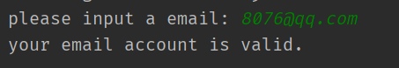
4.
源代码
package test;
public class Student {
private int id;
private String name;
private double chinese;
private double math;
private double english;
public Student(int id, String name, double chinese, double math, double english) {
this.id = id;
this.name = name;
this.chinese = chinese;
this.math = math;
this.english = english;
}
public int getId() {
return id;
}
public void setId(int id) {
this.id = id;
}
public String getName() {
return name;
}
public void setName(String name) {
this.name = name;
}
public double getChinese() {
return chinese;
}
public void setChinese(double chinese) {
this.chinese = chinese;
}
public double getMath() {
return math;
}
public void setMath(double math) {
this.math = math;
}
public double getEnglish() {
return english;
}
public void setEnglish(double english) {
this.english = english;
}
// 获取总分
public double getTotalScores() {
return this.chinese + this.math + this.english;
}
@Override
public String toString() {
return "Student{" +
"id=" + id +
", name='" + name + '\'' +
", chinese=" + chinese +
", math=" + math +
", english=" + english +
", sum=" + getTotalScores() +
'}';
}
}

package test;
import java.util.*;
public class StudentsInfo {
private static Map<Integer, Student> studentMap;
private static Set<Map.Entry<Integer, Student>> studentSet;
private StudentsInfo() {
}
public static Map<Integer, Student> createStudentMap() {
Scanner in = new Scanner(System.in);
studentMap = new LinkedHashMap<>();
System.out.print("请输入学生人数：");
int num = in.nextInt();
for (int i = 0; i < num; i++) {
System.out.println("请依次输入学生的学号、姓名、语文成绩、数学成绩和英语成绩");
int id = in.nextInt();
String name = in.next();
double chinese = in.nextDouble();
double math = in.nextDouble();
double english = in.nextDouble();
Student student = new Student(id, name, chinese, math, english);
studentMap.put(id, student);
}
in.close();
return studentMap;
}
public static Map<Integer, Student> sortStudentMap(Map<Integer, Student> map) {
Map<Integer, Student> newStudentMap = new LinkedHashMap<>();
// 构造函数的参数为实现了collection接口的set，请见Arraylist的API
List<Map.Entry<Integer, Student>> stuList = new ArrayList<>(map.entrySet());
Collections.sort(stuList, new Comparator<Map.Entry<Integer, Student>>() {
@Override
public int compare(Map.Entry<Integer, Student> o1, Map.Entry<Integer, Student> o2) {
Student s1 = o1.getValue();
Student s2 = o2.getValue();
return (int) (s1.getTotalScores() - s2.getTotalScores());
}
});
for (Map.Entry<Integer, Student> entry : stuList) {
int id = entry.getKey();
Student stu = entry.getValue();
newStudentMap.put(id, stu);
}
return newStudentMap;
}
public static Set<Map.Entry<Integer, Student>> createStudentSet(Map<Integer, Student> map) {
sortStudentMap(map);
// TreeSet集合存放的元素必须实现Comparator接口，默认按成绩总分排序
studentSet = new TreeSet<>(new Comparator<Map.Entry<Integer, Student>>() {
@Override
public int compare(Map.Entry<Integer, Student> o1, Map.Entry<Integer, Student> o2) {
return (int) (o1.getValue().getTotalScores() - o2.getValue().getTotalScores());
}
});
// 将studentMap的项取出封装为set集合，并全部添加到studentSet中
studentSet.addAll(map.entrySet());
return studentSet;
}
public static void showStuMsg(Map<Integer, Student> map) {
double sum = 0;
double maxTotalScores = 0;
double minTotalScores = 500;
Set<Map.Entry<Integer, Student>> entries = map.entrySet();
for (Map.Entry<Integer, Student> entry : entries) {
Student stu = entry.getValue();
if (stu.getTotalScores() > maxTotalScores) {
maxTotalScores = stu.getTotalScores();
}
if (stu.getTotalScores() < minTotalScores) {
minTotalScores = stu.getTotalScores();
}
sum += stu.getTotalScores();
System.out.println(stu);
}
System.out.println("最高成绩：" + maxTotalScores);
System.out.println("最低成绩：" + minTotalScores);
System.out.println("平均成绩：" + (sum/entries.size()));
System.out.println("###############################################");
}
public static void showStuMsg(Set<Map.Entry<Integer, Student>> set) {
System.out.println("Treeset表：");
for (Map.Entry<Integer, Student> entry : set) {
System.out.println(entry.getValue());
}
System.out.println("###############################################");
}
}

package test;
import java.util.Map;
import java.util.Set;
public class StudentsInfoTest {
public static void main(String[] args) {
Map<Integer, Student> map = StudentsInfo.createStudentMap();
map = StudentsInfo.sortStudentMap(map);
System.out.println("按照总分排序依次是：");
// 输出排序后的map表
StudentsInfo.showStuMsg(map);
// 将排序过后的学生信息map表，存放到Treeset中
Set<Map.Entry<Integer, Student>> set = StudentsInfo.createStudentSet(map);
StudentsInfo.showStuMsg(set);
}
}

运行截图
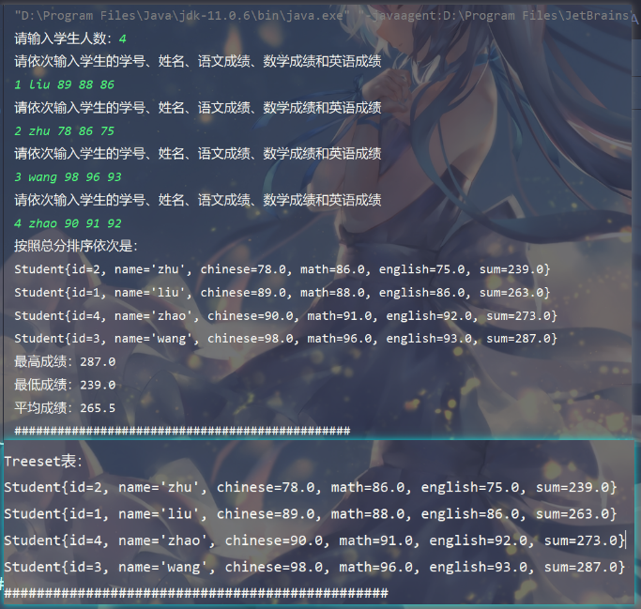

5.
源代码
package test;
public class IntegerSystem {
public static void main(String[] args) {
int num = -1234567;
System.out.println("十进制:" + num);
System.out.println("二进制:" + Integer.toBinaryString(num));
System.out.println("八进制:" + Integer.toOctalString(num));
System.out.println("十六进制:" + Integer.toHexString(num));
}
}

运行截图
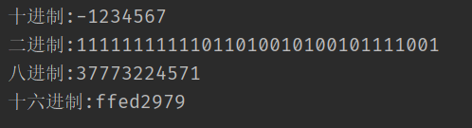

6.
源代码
package test;
public class ShowJavaMsg {
public static void main(String[] args) {
System.out.println(System.getProperty("java.version"));
System.out.println(System.getProperty("java.class.path"));
}
}

运行截图
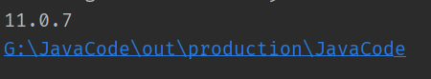
7.
源代码
package test;
import java.io.IOException;
public class OpenCmd {
public static void main(String[] args) {
try {
Runtime.getRuntime().exec("cmd /k start dir");
System.out.println("Hello RuntimeClass");
} catch (IOException e) {
e.printStackTrace();
}
}
}

运行截图
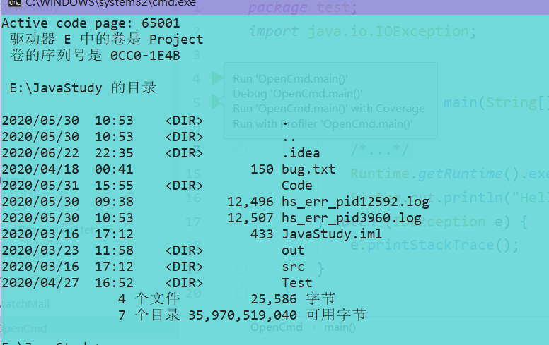

8.
源代码
package test;
import java.text.SimpleDateFormat;
import java.util.Date;
public class FormatDate {
public static void main(String[] args) {
Date date = new Date();
SimpleDateFormat sdf = new SimpleDateFormat("yyyy年MM月dd日");
System.out.println("The date of today is " + sdf.format(date));
}
}

运行截图

四、心得体会：

无

