桂 林 理 工 大 学
实 验 报 告
班级 软件18-3 学号 3182052051402 姓名 黄亿军 同组实验者 实验名称 异常处理与IO流 日期 2020年 7 月1 日
一、实验目的：
1.正常处理异常
2.熟悉IO流的使用

二、实验环境：
IDEA

三、实验内容：
1.运行截图：
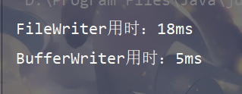
源代码：
package test;
import java.io.BufferedWriter;
import java.io.File;
import java.io.FileWriter;
import java.io.IOException;
public class TenthousandNumber {
private static long start;
private static long end;
private static final File FILE_NUM = new File("E:\\JavaStudy\\Test\\src\\test\\files\\numbers.txt");
public static void main(String[] args) {
testFileReader();
testBufferWriter();
}
private static void testFileReader() {
start = System.currentTimeMillis();
FileWriter fw = null;
try {
fw = new FileWriter(FILE_NUM);
String c;
int num;
for (int i = 0; i < 10000; i++) {
num = (int)(Math.random()*100 + 1);
c = Integer.toString(num);
fw.append(c);
}
} catch (IOException e) {
e.printStackTrace();
} finally {
try {
fw.close();
} catch (IOException e) {
e.printStackTrace();
}
}
end = System.currentTimeMillis();
System.out.println("FileWriter用时：" + (end - start) + "ms");;
}
private static void testBufferWriter() {
start = System.currentTimeMillis();
FileWriter fw = null;
BufferedWriter bw = null;
try {
fw = new FileWriter(FILE_NUM);
bw = new BufferedWriter(fw);
String c;
int num;
for (int i = 0; i < 10000; i++) {
num = (int)(Math.random()*100 + 1);
c = Integer.toString(num);
bw.append(c);
}
} catch (IOException e) {
e.printStackTrace();
} finally {
try {
bw.close();
fw.close();
} catch (IOException e) {
e.printStackTrace();
}
}
end = System.currentTimeMillis();
System.out.println("BufferWriter用时：" + (end - start) + "ms");
}
}

2.运行截图：
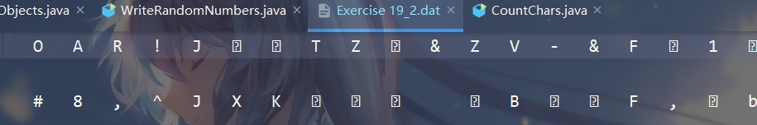

源代码：
package test;
import java.io.*;
public class WriteRandomNumbers {
public static void main(String[] args) throws IOException {
File file = new File("E:\\JavaStudy\\Test\\src\\test\\files\\Exercise 19_2.dat");
if (!file.exists()) {
file.createNewFile();
}
FileOutputStream fs = new FileOutputStream(file);
DataOutputStream ds = new DataOutputStream(fs);
for (int i = 0; i < 100; i++) {
ds.writeInt((int)(Math.random()*100 + 1));
}
ds.close();
fs.close();
}
}

3.运行截图：
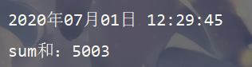
源代码：
package test;
import java.io.*;
import java.time.LocalDateTime;
import java.time.format.DateTimeFormatter;
public class SumOfRandomNums {
public static void main(String[] args) throws IOException {
LocalDateTime rightNow = LocalDateTime.now();
DateTimeFormatter dtf = DateTimeFormatter.ofPattern("yyyy年MM月dd日 HH:mm:ss");
System.out.println(dtf.format(rightNow));
File file = new File("E:\\JavaStudy\\Test\\src\\test\\files\\Exercise 19_3.dat");
FileInputStream fis = new FileInputStream(file);
DataInputStream dis = new DataInputStream(fis);
int sum = 0;
int c;
while ((c = dis.read()) != -1) {
sum += c;
}
System.out.println("sum和：" + sum);
dis.close();
fis.close();
}
}

4.运行截图：
源代码：
package test;
import java.io.File;
import java.io.FileInputStream;
import java.io.IOException;
public class CountChars {
public static void main(String[] args) throws IOException {
File file = new File("E:\\JavaStudy\\Test\\src\\test\\files\\bigbook.txt");
FileInputStream fis = new FileInputStream(file);
int countA = 0;
int c;
while ((c = fis.read()) != -1) {
if ((char)c == 'A') {
countA++;
}
}
System.out.println("bigbook.txt一共有" + countA + "个A");
fis.close();
}
}

5.运行截图：
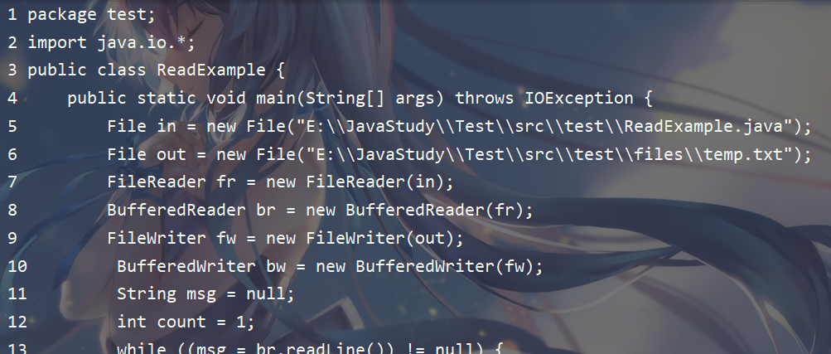
源代码：
package test;
import java.io.*;
public class ReadExample {
public static void main(String[] args) throws IOException {
File in = new File("E:\\JavaStudy\\Test\\src\\test\\ReadExample.java");
File out = new File("E:\\JavaStudy\\Test\\src\\test\\files\\temp.txt");
FileReader fr = new FileReader(in);
BufferedReader br = new BufferedReader(fr);
FileWriter fw = new FileWriter(out);
BufferedWriter bw = new BufferedWriter(fw);
String msg = null;
int count = 1;
while ((msg = br.readLine()) != null) {
bw.write(Integer.toString(count) + " ");
bw.write(msg);
bw.write("\n");
count++;
}
bw.close();
fw.close();
br.close();
fr.close();
}
}

6.运行截图：
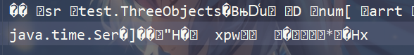
源代码：
package test;
import java.io.*;
import java.time.LocalDateTime;
import java.util.Arrays;
public class StoreObjects {
public static void main(String[] args) throws IOException, ClassNotFoundException {
int[] arr = new int[]{1, 2, 3, 4, 5};
LocalDateTime now = LocalDateTime.now();
ThreeObjects to = new ThreeObjects(arr, now, 5.5);
File file = new File("E:\\JavaStudy\\Test\\src\\test\\files\\Exercise19_5.dat");
ObjectOutputStream obs = new ObjectOutputStream(new FileOutputStream(file));
obs.writeObject(to);
obs.close();
}
}
class ThreeObjects implements java.io.Serializable {
private int[] arr;
private LocalDateTime rightNow;
private double num;
public ThreeObjects(int[] arr, LocalDateTime rightNow, Double num) {
this.arr = arr;
this.rightNow = rightNow;
this.num = num;
}
@Override
public String toString() {
return "ThreeObjects{" +
"arr=" + Arrays.toString(arr) +
", rightNow=" + rightNow +
", num=" + num +
'}';
}
}

四、心得体会：
无

