桂 林 理 工 大 学
实 验 报 告
班级 软件18-3 学号 3182052051402 姓名 黄亿军 同组实验者
实验名称 网络编程 日期 2020年 07 月4 日
一、实验目的：
熟悉java的网络编程

二、实验环境：
IDEA

三、实验内容：
1.运行截图：
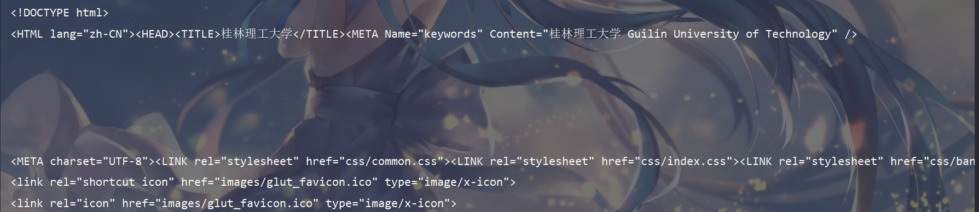
源代码：
package test.net;
import java.io.*;
import java.net.URL;
public class GLUTHome {
public static void main(String[] args) throws IOException {
URL glut = new URL("https://www.glut.edu.cn/");
InputStream is = glut.openStream();
BufferedReader br = new BufferedReader(new InputStreamReader(is));
String line = null;
while ((line = br.readLine()) != null) {
System.out.println(line);
}
}
}

2.运行截图：
服务器Serverfile.txt文件内容
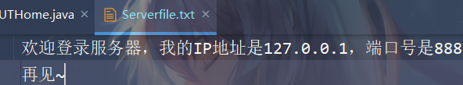
服务器端
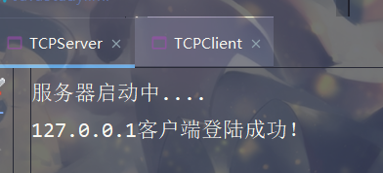
客服端
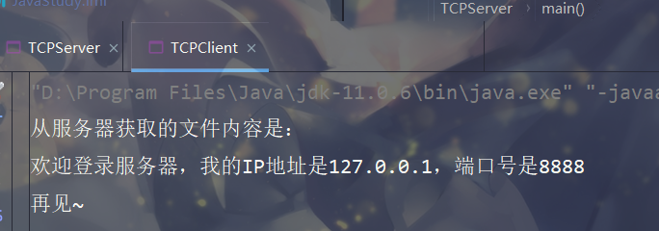

源代码：
服务端
package test.net;
import java.io.*;
import java.net.ServerSocket;
import java.net.Socket;
public class TCPServer {
public static void main(String[] args) throws IOException {
System.out.println("服务器启动中....");
ServerSocket server = new ServerSocket(8888);
Socket socket = server.accept();
System.out.println(socket.getLocalAddress().getHostAddress() + "客户端登陆成功！");
File serverFile = new File("E:\\JavaStudy\\Test\\src\\test\\net\\serverfile.txt");
BufferedInputStream bis = new BufferedInputStream(new FileInputStream(serverFile));
byte[] bytes = new byte[1024 * 60];
int len = 0;
BufferedOutputStream bos = new BufferedOutputStream(socket.getOutputStream());
while ((len = bis.read(bytes)) != -1) {
bos.write(bytes, 0, len);
}
bis.close();
bos.close();
}
}

客户端
package test.net;
import java.io.BufferedInputStream;
import java.io.IOException;
import java.net.Socket;
public class TCPClient {
public static void main(String[] args) throws IOException {
Socket client = new Socket("localhost", 8888);
System.out.println("从服务器获取的文件内容是：");
byte[] bytes = new byte[100];
BufferedInputStream bis = new BufferedInputStream(client.getInputStream());
int len = 0;
while ((len = bis.read(bytes)) != -1) {
System.out.println(new String(bytes));
}
bis.close();
}
}

3.运行截图：
服务器端：
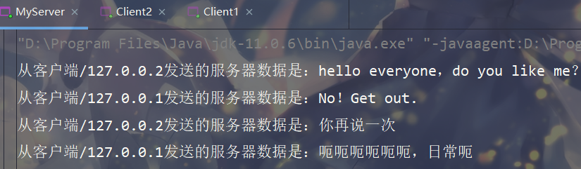

客户端2：
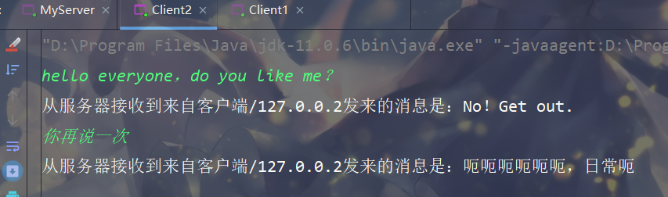

客户端1：
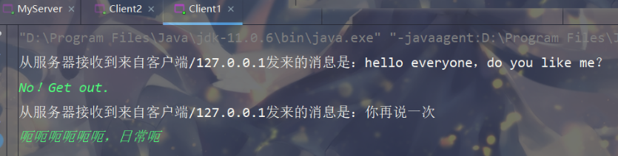

源代码：
服务端MyServer：
package test.net.cs;
import java.io.IOException;
import java.net.ServerSocket;
import java.net.Socket;
import java.util.ArrayList;
/**
* 服务器端
* @author 落霞不孤
*/
public class MyServer {
// 创建保存所有客户端的连接对象的数组
public static ArrayList<Socket> sockets = new ArrayList<>();
public static void main(String[] args) throws IOException {
// 创建服务器对象，接受客户端的连接请求
ServerSocket ss = new ServerSocket(9999);
while (true) {
Socket socket = ss.accept();
sockets.add(socket);
// 每当客户端连接后启动一条服务器线程为其服务
new Thread(new ServerThread(socket)).start();
}
}
}

package test.net.cs;
import java.io.BufferedReader;
import java.io.IOException;
import java.io.InputStreamReader;
import java.io.PrintStream;
import java.net.Socket;
/**
* 服务器线程
* @author 落霞不孤
*/
public class ServerThread implements Runnable {
// 服务器线程需要处理的客户端（就是发送消息的客户端）
Socket client = null;
// 服务端线程处理客户端的输入流对象
BufferedReader br = null;
public ServerThread(Socket client) throws IOException {
this.client = client;
// 获取输入流对象
this.br = new BufferedReader(new InputStreamReader(client.getInputStream()));
}
@Override
public void run() {
String msg = null;
while ((msg = readFromClient()) != null) {
// 输出客户端发送的数据
System.out.print("从客户端" + client.getLocalAddress() + "发送的服务器数据是：");
System.out.println(msg);
// 读取客户端的发送内容，并且把这个信息发送到其他客户端
for (Socket s : MyServer.sockets) {
PrintStream ps = null;
try {
if (s != client) {
ps = new PrintStream(s.getOutputStream());
ps.println("从服务器接收到来自客户端" + s.getLocalAddress()+ "发来的消息是："+ msg);
}
} catch (IOException e) {
e.printStackTrace();
}
}
}
}
// 返回读取客户端数据
private String readFromClient() {
try {
// 读取到客户端的数据
return br.readLine();
} catch (IOException e) {
/*
如果读取不到，说明客户端已经关闭，返回null即可
并且从服务器端的客户端队列移除
*/
e.printStackTrace();
MyServer.sockets.remove(client);
}
return null;
}
}

客户端MyClient
package test.net.cs;
import java.io.BufferedReader;
import java.io.IOException;
import java.io.InputStreamReader;
import java.io.PrintStream;
import java.net.Socket;
/**
* 客户端读取输入数据和接受数据
* @author 落霞不孤
*/
public class MyClient {
private Socket client;
public MyClient(Socket client){
this.client = client;
}
public void sendMsg() throws IOException {
new Thread(new ClientThread(client)).start();
PrintStream ps = new PrintStream(client.getOutputStream());
String readMsg = null;
BufferedReader br = new BufferedReader(new InputStreamReader(System.in));
while ((readMsg = br.readLine()) != null) {
if (readMsg == "" || "".equals(readMsg.trim())) {
throw new IllegalArgumentException("不能发送空白数据！！！");
}
ps.println(readMsg);
}
}
}

package test.net.cs;
import java.io.BufferedReader;
import java.io.IOException;
import java.io.InputStreamReader;
import java.net.Socket;
/**
* 接受服务器转发数据的客户端线程
* @author 落霞不孤
*/
public class ClientThread implements Runnable {
private Socket client;
BufferedReader br = null;
public ClientThread(Socket client) throws IOException {
this.client = client;
br = new BufferedReader(new InputStreamReader(client.getInputStream()));
}
@Override
public void run() {
String msg = null;
try {
while ((msg = br.readLine()) != null) {
System.out.println(msg);
}
} catch (IOException e) {
e.printStackTrace();
}
}
}

两个实例客户端对象client1、client2
package test.net.cs;
import java.io.IOException;
import java.net.Socket;
public class Client1 {
public static void main(String[] args) throws IOException {
Socket s1 = new Socket("localhost", 9999);
MyClient my = new MyClient(s1);
my.sendMsg();
}
}

package test.net.cs;
import java.io.IOException;
import java.net.Socket;
public class Client2 {
public static void main(String[] args) throws IOException {
Socket s1 = new Socket("127.0.0.2", 9999);
MyClient my = new MyClient(s1);
my.sendMsg();
}
}

四、心得体会：
无

