 | UNIVERSITI MALAYSIA SARAWAK  Faculty of Computer Science and Information Technology

Assignment/Report Cover Sheet

Student Name (Group Brainrot) | Student Id Number | Group No | Signature
Awang Taqris Tsaqif bin Awg Baderulhisam | 83331 | GO1
Mohammad Nuruddin Zaid bin Mohammad Nizam | 82694 | GO1 | 
Eizzul Iman bin Isa | 82531 | GO1 | 
Muhammad Irfan Haziq bin Roslan | 82737 | GO1 | 
Muhammad Firdaus Bin Supian | 82729 | GO1 | 

Subject Code: TMA4103 |  | Subject Name: TMA4103
Assignment Title: | Group Assignment #1 |  | Lecturer: | Ts. Abdul Rahman Bin Mat
Due Date: 17 Apr 2026 |  |  | Date Submitted: 17 Apr 2026

This cover sheet must be completed, signed and firmly attached to the front of the submission. All work must be submitted by the due date. If an extension of work is granted, an assignment extension acknowledgement slip must be signed by the lecturer/tutor and attached to assignment. Please note that is your responsibility to retain copies of your assignment.

Plagiarism and Collusion are methods of cheating that falls under Peraturan Akademik Universiti Malaysia Sarawak para 11: Etika Akademik

Plagiarism
Plagiarism is the presentation of work which has been copied in whole or in part from another person’s work, or from any other source such as the internet, published books or periodicals without due acknowledgement given in the text.

Collusion
Collusion is the presentation of work that is the result in whole or in part of unauthorized collaboration with another person or persons.

Where there are reasonable grounds for believing that cheating has occurred, the only action that may be taken when plagiarism or collusion is detected is for the staff member not to mark the item of work and to report or refer the matter to the Dean. This may result in work being disallowed and given a fail grade or if the circumstances warrant, the matter may be referred to a Committee of inquiry for investigation. Such investigation may result in the matter being referred to the University Discipline Committee, which has the power to exclude a student.

Upon placing signature above, I certify that I have not plagiarized the work of others or participated in unauthorized collusion when preparing this assignment.

I also certify that I have taken proper case in safeguarding my work and have made all reasonable efforts to ensure that may work not be able to be copied.

MARK :

Introduction
The FYP used in this report is named Post-Covid Development Strategy 2030 Portal – Forestry Sector. It is a web-based portal system that supports data management and document generation functions. One of the key functions of the system is report generation, where users can produce downloadable reports based on selected parameters and available data.
Report generation is an important feature because it transforms stored system data into a usable output for users. The correctness of this feature affects the reliability of the system output, especially when the generated document is used for viewing, downloading, or further processing.
This report focuses on testing the report generation feature through a selected scenario and a set of related test cases. The purpose of the testing is to verify whether the feature behaves correctly under valid and invalid conditions.

Selected Software Document
The software used in this report is the Final Year Project (FYP), which is developed as a web-based portal system for managing information and producing reports for users. One of the key parts of the system is the report generation feature, where users can request a report based on selected criteria and receive the output in a downloadable format.
The software document chosen for this testing activity is the Functional Specification for the report generation feature. This document is used because it explains the expected input, the way the system should respond, and the output that should be produced after the request is processed. Compared with other documents, it gives a clearer picture of how the selected feature is supposed to work, which makes it more suitable as the main reference for designing test cases.

Scenario description
The selected scenario is Report Generation by an Authorized User. In this situation, a user with the correct access rights opens the report page, enters the required information such as report type and date range, and submits the request to generate a report.
Once the request is submitted, the system should check whether the entered information is complete and valid. If the input is correct, the system should retrieve the related data, process it according to the selected criteria, and generate the report in the required format. The final output should then be made available for the user to download or view.
This scenario is suitable for testing because it involves several important parts of the system in one flow. It does not only focus on input validation, but also covers data retrieval, processing, output generation, and access control.

High-level test cases
High-Level Test Case ID | Test Objective | Expected Outcome
HLTC-01 | Verify report generation with valid input | Report is generated and downloaded successfully
HLTC-02 | Verify behaviour when a required field is missing | System prevents generation and displays validation message
HLTC-03 | Verify behaviour when invalid values are entered | System rejects the request and shows an error message
HLTC-04 | Verify behaviour when no data matches the selected parameters | System informs the user that no data is available
HLTC-05 | Verify behaviour when an unauthorized user attempts generation | System denies access to the feature

Specific test cases – positive
Positive Test Case ID | Test Case | Preconditions | Test Steps | Test Data | Expected Result
PTC-01 | Generate report with valid report type and valid date range | User is logged in and has permission to generate report | 1. Open report page. 2. Select report type. 3. Select valid date range.  4. Click Generate Report. | Report Type: Monthly Summary; Date Range: 01/03/2026 - 31/03/2026 | Report is generated successfully and file download begins
PTC-02 | Generate report with valid parameters and available data | User is logged in and matching data exists | 1. Open report page. 2. Select region.  3. Select date range.  4. Click Generate Report. | Region: Samarahan; Date Range: 01/01/2026 - 31/01/2026 | Generated report contains the correct data and can be downloaded
PTC-03 | Generate report and verify file can be opened | User is logged in and has access to the module | 1. Open report page. 2. Enter valid parameters. 3. Click Generate Report.  4. Open downloaded file. | Report Type: Annual Report; Year: 2025 | File is generated in the correct format and opens successfully

Specific test cases – negative
TC ID | Test case | Preconditions | Test steps | Test data | Expected result
NTC-01 | Generate report without selecting report type | User is logged in | 1. Open report page. 2. Leave report type empty.  3. Select date range.  4. Click Generate Report. | Report Type: Empty; Date Range: Valid | System displays validation message and report is not generated
NTC-02 | Generate report without date range | User is logged in | 1. Open report page. 2. Select report type. 3. Leave date range empty.  4. Click Generate Report. | Report Type: Monthly Summary; Date Range: Empty | System rejects the request and shows required-field message
NTC-03 | Generate report with invalid date range | User is logged in | 1. Open report page. 2. Select report type. 3. Set end date earlier than start date.  4. Click Generate Report. | Start Date: 31/03/2026; End Date: 01/03/2026 | System shows invalid date range message and report is not generated
NTC-04 | Generate report when no matching data exists | User is logged in | 1. Open report page. 2. Enter valid filters with no existing records.  3. Click Generate Report. | Region: No matching record; Date Range: Future period | System informs the user that no data is available and no report is generated
NTC-05 | Unauthorized user tries to generate report | User is logged in without required role | 1. Access report page. 2. Enter valid parameters. 3. Click Generate Report. | Valid report parameters | System denies access or shows permission error
NTC-06 | System error during generation | User is logged in | 1. Open report page. 2. Enter valid parameters. 3. Click Generate Report during system failure. | Valid report parameters | System shows generation failure message and no corrupted file is downloaded

Discussion / findings
The findings from the testing activities indicate that the report generation feature performs in accordance with the specified functional requirements under both valid and invalid conditions. Based on the execution of the defined high-level and specific test cases, the system demonstrates consistent and reliable behaviour when processing report generation requests.
In the positive test scenarios (PTC-01 to PTC-03), the system successfully generates reports when valid parameters are provided by an authorized user. The generated reports contain accurate data, adhere to the expected format, and can be downloaded and accessed without issues. These results confirm that the core processes of input handling, data retrieval, processing, and output generation are functioning effectively.
The negative test cases further highlight the robustness of the system’s validation and error-handling mechanisms. Test cases such as NTC-01 and NTC-02 confirm that the system enforces mandatory input fields by preventing report generation when required parameters are missing. Additionally, NTC-03 demonstrates that logical validation rules, such as verifying the correctness of the date range, are properly implemented to avoid invalid data processing.
The system also exhibits appropriate handling of edge cases and exceptional conditions. In NTC-04, where no matching data is available, the system correctly informs the user instead of generating an empty or misleading report. This ensures the integrity and reliability of the output. Furthermore, NTC-05 verifies that access control mechanisms are effectively enforced, restricting report generation functionality to authorized users only, thereby maintaining data security.
In the case of system-level failures, as illustrated in NTC-06, the system responds appropriately by displaying an error message and preventing the generation of corrupted or incomplete files. This reflects sound error-handling practices and contributes to the overall reliability and stability of the system.

Conclusion
The report generation feature can be tested in a structured way through both positive and negative test cases. Positive test cases are used to verify that the system can generate the report correctly when valid input is provided by an authorized user. On the other hand, negative test cases help evaluate how the system responds when the input is incomplete, invalid, or not permitted.
Overall, the selected feature is appropriate for testing because it combines user input, system processing, and document output within one process. By using the Functional Specification as the main reference, the expected behavior of the report generation process can be identified more clearly and tested in a more organized manner.

Screenshot of group discussion
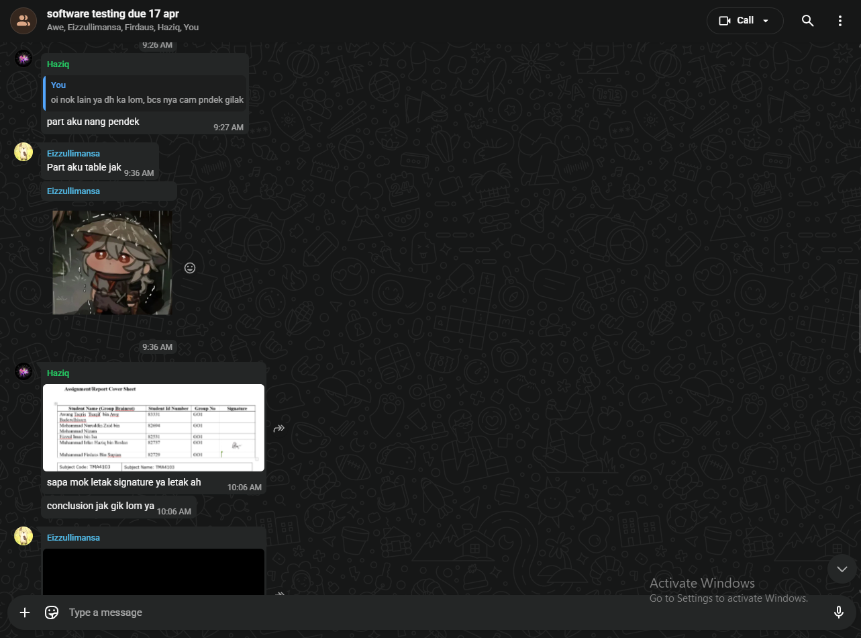
Figure 1

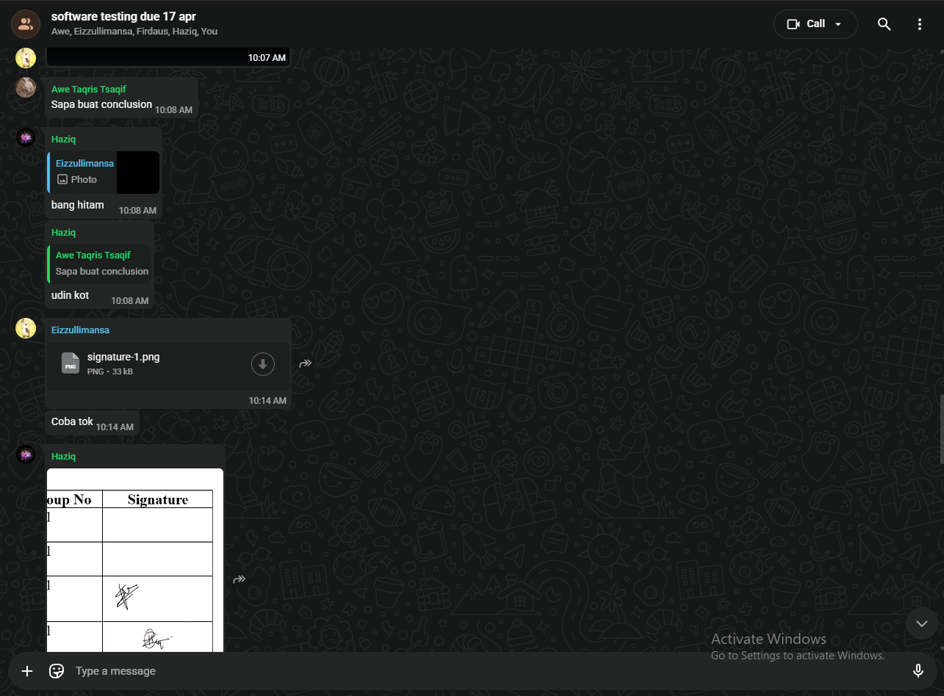
Figure 2
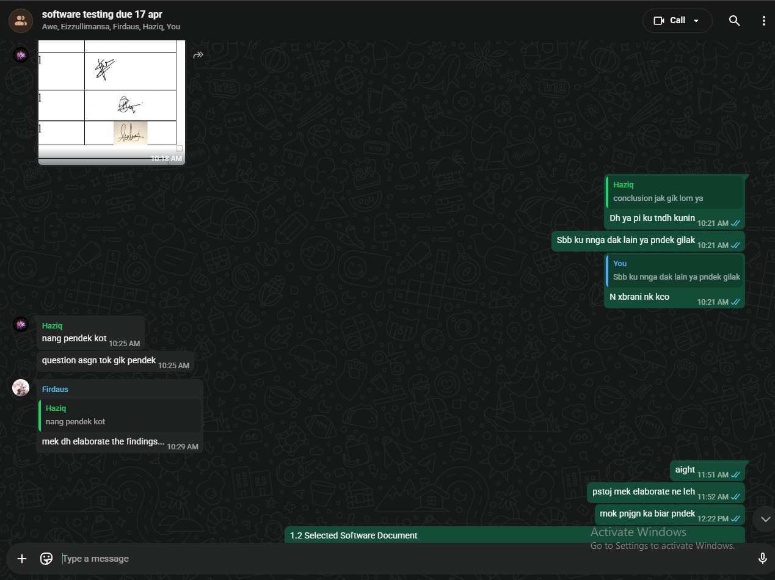
Figure 3

