Rodrigo Ignacio Rojas Garcia

Programming Assignment 4:

**Test Plan:**

The test plan consists of calculating the insertion, update, finding, and removing data from the Table with collision and without the collision case. The test.c file will use the library <time.h> to use function clock() which will allow to determine the average time it takes functions Table_insert, Table_update, Table_find, and Table_remove to complete their task and the average time result will be stored in different variables of type double. Each of these functions will be tested in both collision and non collision cases with a set table size of value 51. In the non collision case, the Table will be inserted with data that will be stored with no collision by implementing a for loop which will run the same amount of times as the Table’s size and set the key number to the counter in the for loop. By doing this, I am assuring that there will be no collisions in the list because the Hash function implemented on my program will return hash values in order, meaning, if the counter of for loop is 0, it will return value of 0. No hash value will repeat itself. In the collision case, the Table will be inserted with data that will be stored with collision by implementing a for loop which will run to a greater value of the Table size and set the key number to a random number using the rand() function. By doing this, I am assuring that there will be collisions in the list because the Hash function implemented on my program will return has values in different orders and there will be a high percentage chance that values will be repeated. The test plan will be ran five times in which the for loop parameter will increase in each test to values of 100,000 , 250,000 , 500,000, , 750,000 , and 1,000,000. The five tests cases will prove that as the number of request increases, the complexity value increases drastically.

Test 1 (100,000) :

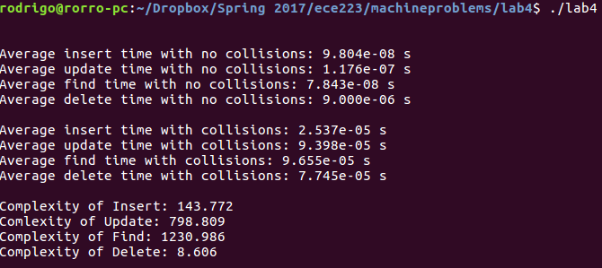

Test 2 (250,000) :

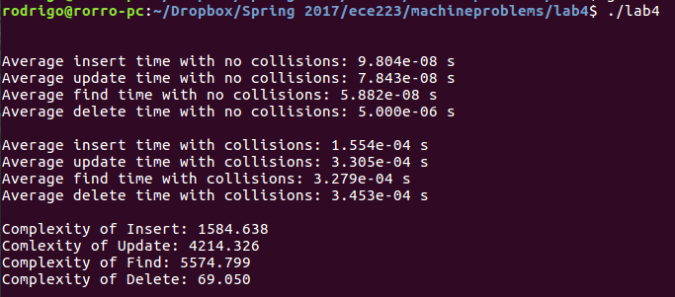

Test 3 (500,000):

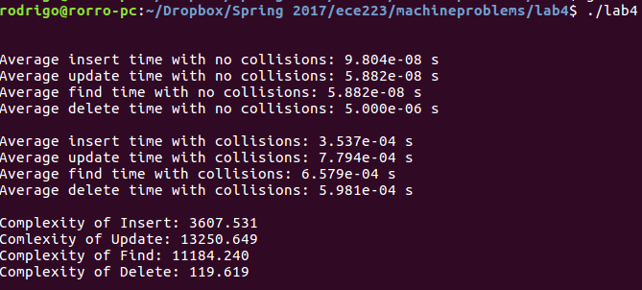

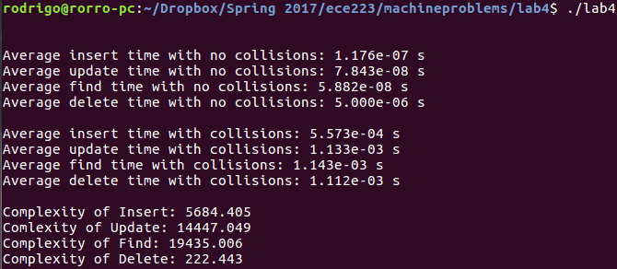Test 4 (750,000):

Test 5 (1,000,000):

