Name: Rodrigo Ignacio Rojas Garcia

Course: ECE 4310

Lab #: 1

Convolution, Separable Filters, and Sliding Windows

In this project the student was to implement three versions of a 7x7 mean filter. The first version was a basic 2D Convolution filter. The second version used separable filters, one 1x7, and the other 7x1. The third version consisted on using the sliding window algorithm and implementing it with the separable filters as well.

**2D Convolution:**

*Code:*

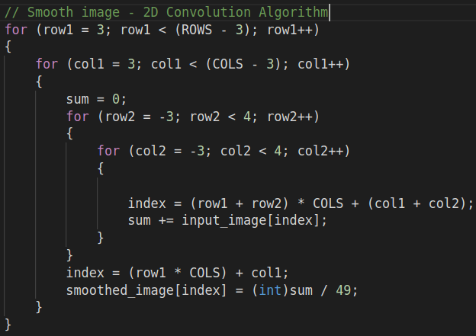

**Separable Filters:**

*Code:*

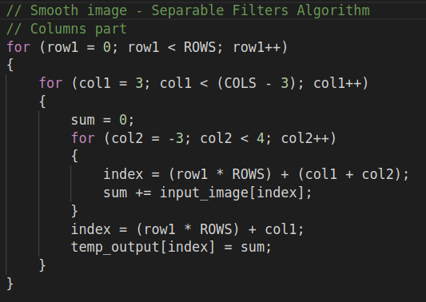

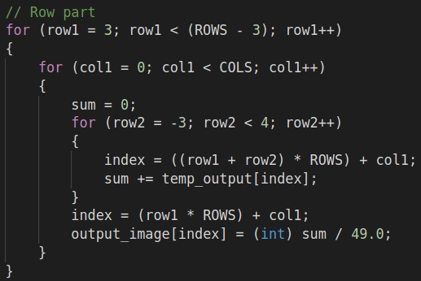

**Sliding Window with Separable Filters**

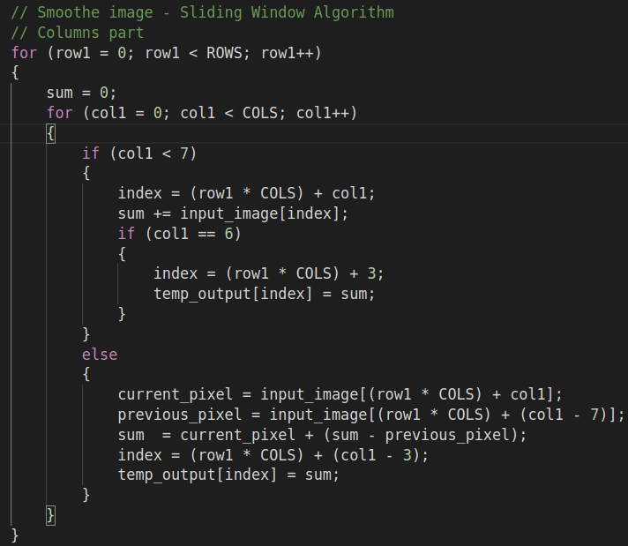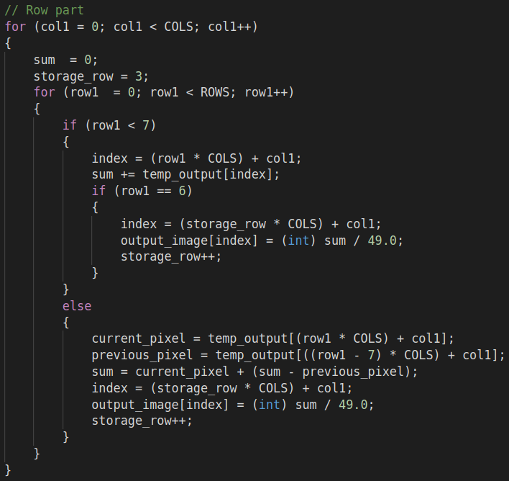*Code:*

**Results:**

*Original Picture:*

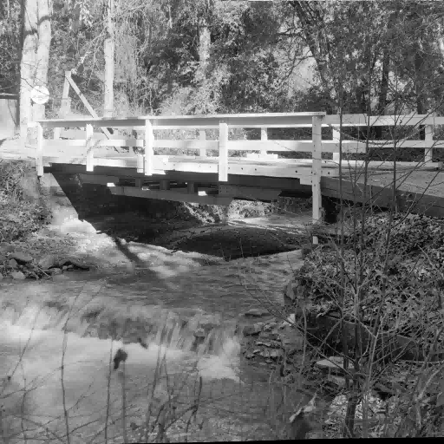

*Smoothed Picture:*

**

*Time:*

|  |  |  |
| --- | --- | --- |
| Time (ms) | | |
| 2D Convolution | Separable Filters | Sliding Window |
| 40.71 | 16.11 | 13.64 |
| 71.16 | 26.94 | 17.59 |
| 101.79 | 37.40 | 21.45 |
| 132.76 | 47.78 | 25.52 |
| 163.24 | 58.28 | 29.62 |
| 193.88 | 69.19 | 33.51 |
| 224.51 | 79.57 | 37.42 |
| 255.22 | 89.97 | 41.27 |
| 285.79 | 1300.63 | 45.14 |
| 316.1 | 111.42 | 49.02 |

|  |  |  |
| --- | --- | --- |
| Average Time (ms) | | |
| 2D Convolution | Separable Filters | Sliding Window |
| 31.60 | 11.14 | 4.90 |

*Difference:*

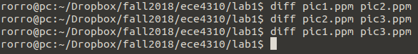

**Conclusion:**

It can be concluded that all the different algorithms produce the same picture, but the Sliding Window algorithm is the fastest of all three algorithms.