Name: Rodrigo Ignacio Rojas Garcia

Course: ECE 4310

Lab #: 2

Optical Character Recognition

In this project the student was to implement a matched filter (normalized cross-correlation) to recognize the letters in an image of a text. The student was provided with an input image “parenthood.ppm”, template image of desired character to be found “parenthood_e_template.ppm”, and a ground truth file “parenthood_gt.txt” which was used to determine if the desired letter was recognized from the matched filter image.

The second laboratory was divided into five steps:

1. Read in the input image, template image, and ground truth file.
2. Calculate the matched-spatial filter (MSF) image
3. Normalize the MSF image into 8-bits
4. Loop through following steps for a range of different Thresholds (T):
   1. Threshold at T the normalized MSF image to create a binary image.
   2. Loop through the ground truth letter locations.
   3. Categorize and count the detected letters as FP (“detected” but the letter is not ‘e’”) and TP (“detected” and the letter is ‘e’)
   4. Output the total FP and TP for each T.

All results of each these were recorded. The MSF, both not normalized and normalized, were saved as gray-scale ppm images. Also, the total output of the total FP, TP, FN, FP TPR, FPR, and PPV were recorded with their corresponding threshold and documented into a CSV (Comma Separated Variable) file.

**STEP 1:**

*Read in “parenthood.ppm” and “parenthood_e_template.ppm” code:*

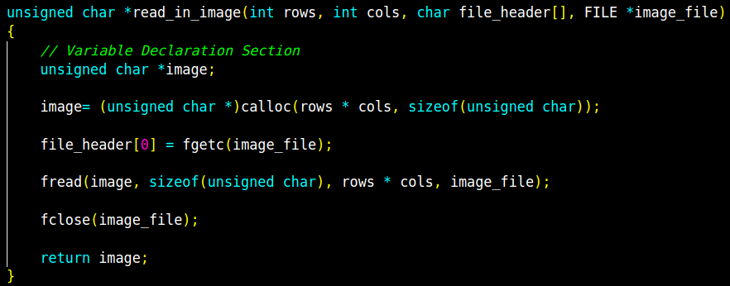

*Read in “parenthood_gt.txt” code:*

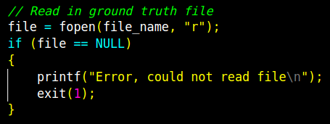

**STEP 2:**

*Calculate Zero-Mean Template:*

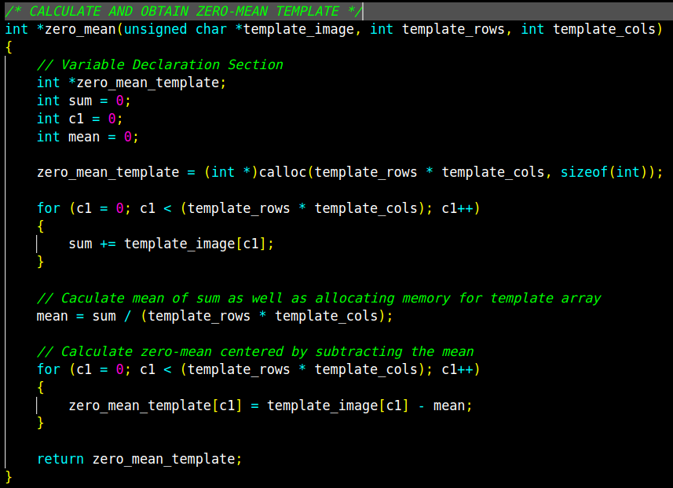

*Calculate MSF (not 8-bit) :*

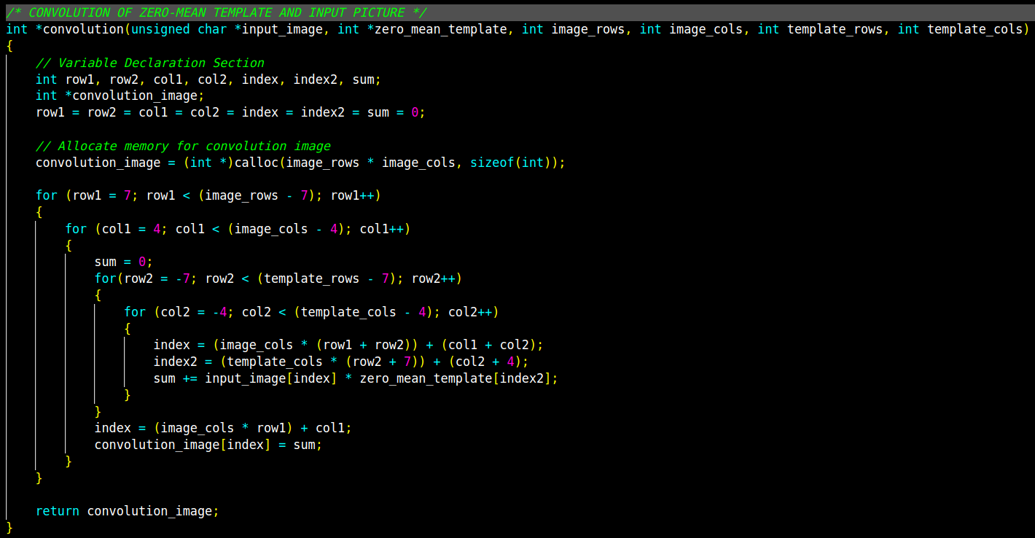

*Normalize MSF:*

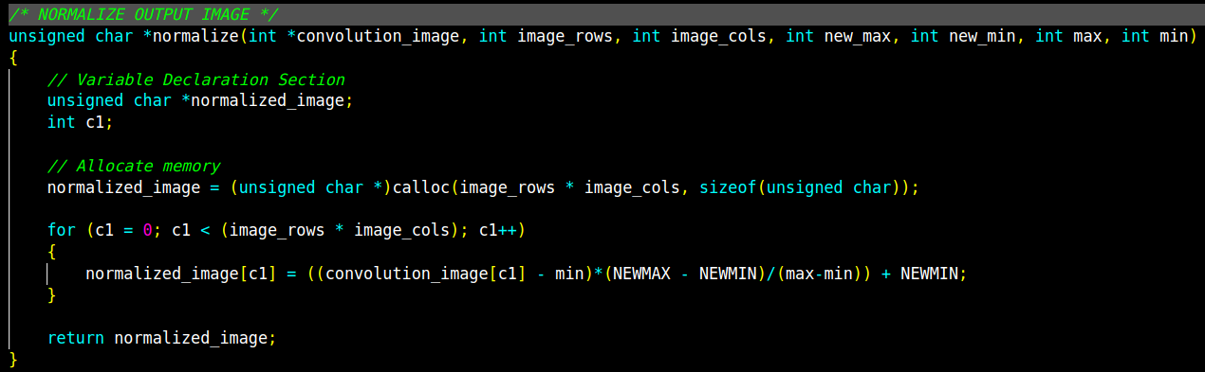

**STEP 4:**

*Loop through normalized MSF to calculate Truth Table with different Thresholds code:*

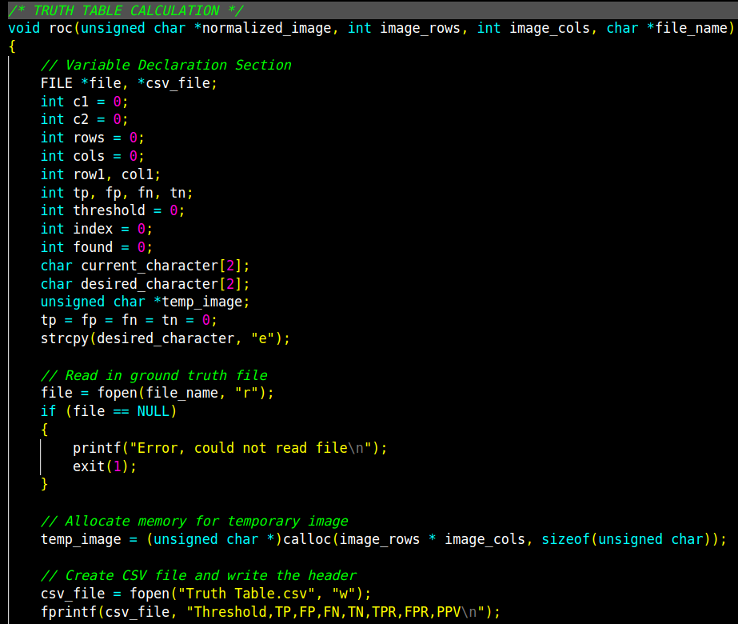

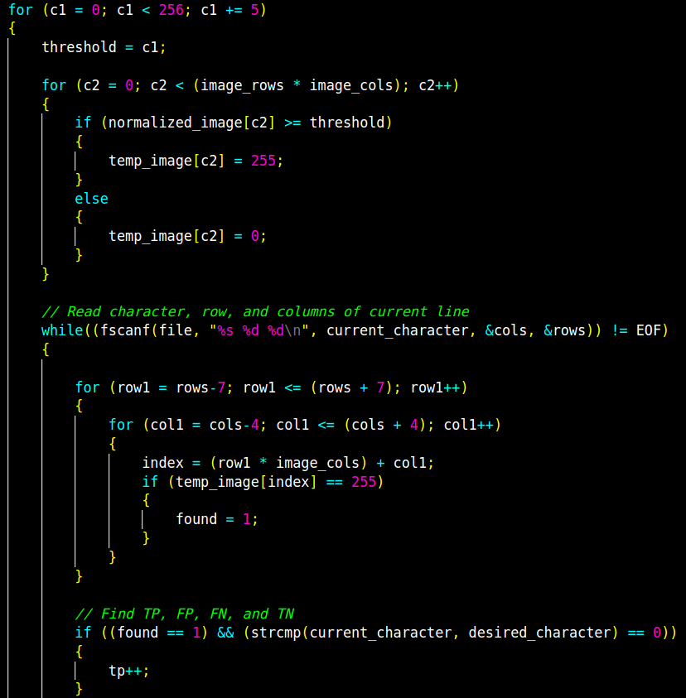

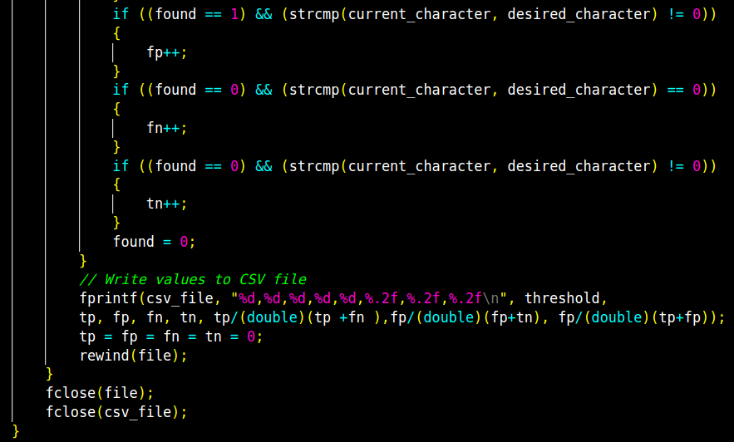

**RESULTS:**

*MSF Image (not 8-bit)*

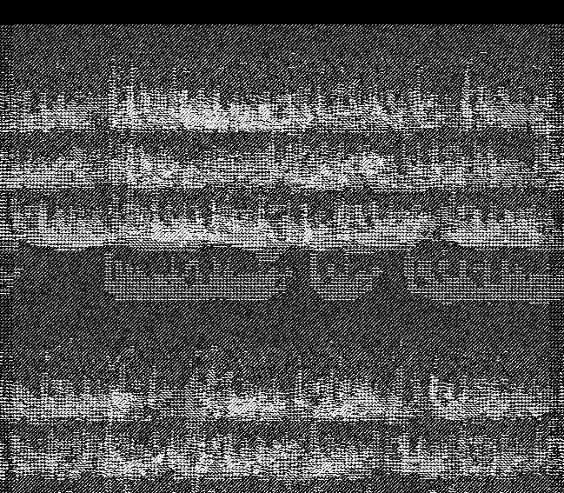

*Normalized MSF Image (8-bit):*

**

*Truth Table with different Thresholds:*

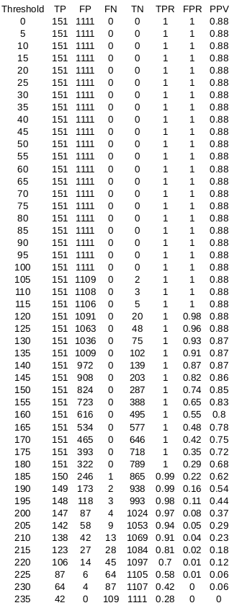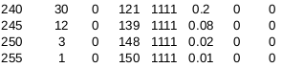

*Receiver Operating Characteristics (ROC):*

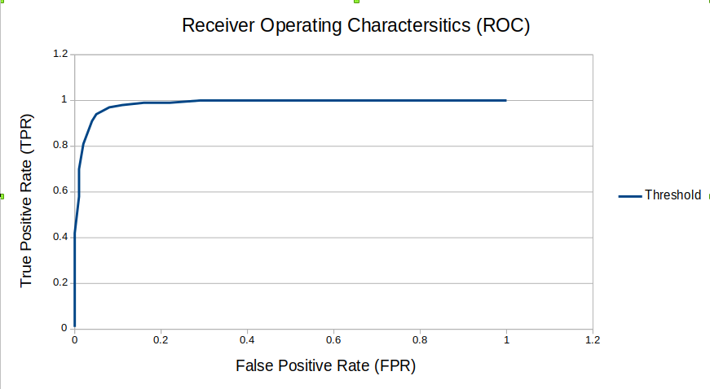

Based on the ROC graph, the best threshold in which the found/not found letter ‘e’ ratio is at threshold 205. The following image shows the ‘e’ found at threshold 205:

