Name: Rodrigo Ignacio Rojas Garcia

Course: ECE 4310

Lab #5

Active Contours

In this project the student was to implement the Active Contour algorithm. The student was provided with a PPM image named “hawk.ppm” and text file containing a list of 42 initial contour points called “initial_contour.txt”. The student was to use these two files in order to complete the following requirements:

1. Read gray scale PPM “hawk.ppm” image
2. Read initial contour points from “initial_contour.txt” file.
3. Draw a “+” shape in a 7x7 window based on the initial contour points on the original PPM gray scale image.
4. Implement Active Contour Algorithm based on initial contour points.
   1. The Active contour algorithm used 2 Internal Energies and 1 External Energy.
      1. First Internal Energy
         1. The first internal energy calculation was based on calculating the square of the distances between the contour points in a 7x7 window.
         2. It should be noted that it was assumed that the contour encloses the area, therefore the last contour point was connected to the first contour point to calculate the First Internal Energy.
      2. Second Internal Energy
         1. The second internal energy calculation was based on:
            1. Calculating the average distance between all contour points.
            2. Taking the square difference between the ravage and the distance between the current contour point and the next contour point.
            3. It should be noted that it was assumed that the contour encloses the area, therefore the last contour point was connected to the first contour point to calculate the Second Internal Energy.
      3. External Energy
         1. The external energy was calculated by obtaining the gradient magnitude of the original image which was calculated by convolution with a Sobel template
      4. Normalization
         1. Each of the Energies calculated in a 7x7 window were normalized by finding the maximum and minimum value of that size window and then re-scaling each window to a min-max value of 0 and 1 respectively.
      5. New Contour Points
         1. After normalization of all Energy windows, the new contour points were calculated by finding the minimum value after the summation of all values in the 7x7 window of the three energies.
      6. Repeat Algorithm
         1. The Active Contour algorithm was run a total of 30 iterations with the purpose of obtaining the best contour points.

All C code can be seen at the end of the report.

**RESULTS**

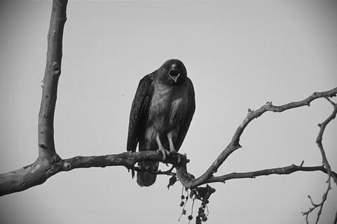

*Original gray-scale PPM image*

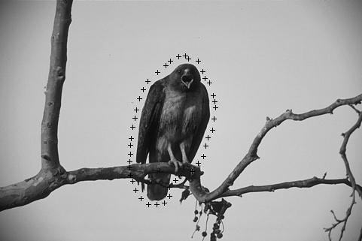

*Original gray-scale PPM image with Initial Contour Points*

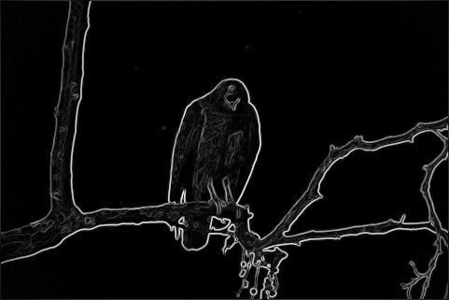

*Sobel Edge Gradient Magnitude Image*

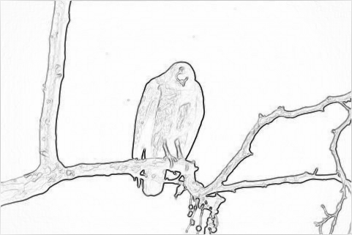

*Inverted Sobel Edge Gradient Magnitude Image*

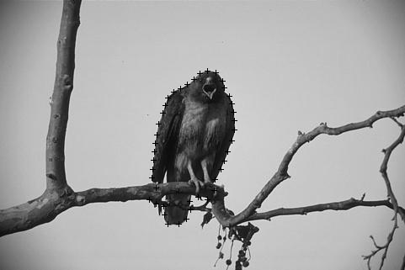

*Original gray-scale PPM image with Final Contour Points*

**

*Initial Contour Points PPM Image vs Final Contour Points Image*

*FINAL CONTOUR POINTS TABLE*

