Name: Rodrigo Ignacio Rojas Garcia

Course: ECE 4310

Lab #7

Motion Tracking

In this project the student was to implement an algorithm to calculate the motion using accelerators and gyroscopes. The student was provided a text file with recorded data of an iPhone regarding Acceleration in the X, Y, and Z direction in units of gravities (G) as well as the Gyroscope movements for Pitch, Roll, and Yaw in units of radians per second. The sample time of each movement was of 0.05 seconds. The student was to use this information with the purpose of creating a C program which automatically segment the data into periods of motion and periods of rests and calculate the motion along and about each axis during the periods of motion. In order to complete the requisities, the following requirements were followed:

1. Read the “data.txt” text file
2. Smooth data
   1. Each Accelerometer and Gyroscope axes were smoothed, meaning, reducing “noise” from the raw data. This was achieved by using a window of size 25 which was used to determine the average value of the previous 24 data points (25th data point included) which replaced the current data point. This process repeated itself until all data points for both Accelerometer and Gyroscope were calculated.
   2. It should be noted that Smoothing of the data was not required, but was implemented with the purpose of visualizing and determining the Accelerometer and Gyroscope thresholds used to determine if object was in movement.
3. Determine Movement
   1. In order to determine if the iPhone was in movement, the variance of along all Accelerometer and Gyroscope axes was required to be calculated. The variance was used to determine if it was greater than a set threshold for Accelerometer and Gyroscope axes (thresholds for both Accelerometer and Gyroscope were different). It should be noted that a window size of 11 and 20 were used for variance. The following formula was used to calculate variance:

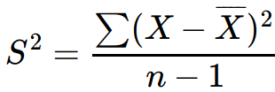

* 1. After determining if the iPhone was moving, the data for Gyroscope was to be integrated once and Accelerometer data to be integrated twice. Gyroscope data was integrated by multiplying the data by the time between samples, in this case 0.05. For the Accelerometer, three values were calculated: velocity at end of sampling period, average velocity during the sampling period, and distance traveled during sampling period. Velocity was calculated by velocity at the time of previous sample plus acceleration reading multiplied by the time between samples (initial velocity is 0, and constant acceleration is assumed). Average velocity was calculated by using average of the initial and final velocities of sampling period. The distance traveled was calculated by using the average velocity multiplied by the time between samples during that sampling period.

All C code can be seen at end of the report.

**RESULTS**

*RAW DATA:*

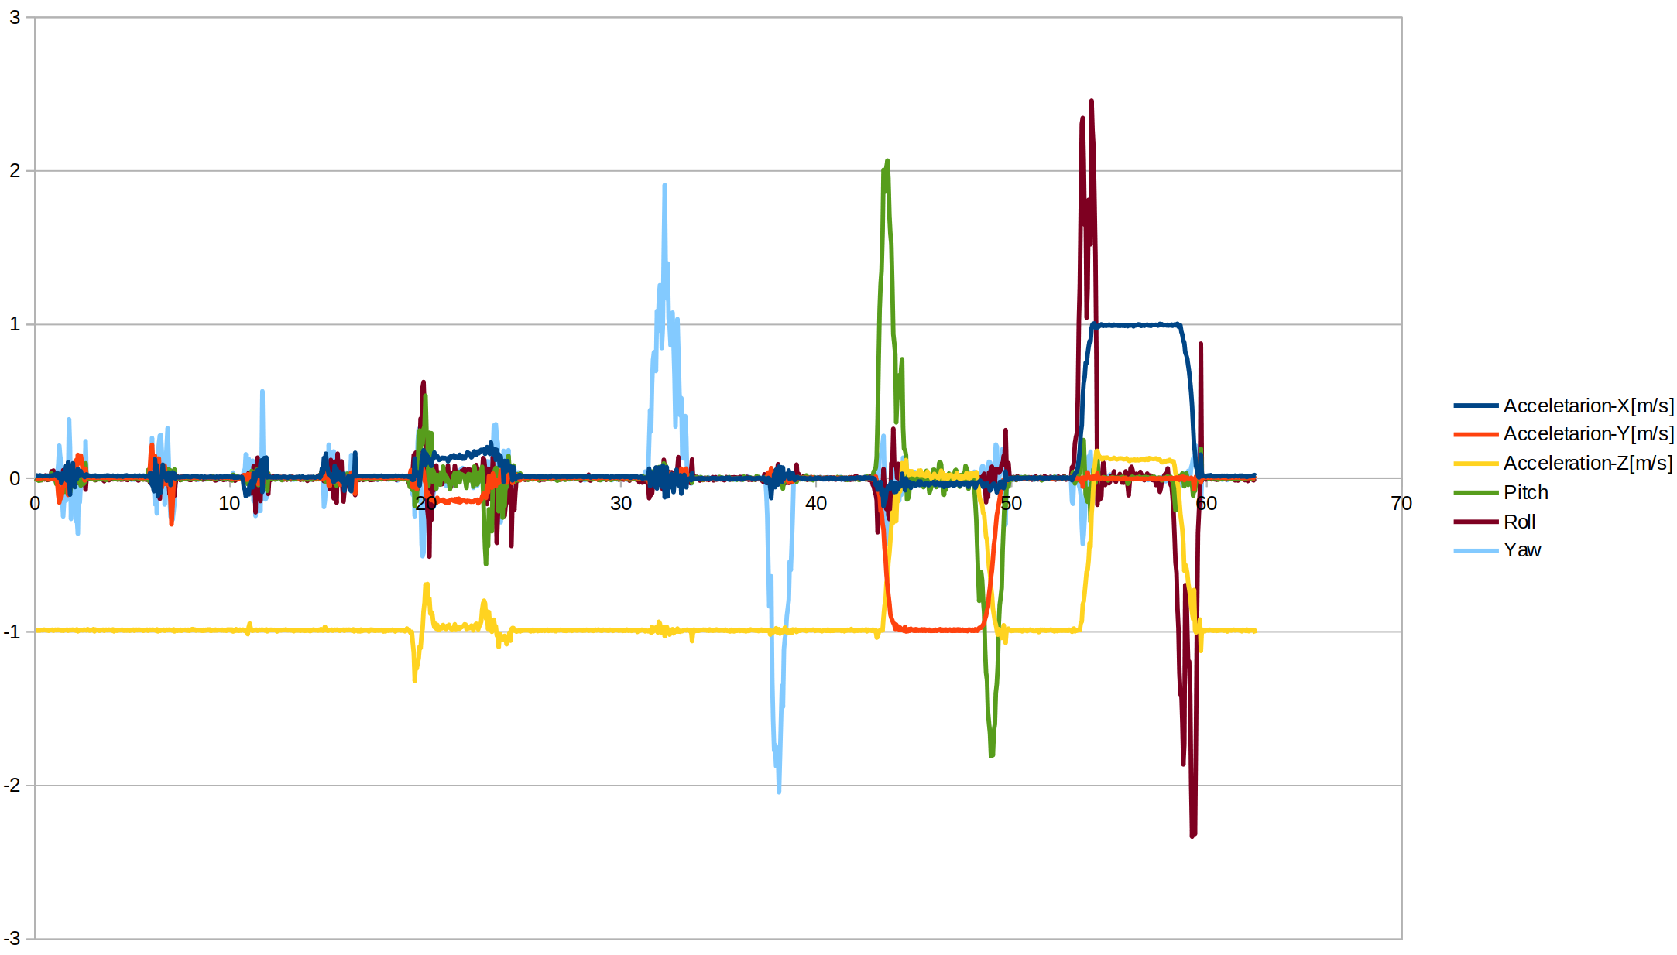

*SMOOTH DATA (WINDOW SIZE 25) :*

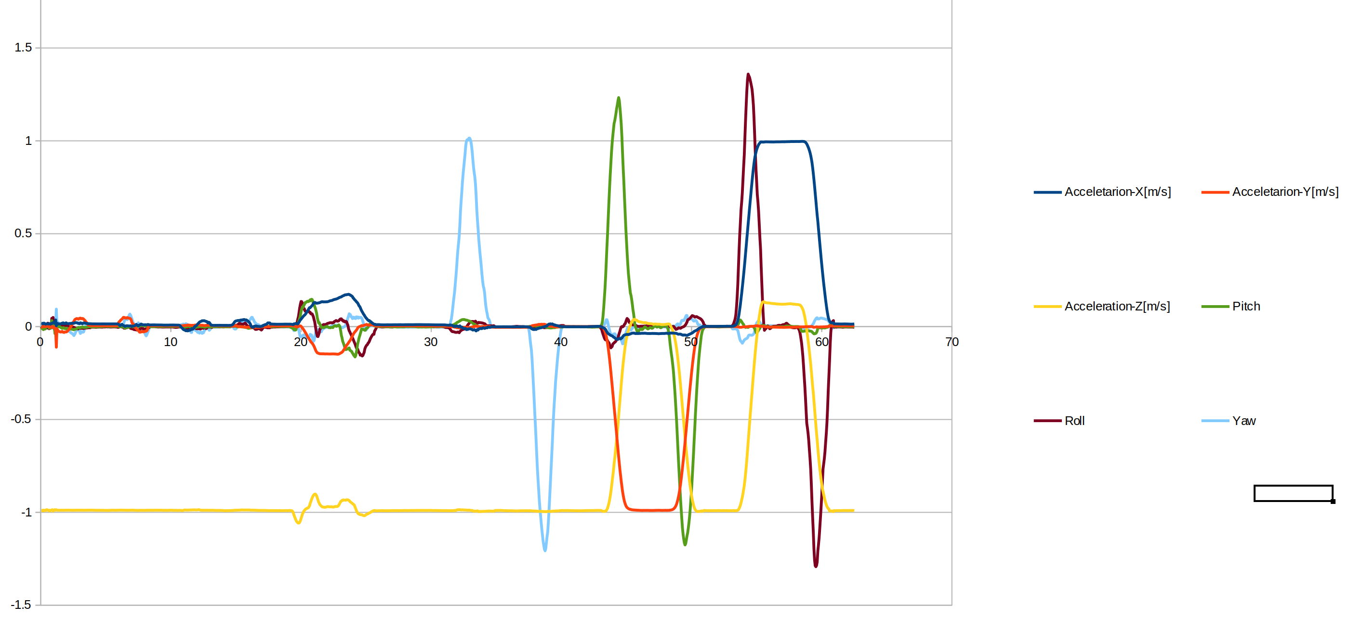

*Movement Segments:*

***Accelerometer Threshold: 0.0009 | Gyroscope Threshold: 0.03 | Variance Window Size: 11***

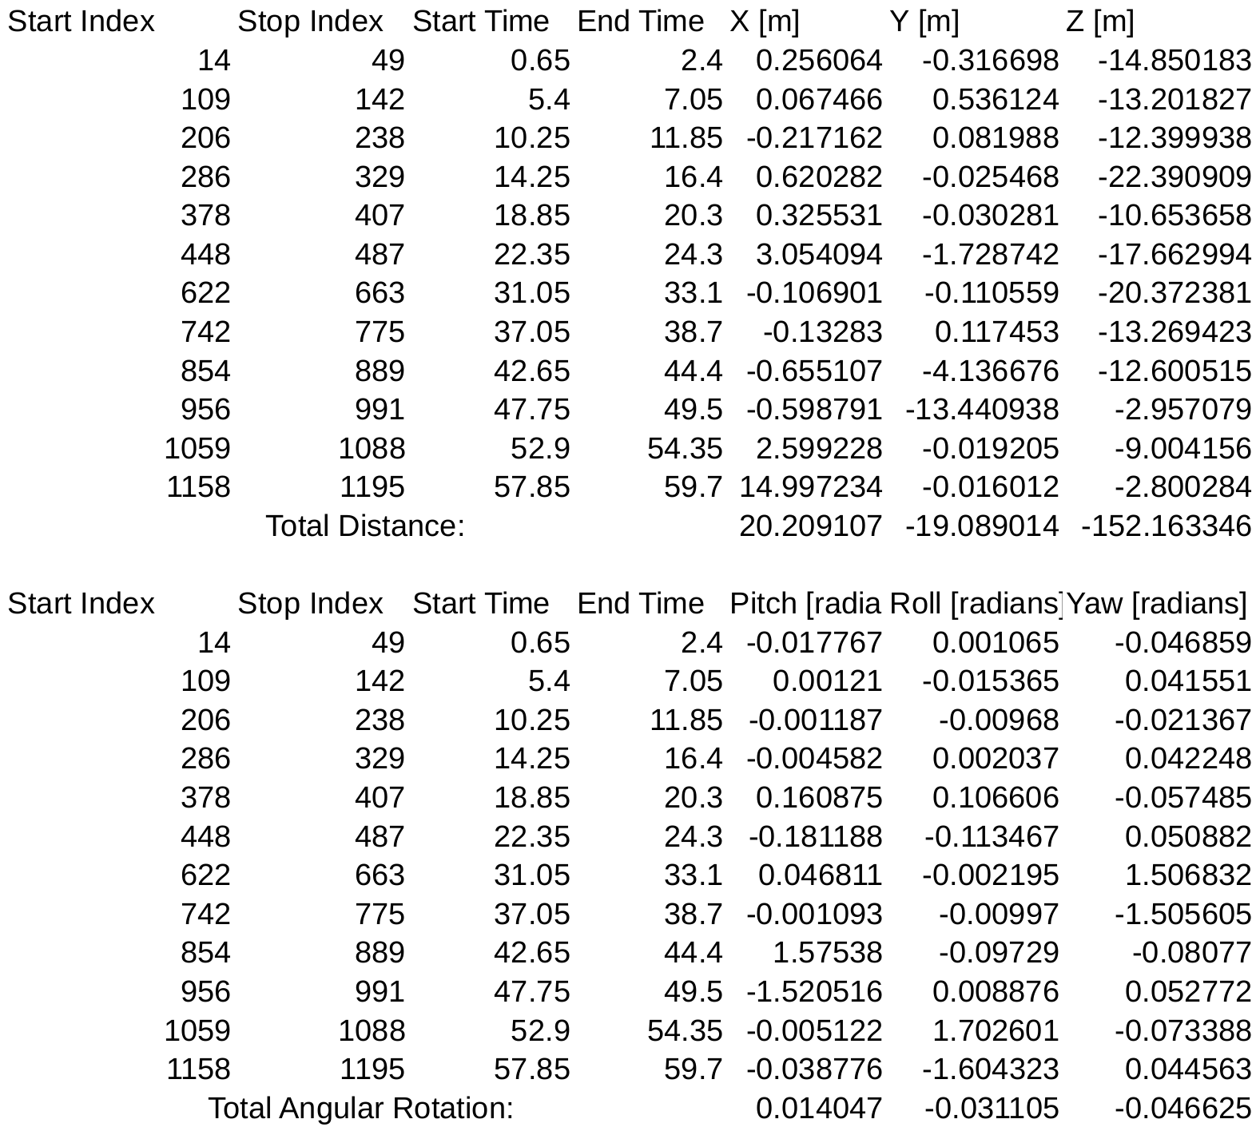

***Accelerometer Threshold: 0.0009 | Gyroscope Threshold: 0.03 | Variance Window Size: 20***

