Name: Rodrigo Ignacio Rojas Garcia

Course: ECE 4310

Lab #8

Range Image Segmentation

In this project the student was to segment a range image based upon surface normals. The student was to use a PPM image called “chair-range.ppm” and C code regarding conversion of pixels into 3D coordinates and Region Grow. The segmentation process used the image grid for grouping of pixels, but used the 3D coordinates for calculating the surface normals for region predicates. The laboratory was successfully completed by completing the following steps:

1. Threshold Image
   1. The image “chair-range.ppm” was thresholded at a value of **137 (value of THRESHOLD on C Code)** with the purpose of removing the background and only leaving the floor and chair in the image.
2. Obtain 3D Coordinates
   1. The C-code provided by Dr. Hoover was modified and implemented in order to obtain the 3D coordinates from pixels from the “chair-range.ppm” image. It should be noted that the slant type was assumed to be of scan-direction downward.
3. Calculate Surface Normals
   1. Surface normals were obtained by using the “chair-range.ppm” image and calculating it by taking the cross product of (B – X) x (A – X), where A and B are both 3D coordinates of those pixels (reference image below). The distance chosen between pixels for cross products were of value **3** **(value of PIXEL_WIDTH on C code).**

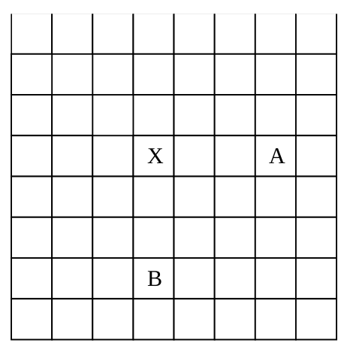

1. Region Growing
   1. The C-code provided by Dr. Hoover regarding queue-based region growing was modified and used to segment regions of the thresholded PPM image. The C-code was modified in order to be able to join a pixel based on the predicate that is within a threshold of the average orientation of pixels already on the region.
   2. The seed pixels for region growing were found by identifying a complete 5x5 window of unlabeled (and not masked out) of still-unlabeled region. The process followed that if any pixel within the 5x5 window was masked out already or already labeled in the 5x5 region, then the pixel could not be considered a seed for a new region. Region growing stopped when there were no more possible seed pixels in the image.
   3. The process of finding a seed pixel was broken down into following steps:
      1. Look through whole thresholded image **(starting at pixel at ROW 2, COLUMN 2).**
      2. Search for seed pixel in 5x5 window
         1. Calculate Angular difference using the dot product
         2. **Predicate: If the angular difference is less than Angular Difference threshold then:**
            1. **Add value to the total Surface Normal for each X, Y, and Z**
            2. **Calculate new Average Surface Normal for each X, Y, and Z**
            3. **Label Pixel**
            4. 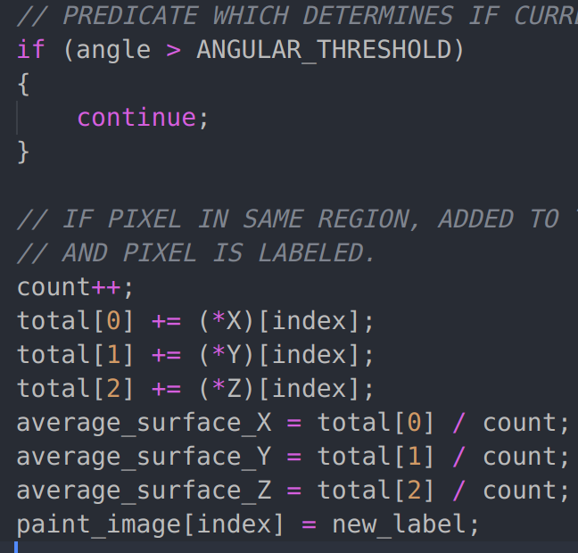**Code:**
            5. **It should be noted that the ANGULAR_THRESHOLD value is of 0.65**
      3. Repeat Process until all image is searched

All C Code can be seen at the end of the report.

**RESULTS**

*Original “chair-range.ppm” Image:*

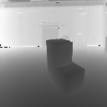

*Thresholded “chair-range.ppm” Image:*

***Threshold value: 137***

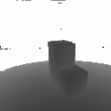

*Segmented & Thresholded “chair-range.ppm” Image:*

***Threshold value: 137***

***Cross Product Distance: 3***

***Angular Difference Threshold: 0.65***

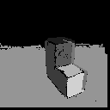

|  |  |  |  |  |
| --- | --- | --- | --- | --- |
| **Region** | **Number of Pixels** | **Average Surface Normal (X)** | **Average Surface Normal (Y)** | **Average Surface Normal (Z)** |
| 1 | 168 | -2.912282 | 327.747653 | -57.789212 |
| 2 | 786 | -50.107734 | 0.919432 | -8.377012 |
| 3 | 479 | 2.569452 | -2.398113 | -4.477929 |
| 4 | 440 | 50.852073 | -1.701171 | -15.616532 |
| 5 | 6844 | -1.519162 | 28.897201 | -8.941283 |
| 6 | 256 | -0.973660 | 8.602109 | -2.396540 |