Course: ECE 4730

Name: Rodrigo Ignacio Rojas Garcia

OpenMP Matrix Multiplication

In this laboratory we were required to write four programs regarding matrix multiplication with the purpose of teaching the student about the speedup with parallel programming when compared with sequential programming.

The first program required the student to create a program which created a square matrix or vector of size **n** and of user desired range in which the numbers in matrix/vector were of type **double** and output the matrix/vector as a binary file.

The second program consisted on developing a program which would print the binary file created from the first program and printed it in ASCII.

The third program was to develop a program which took 2 inputs, a matrix and a vector, with the purpose of outputting a binary file which contained the result of the matrix multiplication.

The fourth program was to create a parallel program which took two input files, a matrix and a vector with the purpose of outputting a binary file which contained the result of the matrix multiplication. To create this parallel program, the student used the OpenMP library and modified the third program.

As a result, the student was to time the matrix multiplication of both sequential and parallel matrix multiplication programs. The parallel program was also tested with four matrix sizes and different number of threads to show the speedup between the parallel and sequential programs. The result be seen below:

**RESULTS**

*Tests:*

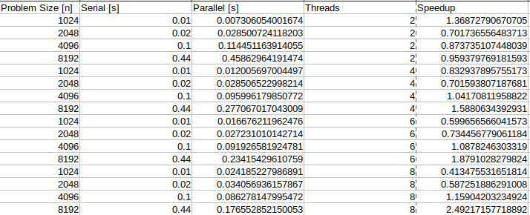

*Speed Up Graph:*

