网约车订单分析

1. 数据说明

本实验使用提供的数据集中的uber-raw-data-sep14.csv文件，为美国纽约九月份网约车Uber订单中的订单日期、乘客上车地点等信息。

1. 分析过程

import os  
import sys  
spark_name = os.environ.get('SPARK_HOME',None)  
if not spark_name:  
 raise ValueError('SPARK_HOME not set')  
sys.path.insert(0,os.path.join(spark_name,'python'))  
sys.path.insert(0,os.path.join(spark_name,'python/lib/py4j-0.10.7-src.zip'))  
exec(open(os.path.join(spark_name,'python/pyspark/shell.py')).read())

Welcome to  
 ____ __  
 / __/__ ___ _____/ /__  
 _\ \/ _ \/ _ `/ __/ '_/  
 /__ / .__/\_,_/_/ /_/\_\ version 3.5.0  
 /_/  
  
Using Python version 3.11.5 (main, Sep 11 2023 13:26:23)  
Spark context Web UI available at http://172.24.63.179:4040  
Spark context available as 'sc' (master = local[*], app id = local-1695959518514).  
SparkSession available as 'spark'.

#测试pyspark是否可以使用#

import findspark  
findspark.init()  
from pyspark import SparkContext  
sc.stop()  
sc = SparkContext("local","count app")  
words = sc.parallelize(  
 ["scala",  
 "java",  
 "hadoop",  
 "spark",  
 "akka",  
 "spark vs hadoop",  
 "pyspark",  
 "pyspark and spark"]  
)  
counts = words.count()  
print(counts)

8

#从HDFS中读取数据#

from pyspark.sql import SparkSession  
spark = SparkSession.builder.getOrCreate()  
df = spark.read.csv('Uber/uber-raw-data-sep14.csv',header=True)  
print(df)

DataFrame[Date/Time: string, Lat: string, Lon: string, Base: string]

#对网约车出行的时间分布进行分析#

from pyspark.sql.functions import to_date, to_timestamp  
dateDF = df.select(to_timestamp(df['Date/Time'],   
 'MM/dd/yyyy HH:mm:ss').alias('date'))

解析日期时收到如下异常：

You can set \"spark.sql.legacy.timeParserPolicy\" to \"LEGACY\" to restore the behavior before Spark 3.0, or set to \"CORRECTED\" and treat it as an invalid datetime string.\r\n\tat org.apache.spark.sql.errors.

发现下面一行代码可以解决问题

spark.sql("set spark.sql.legacy.timeParserPolicy=LEGACY")

DataFrame[key: string, value: string]

dateDF.show()

+-------------------+  
| date|  
+-------------------+  
|2014-09-01 00:01:00|  
|2014-09-01 00:01:00|  
|2014-09-01 00:03:00|  
|2014-09-01 00:06:00|  
|2014-09-01 00:11:00|  
|2014-09-01 00:12:00|  
|2014-09-01 00:15:00|  
|2014-09-01 00:16:00|  
|2014-09-01 00:32:00|  
|2014-09-01 00:33:00|  
|2014-09-01 00:33:00|  
|2014-09-01 00:37:00|  
|2014-09-01 00:38:00|  
|2014-09-01 00:39:00|  
|2014-09-01 00:48:00|  
|2014-09-01 00:48:00|  
|2014-09-01 00:49:00|  
|2014-09-01 01:08:00|  
|2014-09-01 01:17:00|  
|2014-09-01 01:19:00|  
+-------------------+  
only showing top 20 rows

#统计一月内的分布#  
利用SQL中GroupBy和count进行按月统计

from pyspark.sql.functions import year,month,dayofmonth  
stats_d = dateDF.select(  
 dayofmonth('date').alias('day')  
).groupBy('day').count().sort('day').collect()  
  
print(stats_d)

[Row(day=1, count=19961), Row(day=2, count=28831), Row(day=3, count=32631), Row(day=4, count=38360), Row(day=5, count=42319), Row(day=6, count=40520), Row(day=7, count=30134), Row(day=8, count=30360), Row(day=9, count=34560), Row(day=10, count=35910), Row(day=11, count=36439), Row(day=12, count=39540), Row(day=13, count=43205), Row(day=14, count=28122), Row(day=15, count=29454), Row(day=16, count=36092), Row(day=17, count=35531), Row(day=18, count=40274), Row(day=19, count=41017), Row(day=20, count=38864), Row(day=21, count=28620), Row(day=22, count=28312), Row(day=23, count=30316), Row(day=24, count=31301), Row(day=25, count=38203), Row(day=26, count=37504), Row(day=27, count=39468), Row(day=28, count=29656), Row(day=29, count=29201), Row(day=30, count=33431)]

#使用matplotlib绘制柱状图#

import matplotlib.pyplot as plt  
import numpy as np  
  
plt.figure(figsize=(18,16), dpi=80)  
plt.subplot(1,1,1)  
plt.grid(axis="y", linestyle='--')  
width= 0.7  
  
N = len(stats_d)  
values = [d['count'] for d in stats_d]  
index = np.arange(1,N+1)  
  
p2 = plt.bar(index, values, width, color="#87CEFA")  
  
plt.xlabel('Day')  
plt.ylabel('Total Journeys')  
plt.title('Journeys by Month Day')  
  
plt.xticks(index)  
plt.yticks(np.arange(0,50000,5000))  
  
plt.show()

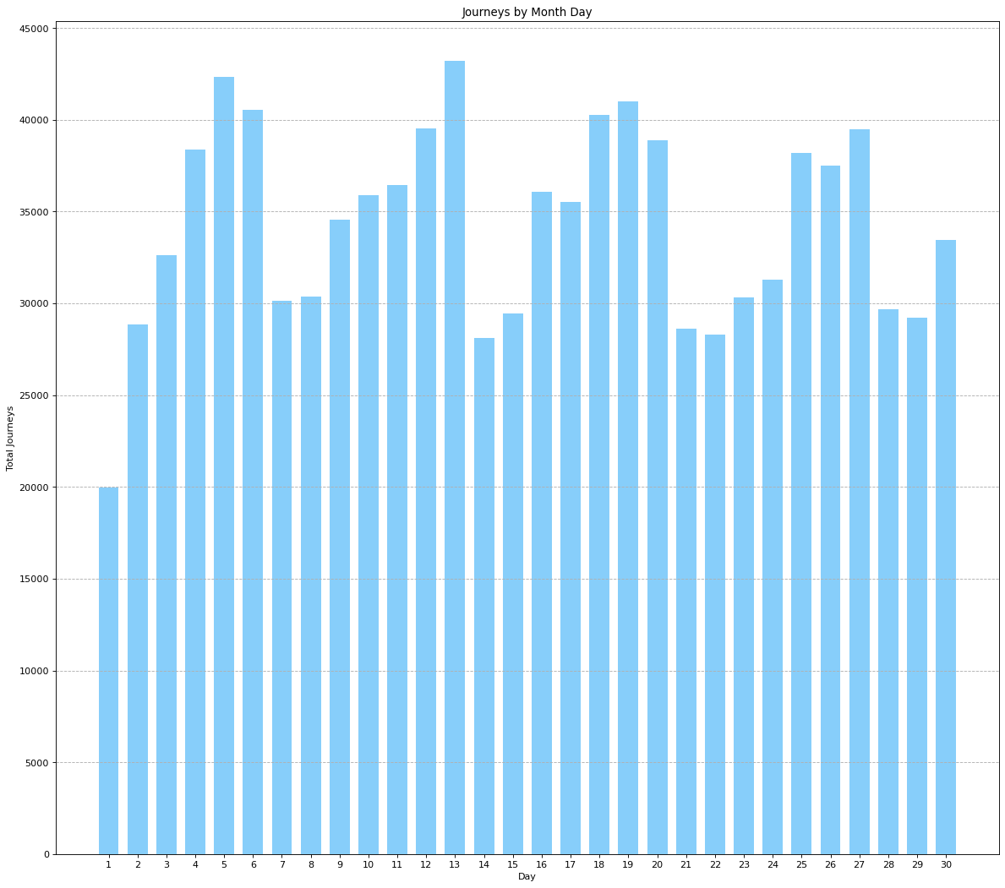

#一周内的分布#

from pyspark.sql.functions import dayofweek  
stats_w = dateDF.select(  
 dayofweek('date').alias('weekday')  
).groupBy('weekday').count().sort('weekday').collect()  
  
print(stats_w)

[Row(weekday=1, count=116532), Row(weekday=2, count=137288), Row(weekday=3, count=163230), Row(weekday=4, count=135373), Row(weekday=5, count=153276), Row(weekday=6, count=160380), Row(weekday=7, count=162057)]

plt.figure(figsize=(13,11), dpi=80)  
plt.subplot(1,1,1)  
plt.grid(axis="y", linestyle='--')  
width = 0.7  
  
N = len(stats_w)  
values = [d['count'] for d in stats_w]  
index = np.arange(N)  
  
p2 = plt.bar(index, values, width, color="#87CEFA")  
  
plt.xlabel('Days of Week')  
plt.ylabel('Total Journeys')  
plt.title('Journeys by Weekday')  
  
plt.xticks(index, ('Monday', 'Tuesday', 'Wednesday', 'Thursday', 'Friday',   
 'Saturday', 'Sunday'))  
plt.yticks(np.arange(0, 200000, 20000))  
  
plt.show()

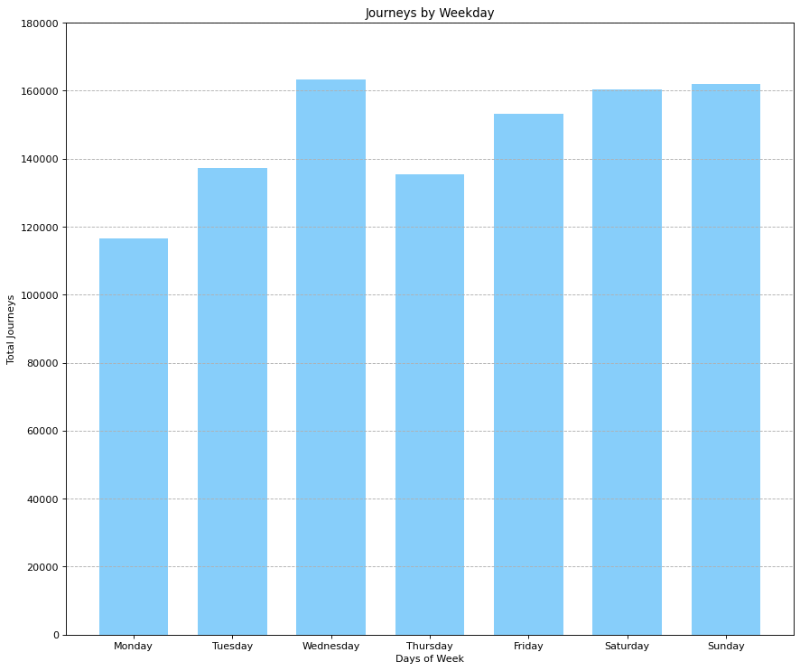

#一天内的分布#

from pyspark.sql.functions import hour  
stats_h = dateDF.select(  
 hour('date').alias('hour')  
).groupBy('hour').count().sort('hour').collect()  
  
print(stats_h)

[Row(hour=0, count=24133), Row(hour=1, count=16107), Row(hour=2, count=10702), Row(hour=3, count=10789), Row(hour=4, count=12675), Row(hour=5, count=20262), Row(hour=6, count=33307), Row(hour=7, count=43314), Row(hour=8, count=44477), Row(hour=9, count=38542), Row(hour=10, count=37634), Row(hour=11, count=38821), Row(hour=12, count=39193), Row(hour=13, count=45042), Row(hour=14, count=52643), Row(hour=15, count=61219), Row(hour=16, count=68224), Row(hour=17, count=73373), Row(hour=18, count=75040), Row(hour=19, count=69660), Row(hour=20, count=63988), Row(hour=21, count=60606), Row(hour=22, count=51817), Row(hour=23, count=36568)]

plt.figure(figsize=(13,11), dpi=80)  
plt.subplot(1,1,1)  
plt.grid(axis="y", linestyle='--')  
width = 0.7  
  
N = len(stats_h)  
values = [d['count'] for d in stats_h]  
index = np.arange(N)  
  
p2 = plt.bar(index, values, width, color="#87CEFA")  
  
plt.xlabel('Hour')  
plt.ylabel('Total Journeys')  
plt.title('Journeys by Hour')  
  
plt.xticks(index)  
plt.yticks(np.arange(0, 80000, 5000))  
  
plt.show()

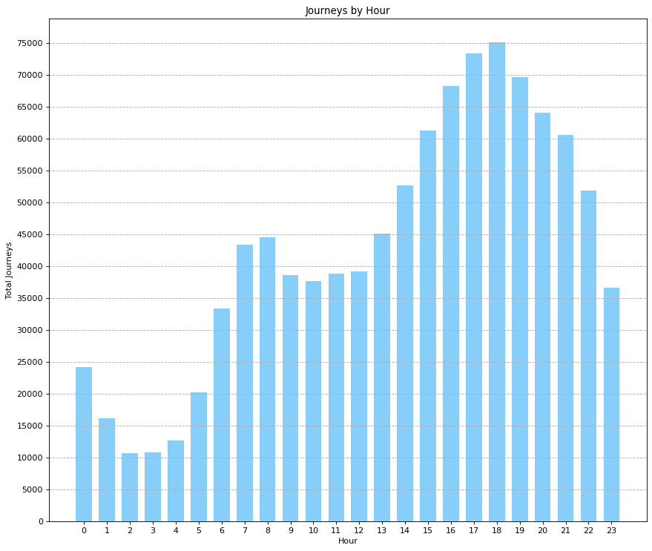

#网约车空间分布分析#

import pandas as pd  
import numpy as np  
import seaborn as sns  
import matplotlib.pyplot as plt  
import os  
import conda  
  
conda_file_dir = conda.__file__  
conda_dir = conda_file_dir.split('lib')[0]  
proj_lib = os.path.join(os.path.join(conda_dir, 'share'), 'proj')  
os.environ["PROJ_LIB"] = proj_lib  
  
  
from mpl_toolkits.basemap import Basemap  
from matplotlib import cm  
  
x_a = np.array([float(r['Lon']) for r in df.select(df['Lon']).collect()])  
y_a = np.array([float(r['Lat']) for r in df.select(df['Lat']).collect()])

#绘制热度图#

west, south, east, north = -74.26, 40.50, -73.70, 40.92  
fig = plt.figure(figsize=(14,10))  
ax = fig.add_subplot(111)  
m = Basemap(projection='merc', llcrnrlat=south, urcrnrlat=north,   
 llcrnrlon=west, urcrnrlon=east, lat_ts=south, resolution='i')  
x,y = m(x_a, y_a)  
m.hexbin(x, y,gridsize=1000, bins='log',cmap=cm.Reds)

<matplotlib.collections.PolyCollection at 0x27660922c50>

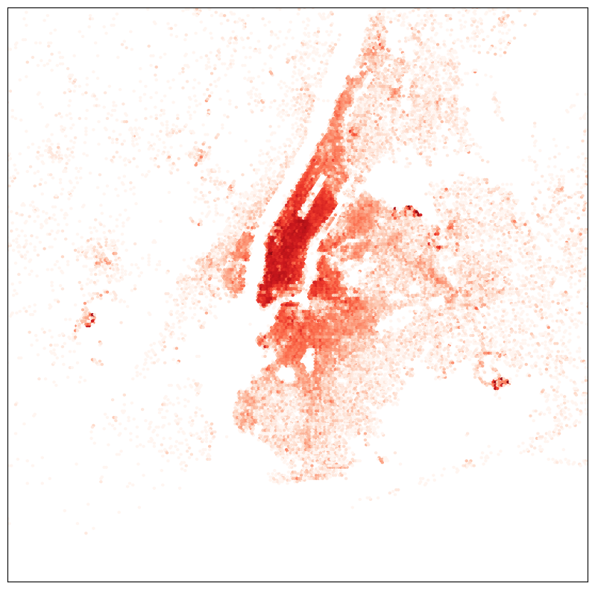

1. 分析结果

从对订单的时间分布与空间分布规律来看，订单最密集的区域对应于纽约最繁华的曼哈顿地区。